Attachment 6 – Thank you letter

DEPARTMENT OF HEALTH & HUMAN SERVICES Public Health Service
Centers for Disease Control and Prevention

National Center for Health Statistics
3311 Toledo Road
Hyattsville, Maryland 20782

Thank you

…for the assistance you have given us in testing our questionnaire. After all testing and corrections have been completed, the final questionnaire will be used to collect information from persons throughout the country. The information will be used for many purposes that will benefit all Americans, such as providing information on the kinds of health conditions that affect most Americans, so that research funds can be best used, or developing screening or education programs to help prevent serious disabilities.

The information you provided will, of course, be held in confidence. When combined with information given by other volunteers, it will help us to identify and correct problems with question wording and order. This will improve the quality of the information collected in the national survey. We greatly appreciate your help in this effort.

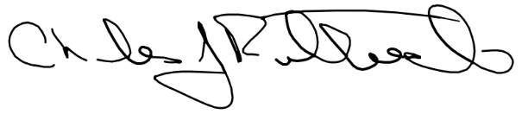

Charles J. Rothwell
Director
National Center for Health Statistics

