Attachment 2a: Semi-targeted advertisement

**Participants Wanted for Research Study**

The National Center for Health Statistics

is looking for adults aged 18 and over to answer a variety of demographic questions that may be asked on national surveys. People with all racial and ethnic backgrounds can participate, but we are especially interested in those who have Middle Eastern or North African backgrounds. The survey research interview will be no longer than 60 minutes and participants will receive $40.

**FOR MORE INFORMATION,**

Call [fill name] at: **301-458-[fill XXXX]**

**Centers for Disease Control and Prevention**

**National Center for Health Statistics**

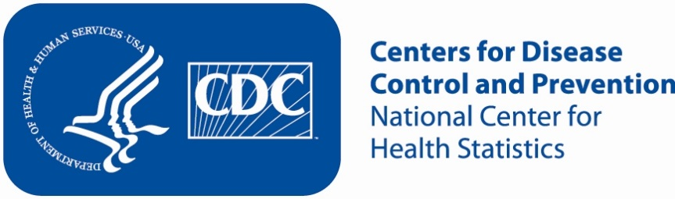**Appendix 2b: Non Specific Advertisement/flyer**

**Participants Wanted for Research Study**

The National Center for Health Statistics

is looking for adults aged 18 and over to answer a variety of demographic questions that may be asked on a national survey. The survey research interview will be no longer than 60 minutes. Participants will receive $40.

**FOR MORE INFORMATION,**

Call [fill name] at: **301-458-[fill XXXX]**

**Centers for Disease Control and Prevention**

**National Center for Health Statistics**

