Attachment 2a: Targeted advertisement

**Participants Wanted for Research Study**

The National Center for Health Statistics

is looking for teens in grades 9-12 (aged 15-18) who have used alcohol or marijuana. The survey research interview will be no longer than 60 minutes and participants will receive $40.

**FOR MORE INFORMATION,**

Call [fill name] at: **301-458-[fill XXXX]**

**Centers for Disease Control and Prevention**

**National Center for Health Statistics**

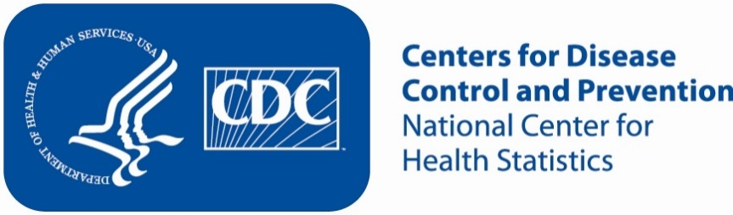**Attachment 2b: Non-Specific Advertisement/flyer**

**Participants Wanted for Research Study**

The National Center for Health Statistics

is looking for teens in grades 9-12 (aged 15-18) to answer a variety of health questions that may be asked on a national survey. The survey research interview will be no longer than 60 minutes. Participants will receive $40.

**FOR MORE INFORMATION,**

Call [fill name] at: **301-458-[fill XXXX]**

**Centers for Disease Control and Prevention**

**National Center for Health Statistics**

