**Attachment 2 – Invitational letter - cognitive interviews**

dhhs_logo

**DEPARTMENT OF HEALTH & HUMAN SERVICES** **Public Health Service**

**Centers for Disease Control and Prevention**

**National Center for Health Statistics**

**3311 Toledo Road**

**Hyattsville, Maryland 20782**

Date

 **What do I do next?**

If you want to schedule an interview or ask questions about this survey research, please call [Fill name] at 301-458-xxxx.

Full name

Street address

City, State, Zip

Dear [Fill]:

The Centers for Disease Control and Prevention’s National Center for Health Statistics (NCHS) will be conducting preliminary survey research on The National Survey of Hospital-Based Victim Services (NSHVS) before it is fielded.

The survey is best completed by someone with **knowledge of all the different ways your hospital provides services to victims of crime or abuse**. Someone from the National Center for Health Statistics’ Center for Questionnaire Design and Evaluation Research will call to ask if you are willing to participate in a research interview.

If you are willing to help us, here is what you need to know:

* In-person interview
* Conducted at your convenience
* No longer than one-hour
* $100 as a token of our appreciation
* Call 301-458-4579 to schedule an appointment

Participation is, of course, voluntary, and you may refuse to answer any question or may stop participating at any time without penalty or loss of benefits. All of the information you provide will be kept confidential.[[1]](#footnote-1)

If you have any questions about your rights as a respondent in this research study, please call the Research Ethics Review Board at the National Center for Health Statistics toll-free at 1-800-223-8118. Please leave a brief message with your name and phone number. Say that you are calling about Protocol #[INSERT # after ERB approval]. Your call will be returned as soon as possible.

We greatly appreciate your interest and your help, and do look forward to working with you on this important topic.

Sincerely,

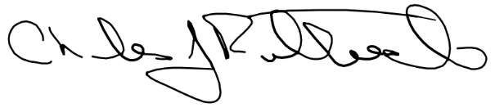

Charles J. Rothwell

Director, National Center for Health Statistics

1. This study is authorized by Section 306 of the Public Health Service Act (Title 42, U.S. Code 242k). All information collected as part of this study will be used for statistical purposes only and held in the strictest confidence according to Section 308(d) of the Public Health Service Act (42, U.S. Code 242m(d)) and the Confidential Information Protection and Statistical Efficiency Act (Title 5 of PL 107-347). [↑](#footnote-ref-1)