Attachment 2 - Invitational letter
DEPARTMENT OF HEALTH & HUMAN SERVICES Public Health Service
Centers for Disease Control and Prevention

National Center for Health Statistics
3311 Toledo Road
Hyattsville, Maryland 20782
Date

Full name
Street address
City, State, Zip

Dear [Fill]:

The Centers for Disease Control and Prevention’s National Center for Health Statistics plans to conduct a self-administered Healthcare Systems ScoreCard (HSSC) Assessment Tool for Primary Care Practices. The purpose of this scorecard is to assist healthcare administrators better assess their policies, practices, and systems that guide the delivery of care for adult patients with chronic disease conditions. The scorecard will also help to prioritize strategies with the highest impact to better manage chronic disease conditions.

We hope that, as a healthcare administrator, who works at a primary care health system, you will be willing to advise us as we seek to improve the survey before it is fielded. If you are willing to participate in a one-hour, in-person interview, you will receive $100 as a token of our appreciation. Participation during the interview is, of course, voluntary, and you may refuse to answer any question or may stop participating at any time without penalty or loss of benefits. All of the information you provide will be kept confidential.

Someone from the National Center for Health Statistics’ Center for Questionnaire Design and Evaluation Research will call to ask if you are willing to participate in a research interview. However, if you would like to schedule an interview or if you have any questions about this research, please call [Lauren Creamer at 301-458-4674/Amanda Titus at 301-458-4579]. If you have any questions about your rights as a respondent in this research study, please call the Research Ethics Review Board at the National Center for Health Statistics toll-free at 1-800-223-8118. Please leave a brief message with your name and phone number. Say that you are calling about Protocol #[INSERT # after ERB approval]. Your call will be returned as soon as possible.

We greatly appreciate your interest and your help, and do look forward to working with you on this important topic.

Sincerely,

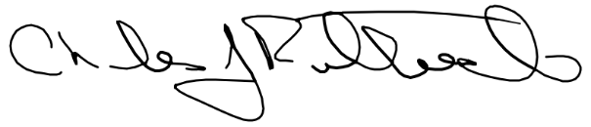
Charles J. Rothwell
Director
National Center for Health Statistics
3311 Toledo Rd
Hyattsville, MD 20782

This study is authorized by Section 306 of the Public Health Service Act (Title 42, U.S. Code 242k). All information collected as part of this study will be used for statistical purposes only and held in the strictest confidence according to Section 308(d) of the Public Health Service Act (42, U.S. Code 242m(d)) and the Confidential Information Protection and Statistical Efficiency Act (Title 5 of PL 107-347).

