Attachment 2a: Semi-targeted advertisement/flyer [note bracketed text may or may not be selected depending on recruiting needs].

Participants Wanted for Research Study

The National Center for Health Statistics
is looking for adults aged 18 and over [who have experienced a head or neck injury [in the past 12 months]]. The survey research interview will be no longer than 60 minutes and participants will receive $40.

FOR MORE INFORMATION,
Call [fill name] at: 301-458-[fill XXXX]

Centers for Disease Control and Prevention
National Center for Health Statistics

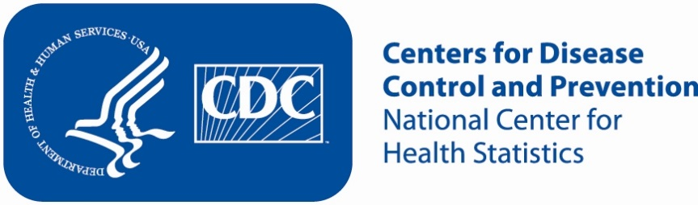
Attachment 2b: Semi-targeted advertisement/flyer [note bracketed text may or may not be selected depending on recruiting needs].

Participants Wanted for Research Study

The National Center for Health Statistics
is looking for adults aged 18 years and over with children living in the household to answer health questions that may be asked on a national survey. [We want to talk to parents or guardians of children 5 to 17 who may have experienced a head or neck injury [in the past 12 months]]. The survey research interview will be no longer than 60 minutes and participants will receive $40.

FOR MORE INFORMATION,
Call [fill name] at: 301-458-[fill XXXX]

Centers for Disease Control and Prevention
National Center for Health Statistics

Attachment 2c: Semi-targeted advertisement/flyer [note bracketed text may or may not be selected depending on recruiting needs].

Note to reviewers: Interviewing dyads is a complex concept to recruit for. Although both 2c and 2d contain the same core message, potential respondents may understand one of the ads better due to the difference in organization. With this in mind, keeping both 2c and 2d will give recruitment the flexibility of using one ad over the other if it is found that people understand one of the ads better than the other.

Participants Wanted for Research Study

The National Center for Health Statistics
is looking for parents and teens to answer health questions that may be asked on a national survey. We want to talk to parents or guardians and teens 12 to 17 years of age [who may have experienced a head or neck injury [in the past 12 months]]. The survey research interview will be no longer than 60 minutes. The parent/guardian and the teen will receive $40 each.

FOR MORE INFORMATION,
Call [fill name] at: 301-458-[fill XXXX]

Centers for Disease Control and Prevention
National Center for Health Statistics

Attachment 2d: Semi-targeted advertisement/flyer [note bracketed text may or may not be selected depending on recruiting needs].

Note to reviewers: Interviewing dyads is a complex concept to recruit for. Although both 2c and 2d contain the same core message, potential respondents may understand one of the ads better due to the difference in organization. With this in mind, keeping both 2c and 2d will give recruitment the flexibility of using one ad over the other if it is found that people understand one of the ads better than the other.

Participants Wanted for Research Study

The National Center for Health Statistics
is looking for parents/guardians of teens (aged 12-17) [who may have experienced a head or neck injury [in the past 12 months]]. Both parent/guardian and teen will participate in the interview. The survey research interview will be no longer than 60 minutes. The parent/guardian and the teen will receive $40 each.

FOR MORE INFORMATION,
Call [fill name] at: 301-458-[fill XXXX]

Centers for Disease Control and Prevention
National Center for Health Statistics
Attachment 2e: Special Interest Group Research Study Notification

Note to Reviewers: Special Interest Group would notify potential participants of the existence of the research study and to provide information about how to contact the investigators. Special Interest Group will not answer any questions about the study, will not ask potential participants if they would like to participate, and will not record contact information of potential participants to give to the investigators.

“You may be eligible to participate in a research study [today/on specified date] if you would like to do so. Researchers from the Centers for Disease Control and Prevention’s National Center for Health Statistics are evaluating a questionnaire on head and neck injuries. Would you mind if I gave your name and phone number to Dr. Meredith Massy from the National Center for Health Statistics? Dr. Massey can tell you more about the study and answer any questions you might have. You can then decide whether or not you want to participate.”

