## What is the PSVA?

PSVA stands for Pre-Submission Validation Application. PSVA was developed in response to interest and demand from the quality reporting community to allow users to validate electronic clinical quality measure (eCQM) data files in real time. The tool provides users with the opportunity to catch and correct errors prior to submission and supports the submission of validated files to the hospital eCQM receiving system for The Centers for Medicare and Medicaid Services (CMS). The application allows for immediate validation feedback within a user’s system/environment and can be run separately from submission. Valid QRDA files may be separated and submitted while invalid files are identified for error correction.

**How does it work?**

The PSVA is a client-side Java application that is portable and easy to integrate with EHR and quality reporting systems. The tool can be leveraged for both internal development and testing activities. PSVA provides software integrators with an abstracted interface to any number of independent validation modules, standardized methods of validating quality reporting data, retrieving validation results, and submitting validated data to CMS.

**High-Level PSVA Overview**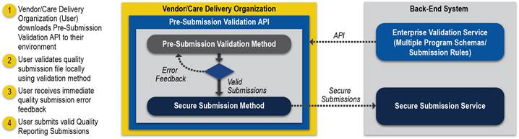

**When will it be available?**

The PSVA Operational Pilot will be available in July 2015. The pilot will consist of a limited group of hospital quality reporting (HQR) participants. These participants will be provided an operational version of PSVA for use in their environment and given the opportunity to provide feedback on features and functionality, having impact on the usefulness of the final product.

## Goals of the operational pilot include:

* Testing the ease of downloading and operationalizing the tool on participants’ systems.
* Testing the process of validating QRDA Category I files and reviewing validation results in participants’ environment prior to submission. Gathering feedback from participants on usability of the tool to guide updates for future releases.

## Requirements for Participation:

* Participant organizations must have the ability to:
  + Create QRDA Category I files based on the HL7 Base Standard for QRDA.
  + Download and install PSVA in their environment from July 1 – July 31, 2015.
  + Attend a 30 minute PSVA Pilot Participant Information Session* in June 2015.
  + Attend two 30 minute PSVA Pilot Feedback Sessions* in July.
  + Record and submit feedback on the use of PSVA.

*Session dates will be announced in May. Arrangements will be made to accommodate individual schedules upon request.

## How do I become a participant?

## If you are interested in participating in the PSVA Operational Pilot please contact Stephanie Wilson, at [Stephanie.wilson@hcqis.org](mailto:Stephanie.wilson@hcqis.org).

Quality Reporting Process Survey

The Centers for Medicare and Medicaid Services (CMS) would like your feedback on their quality reporting submission process. Your responses will be anonymous, and will help CMS evaluate and improve your data submission experience in the future. The survey should take approximately 5 minutes to complete. Please complete the survey by [INSERT DATE].

Your response and time is greatly appreciated. Thank you!

**Please rate your level of agreement with the following statements.**

|  |  |  |  |  |  |  |
| --- | --- | --- | --- | --- | --- | --- |
| **#** | **Survey Question** | **Strongly Disagree** | **Disagree** | **Neither Agree or Disagree** | **Agree** | **Strongly Agree** |
| 1 | The process of submitting data for my CMS quality reporting program is straightforward. |  |  |  |  |  |
| 2 | I am satisfied with the process of submitting data for my CMS quality reporting program. |  |  |  |  |  |
| 3 | I am satisfied with the amount of time that it takes to submit data for my CMS quality reporting program. |  |  |  |  |  |
| 4 | I receive my validation report(s) quickly. |  |  |  |  |  |
| 5 | I can easily access validation report(s) for the data that I submit to CMS. |  |  |  |  |  |
| 6 | I frequently have to resubmit files to CMS. |  |  |  |  |  |
| 7 | I am confident that the data for my CMS quality reporting program will be accepted when submitted. |  |  |  |  |  |