OMB Control Number:1024-XXXX
Expiration Date: XX-XX-XXXX

The National Parks and Federal Recreational Lands Pass Survey
Access Pass Version
Participating Agencies:

U.S. Forest Service
National Park Service
Bureau of Reclamation
U.S. Fish and Wildlife Service
Bureau of Land Management

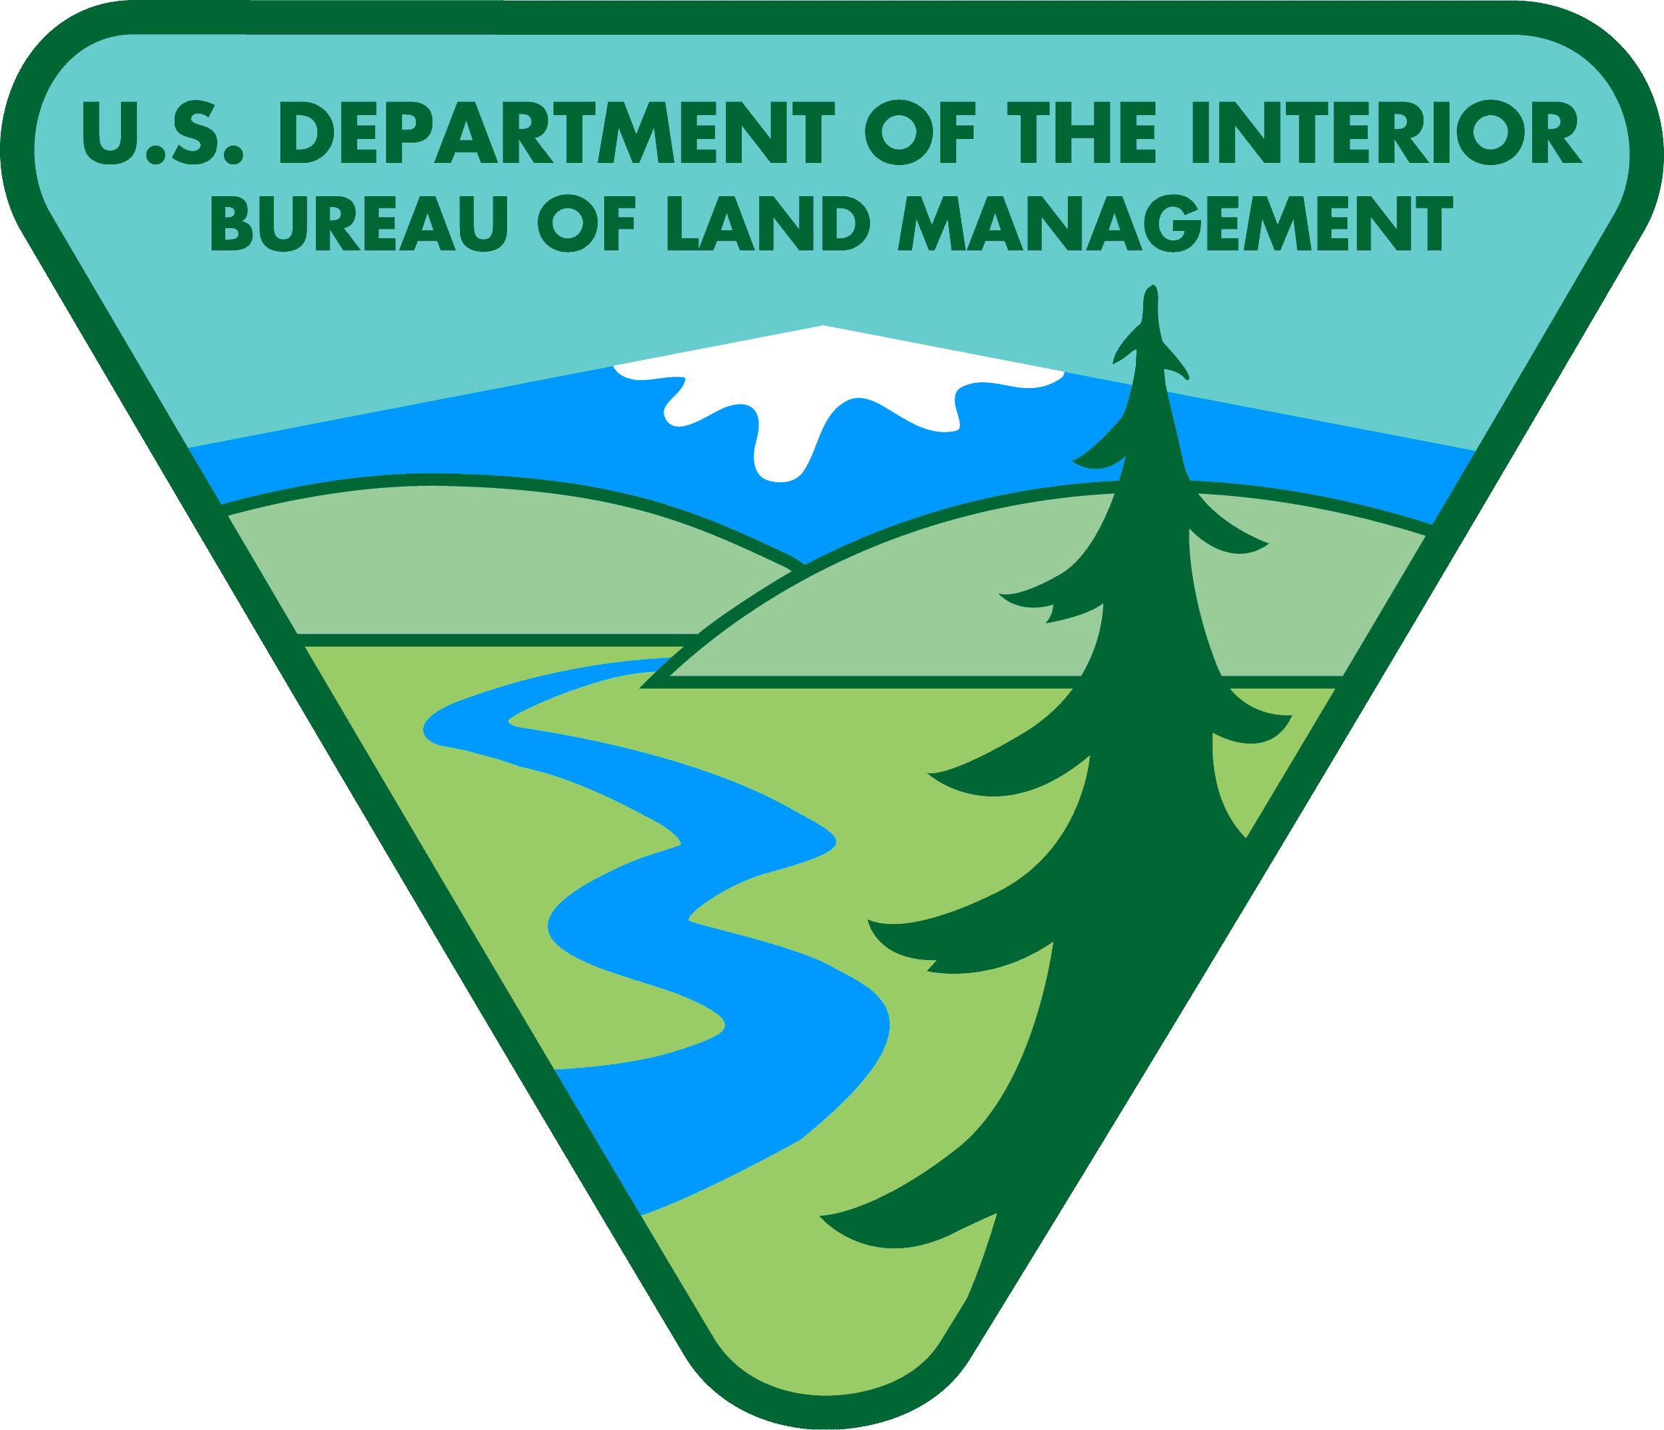
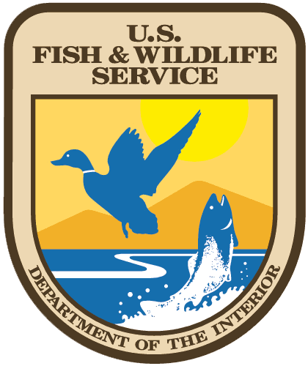
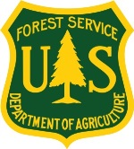

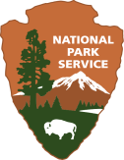

Paperwork Reduction and Privacy Act Statement: The National Park Service is authorized by 16 U.S.C. 1a-7 to collect this information. This information collection will provide data for the Park Service to evaluate the use and administration of the National Parks and Federal Recreational Lands Pass Program. Response to this request is voluntary. No action may be taken against you for refusing to supply the information requested. The permanent data will be anonymous. An agency may not conduct or sponsor, and a person is not required to respond to, a collection of information unless it displays a currently valid OMB control number.

BURDEN ESTIMATE Public reporting burden for this form is estimated to average 15 minutes per response. Direct comments regarding the burden estimate or any other aspect of this form to: Chris Neher at (406) 721-2265; or Phadrea Ponds, NPS Information Collection Review Coordinator.

BACKGROUND INFORMATION ABOUT THIS STUDY

You have been selected to receive this survey because you purchased a National Parks and Federal Recreational Lands Pass within the 12 months. Below is a brief description of the participating agencies and the lands they manage. These agencies would like your help in understanding how you use your pass, what you like about the pass, and what could be improved. Thank you so much for your time and helping the agencies to provide and improve their recreation offerings. A self-addressed stamped envelope is provided for returning this survey.

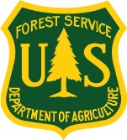
Forest Service
The Forest Service manages over 193 million acres of public land across the nation. With approximately 160,000 miles of summer and winter trails and thousands of other sites such as campgrounds, picnic areas, boating sites, ski areas, cabin rentals, and interpretive sites the Forest Service is America’s largest source of outdoor recreation opportunities.

National Park Service
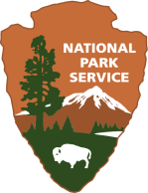
The National Park Service (NPS) manages over 400 sites across the United States. NPS sites include a variety of public lands, including National Parks (like Yellowstone National Park), National Recreation Areas (like Lake Mead National Recreation Area), National Monuments (like Statue of Liberty National Monument), National Historic Sites and Parks (like Independence National Historic Park), and National Battlefields (like Antietam National Battlefield).


Bureau of Reclamation
The Bureau of Reclamation (BOR) manages water projects such as dams, reservoirs, power plants, and canals in the Western United States. BOR has over 6 million acres of land and water available for public recreation, and 289 project areas with developed recreational opportunities.

Fish and Wildlife Service
The U.S. Fish and Wildlife Service (FWS) works to conserve, protect, and enhance fish, wildlife, and plants and their habitats for the continuing benefit of the American people. FWS recreational resources include National Wildlife Refuges (like Kenai National Wildlife Refuge) and National Fish Hatcheries.

Bureau of Land Management
The Bureau of Land Management (BLM) primarily manages public lands in the Western United States. The BLM manages more onshore Federal land than any other agency – over 245 million surface acres. BLM recreational resources include National Monuments (like Sonoran Desert National Monument) and National Recreation Areas (like White Mountains National Recreation Area).

The National Parks and Federal Recreational Lands Pass Program

The National Parks and Federal Recreational Lands Pass Program is a cooperative program of the five major federal land management agencies in the United States. The agencies would like to better understand how these passes are used. The passes issued by the program allow admission to or use of several thousand sites throughout the country. There are three types of passes in the program:
- Annual Passes,
- Senior Passes (for those over 62 years old) and
- Access Passes (for permanently disabled citizens).

You were selected for this survey because you requested a National Parks and Federal Recreational Lands Access Pass within the past 12 months. Your answers to the following questions will help the participating agencies better understand where, when and how often the passes are used. Additionally, your input will help the agencies manage and improve the program.
Your participation is completely voluntary and all responses will remain anonymous. It will take about 15 minutes to complete this questionnaire. When you are done, please use the self-addressed envelope to return your completed survey to our study team.

Thank you for your help!

Section I: How Do You Use Your Access Pass?
Q1-Q3 will be used to determine the frequency of use of passes by the pass-holder and serve to warm up respondents to thinking about their use of the pass.

- In what month did you receive your Access Pass?
Month: ______________________

- Since you received your Access Pass, how many times have you used it to visit Federal recreation lands (any lands covered by the pass)?
  - I have not used it yet
  - 1 time
  - 2 times
  - 3-5 times
  - 6-10 times
  - More than 10 times (Please indicate the number of times if more than 10: ________)

- How many times between now and 12 months from now do you anticipate that you will use your Access Pass?
  - 1 time
  - 2 times
  - 3-5 times
  - 6-10 times
  - More than 10 times (Please indicate the how many times if more than 10: _______)

If you have not used your current pass this year, please skip to Question 10 below
Q4 through Q7 will be used to collect data on the distribution of pass use across participating agency sites and provide “certainty” or “data quality” checks. Q5 & Q7 will be used to interpret responses. These questions are the first part of the core information gathering needed to answer the underlying question of how pass revenue should be distributed among participating agencies.

- Passes can be used to visit several thousand different sites across the nation. Some Access Pass holders use their passes at many different sites, while others use their pass at only one or two sites. How many DIFFERENT recreation sites do you anticipate you will have visited within the first 12 months of having your Access Pass?
  - 1 site (I only use the Access Pass at one site)
  - 2 different sites
  - 3-5 different sites
  - 6-10 different sites
  - More than 10 different sites

- Currently five different land management agencies honor the Access Pass for access to their sites. These agencies are, National Park Service, US Forest Service, Bureau of Land Management, US Fish and Wildlife Service, and Bureau of Reclamation.

For sites where you’ve used your Access Pass, which of the following statements best describes your knowledge of the managing agency(ies)? We would like to know if you are aware of which agency manages the sites where you use your Access Pass. Which of the following statements best describes your knowledge of the managing agency? (select one response)
  - I always knew which agency managed the site(s) I visited
  - Most of the time I knew which agency managed the site(s) I visited
  - I Sometimes knew which agency managed the site(s) I visited
  - I never knew (or didn’t notice) which agency managed the site(s) I visited

Now, thinking about the first 12 months of having your pass, we would like you to estimate how many trips you think you will make to sites managed by each of the land management agencies below. If you don’t think you will take any trips to a certain type of site, please write in a “0”. For examples of the types of sites managed by each agency, please see Page 3.
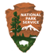 | Trips to National Park Service sites: | trips
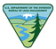 | Trips to Bureau of Land Management sites: | trips
 | Trips to U.S. Fish and Wildlife Service sites: | trips
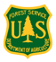 | Trips to U.S. Forest Service Sites: | trips
 | Trips to Bureau of Reclamation Sites: | trips

- How certain are you about the estimates you made in Question Q5? Please circle a number for each of the two questions below, where 1 means “Not at all Certain” and 5 means “Extremely Certain,”

a. How certain are you about the NUMBER OF TRIPS you estimated for each agency?

Not at all Certain | Slightly Certain | Moderately Certain | Very Certain | Extremely Certain
1 | 2 | 3 | 4 | 5

b. How certain are you about which AGENCY(IES) manage the site(s) you have visited or will visit?

Not at all Certain | Slightly Certain | Moderately Certain | Very Certain | Extremely Certain
1 | 2 | 3 | 4 | 5

Questions Q7 through Q9 provide a more detailed picture of pass use and distribution of that use across participating agency lands. Q7 provides supplementary data to Q5 with information on group size, and length of stay. Q8 and Q9 provide information on whether the most recent trip was a “main purpose” trip and what major activity was undertaken. This information may be useful in building explanatory models of pass use as potential covariates.

- We would like to ask several questions about the federal recreation sites where you have most recently used your Access Pass. Please think back on the last few times you used the pass and fill in the following table for up to five (5) of your most recent trips. If you have made fewer than 5 trips with your pass, enter information for those trips.

Beginning with your most recent trip, please fill in the name of the site, the State where the site was located, the number of people in your group that used your Access Pass, and the number of days (or partial days) you visited the site on this trip. Also, please circle the agency responsible for managing the site (to the best of your knowledge), or indicate if you don’t know the managing agency.

Name of Site Visited | State where site is located | Number of people in your group that used your pass | Number of days you visited the site on this trip | Agency managing site  (circle one)
1. (most recent) |  |  |  | National Park Service | Bureau of Land Management | Fish & Wildlife Service
 |  |  |  | Forest Service | Bureau of Reclamation | Don’t Know
2. (next most recent) |  |  |  | National Park Service | Bureau of Land Management | Fish & Wildlife Service
 |  |  |  | Forest Service | Bureau of Reclamation | Don’t Know
3. |  |  |  | National Park Service | Bureau of Land Management | Fish & Wildlife Service
 |  |  |  | Forest Service | Bureau of Reclamation | Don’t Know
4. |  |  |  | National Park Service | Bureau of Land Management | Fish & Wildlife Service
 |  |  |  | Forest Service | Bureau of Reclamation | Don’t Know
5. |  |  |  | National Park Service | Bureau of Land Management | Fish & Wildlife Service
 |  |  |  | Forest Service | Bureau of Reclamation | Don’t Know

- Please tell us which of the following statements best describes why you chose to visit the site listed on line “1” in the previous question? (select one response)

  - The main purpose of my trip was to visit the site.
  - The site was one of several places I visited in the area.
  - I was passing through the area and had planned to also visit the site.
  - I learned about the site while in the area and decided to visit it.
  - Other reason _______________________________________________________________

- What was the primary activity you participated in while visiting site you listed on line “1” in Question Q7?

___________________________________________________________________________________________)

Section II gathers some basic motivational, satisfaction and user opinion data on the pass program. Agency sponsors seek to better understand how pass purchasers researched the pass, what motivated them to get it, and their satisfaction with the process and product. This information will help the agencies improve the pass program in future years.

Section II: Why Did You Choose an Access Pass?

- People request an Access Pass for many reasons. Please look at the list of possible reasons below and check as many as apply to you.

  - I requested the Access Pass to save money
  - I requested the Access Pass because it is convenient to use
  - I requested the Access Pass because it is easy to apply for
  - I requested the Access Pass to support federal lands conservation
  - I requested the Access Pass as a keepsake
  - Other reason _______________________________________________________________

- How did you find out about applying for the Access Pass online?
  - I researched it online
  - I learned about it while visiting a Federal recreation site
  - I heard about it from friends or family
  - I read about it in a newspaper or magazine
  - Other _______________________________________________________________

- We would like to know how satisfied you have been with different aspects of your National Parks and Federal Lands Recreation Pass. (Please circle one number for each statement)

Question | Very Dissatisfied | Somewhat Dissatisfied | Neutral | Somewhat Satisfied | Very Satisfied
How satisfied were you with the application process for the Access Pass? | 1 | 2 | 3 | 4 | 5
How satisfied were you with the types of passes available (Annual Pass, Senior Pass, Access Pass)? | 1 | 2 | 3 | 4 | 5
How satisfied were you with the types of recreation sites that accept the Access Pass? | 1 | 2 | 3 | 4 | 5

- If you could suggest one way to improve the National Parks and Federal Lands Recreation Pass, what would it be?
______________________________________________________________________________________________________________________________________________________________________________________________________________________________________________________________________________

Section III asks respondents a set of standard socioeconomic/demographic questions designed to inform the interpretation.

Section III: Finally a Few Questions about you and your household

In this last section, we would like to ask you some questions about your background that will help us compare your answers with those of other people completing this survey.

- Are you male or female?
- Male
- Female

- What is your age?
________ years old

- How many people live in your household?
________ people 18 years old or older
________ people under the age of 18
________ total number of people in the household
- What is the highest degree or level of school you have completed?
- No high school diploma
- High school diploma or GED
- Some college credit but no degree
- Associate’s degree (for example: AA or AS)
- Bachelor’s degree (for example: BA or BS)
- Some graduate school or professional school credit, or a graduate or professional degree

- Which of the following categories best describes your employment status, and that of your spouse or partner living in your household, if any?
(Please check all that apply)
You Spouse/Partner
  - Employed full time
  - Employed part time
  - Retired
  - Student
  - Full-time homemaker
  - Unemployed
  - Other (please specify) _____________ _____________

- Are you Hispanic or Latino?
- Yes
- No

- Please select the racial category or categories with which you most closely identify by placing an “X” in the appropriate box. (Please check one or more)
- American Indian or Alaska Native
- Asian
- Black or African American
- Native Hawaiian or other Pacific Islander
- White
- What was your total pre-tax household income, including all earners in your household, in 2014?

- Under $25,000
- $25,000 to $34,999
- $35,000 to $49,999
- $50,000 to $74,999
- $75,000 to $99,999
- $100,000 to $199,999
- $200,000 or more

THANK YOU FOR YOUR HELP!

Is there anything else you would like to tell us about your experience with the National Parks and Federal Recreational Lands Pass (Use back cover if more room is needed)?

_______________________________________________________________________________________________________________________________________________________________________________________________________________________________________________________________________________________

Please return only this survey booklet in the enclosed, postage-paid envelope.
For questions, contact:
Chris Neher (406) 721-2265

