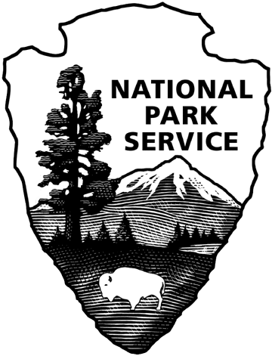
OMB Control Number: 1024-0270
National Park Service
Glen Canyon Survey

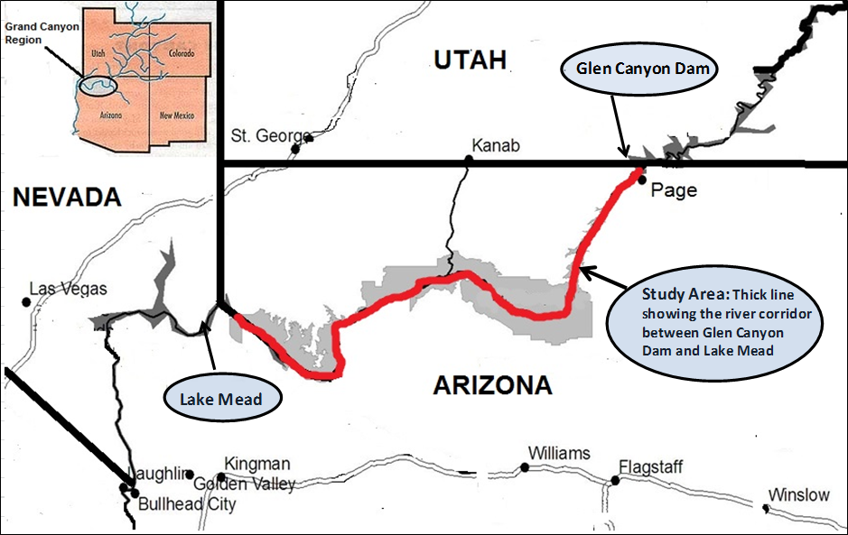

Paperwork Reduction and Privacy Act Statement: The National Park Service is authorized by 54 USC 100702 to collect this information. This information collection will provide data for the economic analysis of the alternative management and operation protocols that will be one piece of information that the Secretary of the Interior will use to evaluate future dam operation plans associated with the current ongoing Glen Canyon DEIS. Response to this request is voluntary. No action may be taken against you for refusing to supply the information requested. The permanent data will be anonymous. An agency may not conduct or sponsor, and a person is not required to respond to, a collection of information unless it displays a currently valid OMB control number.

BURDEN ESTIMATE Public reporting burden for this collection is estimated to average 30 minutes per response. Direct comments regarding the burden estimate or any other aspect of this form to: Chris Neher at (406) 721-2265; or Phadrea Ponds, NPS Information Collection Coordinator, Fort Collins, CO; pponds@nps.gov (email).

BACKGROUND INFORMATION ABOUT THIS STUDY
Please read these pages before you complete the survey.

This study deals with the ways Glen Canyon Dam could be operated to benefit natural resources in the Study area. A map showing the location of the Dam and the Study area appears on the cover. A description of the resources in the Study area is contained on the following pages.

GLEN CANYON DAM AND THE STUDY AREA
Glen Canyon Dam
- Glen Canyon Dam is located on the Colorado River in Arizona.
- It is just upstream from the Grand Canyon within Glen Canyon.
- It was built to provide water supplies and hydroelectricity.
- It was completed in 1963.
- It controls the water flow through the Grand Canyon and a lower portion of Glen Canyon.
- Revenues from the sale of hydroelectricity are used to repay costs of building and operating the dam.

The Study area
- The Study area consists only of the area in and along the Colorado River at the bottom of the Grand Canyon and part of Glen Canyon.
- The Study area begins at Glen Canyon Dam.
- The Study area continues for nearly 300 miles downstream from the dam.
- The Study area ends at Lake Mead near Las Vegas, Nevada.
- Part of the Study area is within the Grand Canyon National Park and part of Glen Canyon National Recreation Area.
- Part of the Study area is bordered by American Indian reservations.

- Have you ever been to Glen Canyon Dam in Arizona?
- No Yes
- Before receiving this survey had you heard of Glen Canyon Dam?
- No Yes

HOW GLEN CANYON DAM AFFECTS THE COLORADO RIVER IN THE STUDY AREA

- The amount of electricity produced by Glen Canyon Dam depends on the amount of water released from the dam: the more water released, the more electricity produced.
- More water is released during periods of high demand for electricity and less water is released during periods of low demand for electricity.
- On a seasonal basis, more water is released during the hottest summer months and the coldest winter months.
- On a daily basis, more water is released during the day than at night.

NATURAL RESOURCES IN THE STUDY AREA
The natural resources in the Study area are located in and along the Colorado River below Glen Canyon Dam.
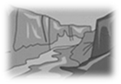
SEDIMENT Deposits of sand and mud called beaches or sandbars, are scattered along the river. Most of the rest of the river bank consists of cliffs and steep slopes covered with rocks, boulders, wind-blown sand and desert vegetation. Beaches with vegetation provide habitat for birds and other small animals. Beaches also are used by river floaters for camping.

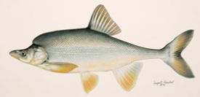
FIVE NATIVE FISH species, including the humpback chub shown, live in the Study area. Only one of these native species is found outside the Colorado River and its tributaries.

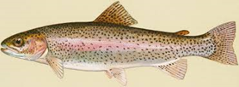
NON-NATIVE FISH also live in the river. Rainbow trout are not native to the Colorado River. They were introduced to this section of the Colorado River for recreational fishing following the construction of Glen Canyon Dam. People fish for rainbow trout primarily in the first 15 miles downstream from Glen Canyon Dam. Several other non-native fish species, including brown trout, common carp, channel catfish, and fathead minnow, also live in the study area.
- Only a small percentage of visitors to the Grand Canyon National Park or part of Glen Canyon National Recreation Area actually see or directly use the natural resources in the study area.
- The only people who directly interact with the resources in the study area are visitors who float the river, backpack or recreationally fish, American Indians using resources in the study area, scientists studying the river and National Park Service personnel.

SOME PEOPLE ARE CONCERNED ABOUT THESE RESOURCES
Because of a reduction in sediment supply below Glen Canyon Dam, erosion has decreased the number and size of beaches along the river.

    - In the first 30 years following construction of Glen Canyon Dam the total size of Grand Canyon beaches decreased substantially. For example, during this period the total acreage of beaches decreased by more than 25%. In the past 20 years, controlled floods released from Glen Canyon Dam have resulted in periodic rebuilding of beaches, slowing the decline in size.
    - The loss of beaches is most severe along the narrow sections of the Colorado River.

Populations of native fish in the Study area declined during the 1990s, but have increased over the last ten years.
    - Eight species of native fish evolved in the Colorado River when the water was warmer in the summer, colder in the winter, and much more turbid year round than it is today.
    - Three of the eight native fish species are no longer found in the Study area.
    - Two of five remaining native species, the humpback chub and razorback sucker, are in danger of becoming extinct.
    - Consistently cold water released year-round from Glen Canyon Dam may be the most important cause of the decline of native fish populations.
    - Predation and competition from non-native fish (trout, carp, catfish, and minnow species) may have contributed to the decline of native species.

Conditions for trout are affected by daily fluctuations in water level.
    - Trout eggs can warm-up or dry out and die if they are laid at high water levels and then the water level drops.
    - The diversity of aquatic invertebrates, many of which feed on trout eggs, may be reduced because of exposure of eggs during low-water periods. This may reduce food options for juvenile and adult trout to a very small number of invertebrate species.

WHAT CAN BE DONE TO BETTER PROTECT THE RESOURCES?
There are a number of tools available for improving natural resource conditions below Glen Canyon Dam. The tools available are:
River flow controls --Dam managers can modify the water releases from the dam to make changes to the timing, fluctuations and average river levels. These modifications may affect sandbar erosion, hydropower revenue, and native and non-native fish. The frequency of short periods of high water releases may affect the rebuilding of sandbars in the Grand Canyon.
Fish management tools -- Resource managers use various tools to increase or decrease native and non-native fish. These controls include direct removal of non-native species, flows designed to promote healthy trout populations (fewer numbers but larger trout), and flows designed to partially control the temperature of water through low summer flows to affect the growth and survival of native fish species.
Native fish and native vegetation restoration - All approaches for this project would include non-flow experimental actions for native re-vegetation/restoration and weed removal and restoration of native fish to certain tributary locations.
Cost of tools -- River managers are able to use these tools in combinations in order to benefit the river corridor resources. All of these tools have costs associated with them. These costs would be passed on to the public through a combination of:
- higher electric power bills for households in the six-state Colorado River Basin, and
- increased federal taxes from all U.S. Residents
Assume that the costs for using the management tools mentioned above for your household (and similar households in your area) would begin in 2015 and would last for the next 20 years.

We presented a lot of material in the background information. We would like to ask a few questions about the background information to make sure it was clearly presented. Please feel free to refer to the first few pages of the survey when answering these questions.

- For each statement below, please circle the letter "T" if you think the statement is true or the letter “F” if you think the statement is false. (Only one answer for each statement)

 | TRUE | FALSE
There are now many more beaches along the Colorado River than there were before Glen Canyon Dam was built. | T | F
Native fish populations in the Colorado River have declined continuously since the dam was built. | T | F
The decrease in river beaches is most severe along wide sections of the river. | T | F
Trout are not native to the study area. | T | F
All native fish species have disappeared from the Grand Canyon. | T | F
Nearly all visitors to the Grand Canyon National Park use the beaches along the river. | T | F
Water levels below Glen Canyon Dam are constant throughout a 24 hour period. | T | F
The Study area consists only of the area in and along the Colorado River between Glen Canyon Dam and Lake Mead. | T | F
Two of the native fish species are in danger of extinction. | T | F
Reducing daily fluctuations in the amount of water released from the dam will reduce the total amount of hydroelectricity produced. | T | F

INSTRUCTIONS FOR NEXT QUESTIONS
Government officials will consider many factors when deciding whether or not to change dam operations. One factor they would like to consider is whether various proposals are personally worthwhile to people like you. In the next questions, we will describe the effects of different proposals to change dam operations. We would like you to tell us if you would vote for the new proposals or for the way the dam is currently operated.
Some people might vote "for the Current Policy" because:
- The cost of the New Policy is too high.
- The effects of the New Policy are not worth anything (not even 10¢) to them.
- They just can't afford the cost.
Some people might vote "for the New Policy" because:
- The cost of the New Policy is low enough.
- The effects of the New Policy are worth what it would cost them.
At this point in time, it is not certain what the cost would be to any specific individual, so we are asking different people about different amounts. Even if the amount we ask you about seems very low or very high, please answer carefully. This will allow us to determine whether people think the proposal is worthwhile at whatever level the final cost is determined to be. For this study, it is important that you tell us how you would vote, based only on your personal evaluation of whether changes in dam operations and their effects are worth the additional cost to you.
Below we have outlined a choice between the Existing Management Plan for operating Glen Canyon Dam, and a new Proposed Plan A. This plan includes river flow control, a specific set of fish management tools, and native fish and native vegetation restoration designed to benefit river resources below the dam. We have highlighted the differences between the plans in terms of impacts on beaches, native fish, trout and the cost of the plans. Note that for some resources, impacts may be the same for both the Existing Management Plan and Proposed Plan A.
We would like to know how you would vote if all U.S. residents were presented with two options—the Existing Management Plan and Proposed Plan A—and asked to vote for the one they prefer. The one with the most votes would be implemented.
- Ask yourself whether you believe the improvements offered under Proposed Plan A are worth $XX each year to your household for the next 20 years. Voting for Proposed Plan A would mean you would have $XX less each year to spend on other things. You would be making a commitment to pay this additional amount each year for the next 20 years. Please check ONE box at the bottom of the table to indicate whether you prefer Proposed Plan A, or the Existing Management Plan
Resources impacted by policies | Existing Management Plan—conditions over the next 20 years | Proposed Plan A—conditions over the next 20 years
River Beaches  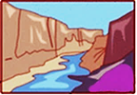  (Size and number) | 25% reduction in size and number | Remain at present levels
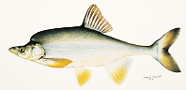  Native fish (humpback chub) populations | Remain at present levels | 25% increase
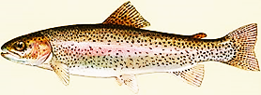  Trout populations | Remain at present condition | 50% increase in large trout
Cost to your HH | $ 0 | $40 per year  for 20 years
I would vote for (check only one )

- How certain do you feel about the choice you made above?
  - Very certain
  - Somewhat certain
  - Not certain at all

Now consider a different choice…
We would now like to know how you would vote if you were presented with a completely different Proposed Plan. For this next choice, please imagine that Proposed Plan A is NOT an option. Please consider how you would vote if you had to choose between the two plans below. When making this choice, please imagine that the ONLY two options are Proposed Plan B and the Existing Management Plan.
- Ask yourself whether you believe the improvements offered under Proposed Plan B are worth $XX each year to your household. Voting for Proposed Plan B would mean you would have $XX less each year to spend on other things. You would be making a commitment to pay this additional amount each year for the next 20 years. Please check ONE box at the bottom of the table to indicate whether you prefer Proposed Plan B, or the Existing Management Plan.
Resources impacted by policies | Existing Management Plan—conditions over the next 20 years | Proposed Plan B—conditions over the next 20 years
River Beaches  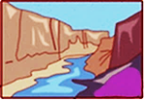  (Size and number) | 25% reduction in size and number | 25% increase in size and number
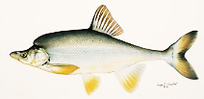  Native fish (humpback chub) populations | Remain at present levels | Remain at present levels
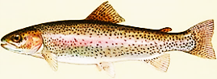  Trout populations | Remain at present condition | 25% increase in large trout
Cost to your HH | $ 0 | $110 per year  for 20 years
I would vote for
(check only one )

- How certain do you feel about the choice you made above?
  - Very certain
  - Somewhat certain
  - Not certain at all
- Thinking about the choices you just made, please rate how much you agree or disagree with each of the following statements. (Circle one number for each statement)
 | Strongly  Agree | Agree | Neither Agree or Disagree | Disagree | Strongly  Disagree
My choices would have been different if the economy in my area were better. | 1 | 2 | 3 | 4 | 5
It is important to restore and protect the Grand Canyon ecosystem no matter how much it costs. | 1 | 2 | 3 | 4 | 5
I do not think I should have to contribute to the protection of the Grand Canyon ecosystem. | 1 | 2 | 3 | 4 | 5
I am concerned that the plans would hurt the economy in the Colorado River Basin. | 1 | 2 | 3 | 4 | 5
The descriptions of the plans were hard to understand. | 1 | 2 | 3 | 4 | 5
I do not believe the plans will actually improve the Colorado River resources. | 1 | 2 | 3 | 4 | 5
Some of the plans would cost too much compared to what they would deliver. | 1 | 2 | 3 | 4 | 5
The survey gave me enough information to make a choice between the options shown. | 1 | 2 | 3 | 4 | 5
I think my taxes will increase if either of the proposed plans passes. | 1 | 2 | 3 | 4 | 5

- If you voted for the EXISTING MANAGEMENT PLAN in either of the choices, please rate how much you agree or disagree with each of the following statements. If not, skip to Q10.

 | Strongly  Agree | Agree | Neither Agree or Disagree | Disagree | Strongly Disagree
I voted for the CURRENT MANAGEMENT PLAN because I am against any more taxes or government spending. | 1 | 2 | 3 | 4 | 5
I voted for the CURRENT MANAGEMENT PLAN because I believe my taxes are already too high. | 1 | 2 | 3 | 4 | 5

- If you voted for PROPOSED PLAN A or PROPOSED PLAN B, please rate how much you agree or disagree with each of the following statements. If not, skip this question.

 | Strongly  Agree | Agree | Neither Agree or Disagree | Disagree | Strongly  Disagree
I voted for the Proposed Plan because I thought it would increase the chances that the government would do the same thing in river basins closer to my home. | 1 | 2 | 3 | 4 | 5
I voted for the Proposed Plan more for future generations than for myself. | 1 | 2 | 3 | 4 | 5

Q11. People often have different views about environmental issues. On a scale of 1 to 5, with 1 being strongly agree and 5 being strongly disagree, please indicate how you feel about each statement written below. (Circle one number for each statement)
 | Strongly  Agree | Agree | Neither Agree or Disagree | Disagree | Strongly Disagree
I have a great deal of concern for protecting wildlife habitat. | 1 | 2 | 3 | 4 | 5
Endangered species should be protected even if they don’t provide any benefit to humans. | 1 | 2 | 3 | 4 | 5
I believe the balance of nature is very delicate and easily upset. | 1 | 2 | 3 | 4 | 5
It is important to protect rare plants and animals to maintain genetic diversity. | 1 | 2 | 3 | 4 | 5
I would be willing to contribute to protecting wildlife habitat even if I never see or enjoy the animals. | 1 | 2 | 3 | 4 | 5
I feel I should be doing more to help protect wildlife and fragile ecosystems. | 1 | 2 | 3 | 4 | 5

Q12 The following statements discuss economic and environmental issues. We would like to understand how you feel about these issues. On a scale of 1 to 5, with 1 being strongly agree and 5 being strongly disagree, please indicate how you feel about each statement written below. (Circle one number for each statement)
 | Strongly  Agree | Agree | Neither Agree or Disagree | Disagree | Strongly Disagree
Economic security and well-being should be considered first; then we can focus on environmental problems. | 1 | 2 | 3 | 4 | 5
If business is forced to spend a lot of money on environmental protection, it won't be able to invest in research and development to innovate and keep us competitive in the international market. | 1 | 2 | 3 | 4 | 5
Some pollution is inevitable if we are going to maintain and improve our standard of living. | 1 | 2 | 3 | 4 | 5
The decision to develop resources should be based mostly on economic grounds rather than environmental or archeological grounds. | 1 | 2 | 3 | 4 | 5

Q13. The following statements discuss hydroelectricity. We would like to understand how you feel about these issues. On a scale of 1 to 5, with 1 being strongly agree and 5 being strongly disagree, please indicate how you feel about each statement written below. (One number for each statement)

 | Strongly  Agree | Agree | Neither Agree or Disagree | Disagree | Strongly Disagree
The benefits of hydroelectric dams on the Colorado River outweigh the impacts to the natural environment and historical places along the river. | 1 | 2 | 3 | 4 | 5
Hydroelectric dams should not be constructed on any section of a river that flows through a national park. | 1 | 2 | 3 | 4 | 5
Hydroelectric dams can have serious impacts on the plants and animals that live in or along the river. | 1 | 2 | 3 | 4 | 5
Hydroelectric dams should be developed wherever it is economically beneficial, even if it means that some rivers will be changed. | 1 | 2 | 3 | 4 | 5

In this section, we would like to learn how you feel about national parks in the United States.
Q14. Have you ever visited any national parks in the United States?

No Yes Don’t Know

Q15. We are interested in learning how you feel about national parks in general. On a scale of 1 to 5, with 1 being “strongly agree” and 5 being “strongly disagree,” please indicate how you feel about each statement written below. (One number for each statement)

 | Strongly  Agree | Agree | Neither Agree or Disagree | Disagree | Strongly Disagree
National parks are a "luxury" we cannot afford in difficult economic times. | 1 | 2 | 3 | 4 | 5
National parks help us to remember that our future is tied to the preservation of nature and natural resources. | 1 | 2 | 3 | 4 | 5
It is important that national parks offer us a chance to see America as the early settlers saw it. | 1 | 2 | 3 | 4 | 5
Americans need places like national parks to "recharge their batteries." | 1 | 2 | 3 | 4 | 5
An important function of the National Park Service is to protect native birds, plants, and animals. | 1 | 2 | 3 | 4 | 5
National parks are only valuable to the people who visit them. | 1 | 2 | 3 | 4 | 5
Oil and natural gas finds on national park lands should be responsibly developed since helps the economy. | 1 | 2 | 3 | 4 | 5
The National Park Service places too much emphasis on preservation. | 1 | 2 | 3 | 4 | 5
I am glad there are national parks, even if I don't visit them. | 1 | 2 | 3 | 4 | 5
People can think a place is valuable, even if they do not actually go there themselves. | 1 | 2 | 3 | 4 | 5
The American people should provide greater financial support for the National Park Service to avoid more commercial activities in the national parks. | 1 | 2 | 3 | 4 | 5
If the National Park Service needs more financial support, they should develop more gift shops and commercial activities to raise money. | 1 | 2 | 3 | 4 | 5

In this section, we are interested in learning about trips you may have taken to Grand Canyon National Park.

Q16. Have you ever visited Grand Canyon National Park?

  - No Skip to Question 19
  - Yes
Q17. Did you see the Colorado River while you were in Grand Canyon National Park?
  - No Skip to Question 19
  - Yes
Q18. Did you go down to the Colorado River while you were at the Grand Canyon National Park?
  - No
  - Yes
Q19. How likely do you think it is that you will visit the Grand Canyon National Park in the future?
- Not at all likely
- Somewhat unlikely
- Somewhat likely
- Very likely
In this last section, we would like to ask you some questions about your background that will help us compare your answers with those of other people.

- Are you male or female?
- Male
- Female

- What is your age?
________ years old

- How many people live in your household?
________ people 18 years old or older
________ people under the age of 18
________ total number of people in the household
- What is the highest degree or level of school you have completed?
- No high school diploma
- High school diploma or GED
- Some college credit but no degree
- Associate’s degree (for example: AA or AS)
- Bachelor’s degree (for example: BA or BS)
- Some graduate school or professional school credit or a graduate or professional degree
Q24. Which of the following categories best describes your household employment status?
(Check all that apply)
Employed full time
Employed part time
Retired
Student
Work in the household (for example, raise children)
Unemployed
Other (please describe) __________________________

Q25. Are you Hispanic or Latino?
No
Yes

- Please select the racial category or categories with which you most closely identify by placing an “X” in the appropriate box. (Check one or more)
American Indian or Alaska Native
Asia
Black or African American
Native Hawaiian or other Pacific Islander
White

- Do you or either of your parents belong to any of the following tribes? (Check all that apply or leave blank if not applicable)
 | Apache |  | Navajo
 | Havasupai |  | Pueblo
 | Hopi |  | Zuni
 | Hualapai |  | Other (please specify):_________________________

- What was your total pre-tax household income, including all earners in your household, in 2014?
 | Under $25,000 |  | $75,000 to $99,999
 | $25,000 to $34,999 |  | $100,000 to $199,999
 | $35,000 to $49,999 |  | $200,000 or more
 | $50,000 to $74,999

If there is anything else you would like to tell us about managing Glen Canyon Dam please use the space below to provide any comment you may have

COMMENT: _____________________________________________________________________________________
_____________________________________________________________________________________
______________________________________________________________________________
_____________________________________________________________________________________
_____________________________________________________________________________________
_____________________________________________________________________________________
_____________________________________________________________________________________
_____________________________________________________________________________________

THANK YOU FOR YOUR HELP!
Please return only this survey booklet in the enclosed, postage-paid envelope
For questions, contact: Chris Neher (406) 721-2265

