lAP 1- Registration Information Screen

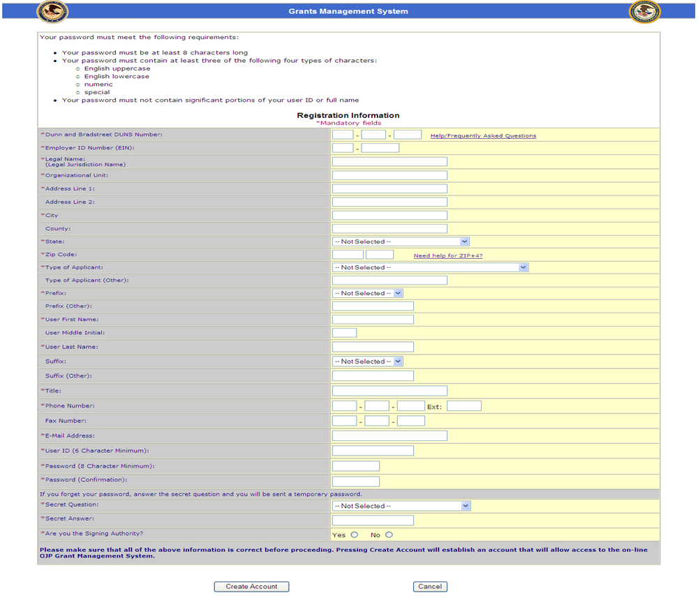

AP 2- Authorized Rep/POC Information Screen
When clicking Yes or No on the previous screen, this screen allows user to enter information

