PPSR 1- Progress Report Overview Screen

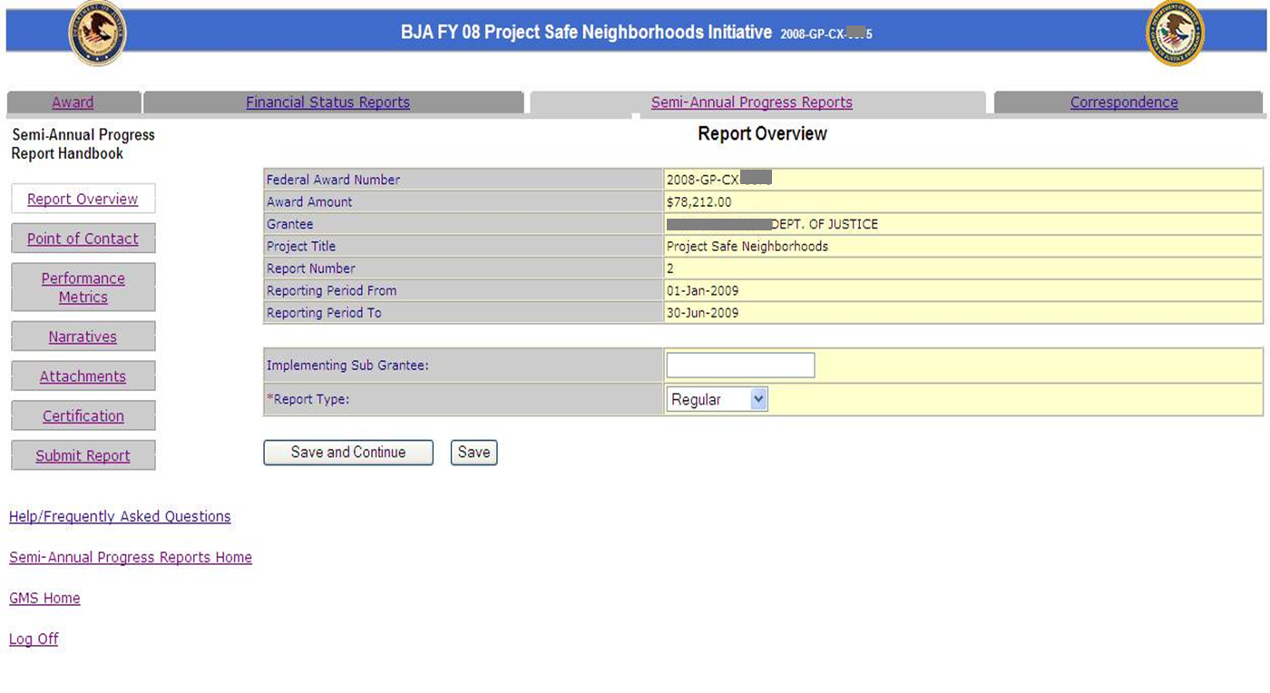

PPSR 2- Progress Report Point of Contact Screen

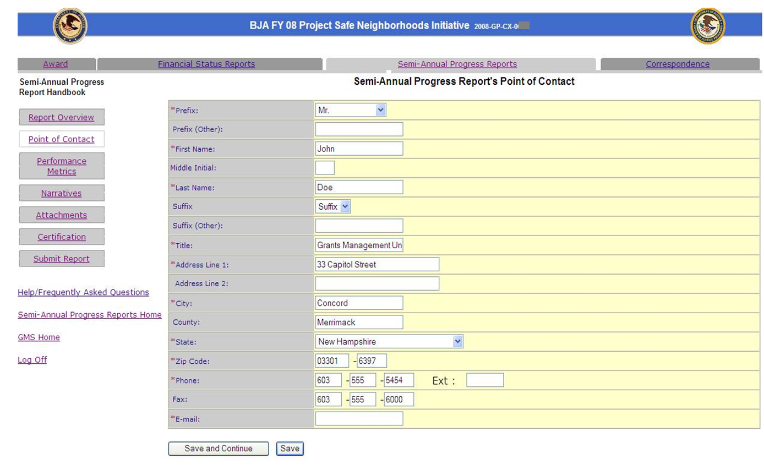

PPSR 3- Progress Report Performance Metrics Screen

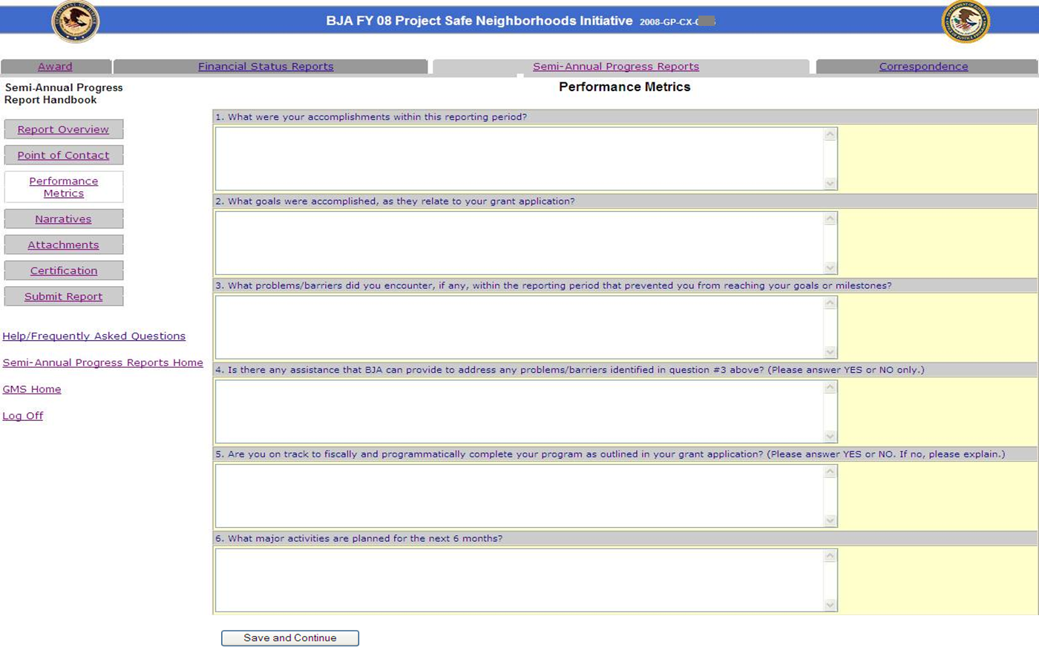

PPSR 4- Progress Report Narrative Screen

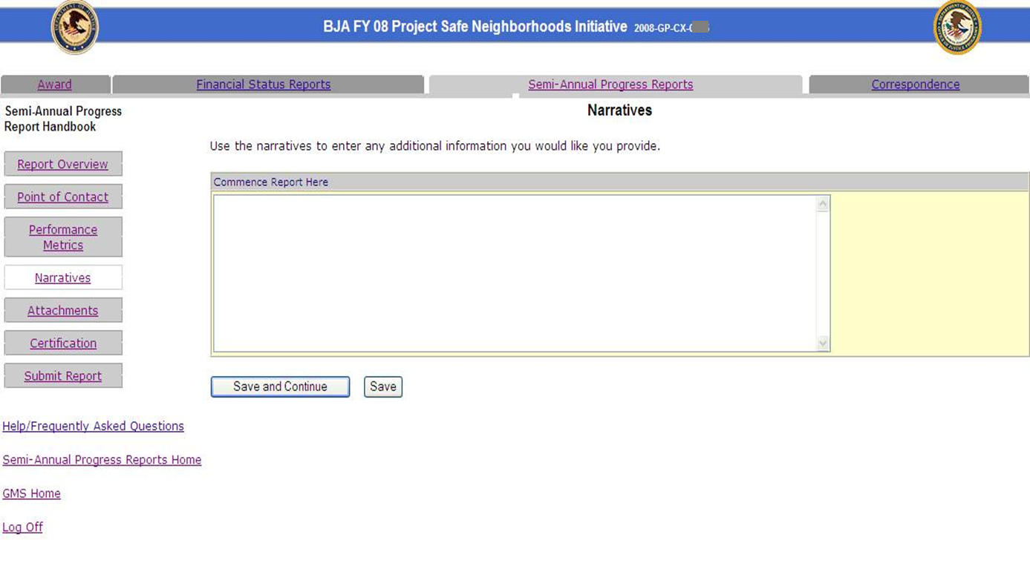

PPSR 5- Progress Report Attachments Screen

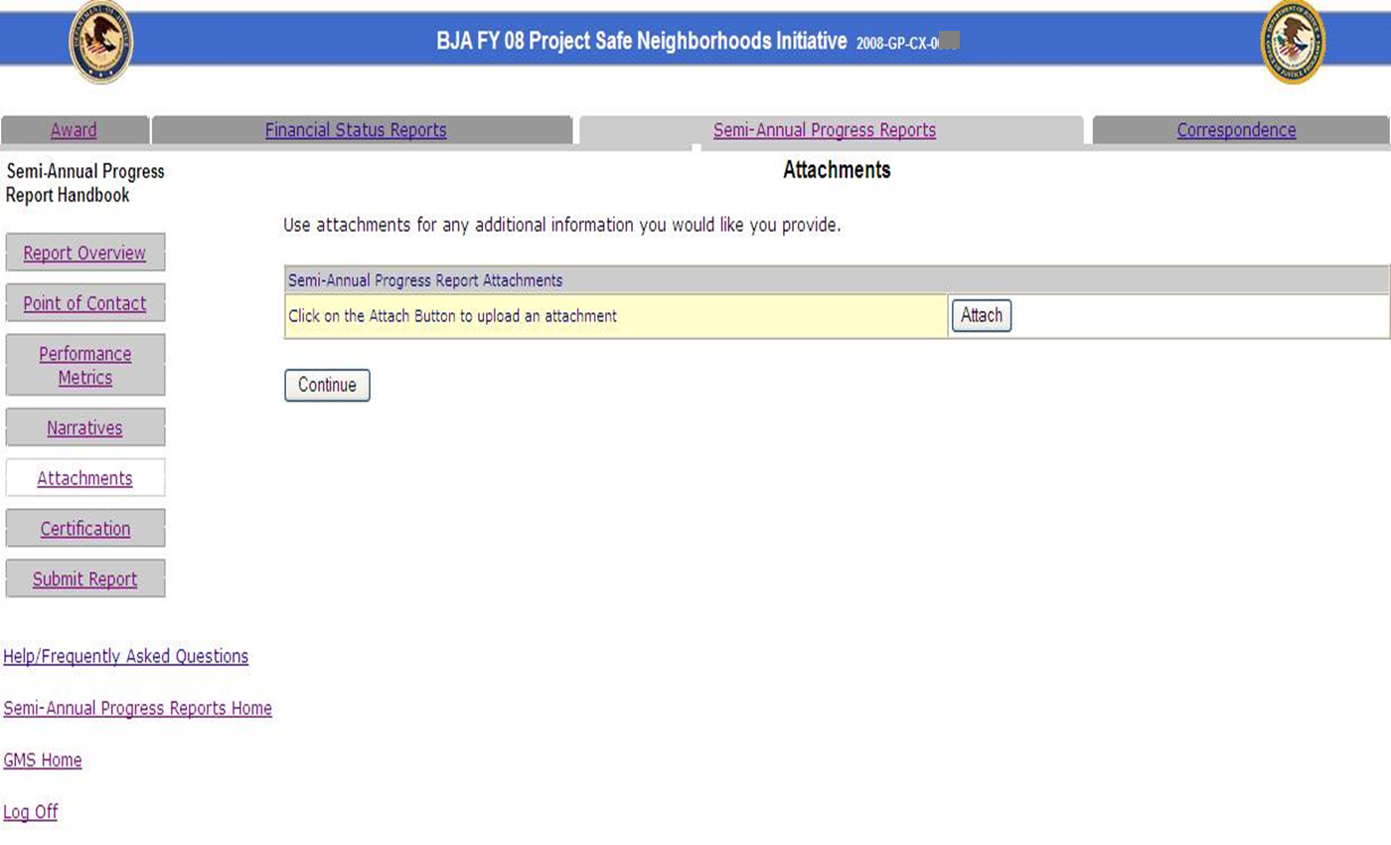

PPSR 6- Progress Report Certification Screen

