GAN 1- Budget Modification Screen

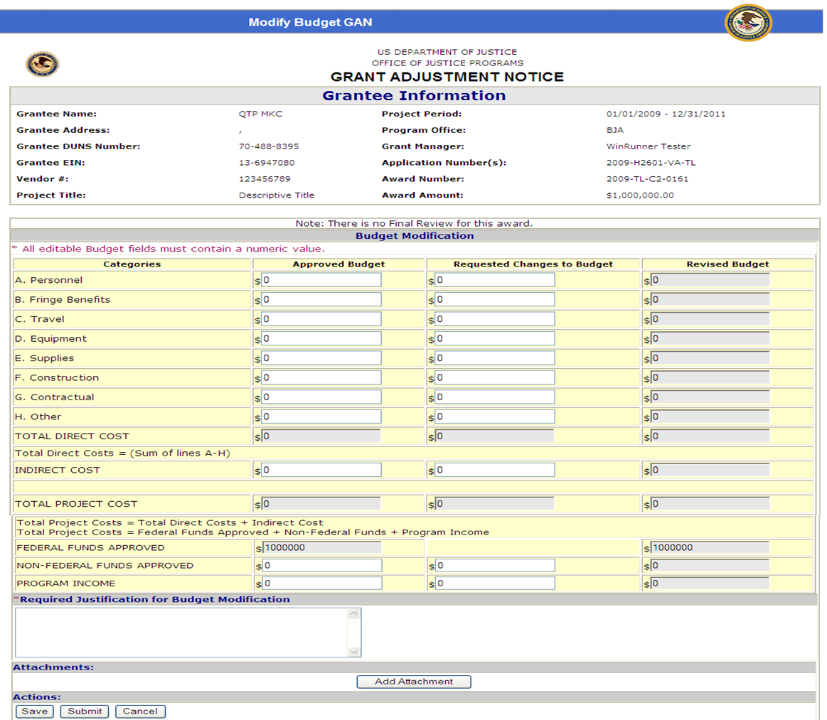

GAN 2- Change Authorized Representative Screen

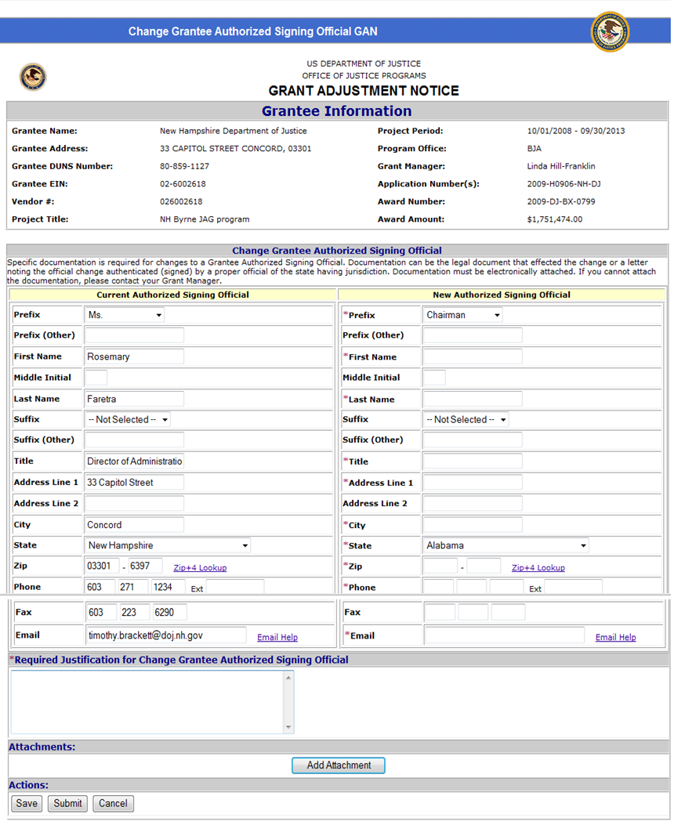

GAN 3- Change Grantee Contact or Alternate Contact/Principal Investigator Screen

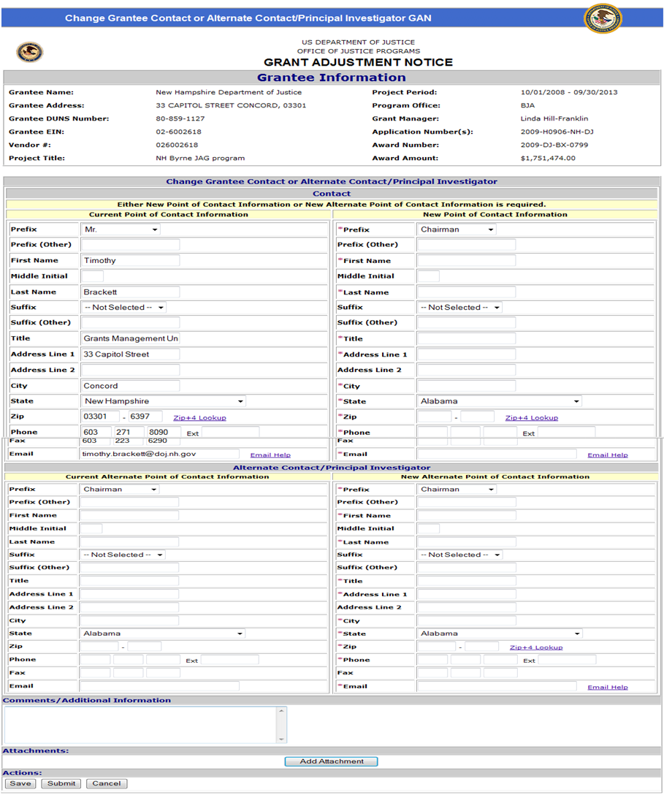

GAN 4- Change DUNS Number Screen

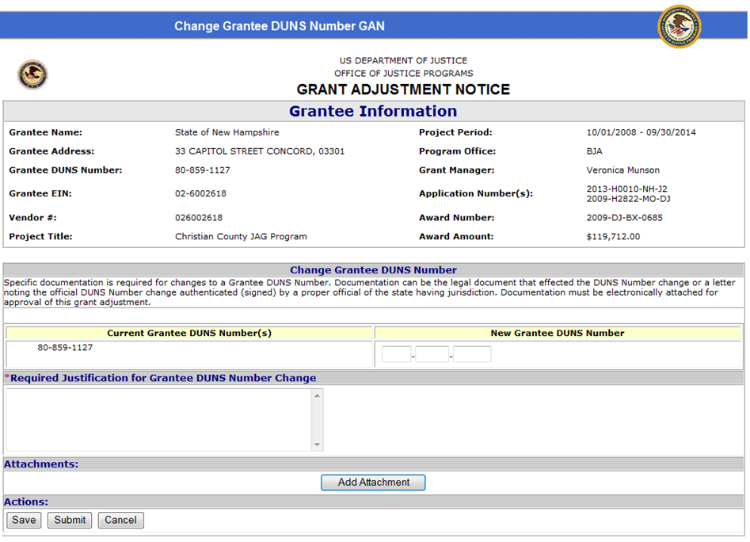

GAN 5- Change Mailing Address Screen

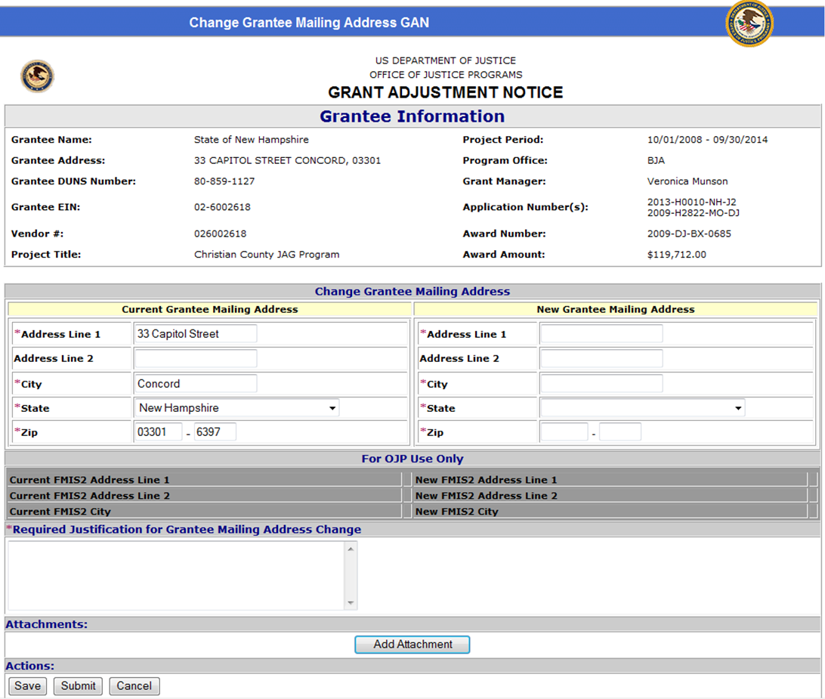

GAN 6- Change Grantee Name Screen

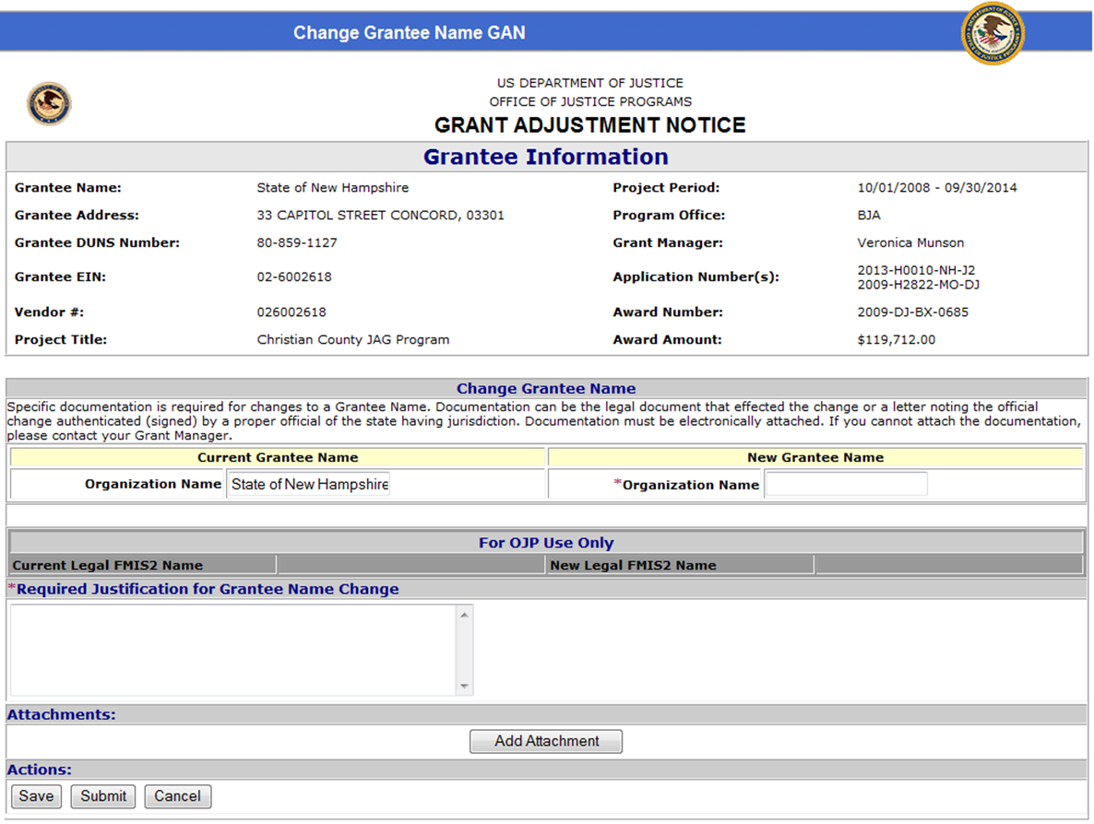

GAN 7- Change Project Period Screen

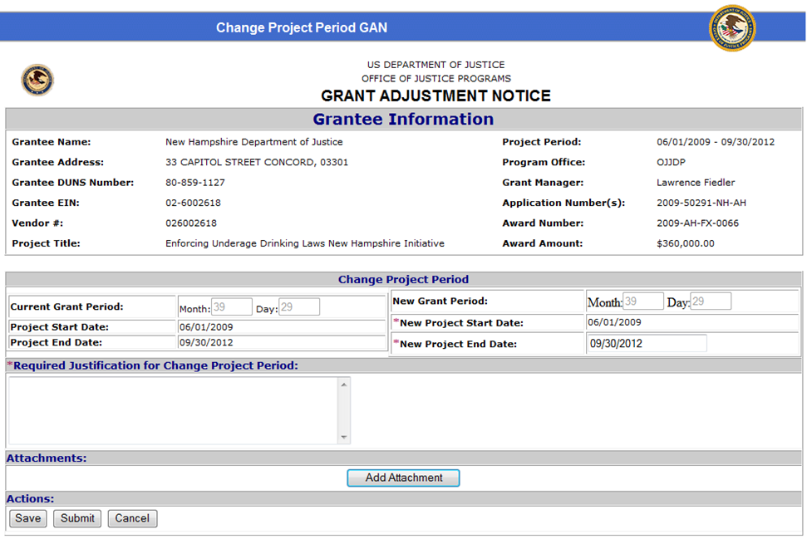

GAN 8- Change Project Scope Screen

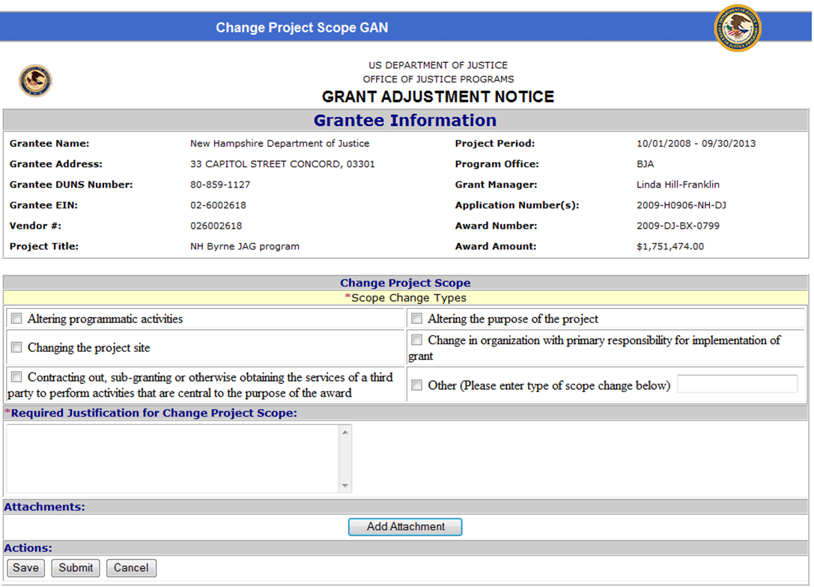

GAN 9- Program Office Approvals Screen

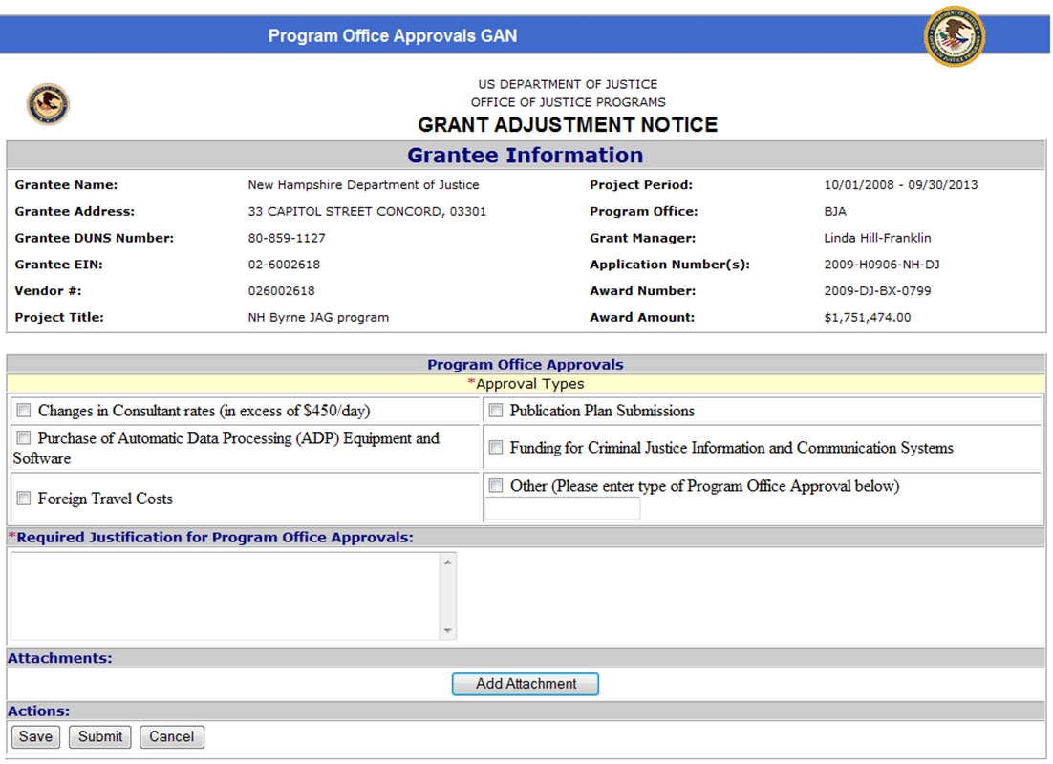

GAN 10- Sole Source Approval Screen

