Starting a Claim:
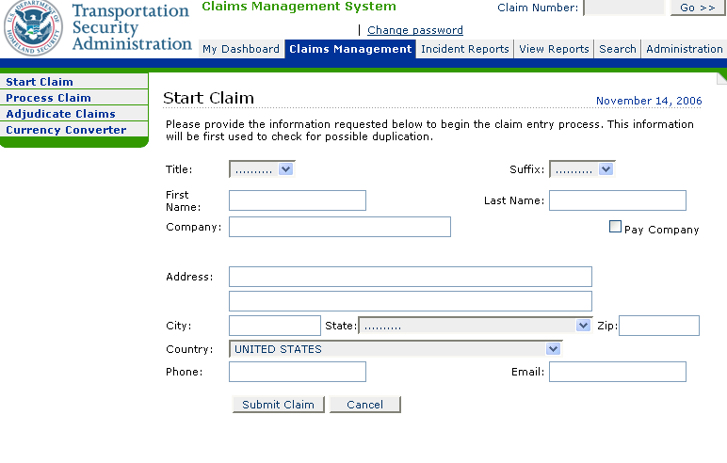
2. Logging In
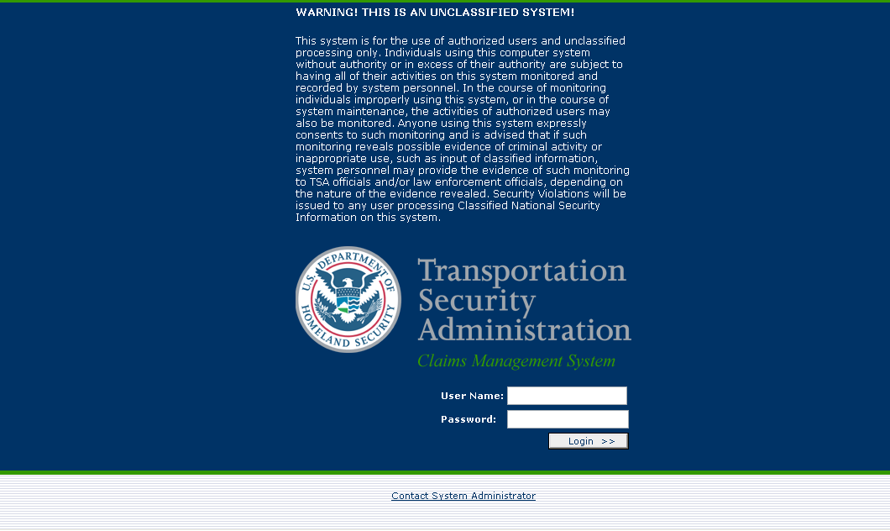

3. CMS Dashboard:
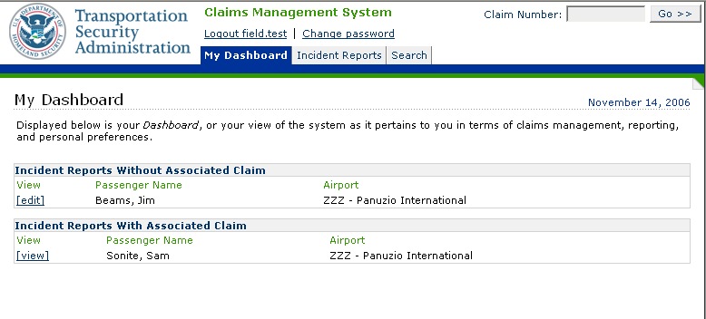
4. Incident Report
5. CMS Dashboard Incidents Reports
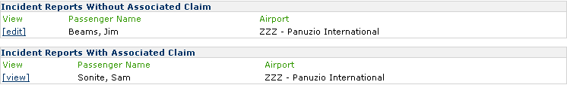

6. New Incident Report Claim Number:
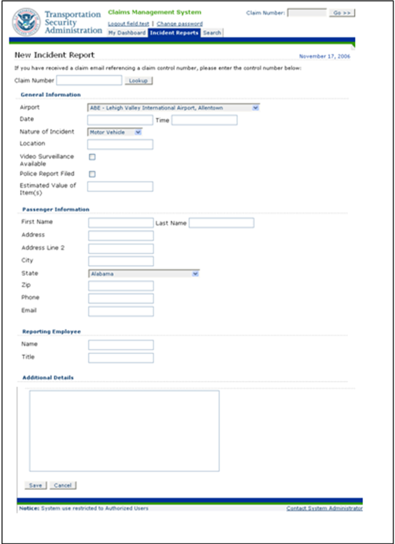
7. New Incident Passenger Information:
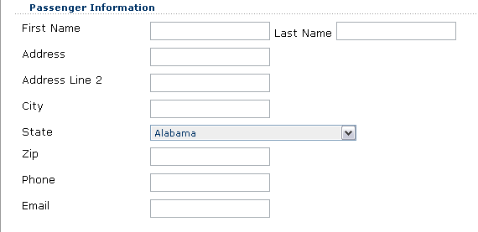

8. Reporting Employee:
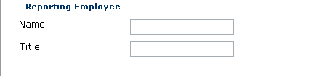
9. Search Features:
