U.S. Department of Homeland Security
Arlington, VA 20598

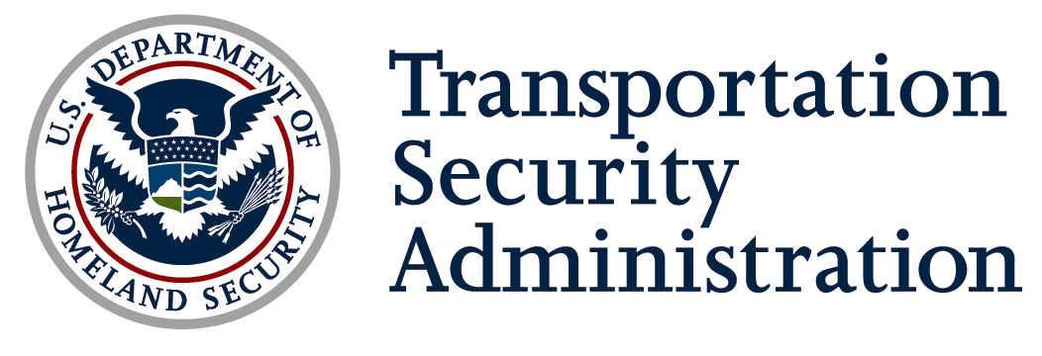

DATE: June 30, 2015

TO: Chandana Achanta
Office of Information and Regulatory Affairs
Office of Management and Budget

THRU: Tyrone Huff,
Office of the Chief Information Officer
Department of Homeland Security

FROM: Christina Walsh
Office of Information Technology
Transportation Security Administration

SUBJECT: OMB Terms of Clearance
OMB Control Number 1652-0062
Highway Baseline Assessment for Security Enhancement (BASE) Program

Purpose
This memo serves as a notification of compliance with the OMB Terms of Clearance for OMB Control Number 1652-0062 Highway Baseline Assessment for Security Enhancement (BASE) Program, issued July 8, 2014.

OMB Terms of Clearance
OMB Terms of Clearance for the Highway BASE Program are as follows:

- Information from this collection shall not be used for program evaluation purposes.

- Following the approval of this collection, DHS/TSA will submit a discontinue request for 1652-0036.

Compliance with OMB Terms of Clearance
TSA has complied with the OMB Terms of Clearance for the Highway BASE collection:
- The Office of Security Operations at Transportation Security Administration has not used the information collected from the Highway BASE Program for program evaluation purposes.

- TSA submitted a discontinuation request on November 22, 2011 for OMB Control Number 1652-0036. On April 30, 2012, OMB discontinued the approval on the collection.

