MEMORANDUM NATIONAL CENTER FOR EDUCATION STATISTICS
Institute of Education Sciences
United States Department of Education

To: Shelley Martinez, OMB
Through: Kashka Kubzdela, NCES
From: Gail Mulligan and Jill McCarroll, NCES
Date: June 1, 2015
Re: ECLS-K:2011 Recruitment Letter for 5th Grade Change Request (OMB# 1850-0750 v.17)

We are requesting a minor amendment to the previously approved Early Childhood Longitudinal Study, Kindergarten Class of 2010-11 (ECLS-K:2011) Spring 4th Grade National Data Collection and 5th Grade Recruitment approved in November 2014 (OMB# 1850-0750 v.16), pertaining to communications with school coordinators during the 5th grade recruitment. As discussed in part A of the approved package, sampled schools will be contacted in the fall prior to the fifth-grade data collection round. In the fall of the 2015-16 school year, school coordinators will be sent information about the study, including a letter describing the study activities planned for the spring, the role of the school coordinator, and a list of participating children who will be assessed in the spring.

During the fall contact period, an experienced team of school recruiters will work with the school coordinators to discuss the logistics of the spring assessment visit. Additionally, school recruiters will confirm whether the students on a list of study children sent to the school are still enrolled in the school, identify the teachers of the sampled children, and set an assessment date for the spring.

Since the approval of the previous clearance package (OMB# 1850-0750 v.16), the National Center for Deafness and Other Communication Disorders (NIDCD), a sponsoring partner for ECLS-K:2011, has decided to exercise a contract option to evaluate children’s hearing in the 2016 spring fifth-grade round. The planned hearing evaluation will be modeled after the ECLS-K:2011 hearing component that was successfully incorporated into the fall second-grade and spring third-grade data collections. The hearing evaluation data will be collected in a subsample of schools, and recruiters need to discuss the logistics for this hearing component with school coordinators during the advanced school contact call in the fall.

Thus, we request to add to the approved 5th grade recruitment materials a letter to school coordinators in schools in which the hearing evaluation will be carried out. This letter is almost identical to the previously approved advance school contact school coordinator letter, which does not mention the hearing evaluation. The only difference is that reference to the hearing evaluation has been added. The study requires two versions of the school coordinator letter because the hearing screenings are conducted in only a subsample of schools.

This request has no associated change in respondent burden for the advance school contact in the fall and does not affect the total cost to the federal government for the recruitment portion of this study. The burden and costs of conducting the hearing evaluations in the spring fifth-grade data collection will be included in the request for the 5th grade data collection.

Additional Letter for School Coordinators
in schools in which the hearing evaluations will be conducted

(for which approval is being sought
in this submittal)

To facilitate review, the added text about the hearing evaluation is reflected here in red font.

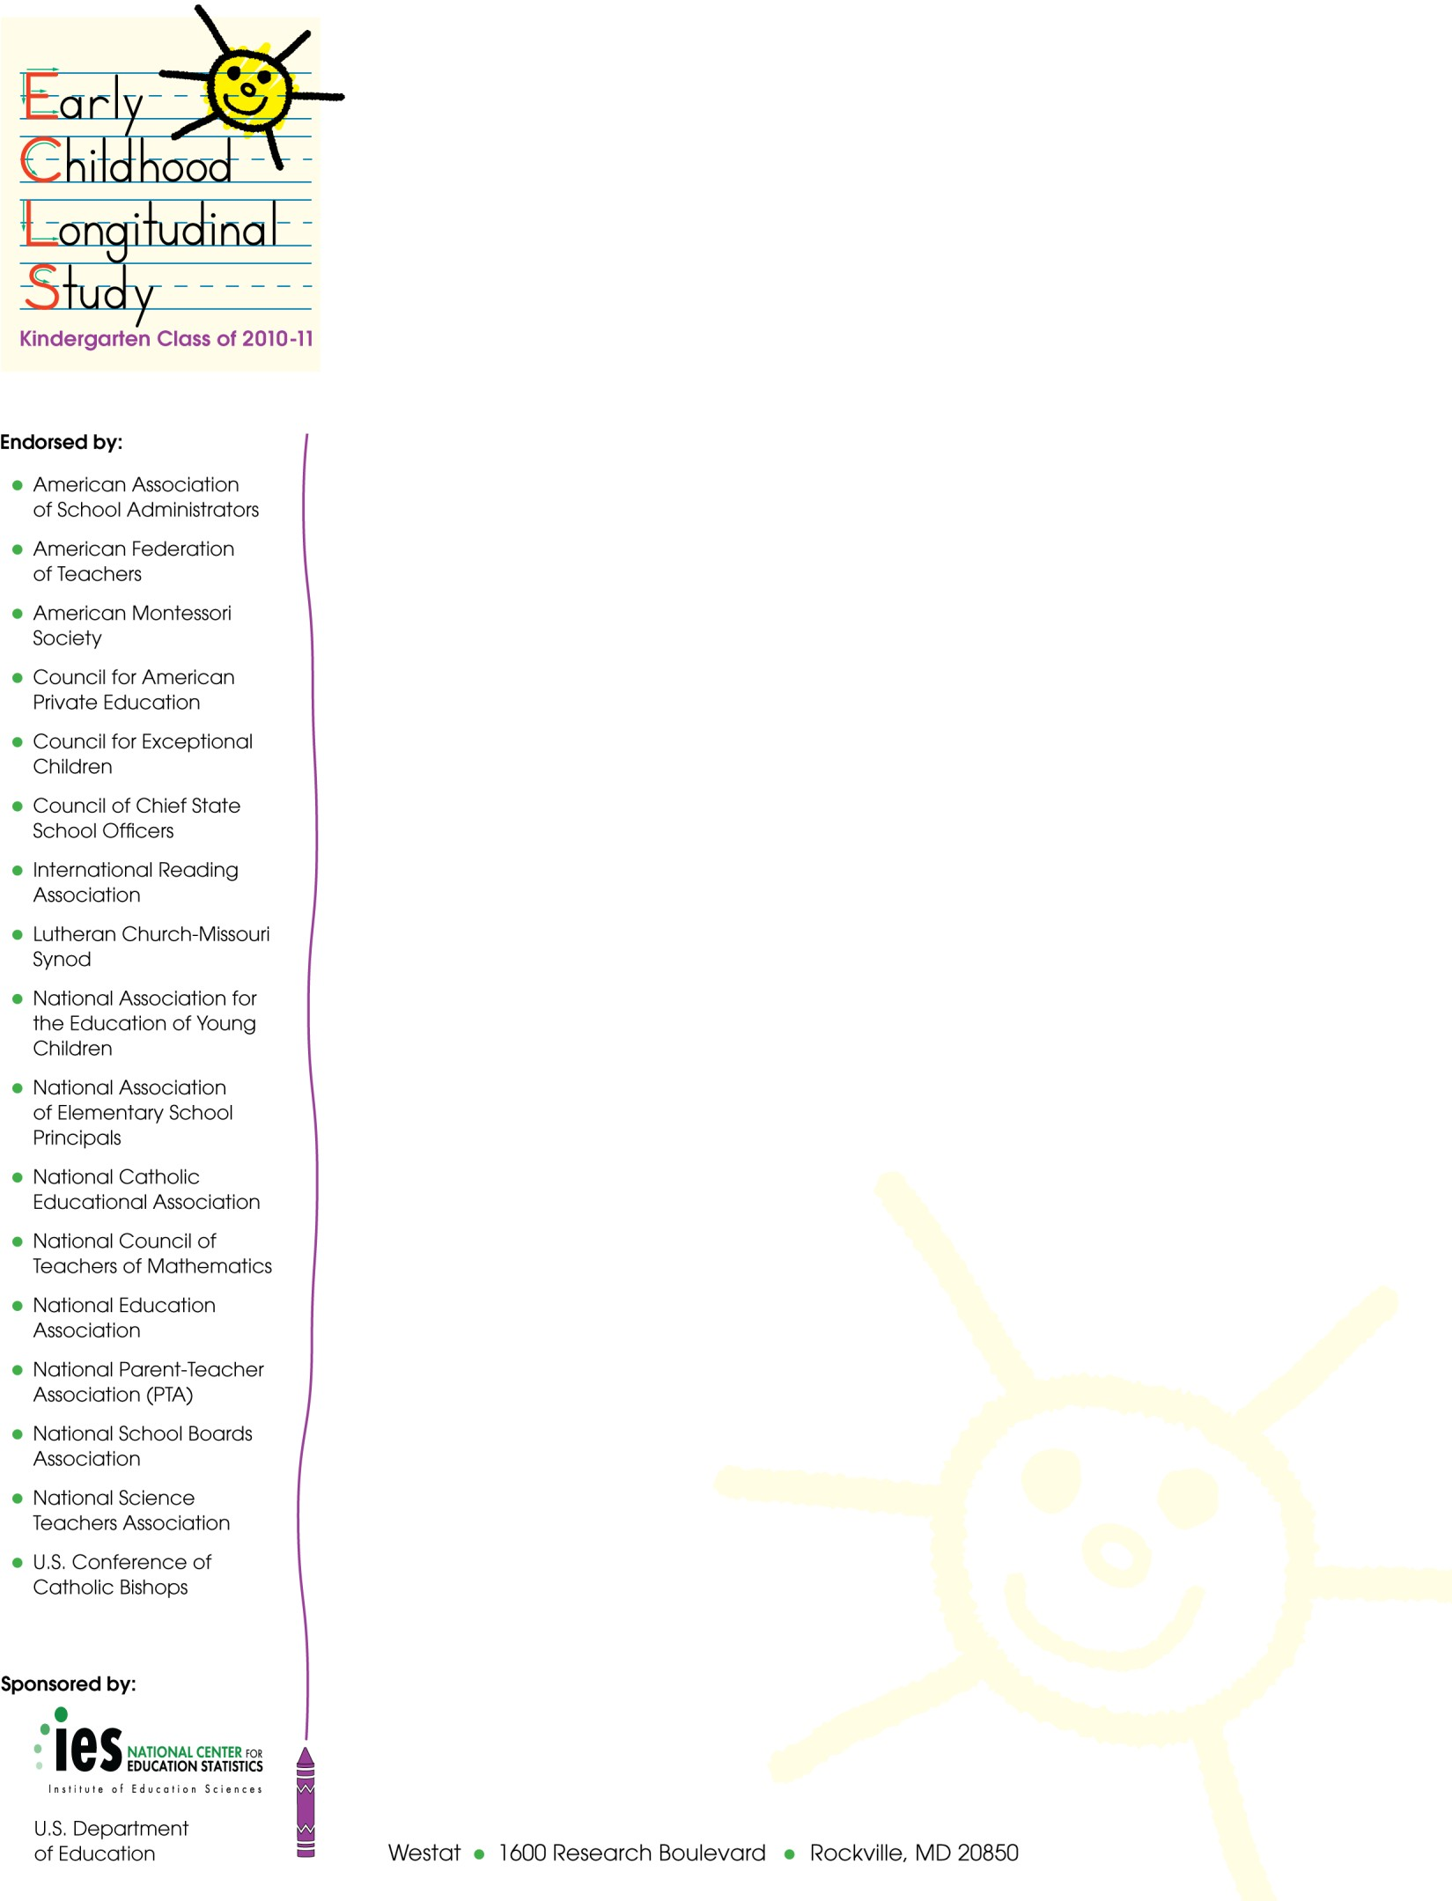
Fall 2015
SPRING 5TH GRADE SCHOOL COORDINATOR LETTER FOR CONTINUING SCHOOLS IN WHICH HEARING EVLAUATIONS WILL BE CONDUCTED, SENT IN ADVANCE OF FALL RECRUITMENT.

[NAME]
[SCHOOL NAME]
[ADDRESS 1]
[ADDRESS 2]
[CITY, STATE ZIP]

Dear School Coordinator:

We are very happy that your school is participating in the Early Childhood Longitudinal Study, Kindergarten Class of 2010-11 (ECLS-K:2011). As you may know, we collected information last year from the children participating in the study, their parents, their teachers, and their school’s administrator. We are looking forward to following these children this school year.

This spring, children will complete one-on-one assessments with trained ECLS-K:2011 assessors. These assessments are designed to measure children’s reading, mathematics, and science skills and knowledge, as well as obtain indicators of children’s memory and ability to follow rules in a structured task. Children also will have their height and weight measured and will complete a questionnaire about themselves and their experiences in school. These assessment activities will take approximately 80 minutes for each child to complete. In addition to participating in the assessment, some children will have their hearing evaluated. These evaluations occur at multiple points throughout the study so that researchers can study how hearing may change during the elementary school years. The hearing evaluation will take about 20 minutes.

A component of the data collection involves collecting information about the sampled students from their teachers using self-administered questionnaires. We also will collect information from the school administrator.

We appreciate your help with four tasks, which are detailed in the enclosed materials. These are (1) confirm that the children participating in the ECLS-K:2011 are attending your school (the list of participating children will be sent separately); (2) determine the date and time for the spring activities; (3) identify an appropriate space for the assessments and hearing evaluations; and (4) identify the primary teachers of the participating children. Please read the enclosed materials for more information about the study and your important role in it.

The National Center for Education Statistics (NCES) of the U.S. Department of Education’s Institute of Education Sciences is the primary sponsor of the ECLS-K:2011, which is being conducted on behalf of NCES by Westat. The ECLS-K:2011 has been endorsed by the national education organizations listed on this letter. NCES is authorized to conduct this study under 20 U.S. Code, Section 9543. Under that law, the data you provide may be used only for statistical purposes and may not be disclosed, or used, in identifiable form for any other purpose except as required by law (20 U.S. Code, Section 9573). The U.S. Office of Management and Budget has approved the data collection under OMB # 1850-0750 (expires 11/30/2017).

Thank you for your support of the ECLS-K:2011. We look forward to working with you and your school again. An ECLS-K:2011 representative will call you in the coming weeks to further explain the study and your responsibilities. If you have questions about the study, please feel free to call Westat toll free at 1- 888-204-4864 or send an email to ECLSKHELP@westat.com.

Sincerely,
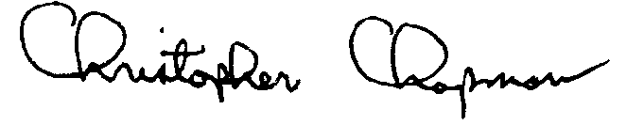
Christopher Chapman
Associate Commissioner, Sample Surveys Division
National Center for Education Statistics, Institute of Education Sciences

School coordinators are previously-identified school staff who serves as a liaison to the project, working with project field staff to arrange for the assessment day activities.
School recruiters are specially-trained data collection contractor staff who recruit districts and schools into the study. They are typically used in advance school contacts because they have experience talking with school staff and discussing logistical arrangements, as well as recruiting new transfer schools that are identified during the pre-assessment contacts.
A full description of the hearing evaluation procedures will be included in the next OMB package for the 5th grade data collection (1850-0750, v.18), scheduled to begin the 60-day public comment period in late June 2015. The hearing evaluation is expected to take 15-20 minutes and will include a short set of hearing-related questions asked of the children to aid analysts in the interpretation of the collected evaluation data, a brief visual inspection of the ears, the collection of measures of middle ear function in both ears, the collection of specific audiometric thresholds, and a brief language impairment screener administered on an ipod. Hearing evaluations following the same protocol and with the same subsample of children were previously conducted as part of the study when the children were in the fall of their second-grade year (OMB# 1850-0750 v.10-11) and the spring of their third-grade year (OMB# 1850-0750 v.15).

