|  |
| --- |
|  |
|
|
|
|

DATE

FNAM LNAM

ADDRESS LINE

ADDRESS LINE

CITY STATE ZIP

Dear FNAM LNAM:

You were recently asked to participate in a survey evaluation of our airman medical certification services. As an airman, you are in a unique position to provide us valuable feedback based on your experiences with the medical certification process. Your input is vital in our effort to improve medical certification services for all airmen applicants (OMB 2120-0707).

Participation in the survey is voluntary and your feedback is anonymous. Your responses will be kept private to the extent provided by law. Your responses go directly to a contractor for removal of any personally identifiable information, before the FAA has access to the dataset.

I encourage you to take this opportunity to have your voice heard. It takes 15 to 20 minutes to complete the survey.

For your convenience, you may complete the survey using your computer or mobile device such as a smartphone. Submit only **one** survey.

* To access the online survey, either scan the QR code using your mobile device or go to the Internet and type the following into the address bar: **www.tinyurl.com/Airman2016**

Note: The survey cannot be accessed using a search engine such as Google or Bing.

To locate the address bar on your Internet browser: (1) go to the Internet, (2) on your keyboard hold down the **Alt** key and press the **D** key to activate and highlight the address bar, (3) type the survey web address: **www.tinyurl.com/Airman2016** and press the Enter key.

* At the survey log in screen, enter this password: **A#CA#** (use upper-case letters) and click the ‘Next’ button.
* To request a paper survey, or to receive a direct link to the survey by email, or for survey support, send an email to: [9-AMC-SurveySupport@faa.gov](mailto:9-AMC-SurveySupport@faa.gov) or call (405) 954-8579 M-F, 9:00 a.m. to 4:00 p.m. Central.

Your participation in this evaluation is greatly appreciated and will help us improve our services to you. The survey will be available today until **DATE**.

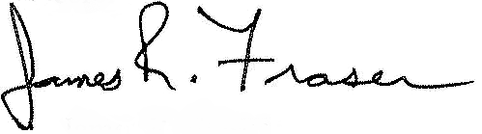Sincerely,

Dr. James R. Fraser

Federal Air Surgeon

FAA Office of Aerospace Medicine