**SUPPORTING STATEMENT**

**2015 National Household Travel Survey**

This is a request for an Office of Management and Budget (OMB) approved clearance for the reinstatement of a periodic information collection entitled “National Household Travel Survey” (NHTS).

Part A. Justification

1. *Circumstances that make collection of information necessary:*

The NHTS is the U.S. Department of Transportation’s (USDOT) nationally representative data source for daily local passenger travel. This inventory of travel behavior reflects travel mode (private vehicle, public transportation, pedestrian and cycling) and trip purpose (travel to work, school, recreation, and personal/family trips) by U.S. household residents. Survey results are used by federal and state agencies to monitor the performance and adequacy of current facilities and infrastructure, and to plan for future needs. Data from the NHTS are included in broader, bi-annual reports to Congress on the performance of the surface transportation system.

The collection and analysis of national transportation data has been of critical importance for nearly half a century. Previous surveys were conducted in 1969, 1977, 1983, 1990, 1995, 2001, and in 2009. The current survey will be the eighth in this series, and allow researchers, planners, and officials at the state and federal levels to monitor travel trends. The NHTS is the only national source of data on how the travel behavior of the American public is changing as demographic, economic and cultural changes are taking place in our country.

Title 23, United States Code, Section 502 authorizes the USDOT to carry out advanced research and transportation research to measure the performance of the surface transportation systems in the US, including the efficiency, energy use, air quality, congestion, and safety of the highway and intermodal transportation systems. The USDOT is charged with the overall responsibility to obtain current information on national patterns of travel, which establishes a data base to better understand travel behavior, evaluate the use of transportation facilities, and gauge the impact of the USDOT’s policies and programs.

Data from the NHTS are widely used to support research needs within the USDOT, and State and local agencies, in addition to responding to queries from Congress, the research community and the media on important issues. Current and recent topics of interest include:

* Travel to work patterns by vehicle mode for infrastructure improvements and congestion reduction,
* Access to public transit, paratransit, and rail services by various demographic groups,
* Incidence of vehicle ownership at various income levels,
* Measures of travel by mode to establish exposure rates for highway safety analyses,
* Bike and walk travel for safety, health measures, and environmental concerns,
* Support for Federal, State, and local planning activities and policy evaluation.

Within the USDOT, the Federal Highway Administration (FHWA) holds responsibility for technical and funding coordination. The National Highway Traffic Safety Administration (NHTSA), Federal Transit Administration (FTA), and the Bureau of Transportation Statistics (BTS) are also primary data users, and have historically participated in project planning and financial support.

1. *How, by whom, and for what purpose is the information used:*

The National Household Travel Survey is the source of the nation’s personal travel information and is used by the Administration, Congress, national and local policy makers, and transportation planners to study the extent and type of daily travel in the United States. Recent changes in travel behavior combined with the transportation community’s emphasis on performance measurement underscore the importance of reliable data for evidence-based decisions. The diversity of information needed to support the wide range of transportation decisions in the current environment is challenging. The NHTS provides critical data on individual travel behavior trends linked to economic, demographic, and geographic factors that influence travel decisions and help predict travel demand.

The NHTS data are unique and not available from any other source since they are collected directly from a stratified random sample of U. S. households. They describe travel behavior that informs research and policy initiatives that relate to safety, congestion, finance, mobility, accessibility, and forecasted demand.

Appendix 1,” National Household Travel Survey, Compendium of Uses, contains the table of contents for research published, January 2014 - December 2014.” The research papers were grouped into 11 categories that were created based on the Subject Areasand index terms identified in each abstract as well as category titles used in previous NHTS compendium databases. The categories are as follows:

1. Bicycle and Pedestrian Studies

2. Demographic Trends

3. Energy Consumption

4. Environment

5. Policy and Mobility

6. Special Population Groups

7. Survey, Data Synthesis, and Other Applications

8. Traffic Safety

9. Transit Planning

10. Travel Behavior

11. Trend Analysis and Market Segmentation

This listing demonstrates the broad spectrum of topics that NHTS data are used to investigate.

To view the full Compendia which contains a one-page abstract of each entry, go to <http://nhts.ornl.gov> and click on Publications and scroll down to the Compendium for the year desired. Note, that the various Compendia have citations going back to research conducted using the 1969 NPTS (the forerunner of the NHTS).

The Office of the Secretary (OST) of Transportation, FHWA, FTA, NHTSA and BTS use NHTS data to address a number of issues in the Department’s Strategic Plan. Specific applications are outlined below.

Safety

Ensuring the safety of the American public when traveling has been a long standing mission of the USDOT. The NHTS is the only source of data available on the level of use of the transportation system by mode of travel and demographic group. Specifically, NHTS data are used by the Department, Administration, and transportation organizations for:

* Calculating exposure rates by age, gender, and vehicle type to compute risk for crashes and fatalities. These data are used to assess the composite impacts on the safety of the American public due to demographic shifts and vehicle technology changes. The risk assessment tool, Traffic STATS, developed by the AAA Traffic Safety Foundation is one example of this use (http://www.aaafoundation.org).
* Developing educational campaigns that reach target audiences. For example, understanding who is traveling at high accident times allows educational campaigns to target traveling market segments, including details on the age and gender of the driver, the number of people in the vehicle, the purpose of travel, and vehicle characteristics which can impact collision severity, such as vehicle age, type, etc.
* Analyzing the incidence of walk and bike trips, characteristics of those making these trips and the trips themselves, such as time of day, and trip purpose to establish baseline measures of exposure, demand for expanded facilities, and address high risk areas (e.g. rural roads) and demographic groups (e.g. Millennials, new immigrants).
* Gathering information on rare modes, such as motorcycle use, to help understand the persistent growth in motorcycle accidents and fatalities in recent years.
* Evaluating new safety initiatives such as Safe Routes to School to understand school aged travel and to help monitor special programs related to bike and walk trips of the student population.

Congestion

Reducing the level of congestion in U.S. cities is one of the top priorities of the USDOT. The NHTS plays an important role in understanding the travel behavior that contributes to the congestion issue. Travel demand is generated by the choices that people make to carry out their daily activities. The steady increase in travel demand over the past fifty years (especially vehicle travel) has created high levels of congestion in our urban areas. Congestion is no longer only a weekday work commute issue. In fact, approximately half of all travel during peak commute times is for non-work purposes. The NHTS is the only national source of information on non-work travel. The NHTS supports policy and planning by USDOT, the Administration, and Congress in measuring the demand side of congestion including:

* Vehicle occupancy during congested times to measure changes in carpool rates,
* Trip purpose distribution for peak and off-peak travel, including non-work,
* Mode share for all trips by time of day and day of week,
* Trends in time, distance, and speed for work and non-work travel, and

Mobility

Mobility issues are particularly acute for the elderly, new immigrants, and the poor. Issues include access to and use of alternative means of transportation, the range of daily mobility, and the relative cost of transportation for the household. In particular, the NHTS provides data that support an examination of:

* Mobility of people of color and language differences, including whether their reduced mobility is due to access based on race/Hispanic origin, income, residential location, or other barriers.
* Women’s travel issues, particularly the travel behavior of working mothers who continue to retain primary responsibility for family and household needs, and elderly women who may be isolated when they give up driving.
* Teen travel behavior, especially in the pre-driving age and through the later teens. Teen travel behavior has impacts on safety, household trip generation, and future transportation service needs and demand.
* Transit use in terms of the socioeconomic characteristics of users, availability and access to transit, and trip characteristics including wait time, trip purpose, length, travel party size, and time of day.

Economic Issues

Financing options for the highway system and the quantification of the cost of transportation issues such as congestion on the U.S. economy are top issues in the USDOT, Congress, and Administration. National data on passenger travel, as collected in the NHTS, inform on key aspects of economic issues related to cost and finance of the surface transportation system. These include:

* Evaluation of highway finance options,
* Measures of efficiency of surface transportation modes, such as travel time data and trends in travel time,
* The impact of user fees based on estimates of the socio-economics of the traveler, the purpose of travel during peak periods, and the other relevant characteristics of peak period travel,
* Characteristics of travel to work, or working from home, with particular emphasis on the NHTS data serving as a bridge for state and metropolitan planners to American Community Survey (ACS) data in their travel models, and
* Data on vehicle ownership, vehicle characteristics and amount of travel as used in the FHWA revenue forecasting model to forecast Highway Trust Fund receipts for use by USDOT and the Department of Treasury.

Private Vehicle Fleet Characteristics

The NHTS is a national source of data on the composition of the household vehicle fleet, particularly vehicle type and age, and how it has changed over time. In addition, the Energy Information Agency (EIA) partners with USDOT to append data on fuel efficiency, gas cost (at the household’s location in the month of data collection), and annual fuel use. These data are critical for determining both trends in fuel use and understating the changing types and levels of emissions. Important changes in the character of the vehicle fleet have been tracked using the NHTS data including:

* Increased ownership and use of SUVs and the impacts of that trend on fuel type and use and vehicle emissions,
* The relative cost of travel and fuel usage by the type of vehicles owned by the household and the household’s location,
* Increased ownership and use of hybrid and electric vehicles,
* Baseline data for examining optimal charging schedules and grid utility for increasing electric vehicle use,
* Changes in the overall fuel efficiency of the residential vehicle fleet, and
* Changes in the overall age of the residential vehicle fleet and availability of safety features to key demographic groups.

Local Level Planning and Policy

In addition to USDOT policy issues and Strategic Plan goals, a key function of NHTS data is in the planning processes of States and Metropolitan Planning Organizations (MPOs). NHTS data are used to supplement, or even substitute for, local data on key variables needed in the policy and planning process. States and MPOs have used NHTS data as inputs into the travel demand forecasting, safety planning, and air quality analyses that are mandated by Congress. Since many large urban areas collect their own travel survey. NHTS is most useful to small and mid-size MPOs with limited resources and/or to States who are piecing together data from a number of urban areas or require estimates of rural travel behavior to fill in State data gaps.

National Academies of Science

The NHTS is used in research conducted by the National Cooperative Highway Research Program (NCHRP) of the National Academies of Science. NCHRP research is highly respected and used widely by federal, state and local governments, travel modeling firms and the broader transportation research community.

1. *Extent of automated information collection:*

This survey will build on the lessons learned during the administration of the last two iterations (2001, and 2009) of the NHTS to efficiently and successfully conduct the 2015 NHTS. The technical approach represents diverse and creative survey practices and offers the FHWA the most current knowledge and experience from all types of survey data collection.

Over 80 percent of U.S. households currently have access to the Internet,[1] while only 59 percent[2] have a landline telephone in the home (down from 75 percent during the 2009 NHTS) with even fewer using the landline telephones they have for making or receiving calls. The planned survey methodology will leverage this shift in technology, in particular the move away from home telephone usage, to structure a survey design that uses web, mail, and telephone data collection modes.

The methodological approach starts with a national address-based sample (ABS), a change from the random digit dialing (RDD) telephone-based sample design used in recent past NHTS efforts. However, the planned methods also incorporate core data elements that have been part of the NHTS since 1969. For 2015, the survey will implement a creative approach to incentivizing respondents; use a mail out/mail back recruitment survey designed to be relevant, aesthetically pleasing, and elicit participation; provide each household with personalized travel logs by mail; and offer the option of completing the retrieval survey by web or telephone.

Data collected using the paper-based recruit instrument will be processed through commercial, off-the-shelf (COTS) software and reviewed by analysts as needed. Open-end response fields will be configured within the software to be reviewed and verified by analysts. Once these data are reviewed, households that provided valid responses to required recruitment variables will have their data loaded onto the online survey engine for initial processing. This post-load process also will be used to generate fulfillment retrieval materials that will be mailed to households, including the assignment of travel dates.

Unlike previous iterations of the NHTS, the 2015 survey will rely primarily on internet data collection for the retrieval portion of the survey, which constitutes over 90% of the data collected. The NHTS contractor will use an approach that allows respondents to only be presented with questions that are necessary and appropriate for that respondent. The NHTS will use a Web GeoSurvey (WGS) survey engine to implement the majority of the online instrument and its TripBuilder Web (TBW) travel data retrieval tool to collect all places visited on each assigned travel date. This dedicated website and custom software enable respondents to self-report their travel activity and they provide appropriate prompts and sophisticated question branching and skip patterns to facilitate accurate trip reporting. Look up tables are available to allow respondents to insert correct vehicle make and model information, and Google Maps type search engines will assist in identifying specific place names and locations. Household rostering (the listing of all vehicles and persons in the household) allows a trip report from one household member that includes another (e.g. spouses who travel to dinner together) to be inserted into the second person’s record, reducing reporting burden by not requiring respondents to report trips already reported by another household member.

When respondents choose to report their travel by telephone interview, project staff members use the same web-based data entry system so that all data are subject to the same range checks and consistency checks. These automatic edit checks reduce reporting error, reduce survey length, and maintain the flow of data reporting. This approach ensures consistency in reporting while minimizing the respondent burden, and maximizing data quality.

Figure 1. TBW sample screenshot

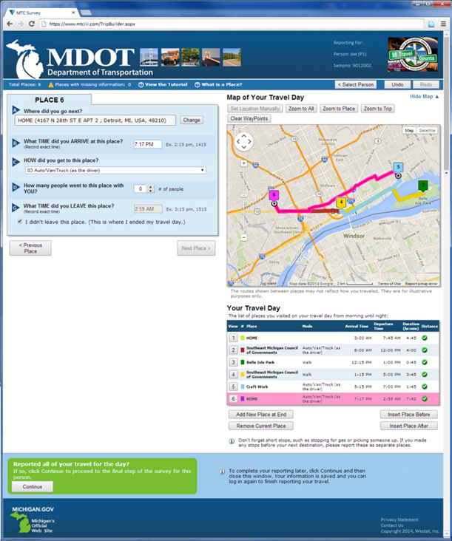An example of a TBW screen is presented in Figure 1. It is important to note that major issues with accurate geocoding of locations, issues which were prevalent in travel surveys of the past, are virtually nonexistent when using TBW, where every reported destination is geocoded as the travel behavior details are captured. To date, travel details from more than 110,000 households have been retrieved through the use of TBW.

The web-based geocoding user interface (UI) allows respondents to enter address and place name information using free-form text (i.e., it is not required to type in address components into separate fields).

The address input is capable of processing street address and intersection information, and examples are provided as part of the UI to assist respondents in the process. The address and place name information entered is then sent to the Google Maps geocoding and Google Places Search application-programming interface (API).

The address data are used to search for geocode matches, while the place name is used to search for points of interest (POI) locations around the provided addresses. This design ensures 100 percent geocoding of the home, work, and school locations of households that complete the retrieval interview. This will also make it possible to compute “as crow flies” distances between all reported places. In addition, TBW will save shortest path routes between these places, whenever a routing solution is possible, as well as shortest path route distances. Together, these two sources of travel distance information will provide FHWA new alternatives for deriving Vehicle Miles Traveled (VMT) estimates from the 2015 NHTS.

In addition to the range, edit, and consistency checks in the WebGeoSurvey online retrieval instrument, TBW will integrate several travel data consistency checks within its user interface. These will ensure that collected places pass basic data completeness and consistency requirements. One of these checks includes the requirement that all visited places be associated with a geocoded location. This will ensure that all records deemed complete at the end of the retrieval instrument will have all destinations geocoded. Other checks built into the TBW user interface include:

* All places must have valid arrival and departure times (i.e., times must increment),
* All places after the first one must have an inbound travel mode associated with them,
* Places with an inbound travel mode of private vehicle must identify which vehicle was used to complete the trip (an option for non-household vehicle is provided),
* First trip of the day, which must take place after 4 a.m.,
* Last trip of the day, which must be completed by 3:59 a.m. of the following day.

Once the household completes the retrieval interview or survey, additional quality checks by means of the contractor’s proprietary’s Trip Processing System (TPS) - an automated household travel survey data check and review system will be conducted.

1. *Efforts to identify duplication:*

The NHTS is not only the sole source of information on mode use for all purposes by the American public, but it is also a key component of the major federal datasets that were designed to maximize information utility while identifying and eliminating duplication. The complementary data collection programs frequently used in concert with the NHTS include the Highway Performance Monitoring System (HPMS), American Community Survey (ACS), and tourism and traveler surveys such as those collected by the Travel Industry Association (TIA).

Estimates of passenger and commercial vehicle miles travelled on various roadways are the focus of the HPMS. The FHWA aggregates local vehicle count data from all 50 states, the District of Columbia, and Puerto Rico to measure the use of the highway system and the volume of travel. These data are enhanced by the ability of the NHTS to estimate the proportion of all roadway travel that is generated by personal passenger travel versus commercial or freight. The NHTS also enhances HPMS data through its ability to describe the demographics of travelers, trip purpose, and travel party size. Such information cannot be collected from the simple travel counts generated through the HPMS.

The NHTS program and the Census Bureau closely collaborate, especially in developing the Journey to Work data that are part of the ACS. The Census Bureau has collected data limited to “typical” work trip mode and travel time since 1960. The work trip data collected by the NHTS include actual travel time and mode characteristics on the assigned travel day. The NHTS also collects descriptive information on all other types of trips – data not available from any other source. Previous NHTS surveys indicate that work trips account for about 17 percent of all trips for all people; even for adults in the workforce, the trip to work is only one of four trips made on an average day.

The American Time Use Survey (ATUS) conducted by the Bureau of Labor Statistics does collect some travel information as it estimates the type and time spent by people on various activities. The NHTS survey collects a level of travel detail not available in the ATUS, and is used to benchmark those data.

Tourist and travel surveys can provide national estimates of recreational travel, with a focus on long distance trips (100 miles or more). The NHTS obtains some information on long distance travel (if such a trip was taken by a household member on an assigned travel day). However, the primary focus of the NHTS is not on tourism but on the daily travel of the American public.

1. *Efforts to minimize the burden on small businesses:*

Small businesses are not being recruited to participate in this study. No information will be collected from small businesses.

1. *Consequences of the data not being collected or of less frequent data collection:*

As NHTS is the only source of national data on the travel of the American public by all modes and for all purposes, the Administration, Congress, and the USDOT would be missing essential information regarding key transportation indicators. These include mode share, travel demand, trip purpose distribution, and exposure levels that feed directly into transportation and safety planning, program evaluation, highway finance, performance measurement, and policy development. Without the next survey in the series, the transportation community will have no information on:

* Changes in the purpose and type of travel related to decreases/increases in fuel costs. The EIA appends current fuel data onto the NHTS, but changes in behavior related to the price of fuel require new travel information. In addition, the vehicle fleet is changing, and tracking the penetration and use of alternate fuel vehicles is important in revenue forecasting for the Department,
* Vehicle miles of travel by drivers by age, sex, ethnicity, and time of day. This has been used in applications from safety measures and program evaluation to outreach targeting to evaluating the occurrence of racial profiling,
* The travel behavior of Millennials as a group is much different from previous generational waves. This group tends to live and work in the city and rely on walking, public transportation and new services, such as ZipCar, Car2Go, Uber and Bikeshare. Their rate of driver licensing and vehicle use is lower than previous demographic waves. Monitoring such trends is important to the environmental effects of transportation and to the potential future funding stream of the Highway Trust Fund.
* Impact of baby-boomers retirement and working past traditional retirement age. Important demographic changes are occurring in the users of the transportation system, affecting congestion, trip purpose and time of day of travel, and other information important to policy analysis,
* Measures of peak spreading, and increases in midday and weekend travel. For many areas around the country, vehicle starts on Saturday afternoon are higher than any peak period during the weekday (expect Friday afternoon),
* Travel by special populations, such as the disabled, new immigrants, poor, and people without cars. These data are vital for evacuation planning, mobility, and safety,
* Effects of graduated licensing programs on teen driving. As more and more states use graduated licensing, the effect on vehicle occupancy, age, purpose, and time of day of travel are important to track, and
* Updates to the default air-quality and trip generation parameters used by local planners. These data feed local models that forecast travel demand for major investment studies, congestion pricing, new transit starts, and other local transportation improvements.
* Travel by recent vehicle and bike sharing uses can reflect the trends in vehicle ownership and impact the economic transportation trends.

As a data driven agency, FHWA needs to continue its leadership in collecting and disseminating information that support sound planning and policies at all levels of government. FHWA’s continued leadership at the Federal, State, and local level will have an enormous impact on the safety, reliability, and accessibility of our system in the future. The NHTS provides data that inform USDOT and FHWA on travel behavior that impacts our decisions and programs related to USDOT’s strategic goals. The NHTS is a critical data program. For the upcoming reauthorization, the NHTS will be an important resource in confirming national strategies and priorities.

1. *Special circumstances:*

There are no special circumstances

1. *Compliance with 5 CFR 1320.8:*

Docket number DOT – 2015-0004 was established as a repository for comments received in response to the Federal Register 60 Day Notice and Request for Comments published on February 19, 2015, Volume 80, Number 33, and Page 8922. No comments were submitted to the docket during this period.

The Federal Register 30 Day Notice was published on April 23, 2015.

Efforts to consult with persons outside the agency

The NHTS and its predecessor, the NPTS (National Personal Transportation Survey) have been in existence since the first survey in the series, conducted in 1969. Over that span of time, the NHTS user community has grown significantly. FHWA and the users have made use of technological changes to increase our points of contact, coordination, feedback and input to the next survey in the series. This process was formalized in 2011 with the creation of the Transportation Research Board’s Task Force on Understanding New Directions for the NHTS (ABJ45T).

The Task Force is composed of state and local transportation practitioners, academics, travel modelers, and representatives of organizations active in travel behavior research. The Task Force conducted an extensive outreach effort to describe the proposed NHTS redesign for 2015 and get feedback from the various user communities. They attended 12 conferences and meeting and held special NHTS workshops to gather input for the next NHTS. Details on the topics discussed and the input received are found in the excellent document TRB Circular E-C178, “Exploring New Directions for the NHTS: Phase One Report of Activities, October 2013 (see Appendix 17).

A number of user groups expressed the need for tutorials on specific topics within the overall NHTS framework. As a result the NHTS Academy was initiated as part of the NHTS website <http://nhts.ornl.gov> and 9 modules have been developed so far, including those on topics such as Vehicle Occupancy computations, Trip Purpose categorization, the Updated file with 2010 Census Boundary definitions. Users and Task Force members have commented positively on these tools.

The NHTS, like many other American surveys of the general population, is facing issues of engaging potential respondents and obtaining a representative sample. Those issues coupled with our redesign to a self-administered survey, led us to seek assistance from a group of nationally-recognized survey methodology experts. Two Expert Panel sessions were convened to review plans for the next NHTS and provide input to our planning process. Members of the Expert Panel include Mick Couper (University of Michigan), Don Dillman (Washington State University), Laura Erhard (Consumer Expenditure Survey at Bureau of Labor Statistics), Paul Lavrakas (University of Chicago and Michigan State University) and Clyde Tucker (American Institutes for Research). Steve Polzin (Center for Urban Transportation Research, USF) and Guy Rousseau (Atlanta Regional Commission) are the Task Force members who round out the panel with a focus on the unique needs of transportation planning.

The NHTS Program Manager and Team also have extensive contacts with a number of Federal agencies both within and outside DOT. Within DOT there is coordination with NHTS users in BTS, NHTSA, FTA and OST. EIA is a user of NHTS and has improved the NHTS dataset considerably by appending data on fuel economy and gas cost at the individual vehicle level to the data files. EPA uses the NHTS data in their MOVES model, which is used by metropolitan area in analyzing compliance with the Clean Air Act. There is strong coordination with the CDC, who has had input to the walk and bike questions in the 2015 NHTS.

Likewise, there is coordination with private groups and associations. The AARP Policy Institute is a strong user of the NHTS data for various analyses of senior mobility issues. AAA and The Insurance Institute for Highway Safety (IIHS) are data users. Other organizations the NHTS coordinate with include the American Association of State Highway and Transportation Officials (AASHTO) and the Census CTPP and the American Public Transit Association (APTA).

Over the 48 years of its existence, the NHTS has developed an extensive network of public and private users through the interactive website and the User Support staff and we are constantly receiving input from our very broad user community.

1. *Payments or gifts to respondents:*

Incentives are an essential component of survey research. Determining a responsible level of incentives is vital to the success of the project. The incentive plan is designed to incrementally reward participation, which will lead to higher response rates and lower survey costs. In the design, each sampled address will receive a $2 cash incentive in the first mail contact. The travel log package sent to each recruited household will contain a $5 cash incentive and a planned additional $20 for successfully completing the reporting of household travel. The log letter will make use of the approach outlined by Tourangeau and Ye[3] (2009) of appealing to respondents to avoid decreasing the research value of their earlier response by going to the web for the more complex second phase response. The total amount will be $27 ($2 + $5 + $20) per household.

1. *Assurance of confidentiality:*

FHWA does not provide an assurance of confidentiality. FHWA will follow all DOT security and privacy guidelines regarding the handling of sensitive information. To protect the identity of the respondents, the database will not contain names, addresses, telephone numbers, or other direct identifiers. Neither will the publicly available data files contain variables such as the collected latitude and longitude of locations that could be used to match records to an external file containing names and addresses. Further, potentially identifying information such as ownership of unique vehicle make-model combinations, ages of individuals above a certain cutoff and other like items will not be displayed on the public use data file.

Confidentiality procedures will also be applied rigidly to all electronic files. Password systems will be maintained to ensure that only authorized staff members can access the files. Furthermore, physical access to the computer equipment will be restricted to authorized systems operations personnel.

The contractor requires all project staff members to participate in annual training on legislation and guidelines concerning protection of human subjects and their right to privacy. All contractor personnel associated with the survey, including interviewers, interviewer supervisors, and professional staff, will be required to sign a statement pledging to maintain the confidentiality of all survey data.

Informed consent procedures will be implemented for the NHTS. The contractor will inform all survey respondents of the following: the enabling legislation for the study, the principal purposes for which the information is needed, the routine uses that will be made of the data collected, that their participation is voluntary. The respondents will also be told that their responses will be held in the strictest confidence and that reports from the survey data will be summaries that do not allow individuals to be identified. A statement to this effect will be included in the introduction to the NHTS questionnaire.

There are two stages to the survey during which information is collected. The first stage is the recruitment process where information about the household is collected from one household respondent– the Recruitment Data Process (Figure 2). The second stage is where information about each household member is collected regarding typical daily travel and their specific activities on the travel day – the Retrieval Process (Figure 3).

*Recruitment Data Collection Stage*

Personal identification information will be necessary and used only for confirming that the respondents live at the sampled address, to attach a randomly assigned personal identification number (PIN) to that household, and for follow-up data collection. All household members will be enumerated and the household respondent will be asked to provide their identities, age, gender and driving status. These will be recorded as first names, nicknames, initials, numbers, or whatever the respondent chooses. These identifiers are used solely to link travel information to specific demographics such as age and gender. The household respondent will be asked to provide a telephone number and email address. This information will be used solely for the intended purposes: to remind participants of their assigned travel dates and the need to record their travel log information, or to re-contact to complete the retrieval stage of the survey or to clarify any data issues. All information will be collected on a secure web server hosted by the consultant during the recruitment phase of the survey.

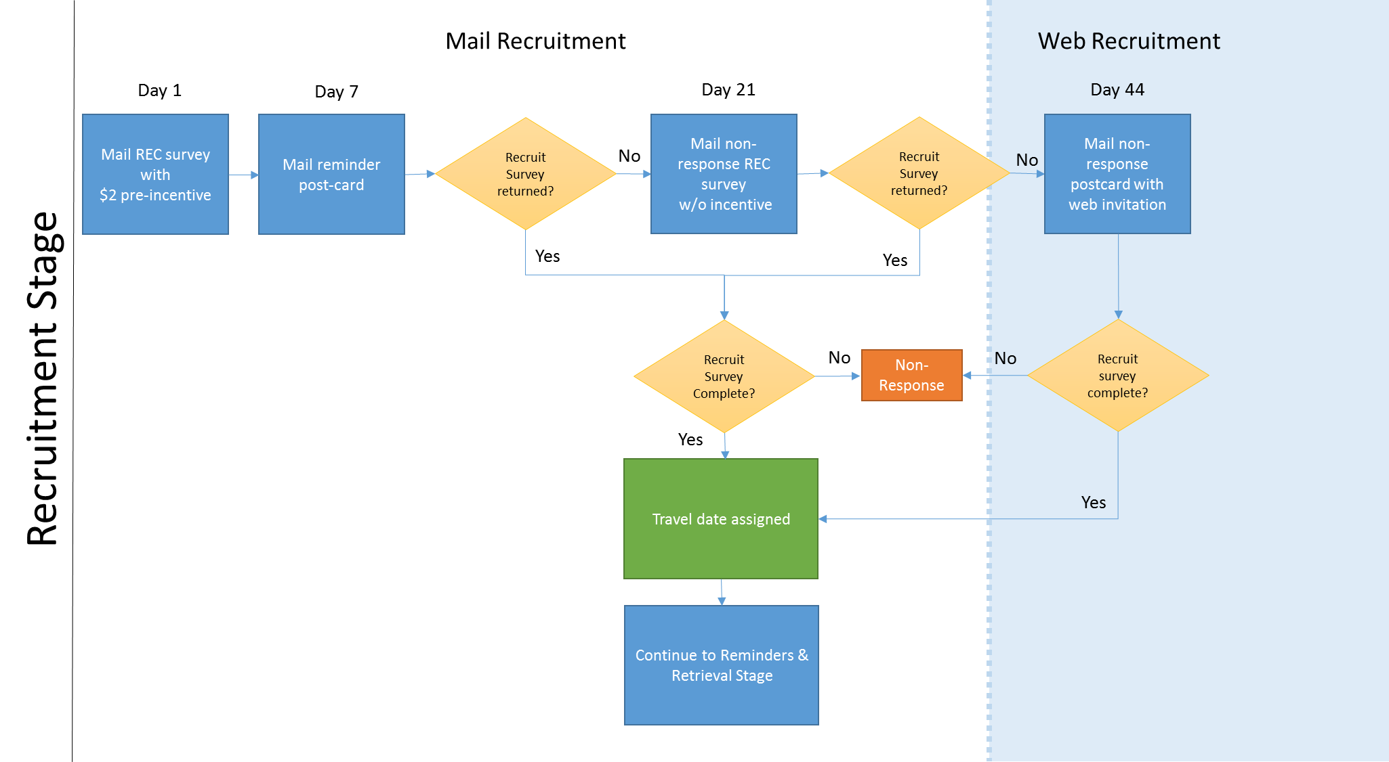

Figure 2 Recruitment Data Process

*Retrieval Travel Data Collection Stage*

Participant travel information will be collected via a dedicated website developed specifically for the NHTS. Access to the survey portal will be controlled via an assigned personal identification number (PIN). Data will be entered on the same site by respondents who choose Web access, or by contractor telephone interviewers who will record participant data using the same site. The website will be hosted on a secure server subject to stringent information technology protocol and controls.

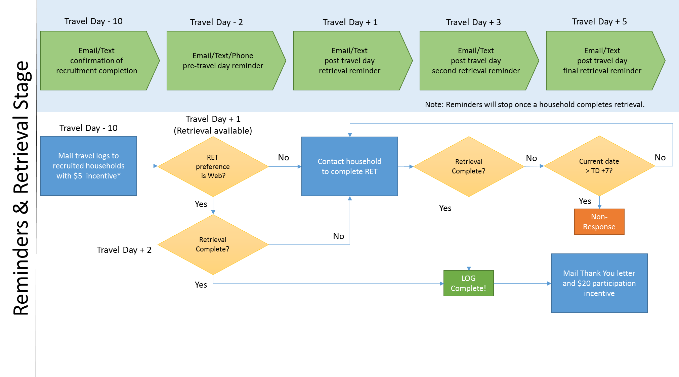

Figure 3 Reminders and Data Retrieval Process

1. *Justification for collection of sensitive information:*

Every effort has been made to reduce the number of sensitive questions in the 2015 survey while maintaining the collection of information so vital to the program. There are several important questions that may be considered sensitive by some respondents.

An income question is included among other questions designed to identify socioeconomic characteristics that are essential to the travel analyses. It is necessary to collect income data because there is a direct correlation between travel behavior and the financial resources available to household members. The link between income and the amount of travel as well as the types of trips made is critical to analyzing current travel and projecting travel in the future. Travel forecasting models most often use household size and income as prime determinants of projected travel. This question has been modified for the 2015 survey for presentation in a self-administer web survey.

Questions on immigrant status have been collected in the 2001 and 2009 surveys. These questions have been highly useful in policy and program analyses regarding immigrant travel behavior and demand projections. These questions were originally added because much of the projected growth of the U.S. population over the next several decades will result from immigration, and immigrants, particularly recent immigrants, face unique travel and mobility challenges. We recognize the sensitivity of asking immigrant status, have included a brief statement about why we are asking it on the questionnaire, and will continue to closely monitor respondent sensitivity to this topic.

Verification and collection of home and workplace location is requested from respondents to the NHTS. The home location already will be available from the sample frame used to recruit the respondents. Primary work location will be asked for respondents indicating they are employed. These data allow for a connection with the Journey to Work data provided by the American Community Survey as part of the Census Transportation Planning Package, which is produced for and distributed to every state and Metropolitan Planning Organization (MPO) in the country. Journey to Work data have long been a staple of the transportation planning process and such a link is a necessary element supplementing travel to work data with non-work data available in NHTS.

Home and workplace location information also is needed to enhance the NHTS data with a profile of the home and workplace neighborhood characteristics from an outside source such as Nielson Claritas. The connection between land use and transportation is a recurring issue, and providing outside data on the neighborhood characteristics of the residence and the workplace has been an effective tool in promoting use of the NHTS data for research on this topic.

1. *Estimate of burden hours for information requested:*

The respondent burden for the NHTS will result from the time spent responding to the questions in the initial recruitment mail-out, and completing the travel log survey by recording details about each trip taken on an assigned day, and then reporting these data via the web or telephone.

The initial recruitment survey contains only 16 questions that include basic household information for future contact, rostering and enumeration, and a few engaging opinion-based questions about travel topics. The initial review of and response to these questions using the paper form is expected to take one household member 8 minutes. The form will be returned to the consultant using the provided business response envelope. Note: The initial mailings are estimated to be 149,813, with these 3 assumptions:

* Ten percent (14,981) of the 149,813 are those addresses where the letter never is opened or received (return mail) resulting in “zero” burden to the household.
* About 108, 832 of these 149,813 are addresses that read the letter but decide to not participate. We estimate 3 minutes for a household respondent to read the letter thus, 3 minutes X 108, 832 / 60 minutes = 5,441 hours of burden is estimated.
* An estimated 26,000 mailings will participate in the complete collection.

For the data collection and retrieval portion of the survey, minimal recordkeeping is required from most respondents. The recordkeeping consists of maintaining a simple travel log for a 24-hour period and reporting the maximum odometer reading for household vehicles. The diary is a straightforward form that asks the respondent to record six items for each trip: where they went (e.g., home, work, other), why they went (work, shop, school, etc.), the times the trips began and ended, the means of transportation, and who traveled with the respondent. Our experience shows that the use of the travel log/diary is essential in improving recall of specific trips, particularly incidental trips. A copy of the travel diary/log is included as Appendix 4. Completion of the travel diary is expected to take an average of 3 minutes. The odometer log Appendix 5, requires recording just the maximum number of miles for household vehicles. Completion of the odometer log is expected to take 2 minutes.

As a final step, respondents will report their travel data through either a dedicated, secure website, or a telephone interview. As described, above, the database is designed to minimize respondent burden by pre-populating responses where possible, and using branching and skip pattern techniques. Average time to report travel data via the website or through a telephone interview is expected to take 13 minutes

The hourly value of time used here is the value of personal travel time as provided in the USDOT’s *Departmental Guidance for the Valuation of Travel Time in Economic Analysis*, 2011 adjusted to 2015 dollars. This value is being used because the opportunity cost of time spent on personal travel is some non-employment related activity (i.e., leisure activity), as is the opportunity cost for time spent in participating in this study. The 2015 adjusted hourly value is $8.93 [2016 value is $11.90]

The table below displays the household burden associated with participating in the NHTS. Approximately 500 households are expected in the first year, and 25,500 households in the second year – a total of 26,000 households. We anticipate that the average household size will be 2.5 persons yielding 65,000 respondents over the two years. Each household will complete a recruitment survey and an odometer sheet. Each enumerated household member of age 5 or older will complete one travel log and retrieval survey. As indicated earlier, times to complete the individual information requests are 8 minutes for the recruitment survey, 2 minutes for the odometer sheet, 3 minutes for the travel log, and 13 minutes for the retrieval survey.

|  |  |  |  |  |  |
| --- | --- | --- | --- | --- | --- |
| **Household Burden Hours** |  | |  | |  |
|  |  | |  | |  |
| **Collection Request** | **Respondents** | | **Time** | | **Burden Hours** |
| Initial Recruitment Letter | 108,832 | | 3 min. | | 5,441 |
| Reminder Post Cards  (7 day, 21 day, Final Notice) | 108,832 | | 6 min.  (2 min. each) | | 10,883 |
| Recruitment Survey1 | 26,000 | | 8 min. | | 3,467 |
| Odometer Sheet1 | 26,000 | | 2 min. | | 867 |
| Travel Log2 | 65,000 | | 3 min. | | 3,250 |
| Travel Retrieval Survey2 | 65,000 | | 13 min. | | 14,083 |
| **Totals** | **399,664** | |  | | **37,992** |
|  |  | |  | |  |
| 1 Completed once per household. |  | |  | |  |
| 2 Completed by all eligible household members. Assumes 2.5 persons per household are eligible. (26,000 Households X 2.5 persons = 65,000) | | | | | |
|  | |  | |  |  |
| ***The total numbers are based on a 2 year collection period. For ROCIS purposes FHWA has taken the total respondents and total burden hours and divided them by 3 (3 years).*** | | | | | |
|  | |  | |  |  |
| ***Annual Respondents = 133,222*** | |  | |  |  |
| ***Annual Burden Hours = 12,665*** | |  | |  |  |

1. *Estimate of total annual costs to respondents:*

The cost of the hourly burden is expected to be $4,465 in year one and $227,715 in year two for a total of $232,180.

1. *Estimate of the cost to the Federal government*

Contract DTFH61-14-R-00032 was awarded to Westat on September 26, 2014 to design and conduct the survey at a cost of $7,716,075. Total cost equal $7,834,075, which includes the Federal staff salaries.

1. *Explanation of program changes or adjustments*

The proposed NHTS design is a two-stage survey with an ABS frame, mail-out/mail-back recruitment stage and web-based travel day retrieval, using multiple modes for reminders at key points, telephone retrieval as an option when necessary, and cash incentives at key stages. Most regional household travel surveys have adopted an approach that includes an ABS frame, mailing letters that encourage recipients to recruit online, multiple electronic and reminder postcard contacts, and varying levels of telephone follow-up.

This approach is well-suited for studies with compressed data collection schedules that are unable to accommodate the longer recruitment effort that we are proposing for the NHTS. The NHTS, with its significantly longer field period, can accommodate the unique strategy summarized above, which has demonstrated higher response rates than currently found in the regional model. Based on the consultants’ recent experience with this proposed recruitment methodology, we anticipate a 30 percent recruitment rate for the 2015 NHTS

Both the FHWA and Westat are sensitive to the potential impact a change in methodology could have on continuity and trend analysis in the long-standing NHTS program. For the 2015 NHTS, Westat plans a study design that makes use of mail, web, and telephone data collection options optimizing the individual strengths of each mode. With major changes in sample frame and survey methodology required to keep the NHTS relevant now and in the future, maintaining these trends presents one of the biggest challenges facing the 2015 NHTS. However, the 2015 NHTS will not be the first in the series to undergo a major methodology redesign. In 1969, 1977, and 1983 the survey was conducted as a retrospective, in-person interview. In 1990, the first telephone-based sample design was implemented, and in 1995 the first two-stage design was used. The current research plan includes processes for addressing continuity through the survey design and weighting methodology, and by means of analytical techniques to determine the impact of changes in survey methods

1. *Publication of results of data collection:*

Congress requires the USDOT to report the state and performance of the surface transportation system every two years in the Conditions and Performance Report. The NHTS is used in this report. The NHTS is also used extensively in the existing National Surface Transportation Policy and Revenue Study Commission with regards to forecasted travel demand by geographic and demographic groupings. In addition, the NHTS data has informed on several policy and revenue areas through white papers on topics such as trends and forecasts in telecommuting, work and non-work travel, new immigrant travel, and older driver safety.

Other reports are compiled for the USDOT, state and local agencies, and the transportation research community. These reports provide key indicators of travel demand across trip, person, household, and vehicle characteristics. In addition, bi-monthly briefs on current transportation policy issues are provided to USDOT and outside parties. All reports and documentation from the 2009 NHTS and previous surveys can be found on our study website at <http://nhts.ornl.gov>.

One of the primary documents for the NHTS data series is the Summary of Travel Trends (STT) report. This overview of the NHTS survey findings is published by FHWA and provides basic travel indicators for each of the survey years, side-by-side with a short explanation of patterns and differences in the estimates. The report is widely used and cited often as the authoritative documentation of the survey findings.

The 2009 report includes a summary description of the survey protocols, a statement on the reliability and accuracy of the estimates, 36 tables and 12 figures with short narrative descriptions, and an appendix 17 describing the changes in survey conduct over time. The most recent report also includes confidence intervals for the 2009 estimates for the first time.

The required final summary report for 2015 is designed to update the 2009 STT using the results from the 2015 NHTS. The descriptive sections, including the profile of the survey, the protocols used in data collection, and the appendices identifying key changes over time will be updated to include specific details of the 2015 survey.

The tabulation of the estimates from the 2015 NHTS will be constructed using the same or similar assumptions and exclusions as used for the earlier data to make the comparison to 2009 as stringent as possible. The final approved comments and conclusions will form the narrative portion of the report. As in the 2009 Summary of Travel Trends, the 2015 report will also display the 95 percent Confidence Interval for each 2015 data point. The consultant will compute the confidence interval, compare the results to the 2009 range of estimates, and identify areas where travel indicators have changed or remained statistically stable between 2009 and 2015.

The final data set and related metadata will be delivered to the FHWA in SAS format. All tables and figures will be provided in Excel formats.

1. *Approval for not displaying the expiration date of OMB approval*

Not applicable

1. *Exceptions to certification statement*

None

1. Source: U.S. Census Bureau, Current Population Survey, Select Years, Internet Release date: January 2014.
2. Blumberg, S.J., and Luke, J.V. (2014). *Wireless substitution: Early release of estimates from the National Health Interview Survey, July – December 2013*. National Center for Health Statistics. Available from http://www.cdc.gov/nchs/nhis.htm.
3. Tourangeau, R., and Ye, C. (2009). The framing of the survey request and panel attrition. *Public Opinion Quarterly*, 73(2), 338-348.