The survey will be deployed to targets via Survey Monkey. Here is a link to the survey in Survey Monkey for evaluation purposes: <https://www.surveymonkey.com/r/PFNZWPR>.

The first page of the survey contains the Paperwork Reduction Act (PRA) statement and an introduction to provide context for the survey. The first page of the survey is too large for a single screenshot. The first page of the survey spans the following two screenshots.

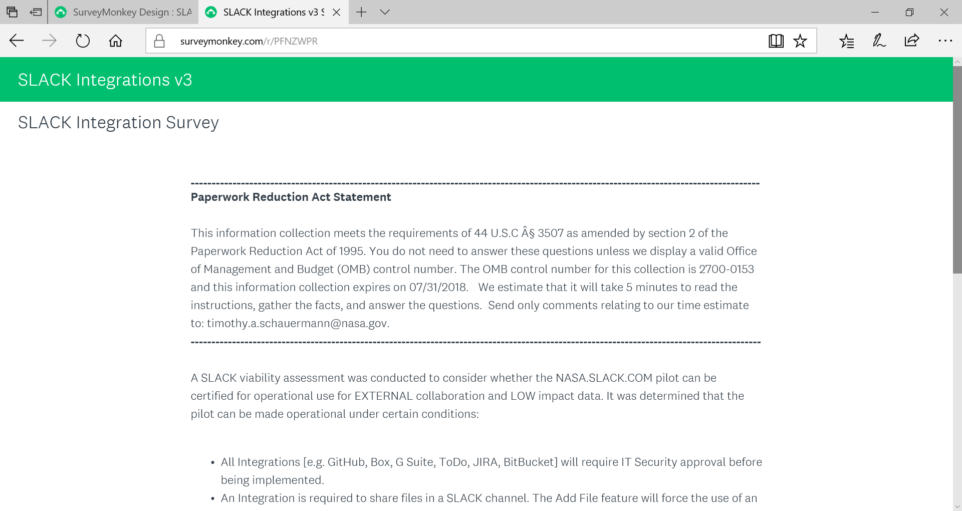

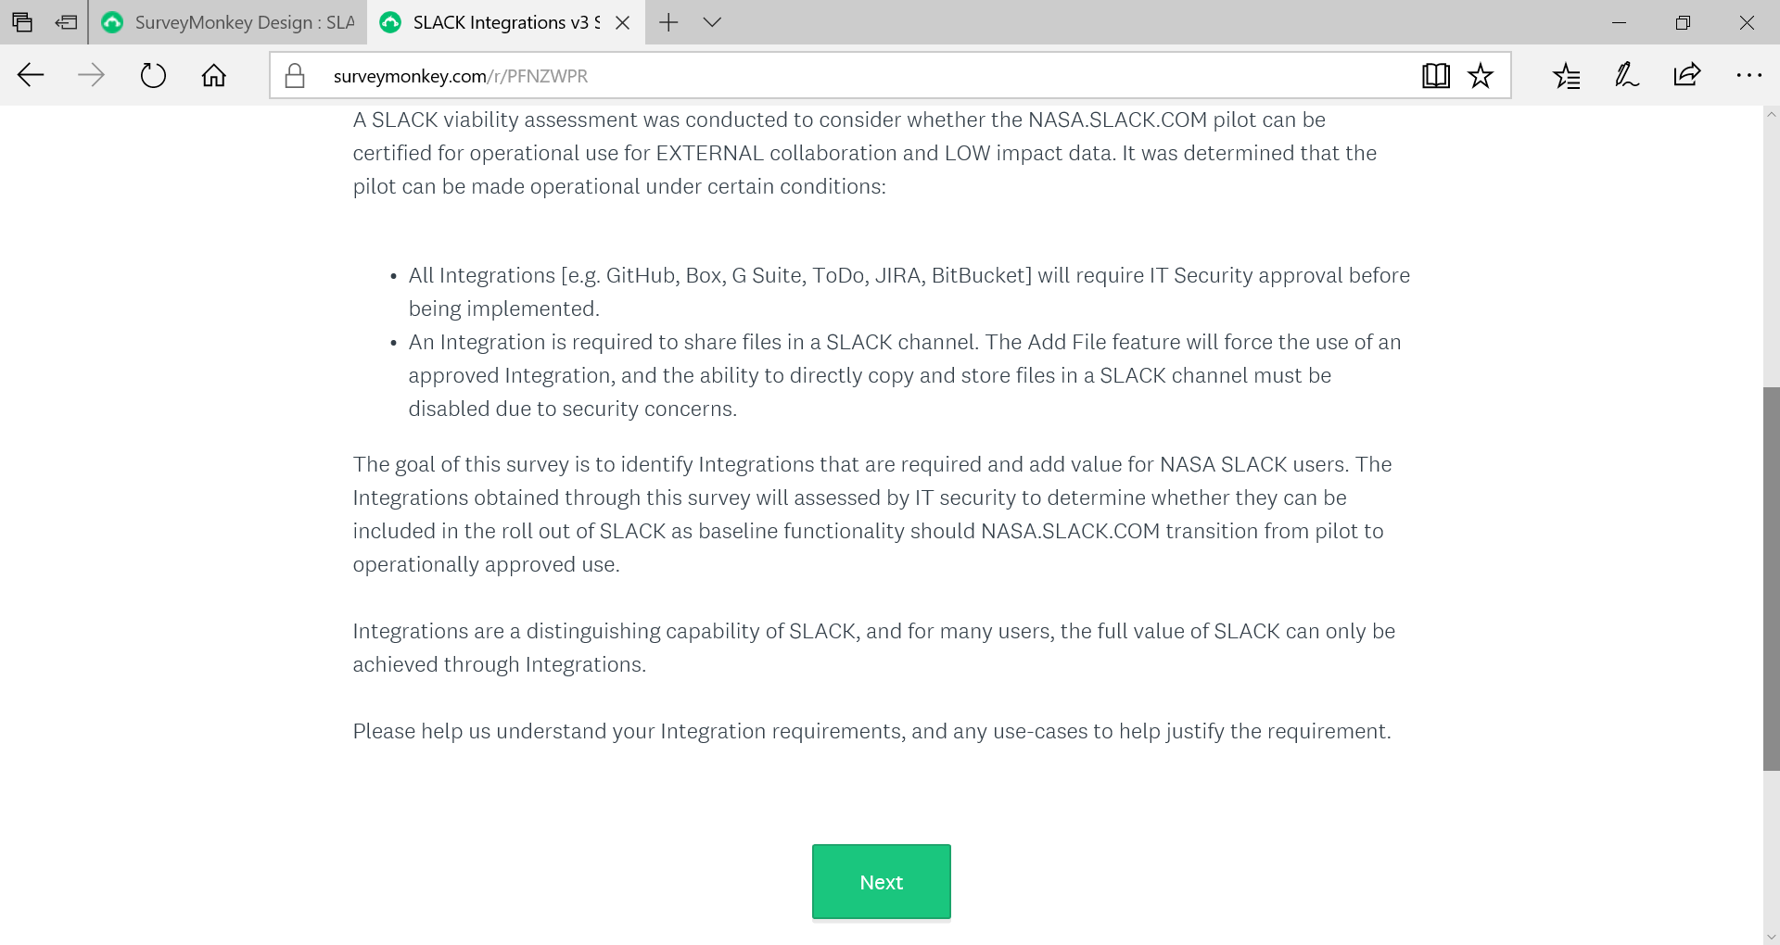

The third question will determine whether the next page (with three question) is relevant. If the answer is ‘yes’, then the following page with questions 4-6 (screenshots below) will be displayed. If the answer is ‘no’ then question 7 will be displayed.

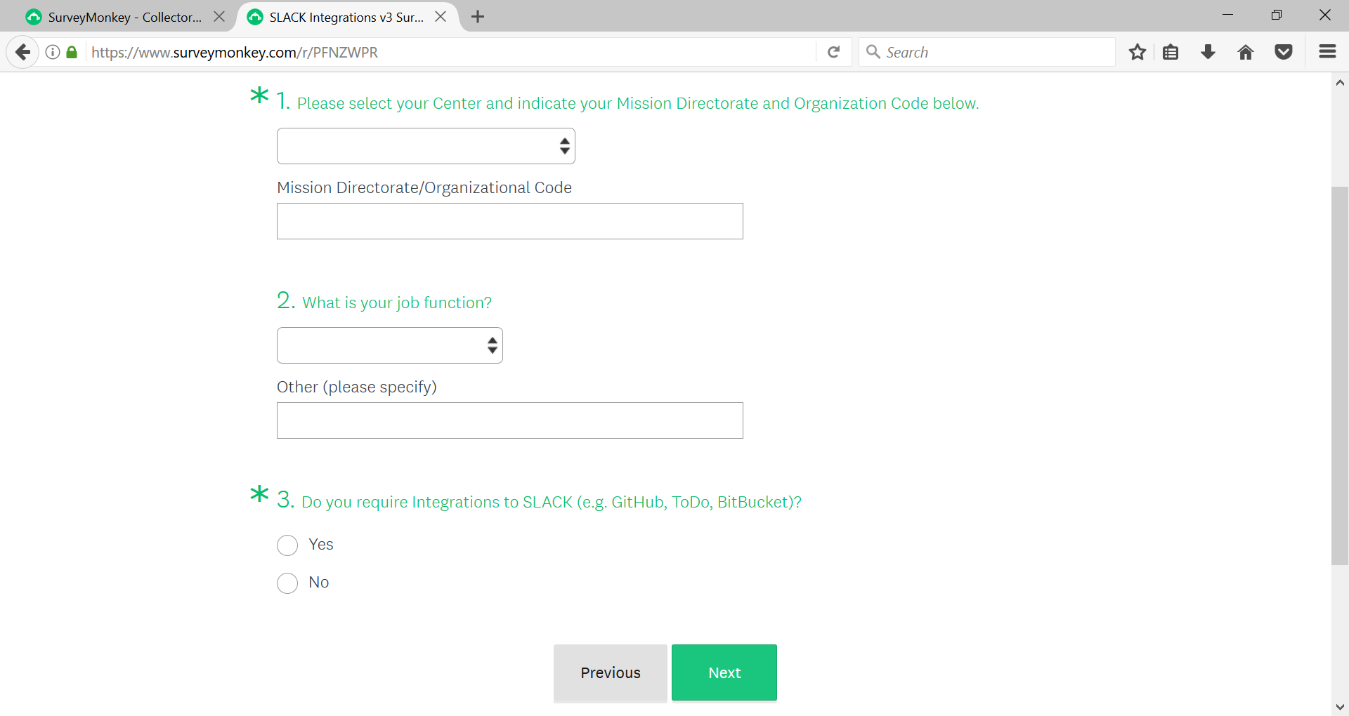

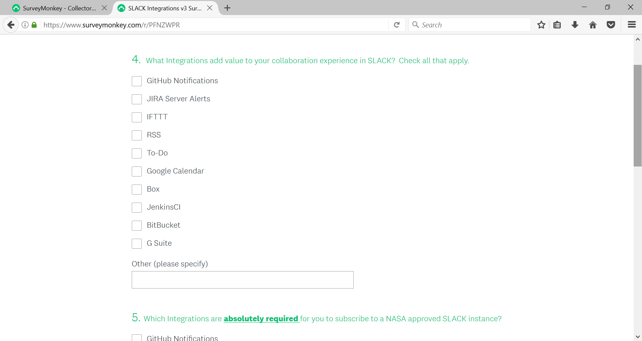

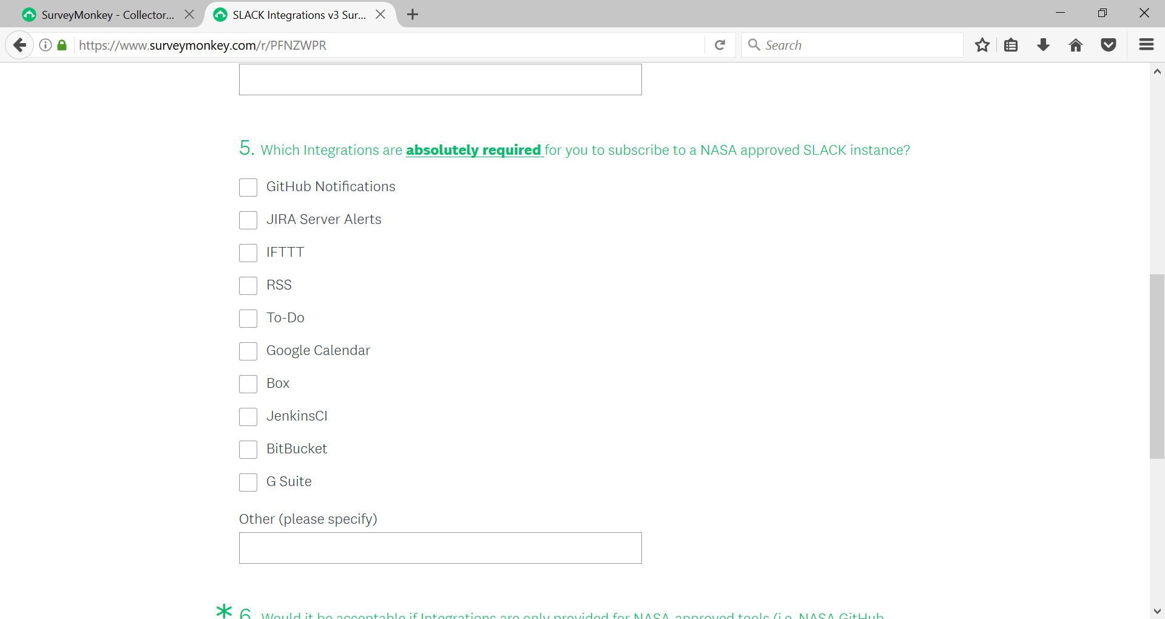

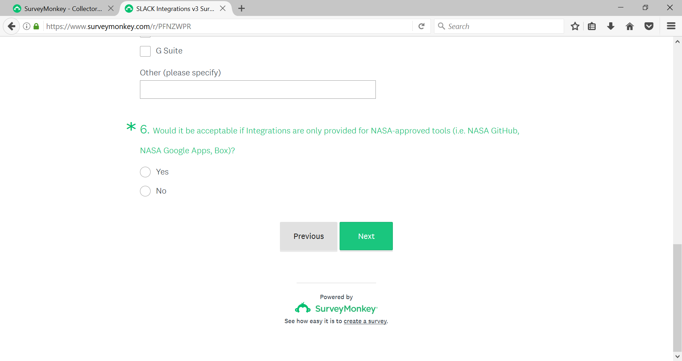

The answer to question 7 will determine whether the next two pages are relevant. If the answer is ‘yes’, then the following page two pages with questions 8-9 (screenshots below) will be displayed. If the answer is ‘no’ then question 10 will be displayed.

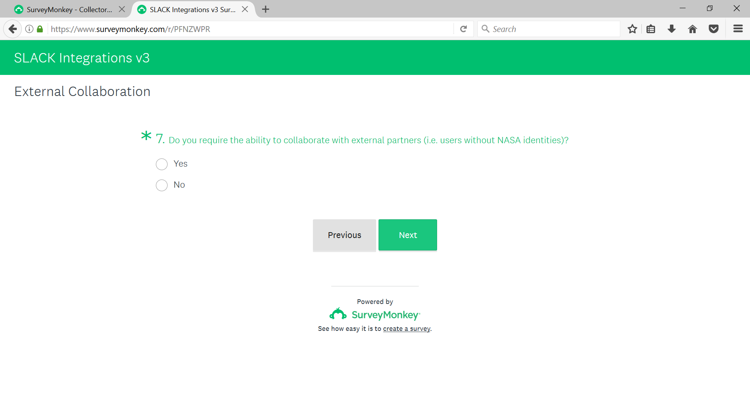

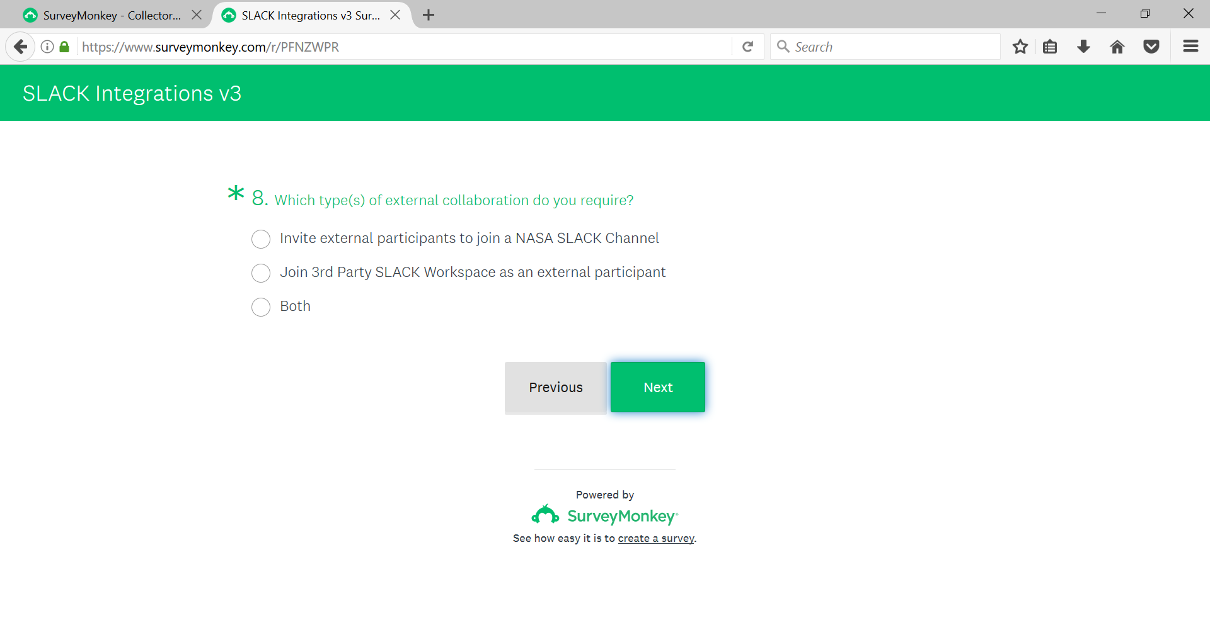

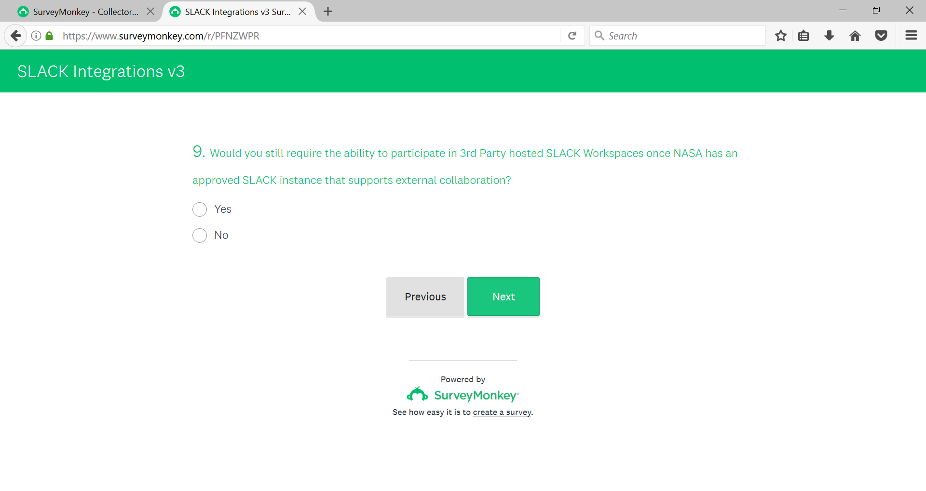

The answer to question 10 will determine whether the next page is relevant. If the answer is ‘yes’, then the following page with question 11 (screenshots below) will be displayed. If the answer is ‘no’ then question 12 will be displayed.

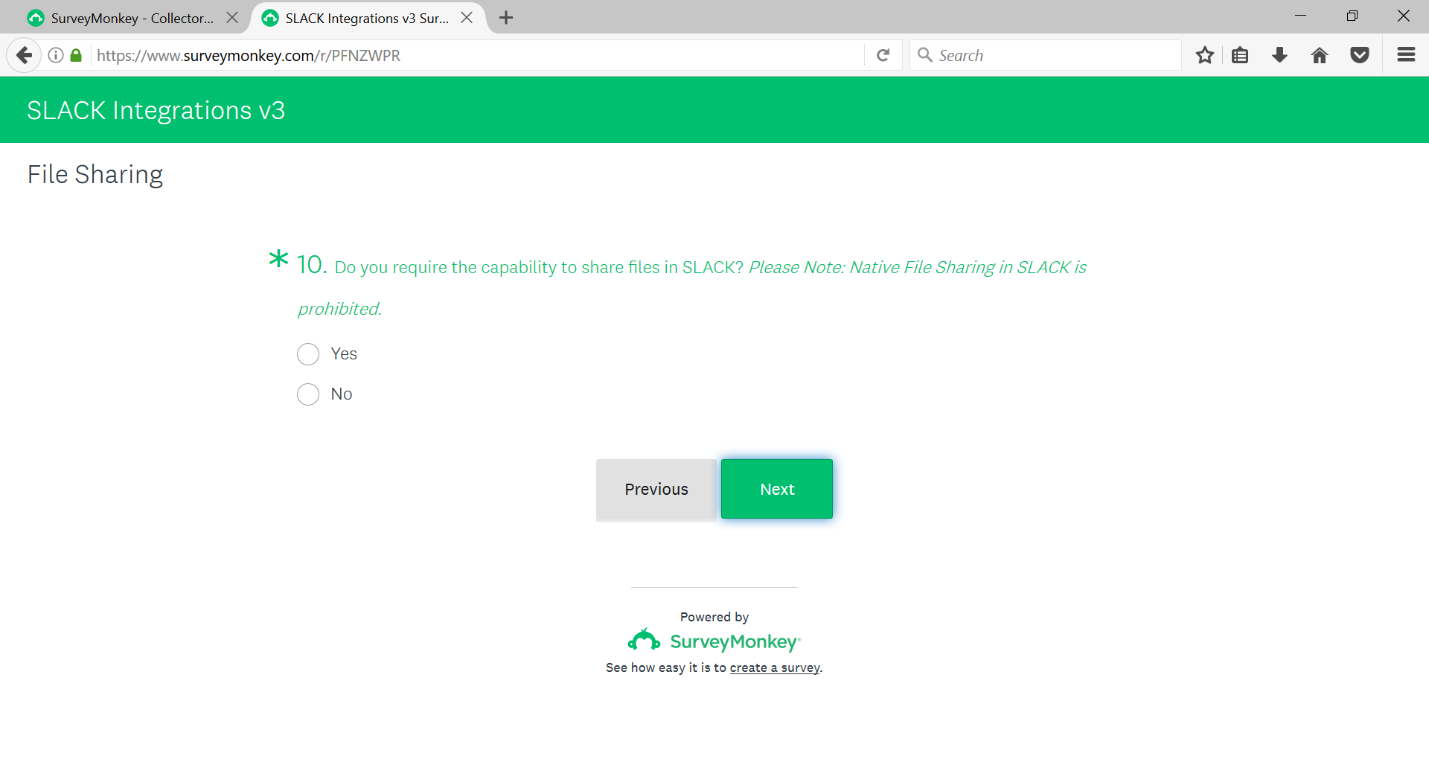

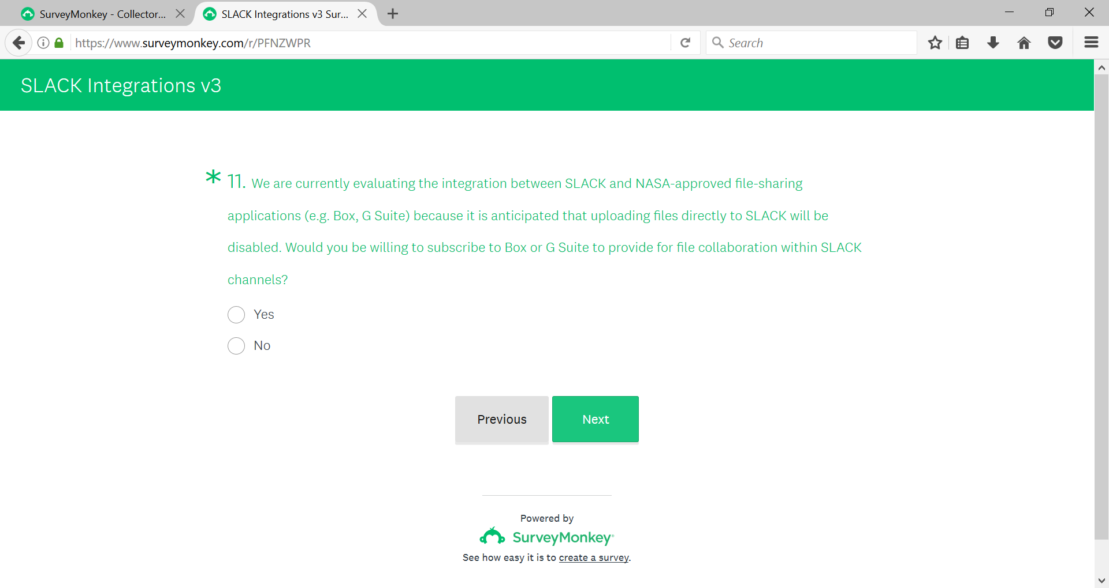

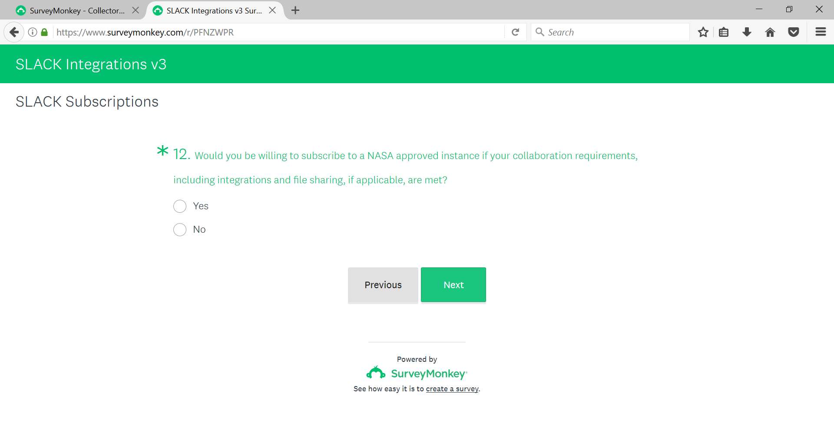

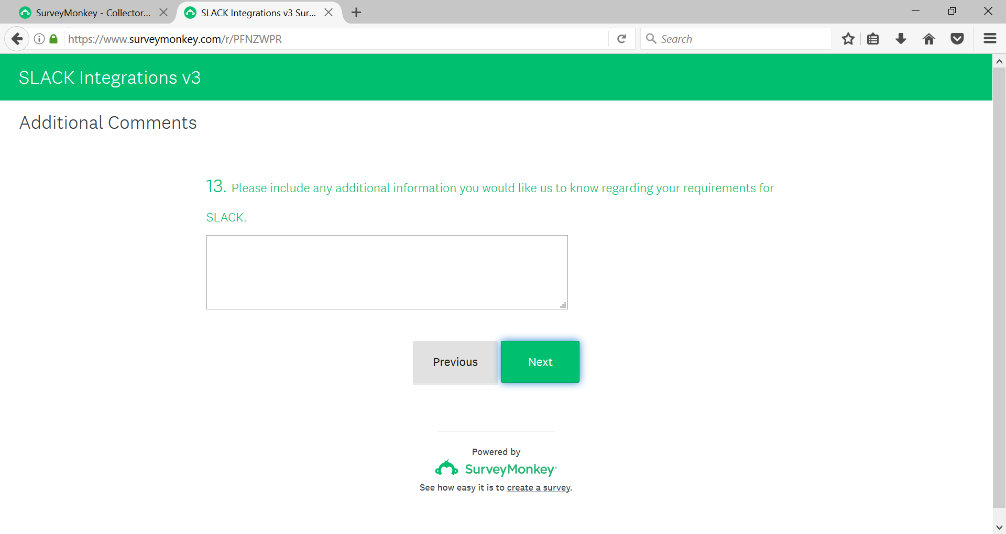

The answer to question 14 will determine whether the next page is relevant. If the answer is ‘yes’, then page 15 will be displayed. If the answer is ‘no’ then the survey will end.

