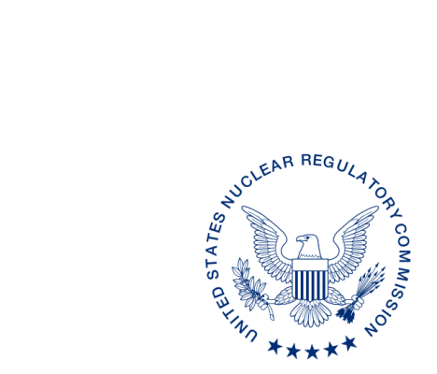
UNITED STATES
NUCLEAR REGULATORY COMMISSION
WASHINGTON, D.C. 20555-0001

August XX, 2018

ALL AGREEMENT AND NON-AGREEMENT STATES
STATE LIAISON OFFICERS

OPPORTUNITY TO REVIEW AND COMMENT ON INTERNATIONAL ATOMIC ENERGY AGENCY (IAEA) DRAFT SAFETY GUIDE DS469, “PREPAREDNESS AND RESPONSE FOR AN EMERGENCY DURING THE TRANSPORT OF RADIOACTIVE MATERIAL” (STC-18-0XX)

Purpose: To provide States with the opportunity to review and comment on the Draft Safety Guide DS469, “Preparedness and Response for an Emergency During the Transport of Radioactive Material” by October 31, 2018, to the contact listed.

Background: The International Atomic Energy Agency (IAEA) has made available the Draft Safety Guide DS469, “Preparedness and Response for an Emergency During the Transport of Radioactive Material” for Member State review and comment. Proposed changes from Member State review will be taken into account in the finalization of the safety standard. The objective of Draft Safety Guide DS469 is to provide guidance on preparedness and response for a nuclear or radiological emergency during the transport of radioactive material. It is intended to be used by emergency planners and response organizations, including regulatory bodies, national authorities, civil defense/civil protection/emergency management agencies, emergency responders, consignors, carriers, consignees, and others who are responsible for developing and implementing emergency preparedness and response arrangements.

Discussion: The U.S. Nuclear Regulatory Commission (NRC) is coordinating the U.S. review of this safety guide. Consolidated comments will be submitted to the IAEA by the NRC through established official channels. Please provide your comments to Doris Lewis (Doris.Lewis@nrc.gov) by October 31, 2018. The attached IAEA comment template is provided for your use. Any comments provided should refer to the relevant paragraph number in the draft text being reviewed and should propose alternative text, as appropriate.

The review should focus on the following:
1) Are there any safety issues that may be inconsistent with States’ regulations or common practices?
2) Relevance and usefulness of this document — Are the stated objectives appropriate, and are they met by the draft text? Do you have any suggestions to include in the document?
3) Scope and completeness — Is the stated scope appropriate and is it adequately covered by the draft text?
4) Quality and clarity — Does the guidance in the document represent the current consensus among specialists in the field, and are they expressed clearly and coherently?

Comments of an editorial nature will be considered; however, it should be noted that the draft text will be comprehensively edited by the IAEA Secretariat.

Enclosed is: (1) communication from the IAEA concerning Draft Safety Guide DS469 and its review, including an “Explanatory Note” regarding this document; (2) Draft Safety Guide DS469, “Remediation Process for Areas Affected by Past Activities and Accidents;” and (3) blank template for comment preparation.

If you have any questions regarding this communication, please contact the individual named below:

POINT OF CONTACT: Doris Lewis E-MAIL: Doris.Lewis@nrc.gov
TELEPHONE: (301) 287-3794

Daniel S. Collins, Director
Division of Material Safety, State, Tribal
and Rulemaking Programs
Office of Nuclear Material Safety
and Safeguards

Enclosures:
1. Explanatory Note from IAEA
2. Draft Safety Guide DS469
3. IAEA Comment Template

This information request has been approved by OMB under clearance numbers 3150-0029, expiration 01/31/2018 and 3150-0200, 10/31/2018. The estimated burden per response to comply with this voluntary collection is approximately 16 hours. Send comments regarding the burden estimate to the Information Services Branch, U.S. Nuclear Regulatory Commission, Washington, DC 20555-0001, or by e-mail to infocollects.resource@nrc.gov, and to the Desk Officer, Office of Information and Regulatory Affairs, NEOB-10202 (3150-0029 and 3150-0200), Office of Management and Budget, Washington, DC 20503. If a means used to impose an information collection does not display a currently valid OMB control number, the NRC may not conduct or sponsor, and a person is not required to respond to, the information collection.

