Survey Instrument – Assistance Reporting Tool (ART) Screenshots

Header (appears on every tab)
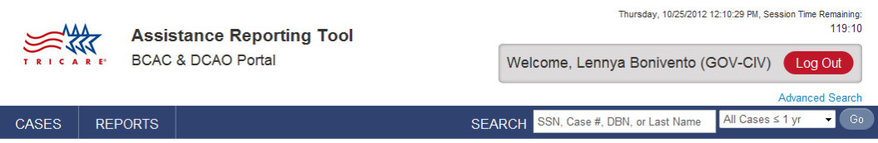

Footer (appears on every tab)
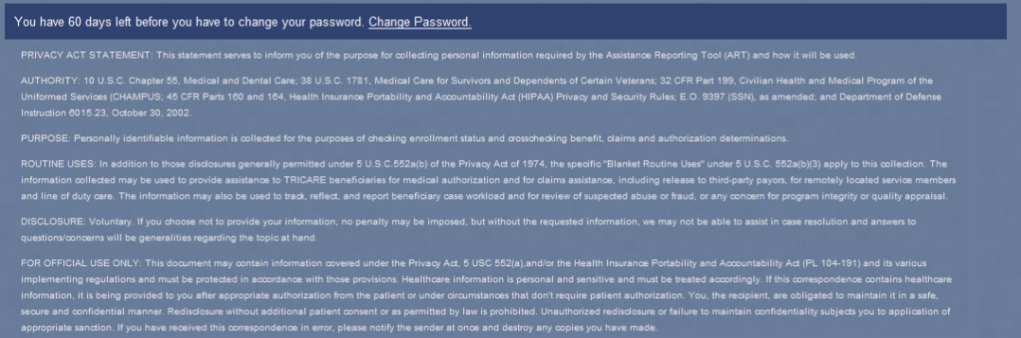

Basic Information Tab
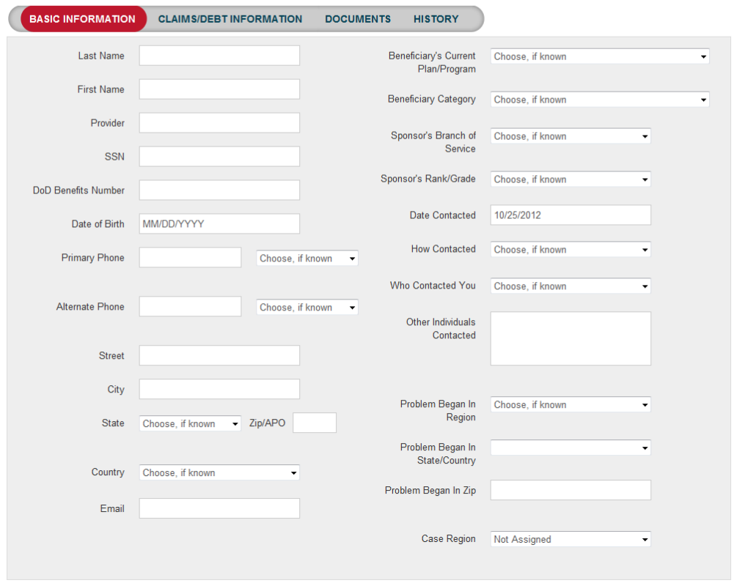
Claims/Debt Information Tab
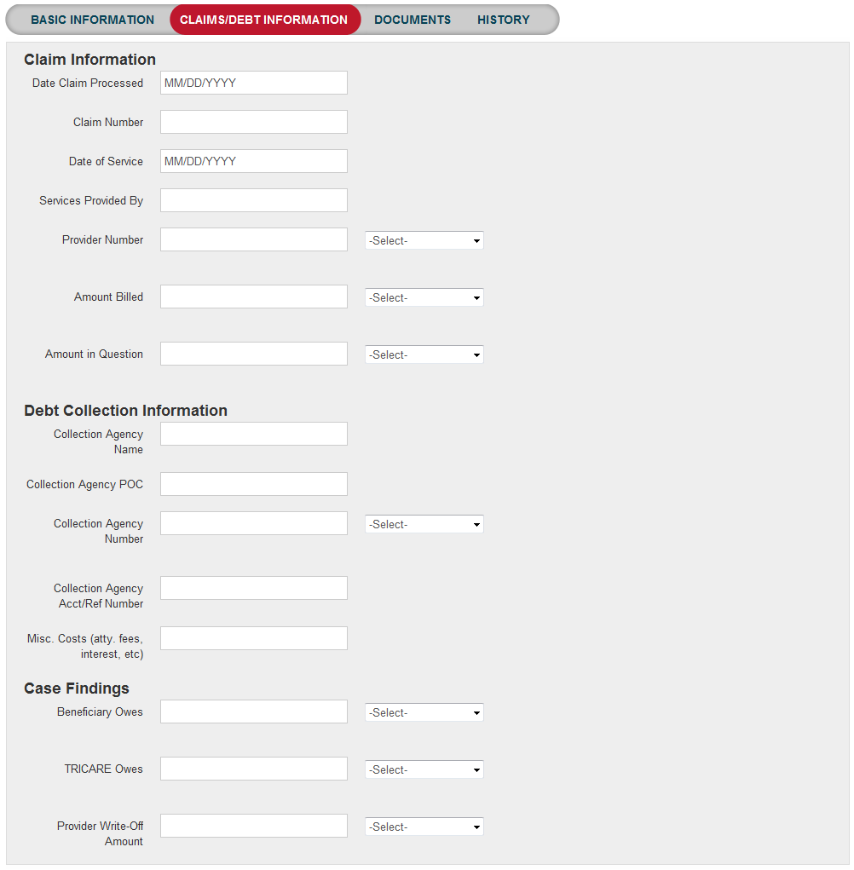

Documents Tab
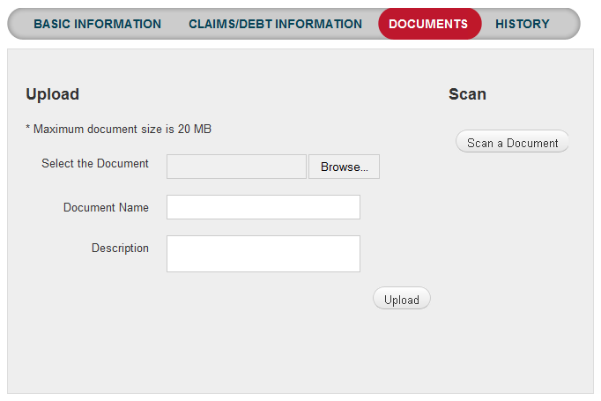
Pre-authorization Tab
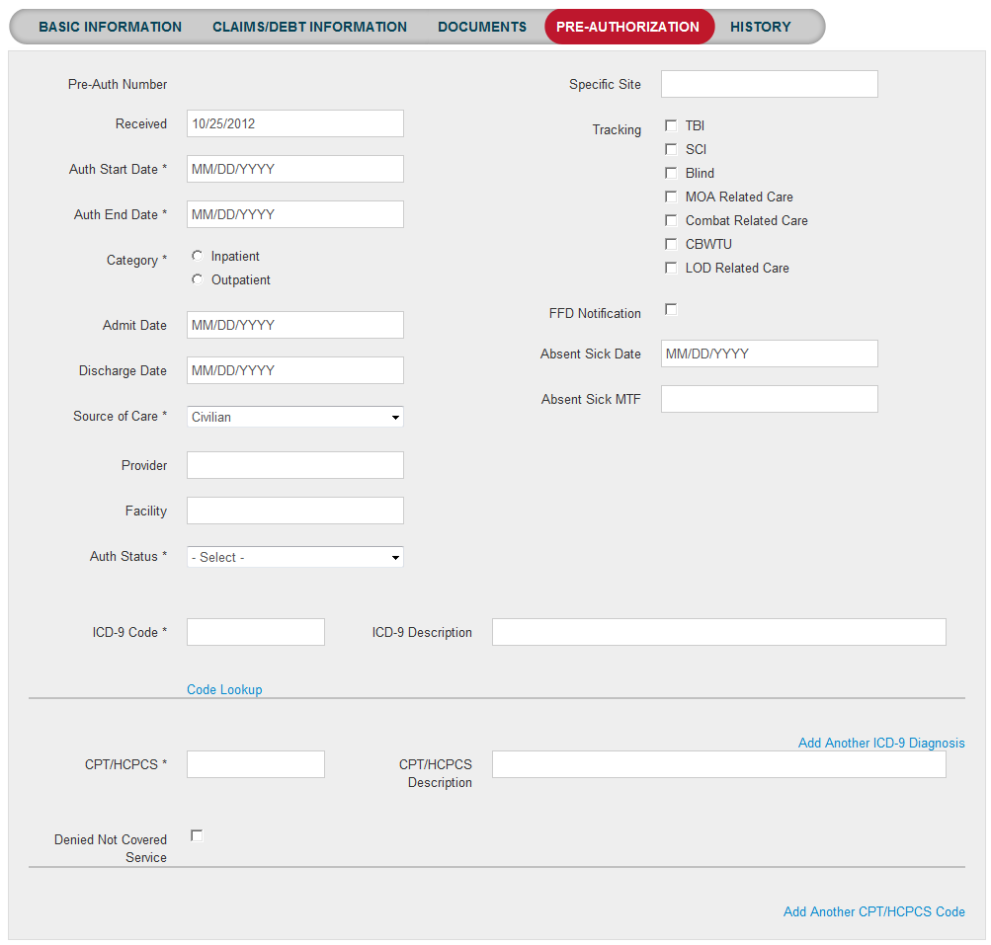
Fitness for Duty Tab
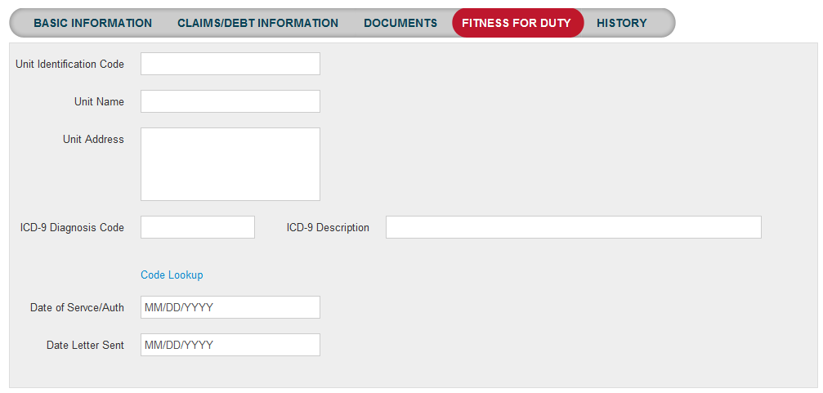

Line of Duty Tab
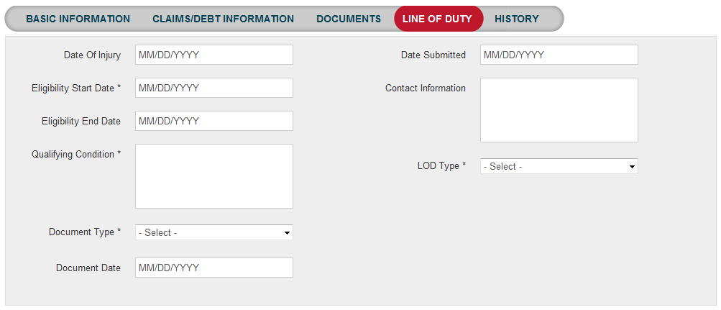

Transitional Care for Service-related Conditions (1637) Tab 