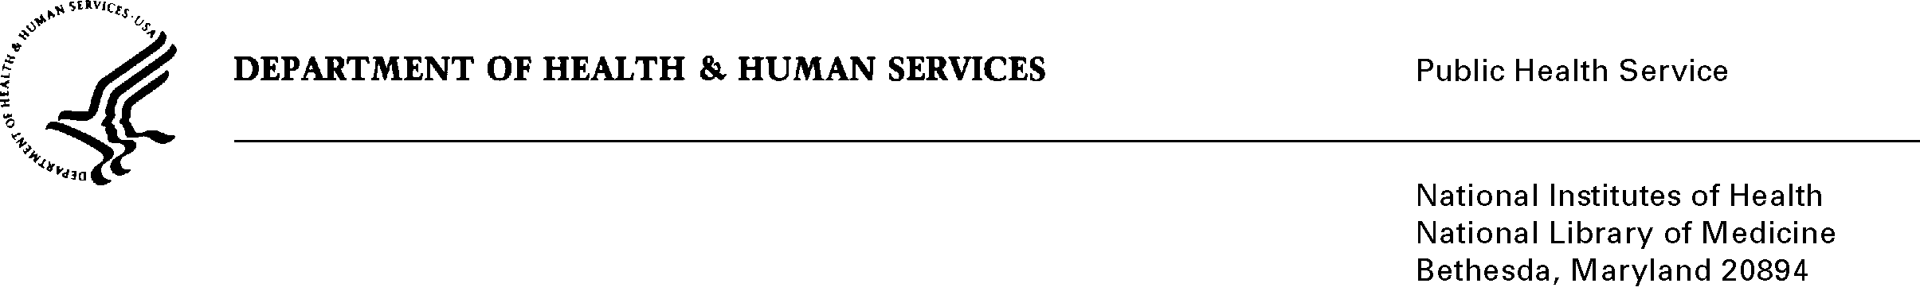

Date: September 22, 2014

To: Office of Management and Budget (OMB)

Through: Darius Taylor, Report Clearance Officer, HHS

Seleda Perryman, Project Clearance Officer, NIH

From: David Sharlip, Project Clearance Liaison, NLM

Subject: Nonmaterial/Non-substantive change request for NLM Generic Clearance to Conduct Voluntary Customer/Partner Surveys

(OMB Control #0925-0476, Expiration Date: 07/15/2015)

This is a request for OMB to approve a Nonmaterial/Non-substantive change request for the National Library of Medicine (NLM) “**Generic Clearance to Conduct Voluntary Customer/Partner Surveys**”.

In submitting this request, NLM is seeking OMB approval to expand the current scope of the existing generic clearance to allow for the public collection of information from respondents consisting primarily of students who may be advancing their education in a health-related field.

As part of NLM’s mission to provide ongoing outreach programs in collaboration with our customers and partners, distance education learning has been developed for school students interested in careers in healthcare professions. The programs use synchronous, interactive online videoconferencing technology to reach special populations and expose then to a range of health professionals with similar backgrounds who discuss their specialties and careers.

NLM has managed the distance learning program for over a decade with the objectives of increasing minority high school students’ interest in a range of health careers and their understanding of health science subjects and resources. The program exposes students to range of health professionals, not just physicians and nurses, who come from a variety of ethnicities and backgrounds, including those of the students. Health professionals discuss the problems they solve and, when relevant, their research interests, while also explaining why they chose their careers. Information resources relevant to health careers and health concepts and issues are discussed within these contexts.

To better assess the effectiveness and customer/partner satisfaction in administering our distance education outreach engagements, NLM would collect baseline career information from students during the course of their education mentoring programs. These measures or survey instruments will typically be student career essays, a health career knowledge-interest inventory, and general career inventories.

At this time, studies have provided little evidence for the actual impact on students’ career choices or post high school education choices to train for careers. NLM will use these student career assessment information collections to further explore state-of-the art technologies and methodologies for providing real time “hands on” assistance to learners at a distance when they practice using complex online biotechnology tools.

The enclosed Supporting Statement (A) has been modified to expand the scope of NLM’s existing generic clearance to encompass the purpose and intended use of these additional information collections. Upon OMB’s further consideration in approving this Nonmaterial/Non-substantive change request, NLM will be able to greatly enhance our stakeholder’s satisfaction for these important distance education learning programs which play an integral part in fulfilling our healthcare outreach mission objectives.

**Enclosure**: Supporting Statement A_NLM Generic_Rev Sept 2014