xTRACT Home Page
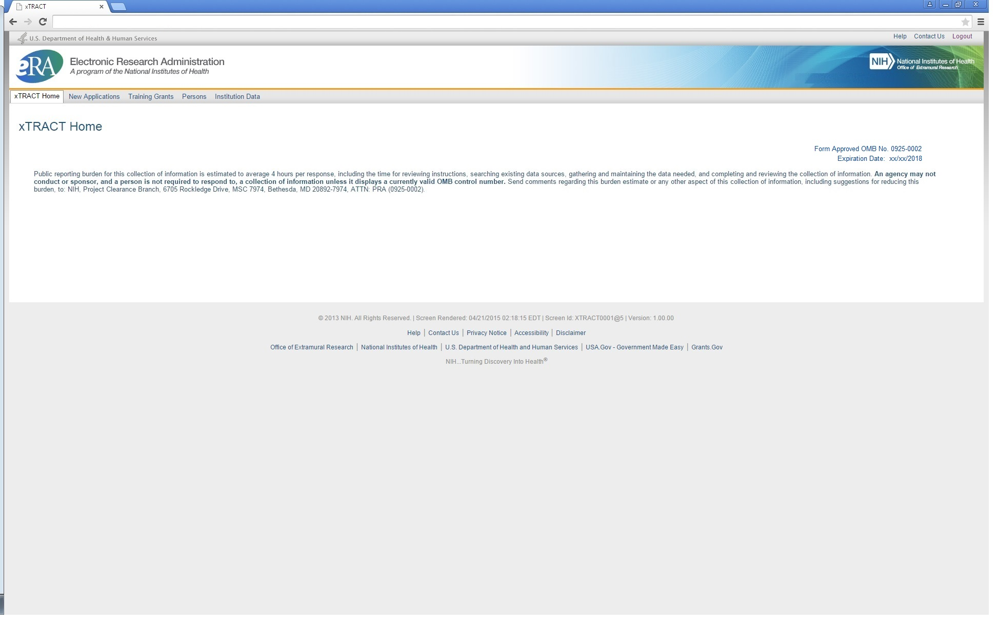

SCREENS FOR PREPARING NEW APPLICATIONS

The following pages present the screens used to create/maintain Research Training Data Sets for use in New Applications. Since many of these screens are identical to the screens for preparing renewal applications, only those which are unique to New Applications will be shown here. Any menu options which are identical to renewal options (and therefore presented in the renewal section of this document) will be so noted.

New Applications Main Screen

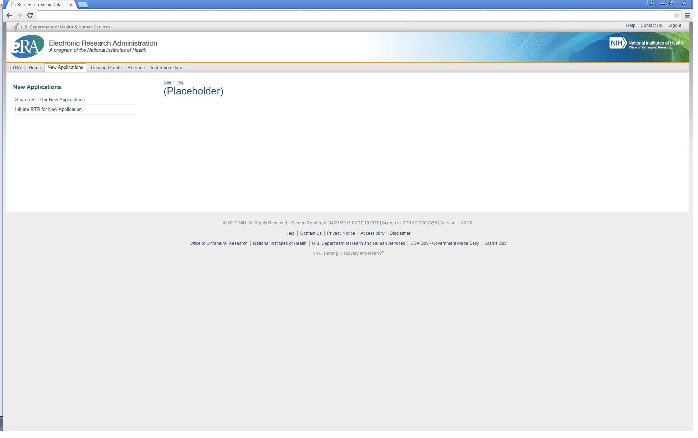

Search for any New Application Research Training Datasets (RTDs) that have already been created and saved

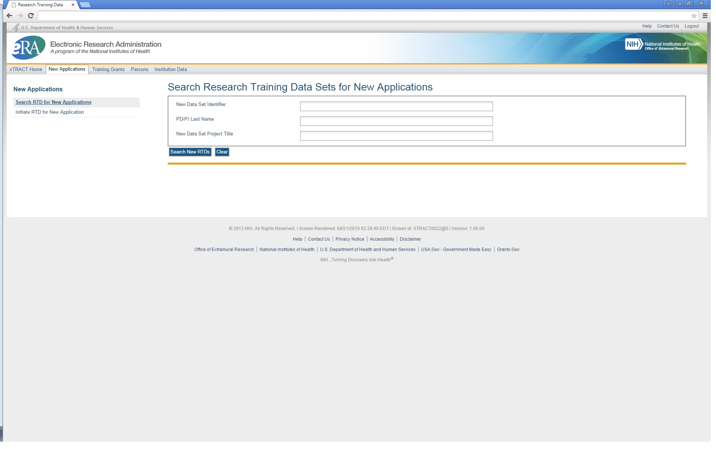

Results of a search for New Application RTDs

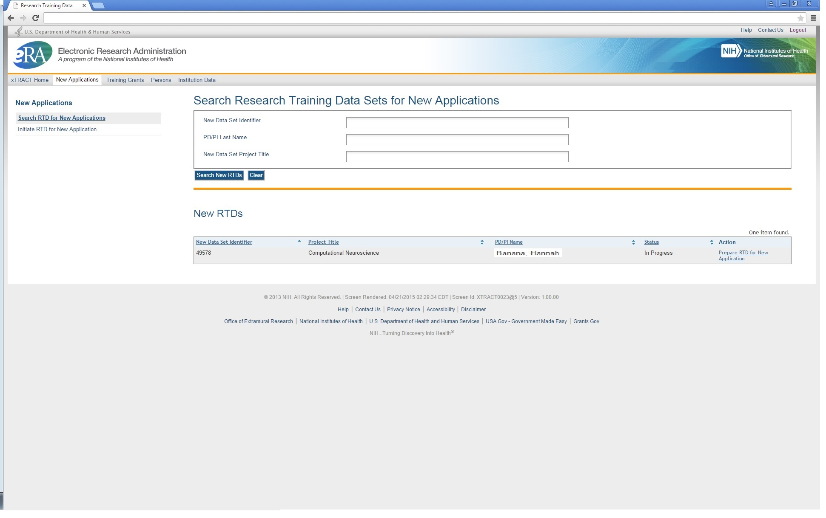

Initiating an RTD for a New Application

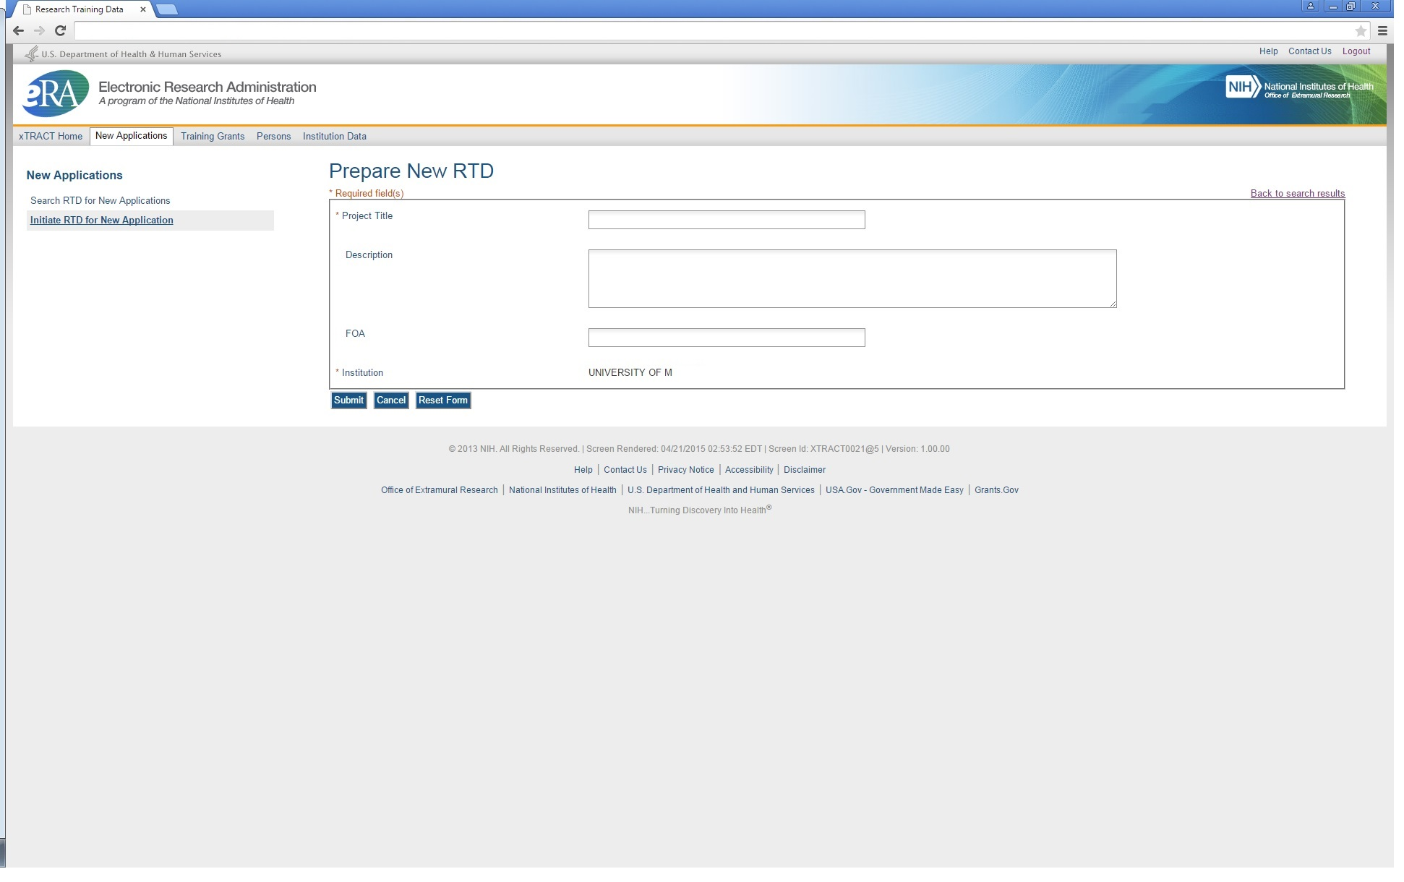
Initiate RTD for a New Application (showing sample data), after saving
Note that “Description” block is optional and that the text for this is provided for the user’s convenience, so that a meaningful description of the RTD’s purpose can be retained. This description is purely for use within xTRACT and is not part of the data submitted with the training grant application.
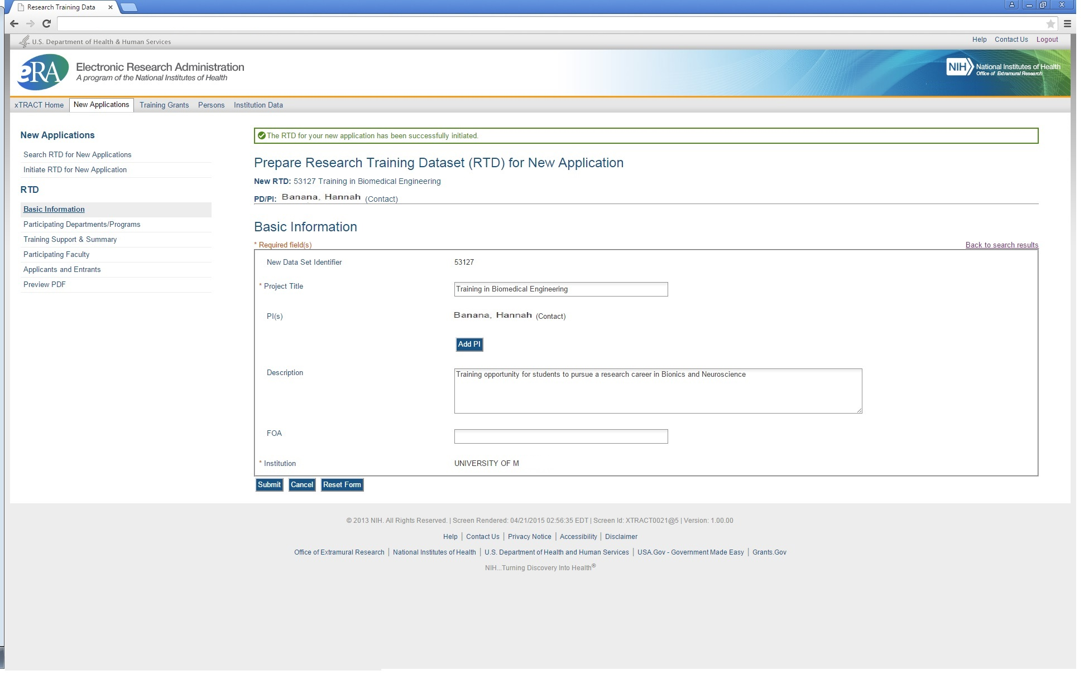
Search to add Principal Investigators (PIs) to the RTD

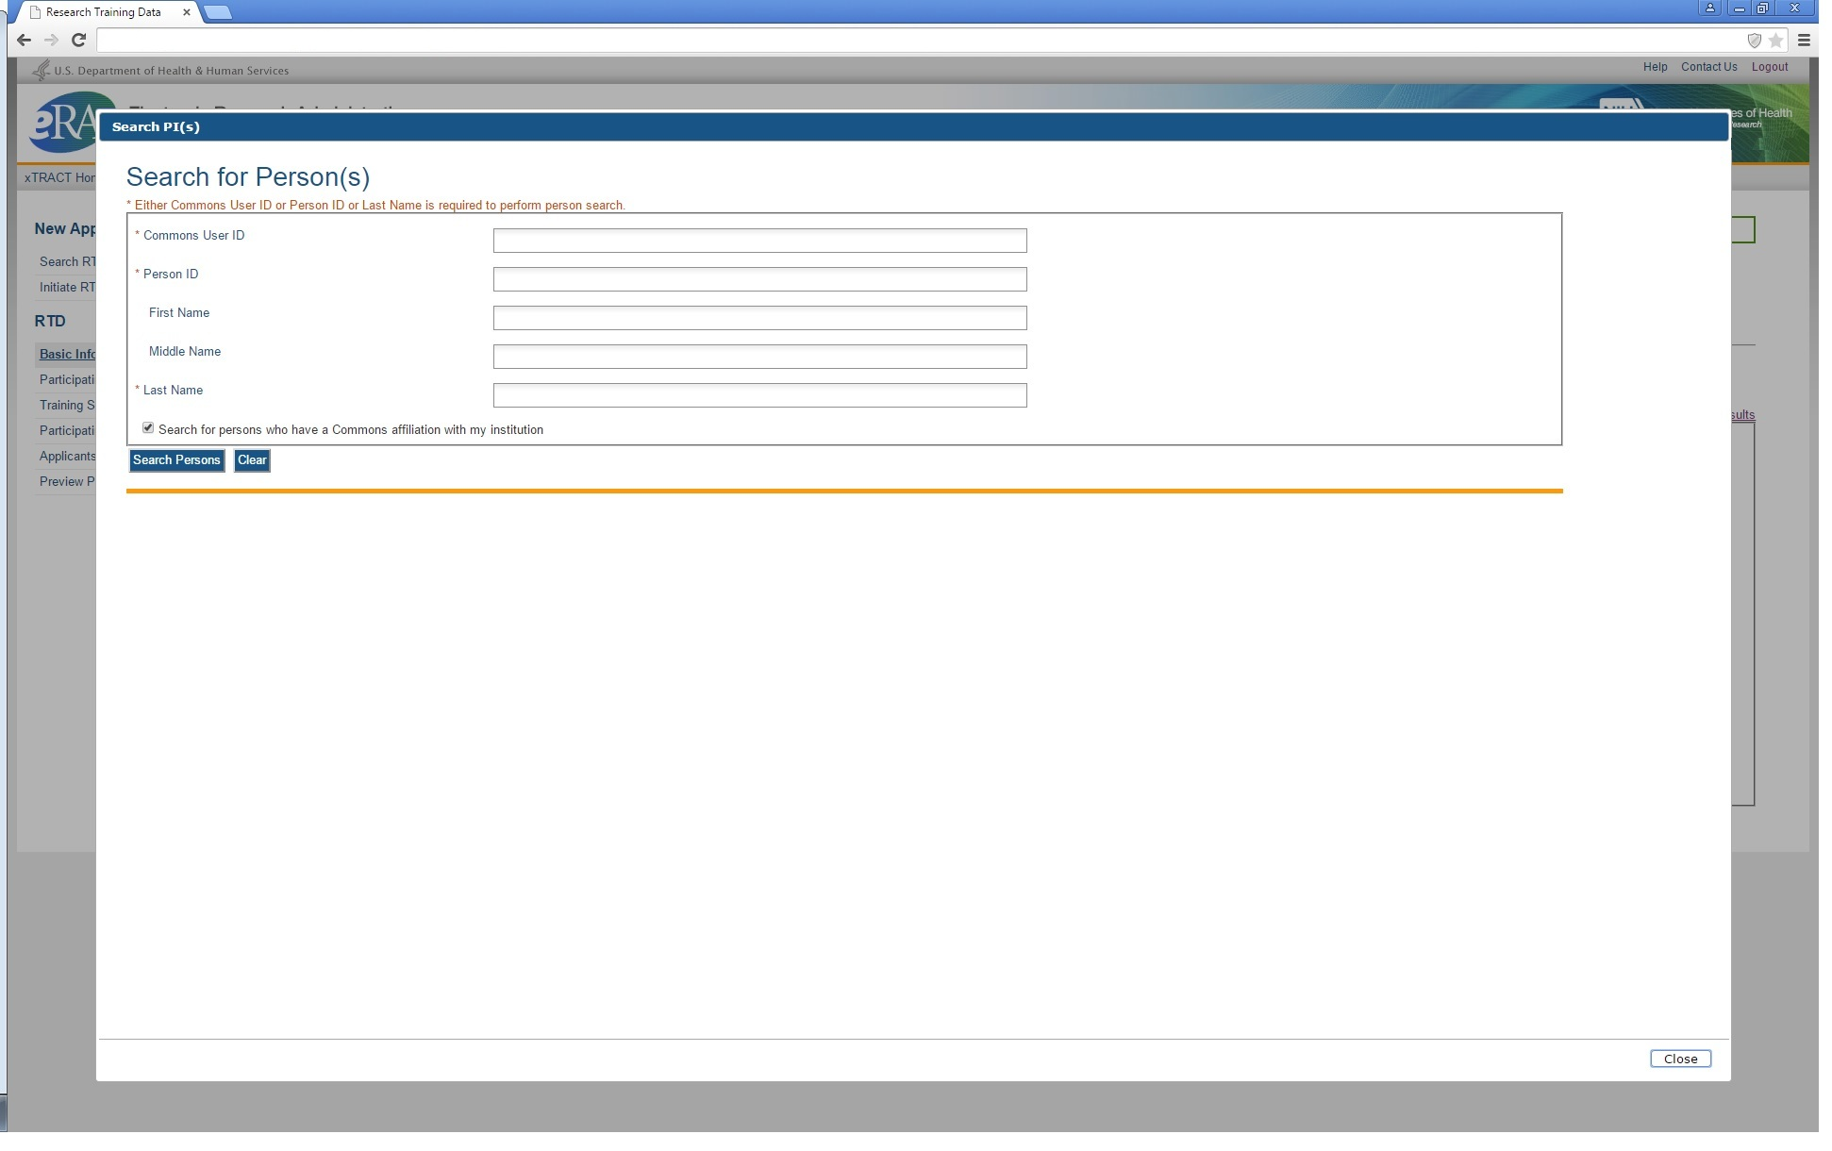
Additional PI successfully searched, selected and added

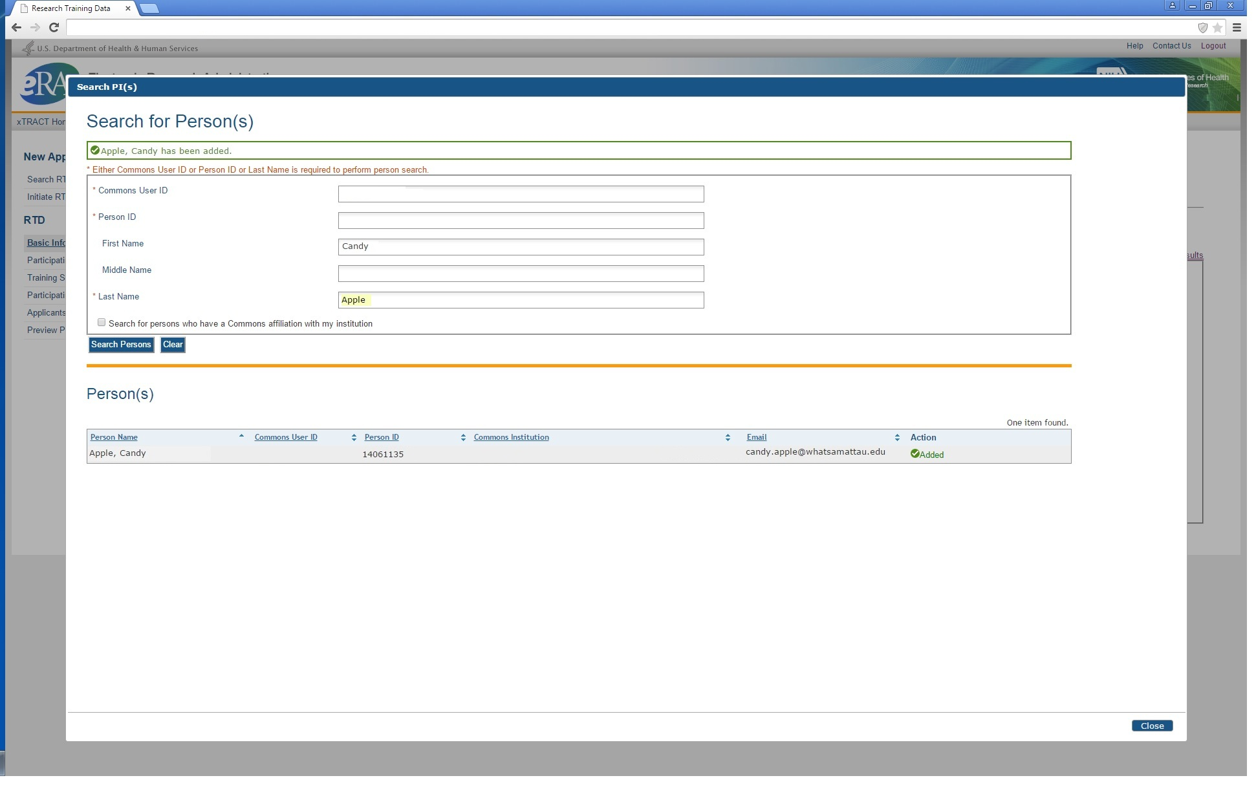
Return to New Application RTD Basic Information, after PI has been added

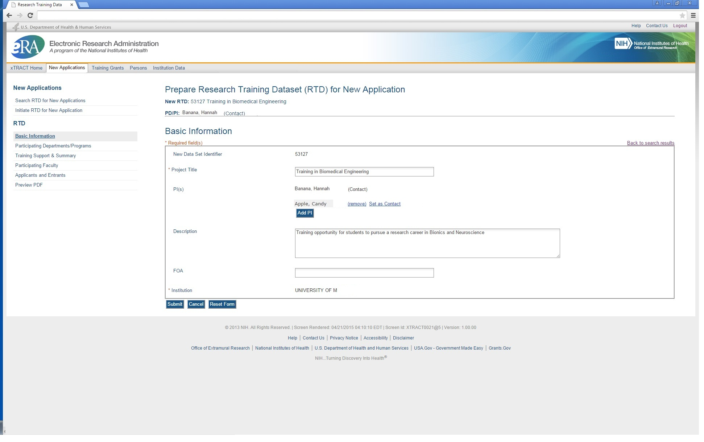
The remaining menu options for New Application RTDs take the user to screens which are identical to those for Renewal RTDs (these menu options are circled below).

SCREENS FOR PREPARING RENEWAL APPLICATIONS

The following pages present the screens used to create/maintain Research Training Data Sets (RTDs) for use in Renewal Applications. Note that the preceding section (New Application RTDs) refers to the applicable screen shots in this (Renewal) section. For any of the following screens to which this applies, if there are any significant variations based on context (New application vs. Renewal) these variations shall be noted.

Search for Training Grants
Preparation of an RTD for a Renewal Application begins with a search for existing training grants which have been awarded to the user’s institution. The screen below is used to find eligible grants for renewal, whereby the desired grant may then be selected.

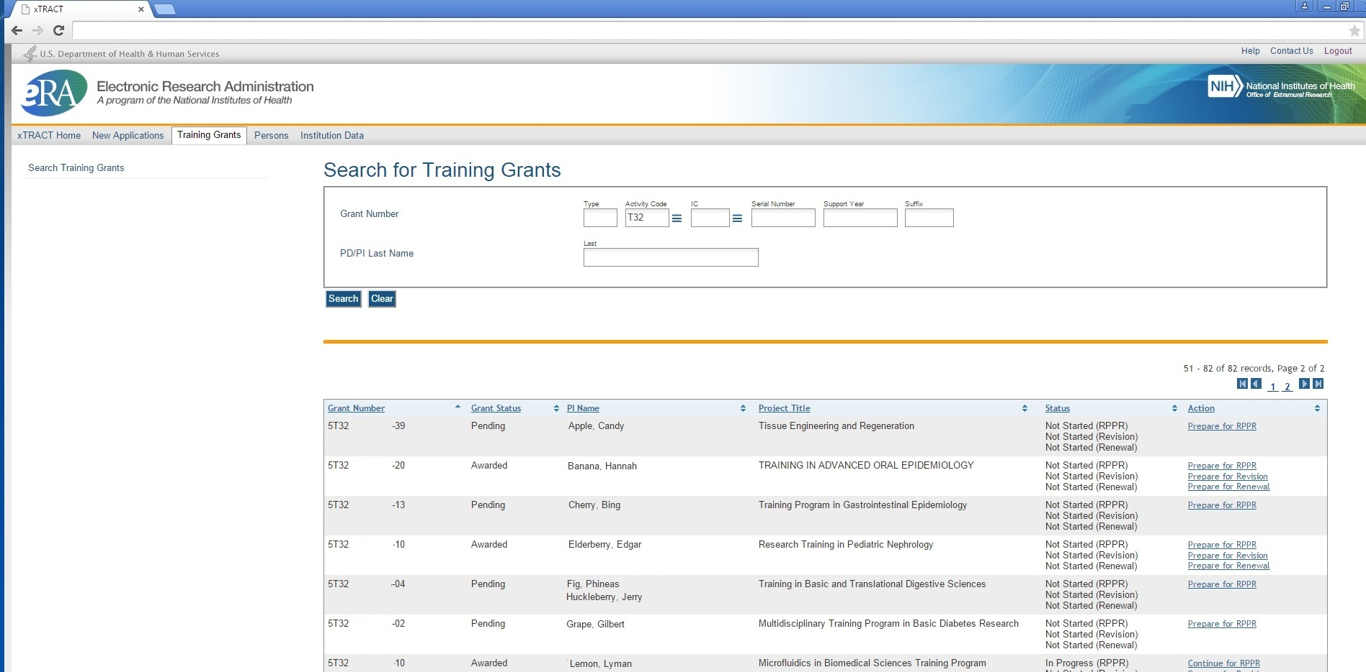

Prepare RTD For Renewal (main screen)

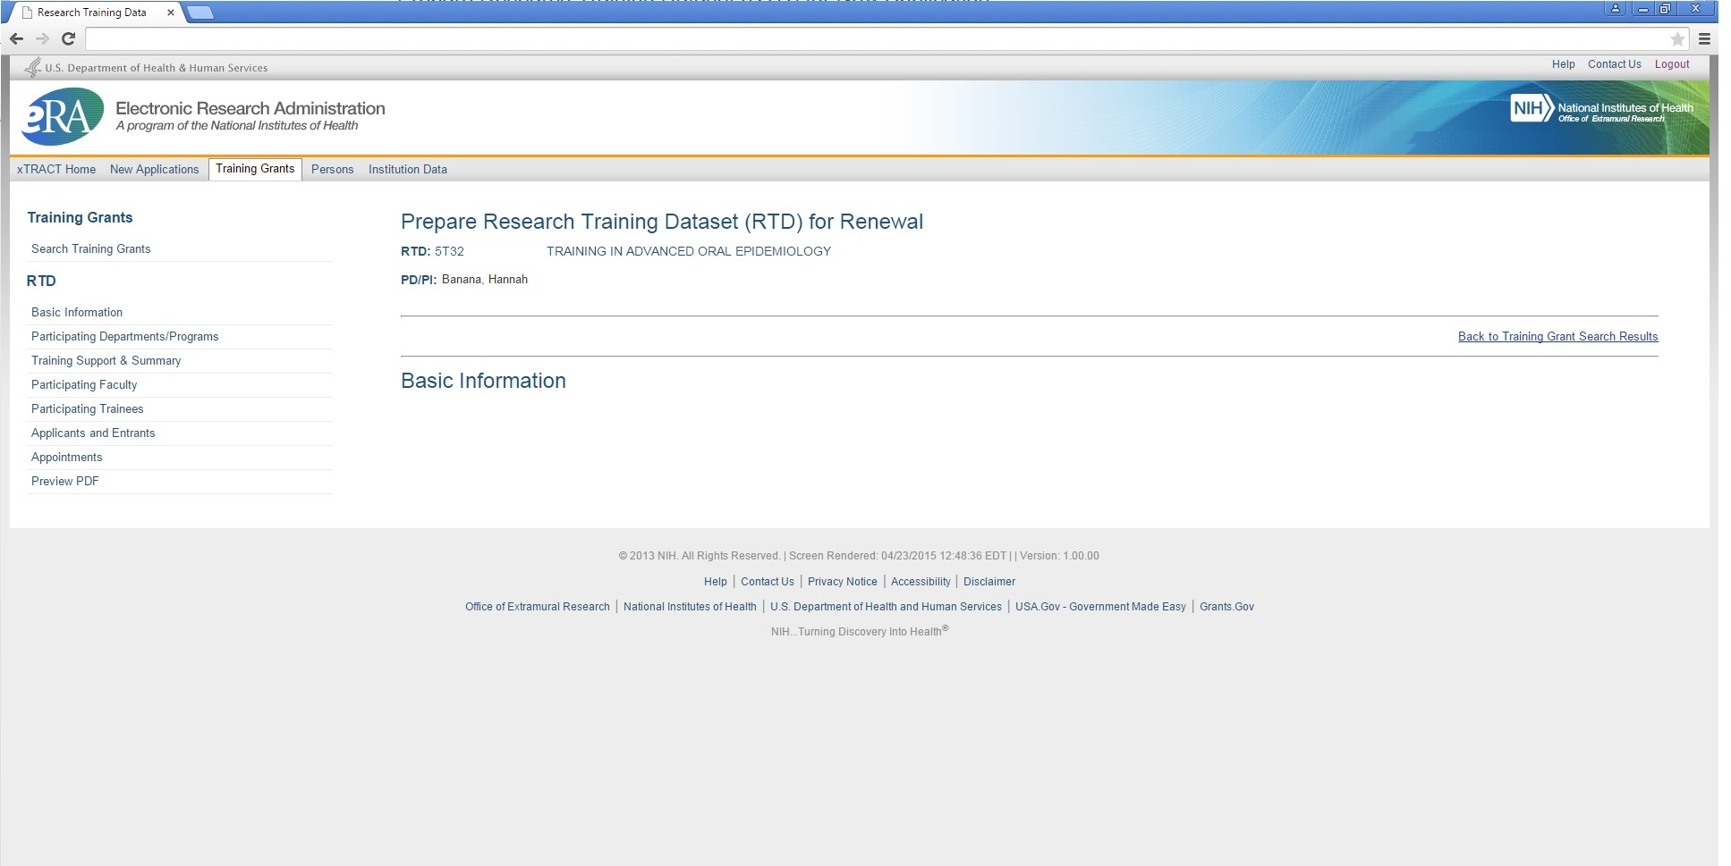
Participating Departments and Programs

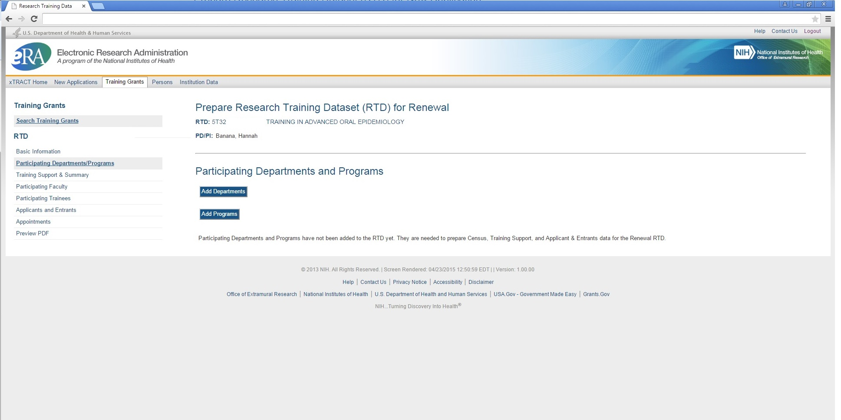
Participating Departments and Programs – Search to Add Department

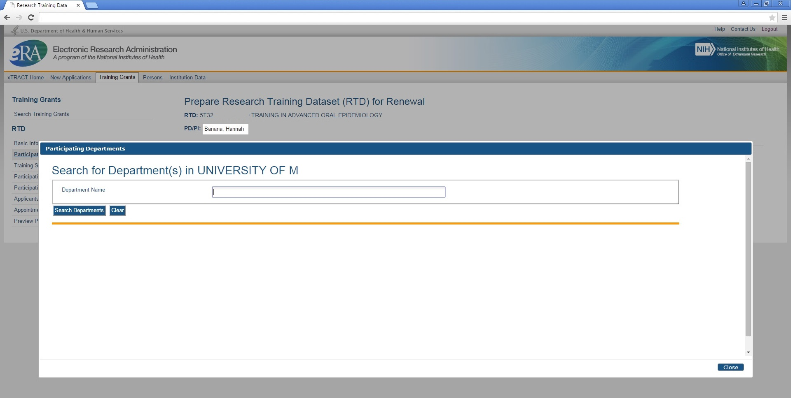

Participating Departments and Programs – Search Results, to Add Department

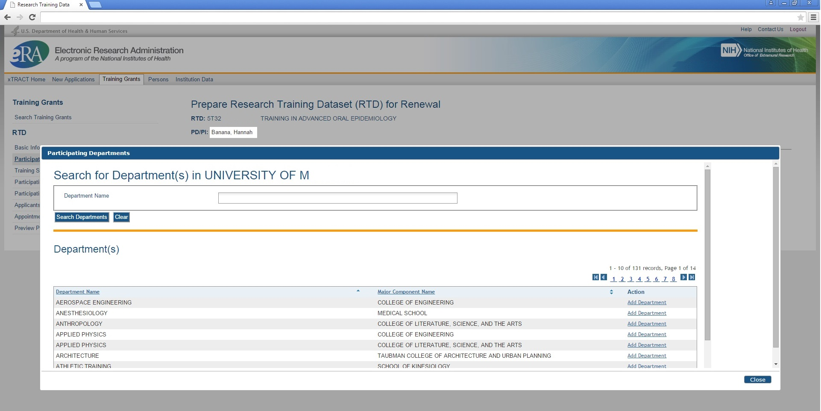
Participating Departments and Programs – Departments Selected and Added

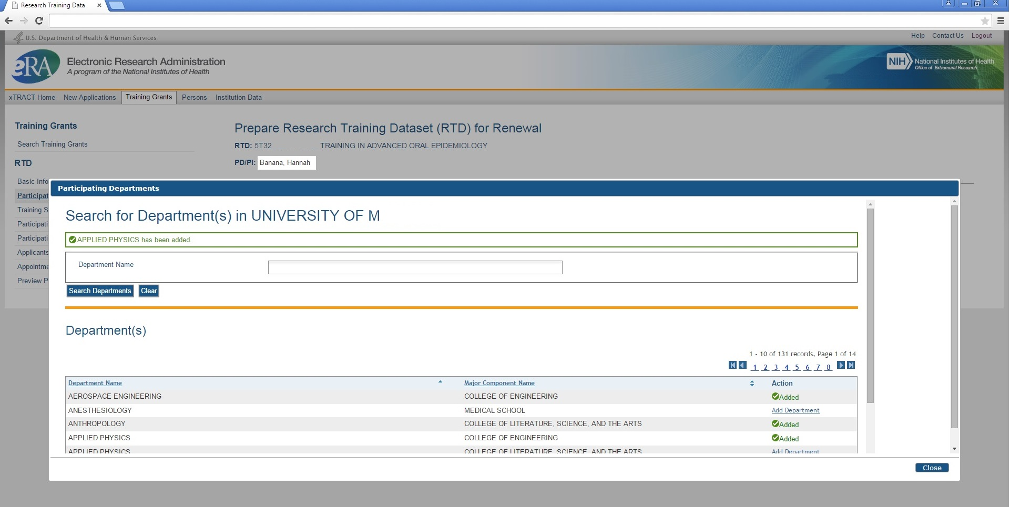
Participating Departments and Programs – Screen refreshed with added Departments

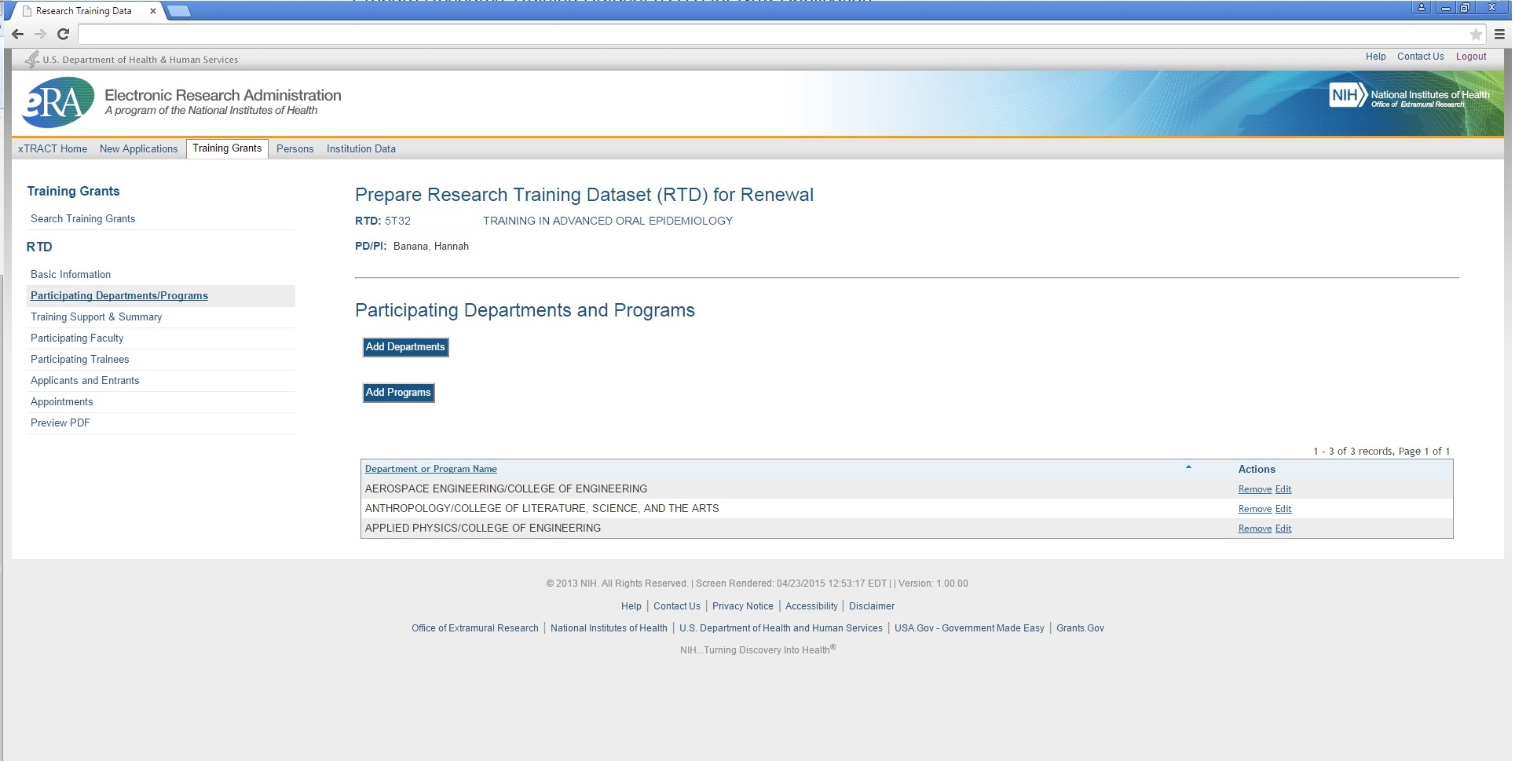
Participating Departments and Programs – Search to Add Program

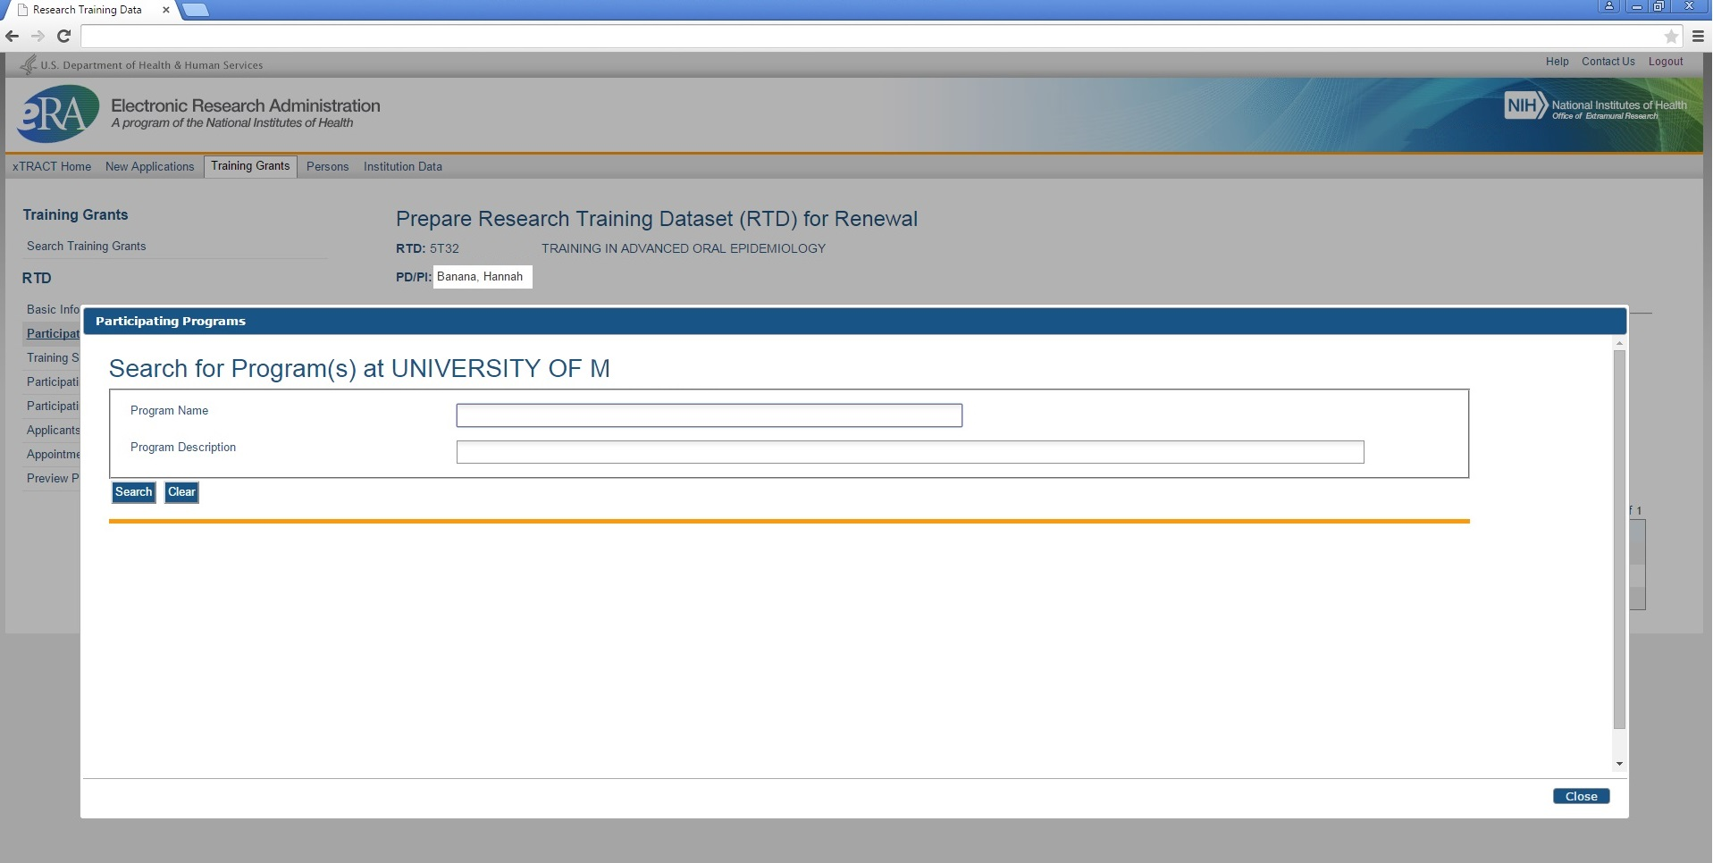
Participating Departments and Programs – Search Results, to Add Department

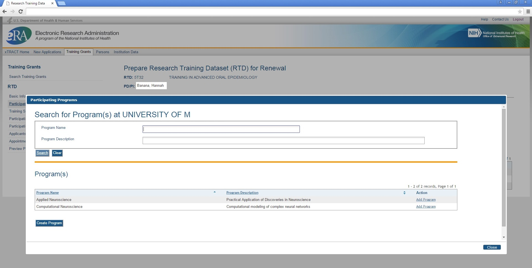
Participating Departments and Programs – Programs Selected and Added

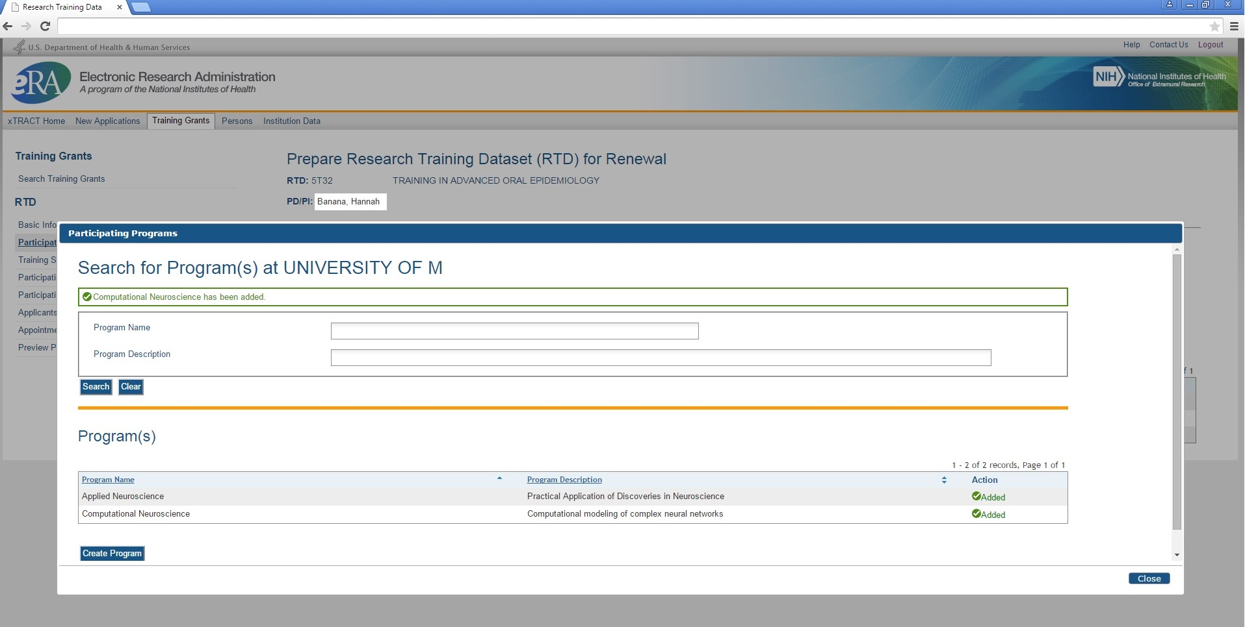

Participating Departments and Programs – Screen refreshed with added Programs

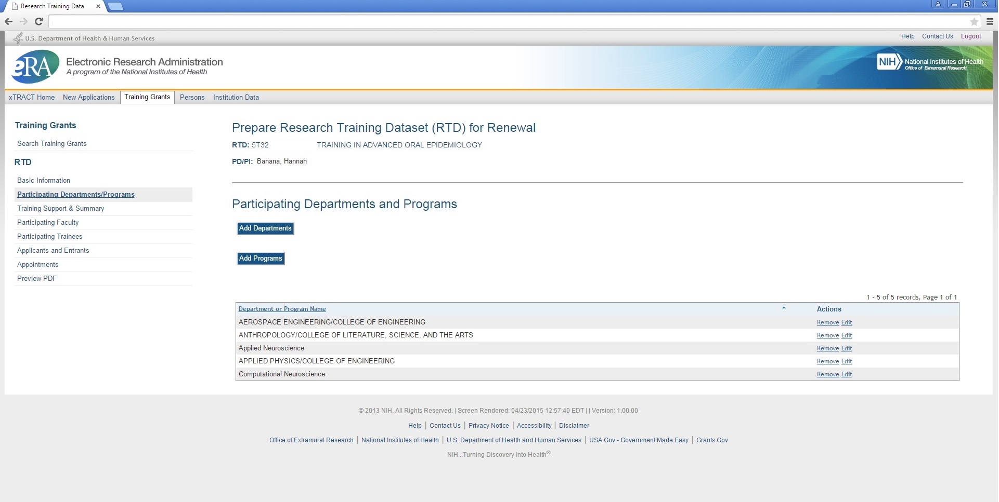
Training Support and Summary

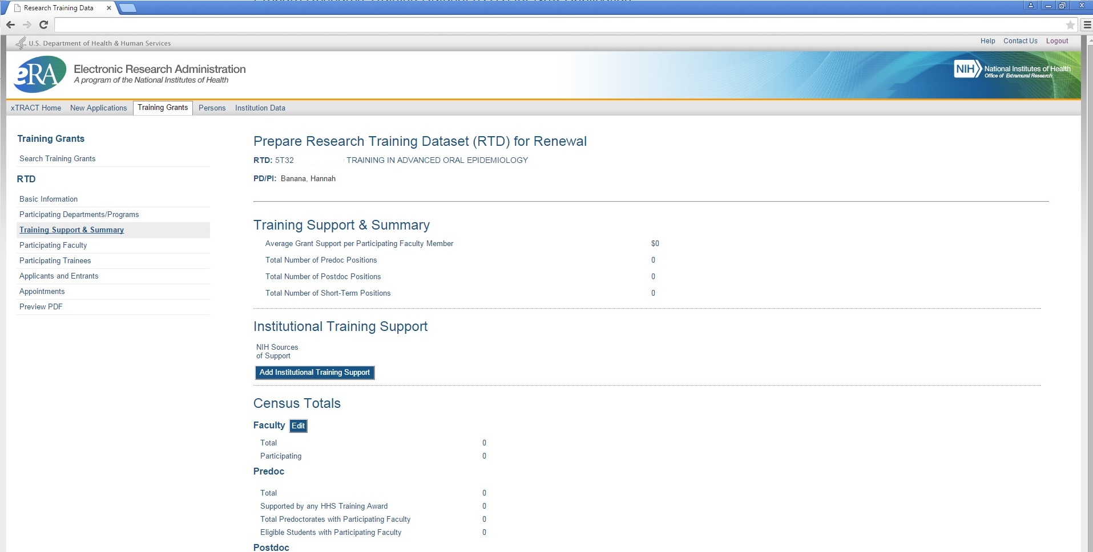
Training Support and Summary, Search to Add Institutional Training Support

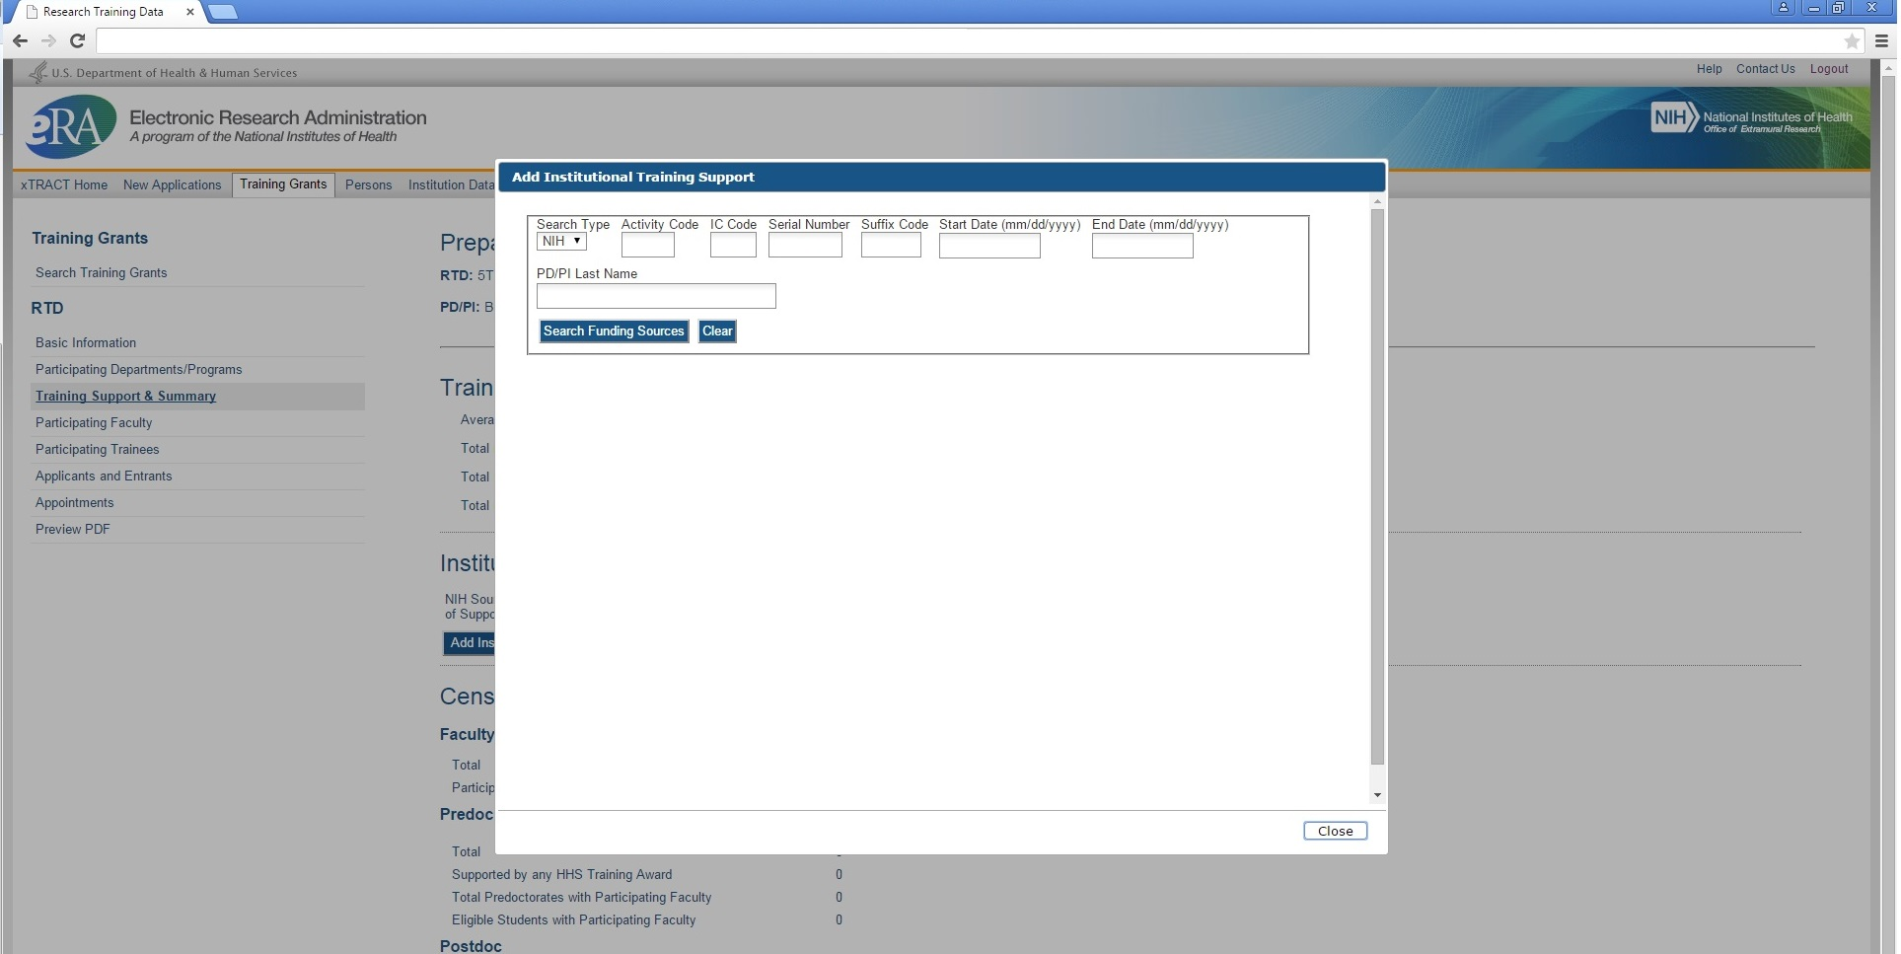
Training Support and Summary, Search Results to Add Institutional Training Support

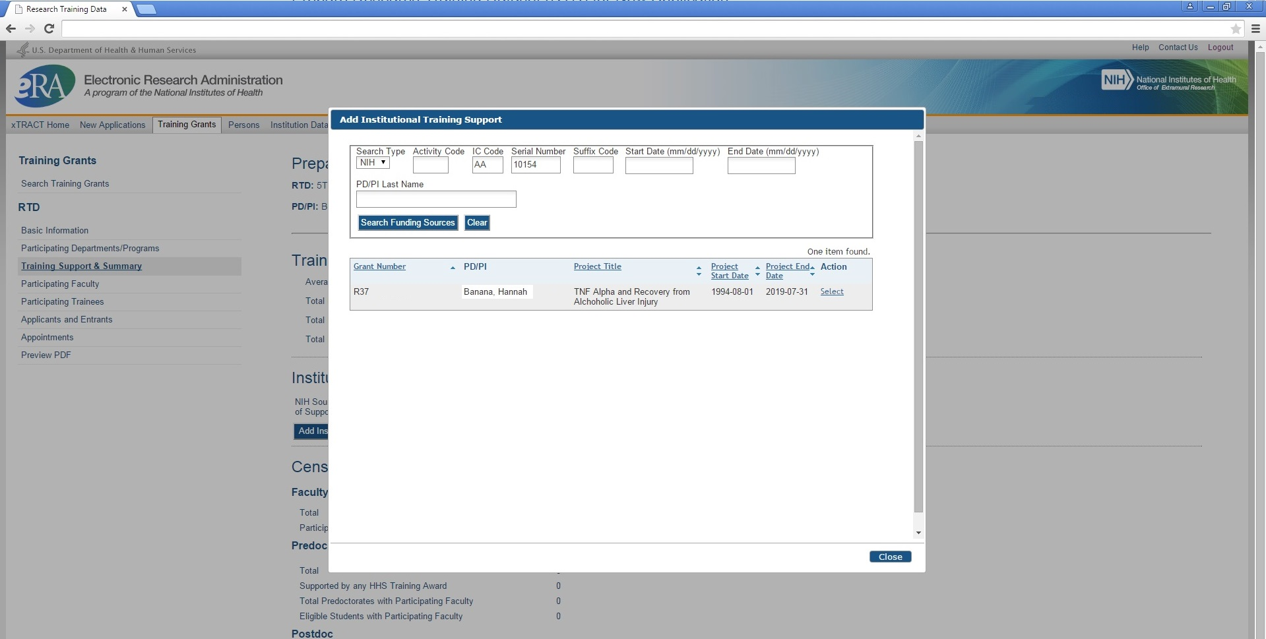
Training Support and Summary, Institutional Training Support Added

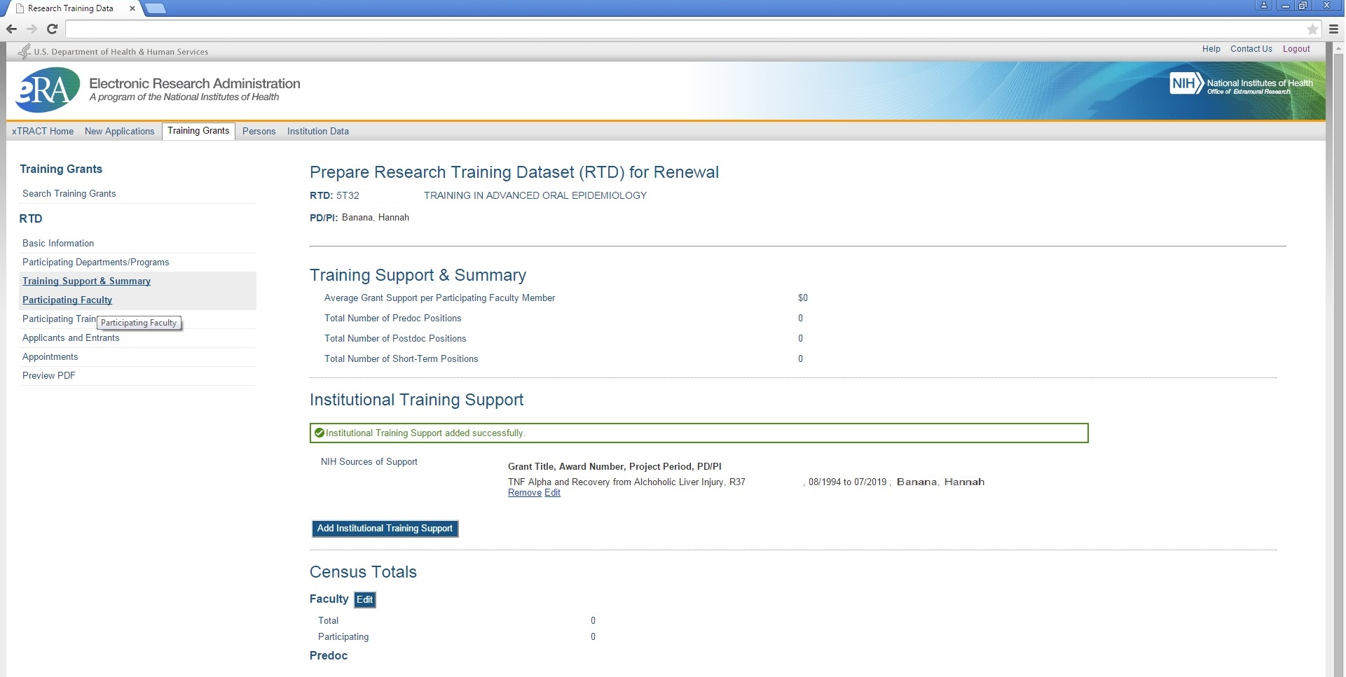
Training Support and Summary, Edit Faculty Census

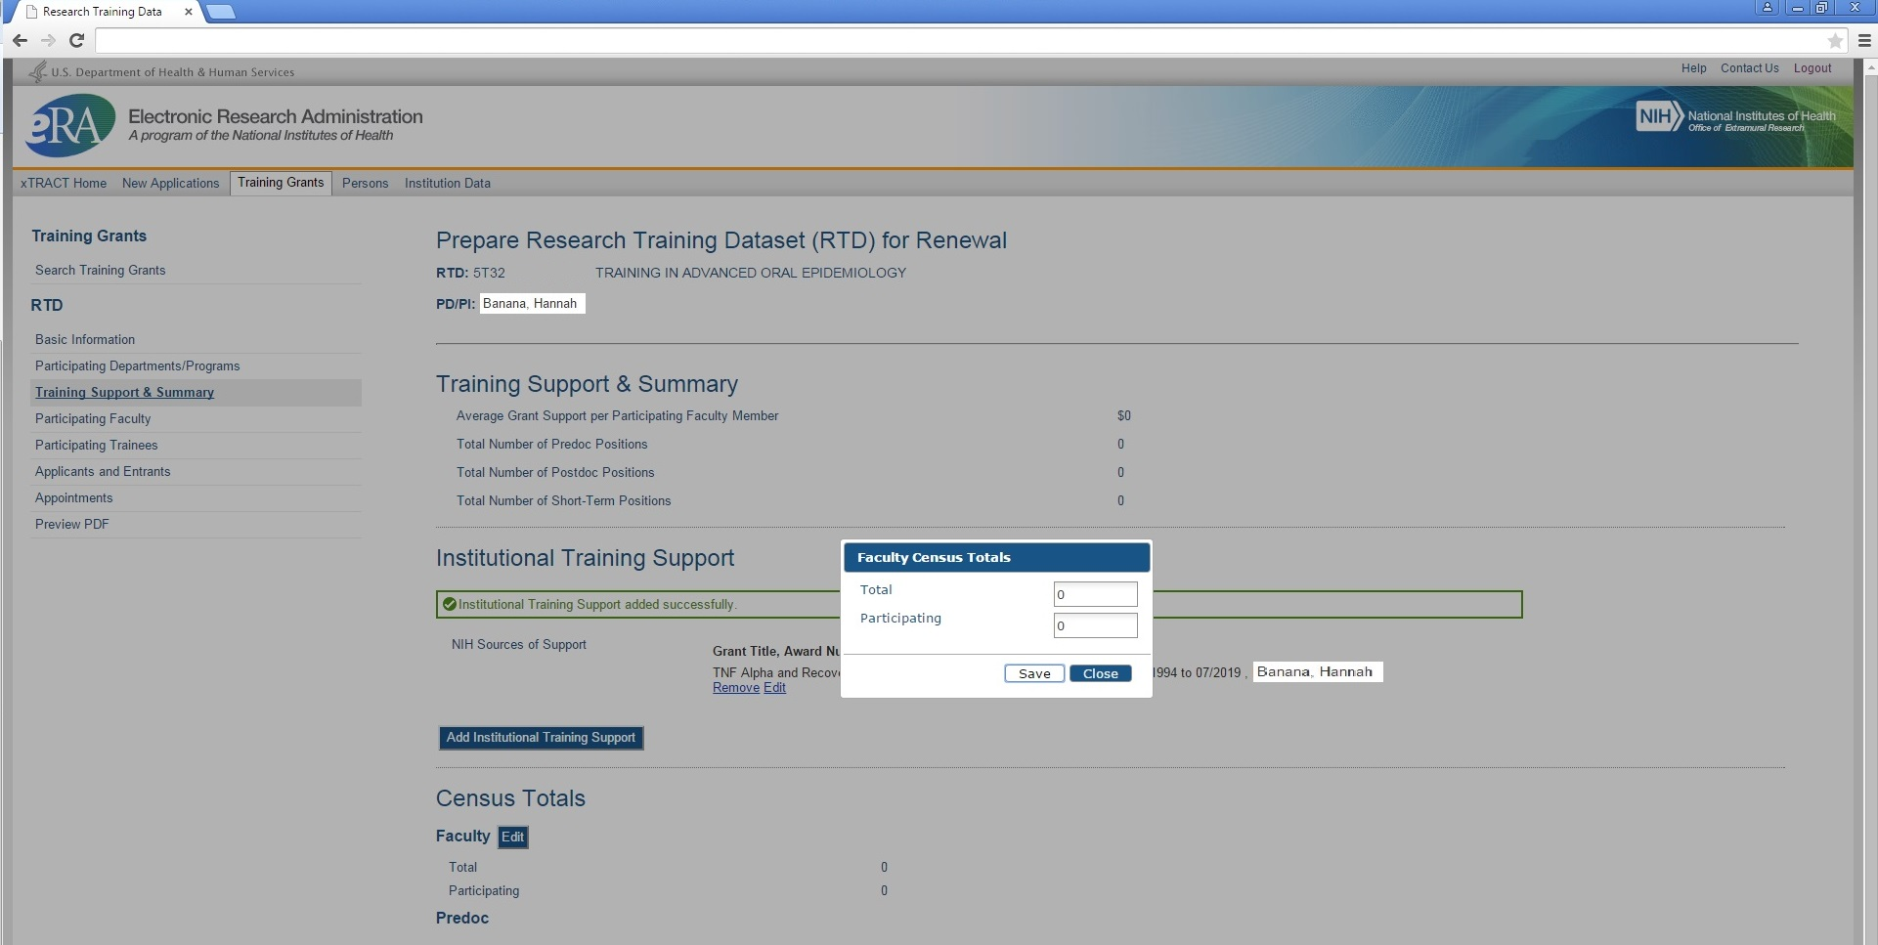
Training Support and Summary, Faculty Census Data entered and saved

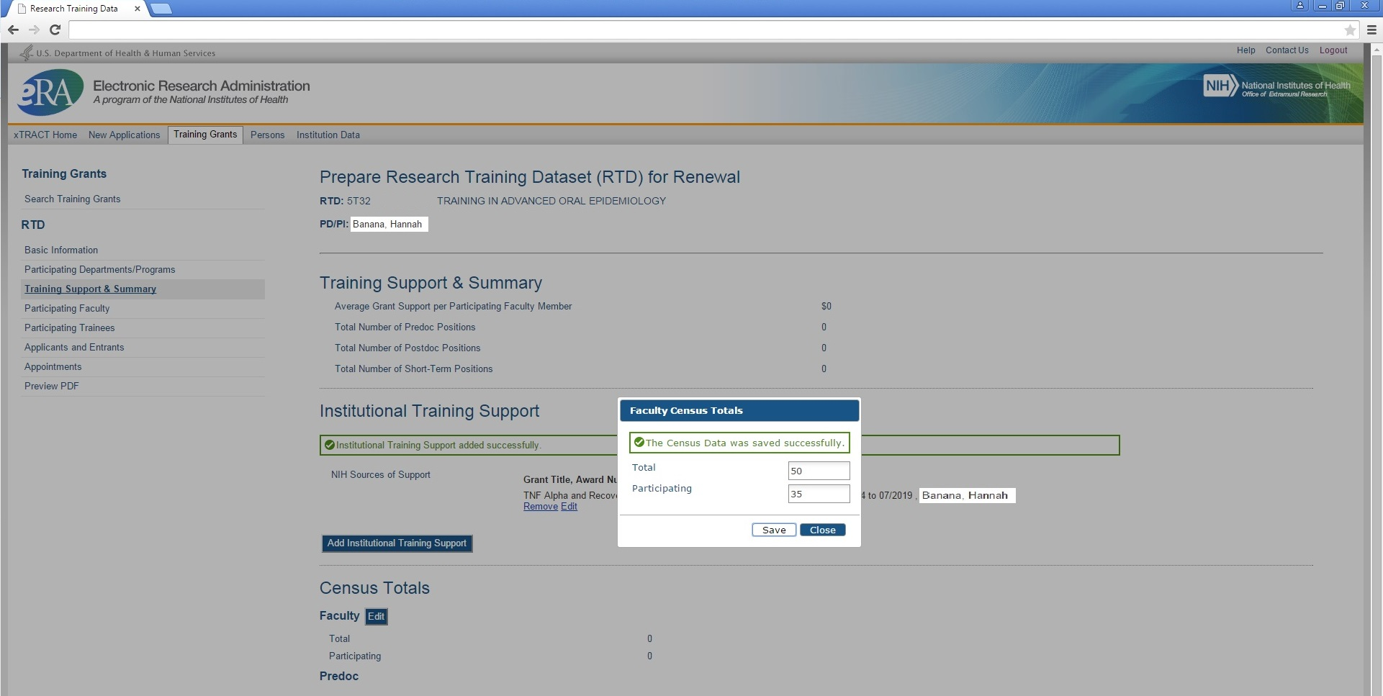
Training Support and Summary, Refreshed with edited Faculty Census Data

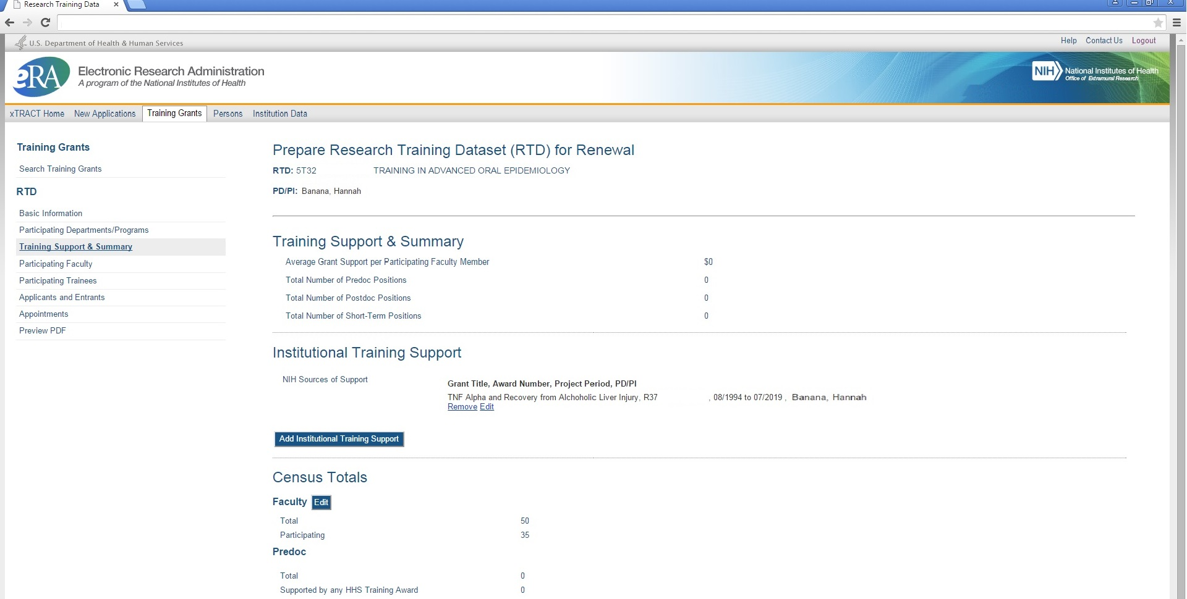
Participating Faculty

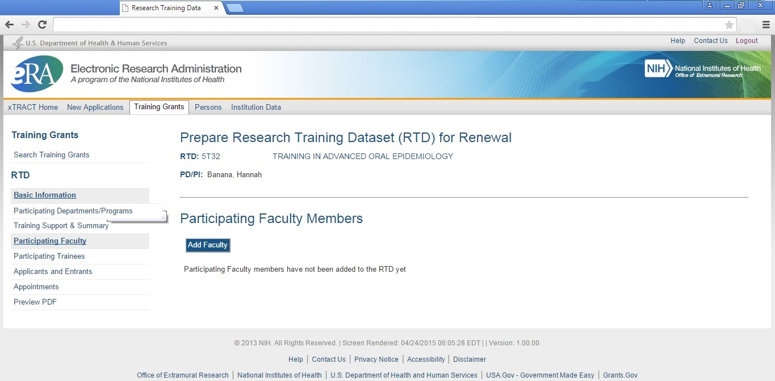

Participating Faculty, Search to Add Faculty

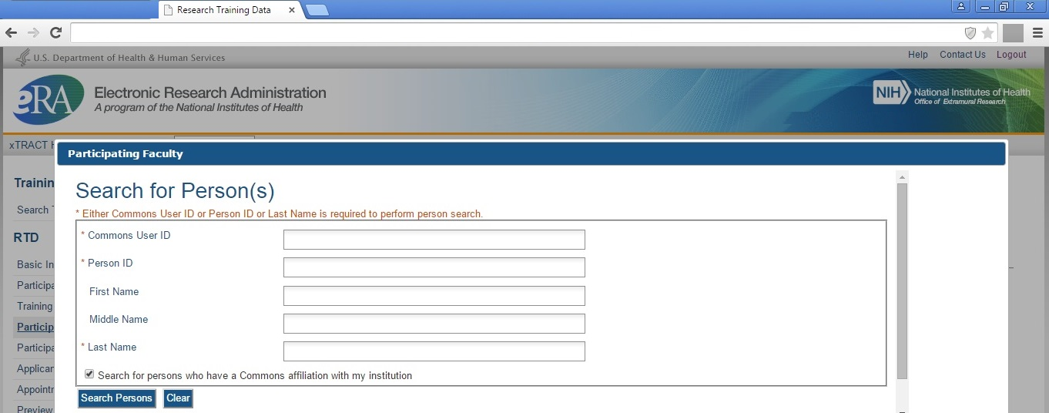

Participating Faculty, Faculty Search Results

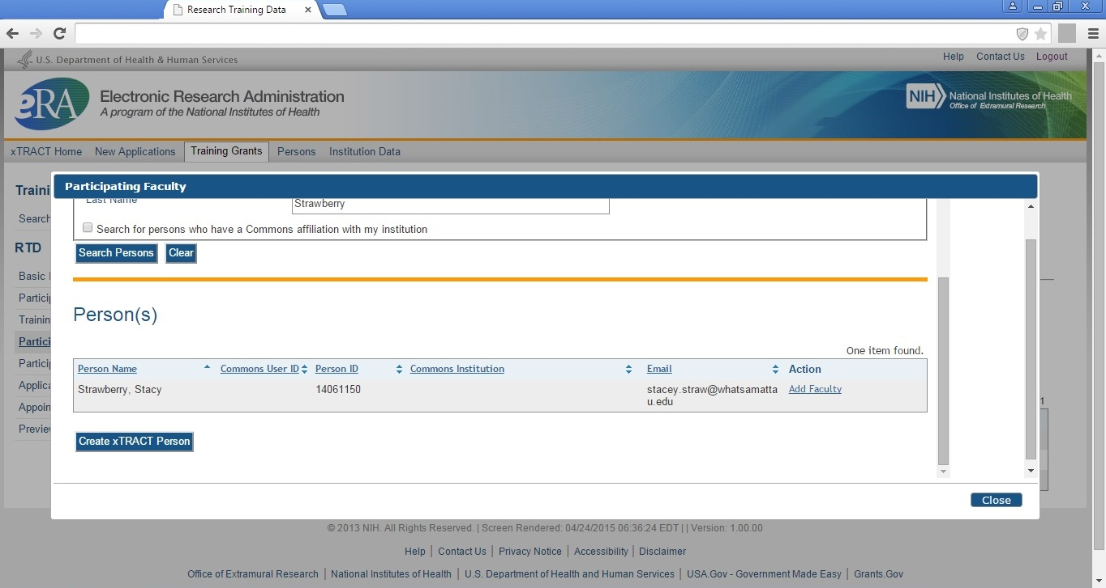

Participating Faculty, Faculty selected and added

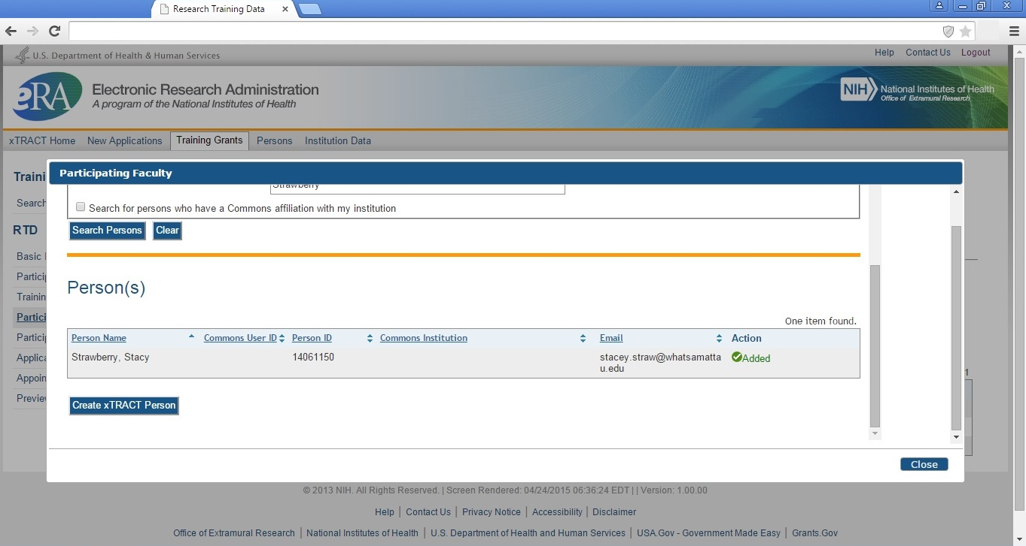
Participating Faculty, refreshed after several faculty added

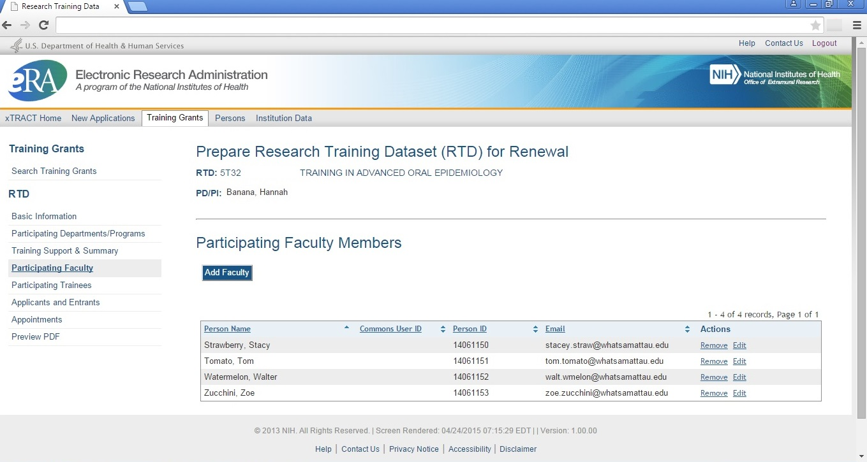
Participating Trainees (Note: for new applications, screen labels on this and subsequent screens will refer to these as “Students” rather than “Trainees”)

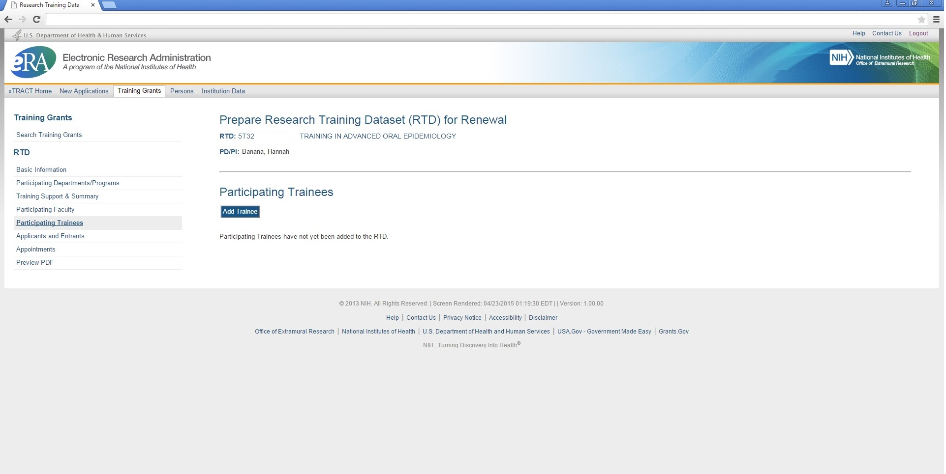
Participating Trainees, Search to add trainees

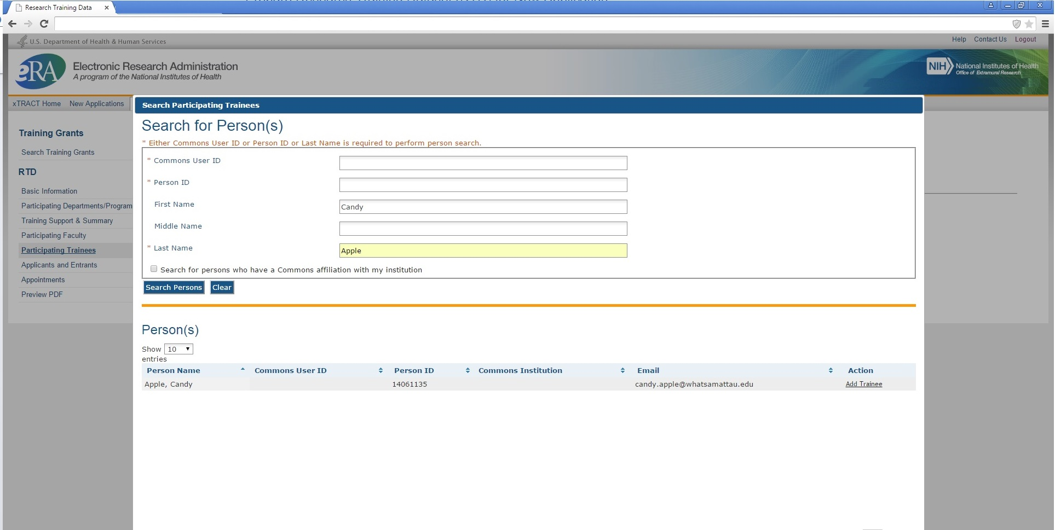

Participating Trainees, Selecting Trainee from Search Results and Identifying Trainee Type
Please note: it is planned to add another trainee type (“undergraduate”) to the list of available options shown here.

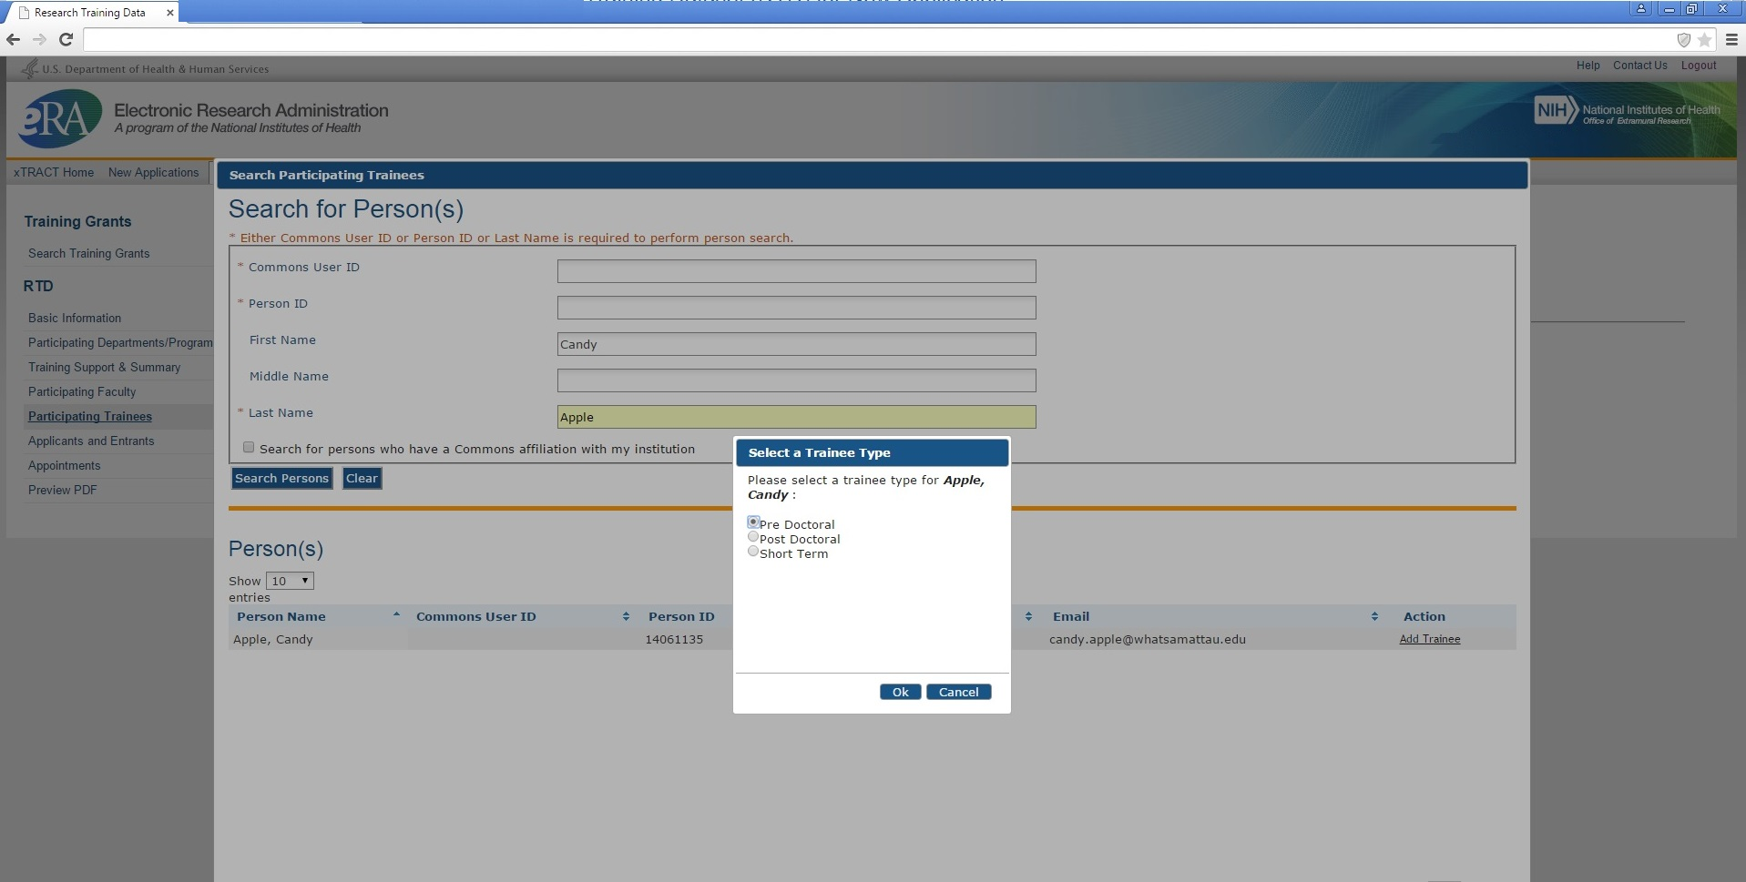

Participating Trainees, Search screen confirming that trainee has been added

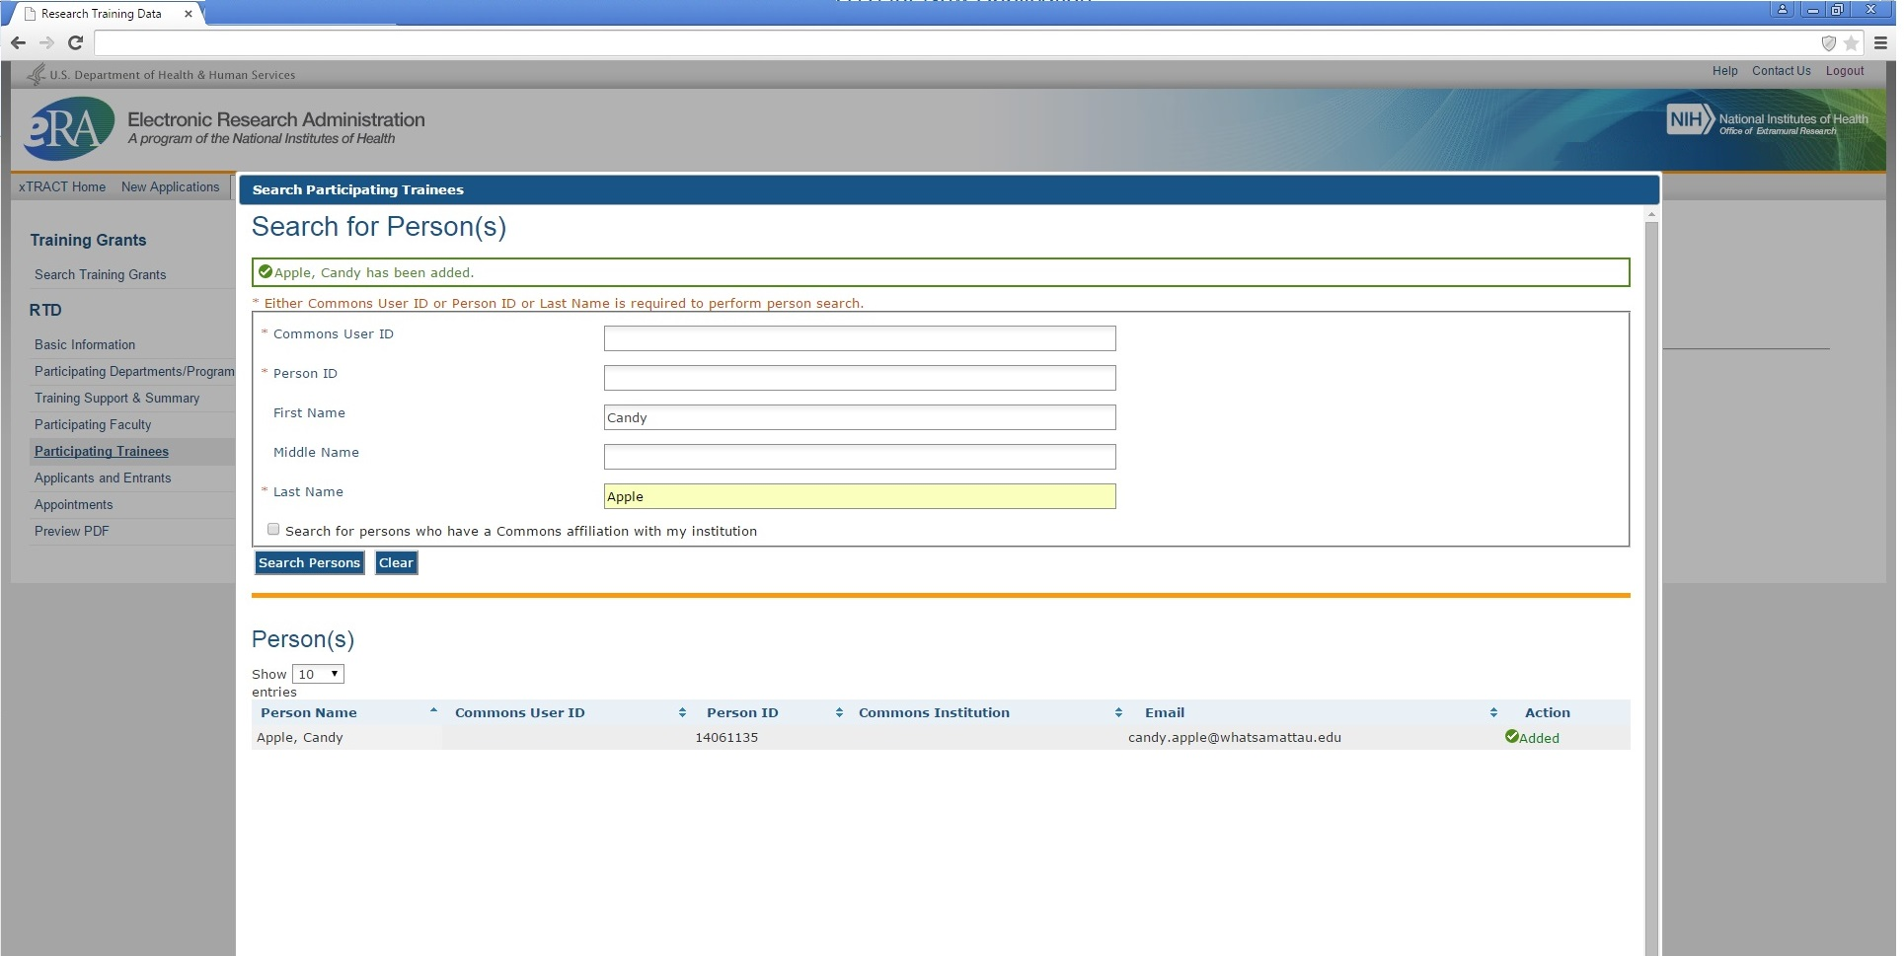
Participating Trainees, after several trainees have been added (showing various trainee types)

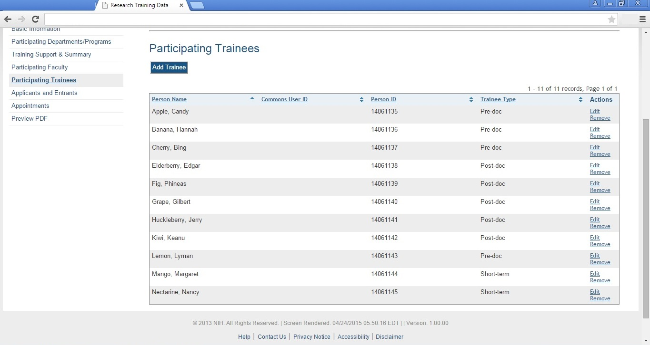
Participating Trainees, Edit Publications
Please note: While the screen shot below only shows “Trainee Data” and “Publications” sections, the xTRACT system will also collect these additional sections for Participating Trainees for Renewal (once development for the system has been completed): In Training Data, Support During Training, Post-Training Positions, Subsequent Grants. The data entry needed for these additional sections will match the information that is shown in the screen shots for “RPPR, Edit Participating Trainee (Predoctoral)” – which are presented later in this package.

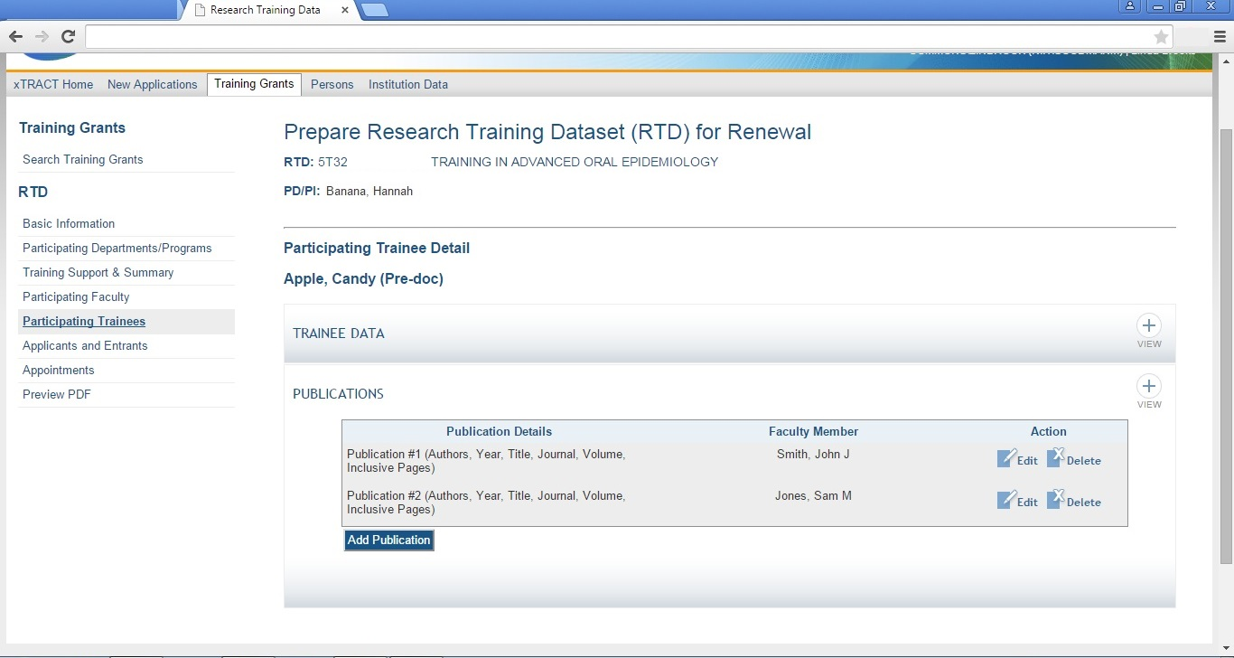
Participating Trainees, Edit or Add Publication Associated with Trainee
Note: Publication details may actually indicate that there are no publications. In which case the user will indicate “No Publications:” followed by one of the following explanatory phrases: “new entrant”, “leave of absence”, “change of research supervisor”, “left program”, or “other”.

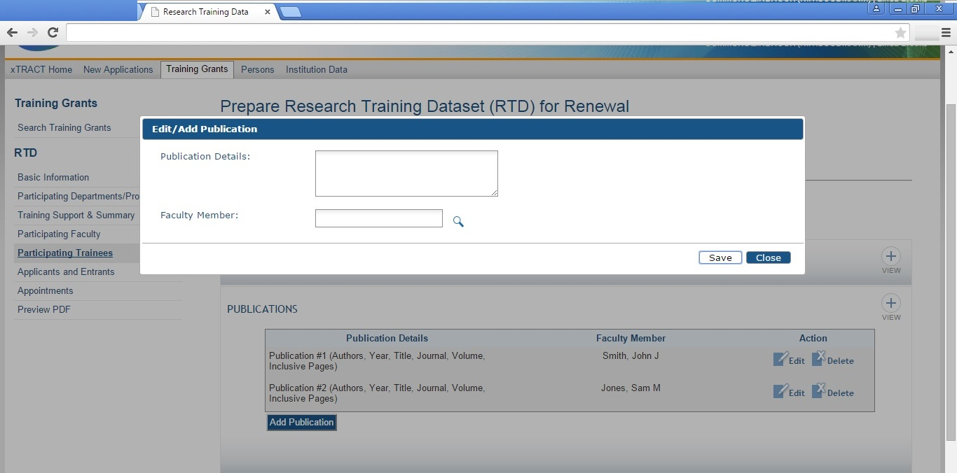

Participating Trainees, Edit or Add Publication, Search to Associate Faculty Member with Publication

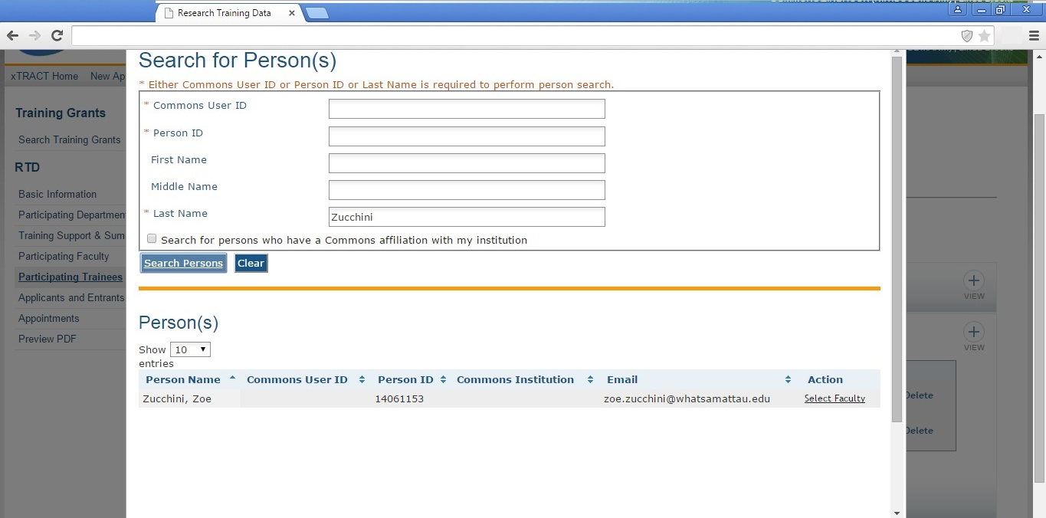
Participating Trainees, Edit or Add Publication, Data Provided

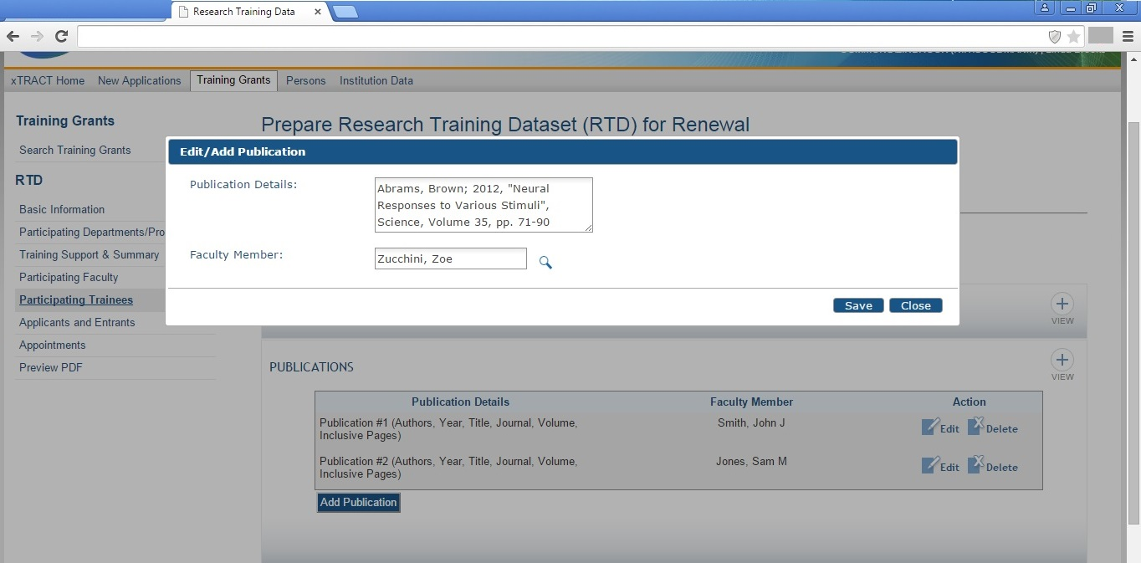
Applicants and Entrants

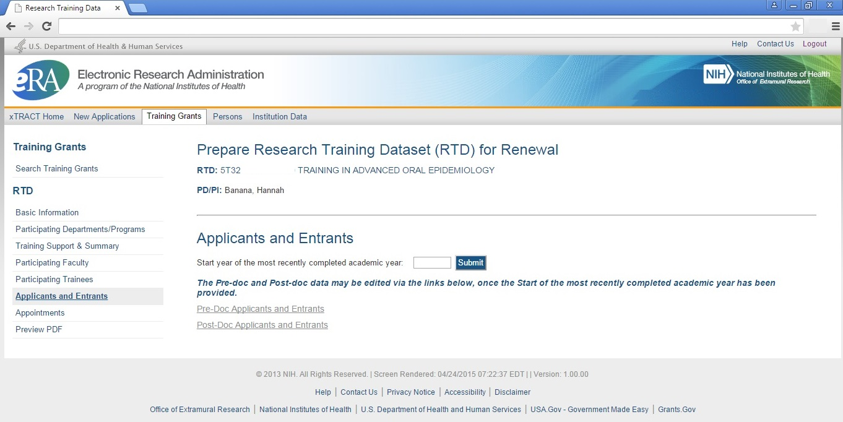
Applicants and Entrants (After User Enters Start Year of Most Recently Completed Academic Year)

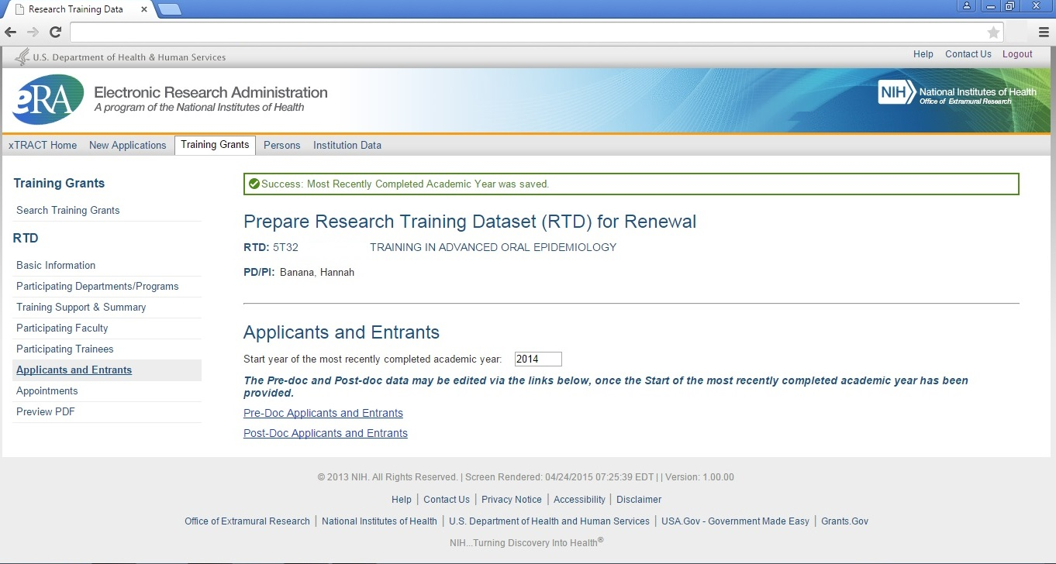

Applicants and Entrants, Predoctoral (overall)

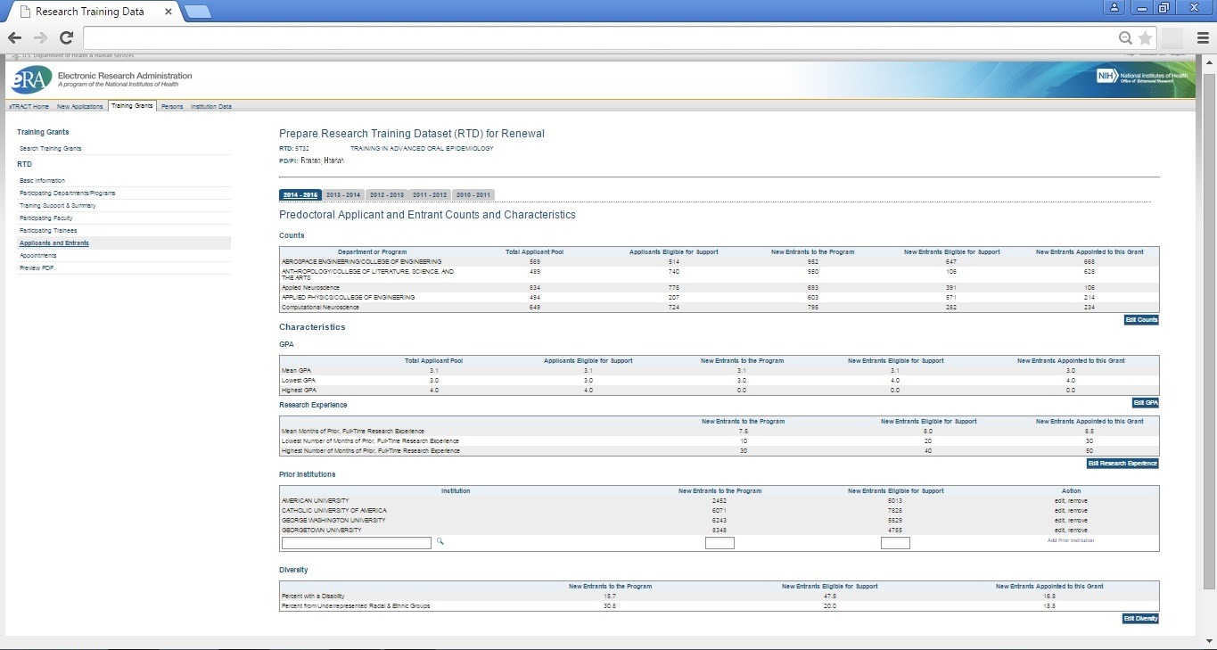
Note that the columns circled below WILL NOT APPEAR on this screen, when entering data for a new application RTD. Statistics pertaining to “this grant” only apply in the context of an existing awarded training grant.

Applicants and Entrants, Predoctoral, Edit Counts Section

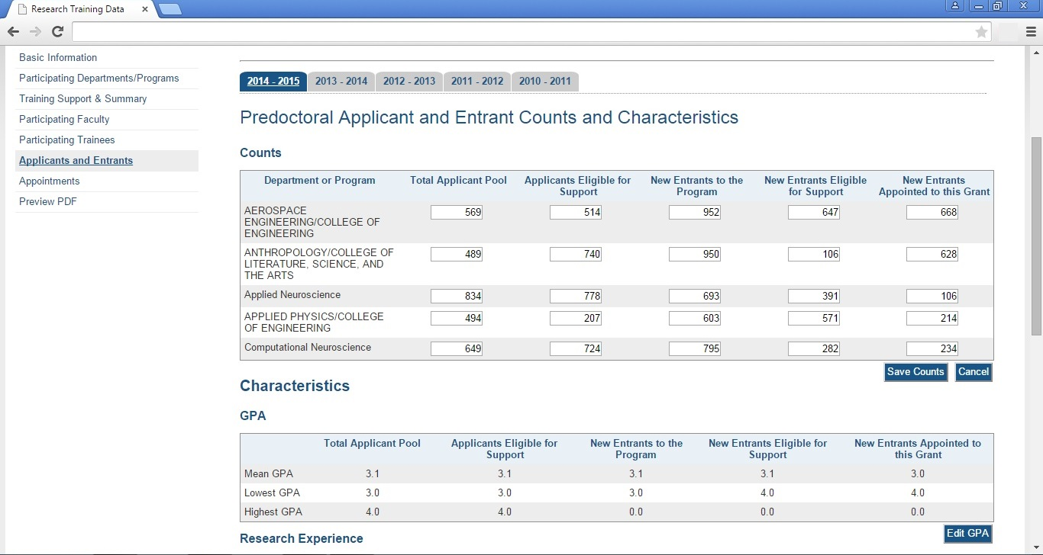
Applicants and Entrants, Predoctoral, Edit GPA Section

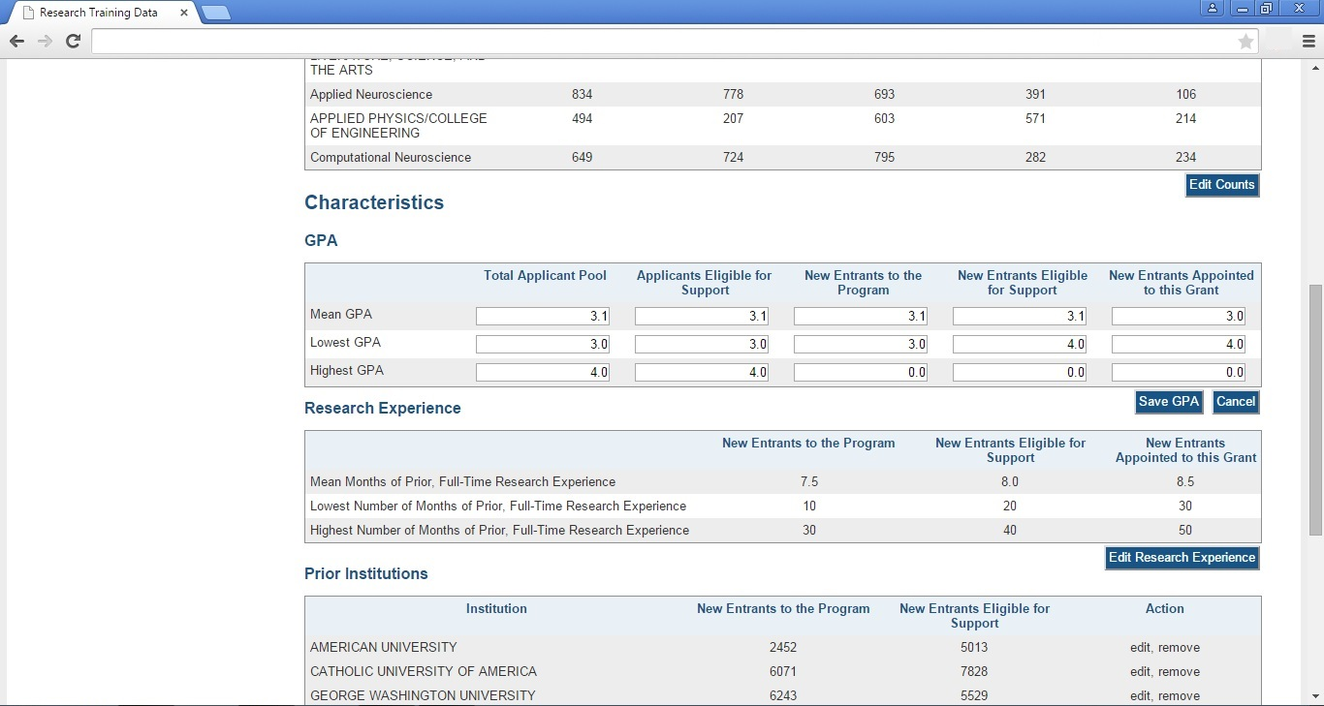
Applicants and Entrants, Predoctoral, Edit Research Experience and Edit Prior Institution Sections

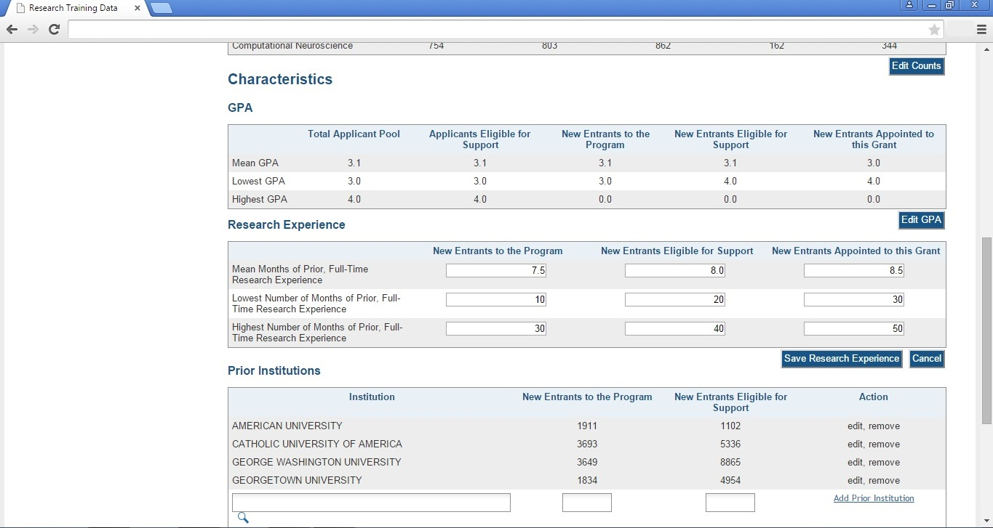
Applicants and Entrants, Predoctoral, Add Prior Institution (search for institution to be added)

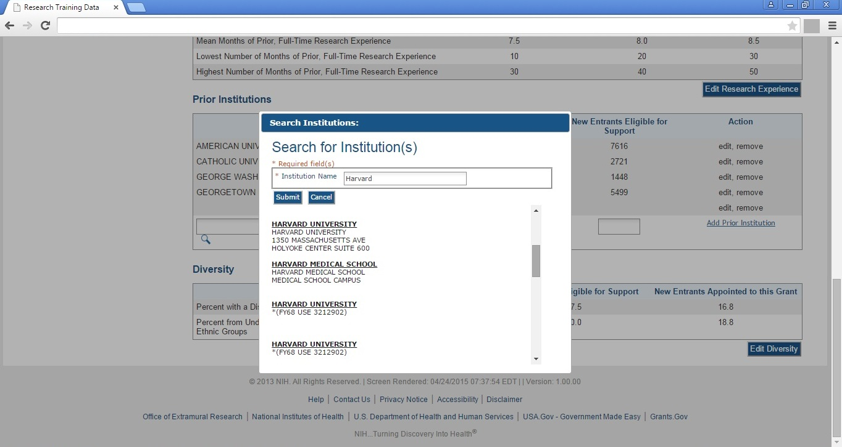
Applicants and Entrants, Predoctoral, Edit Diversity Section

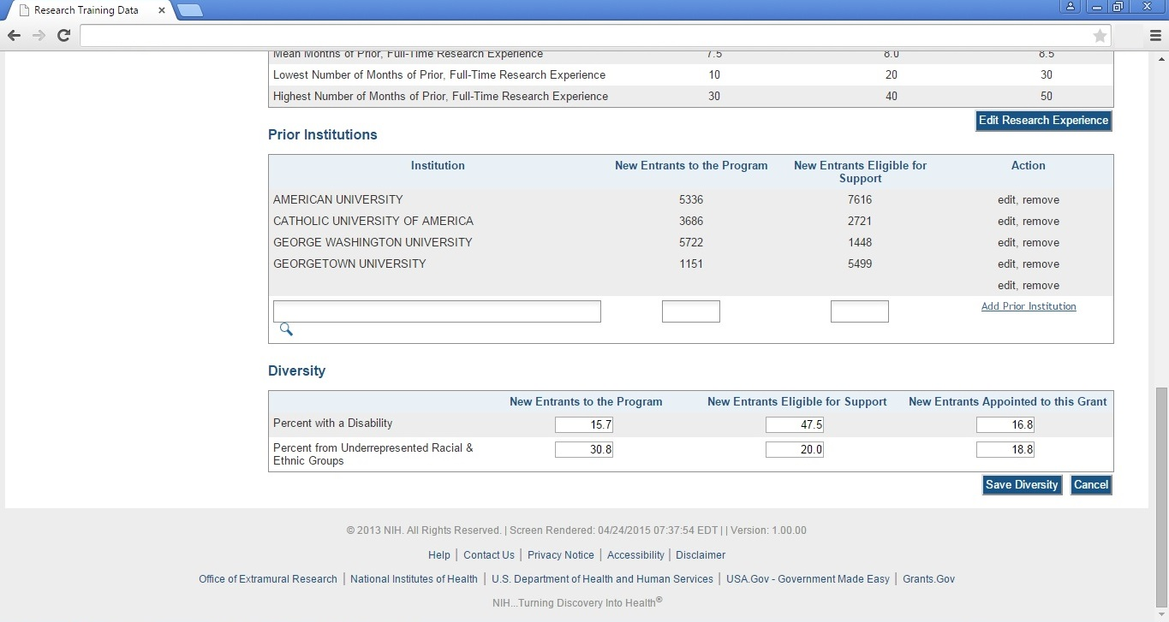
Applicants and Entrants, Postdoctoral (overall)

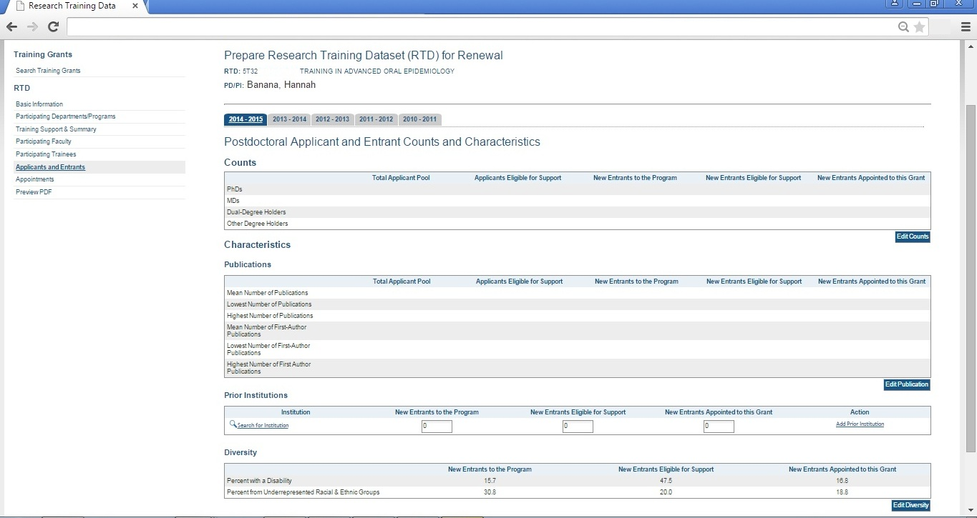
Note that the Prior Institutions and Diversity Sections are identical to those collected for “Applicants and Entrants, Predoctoral”. For screenshots describing data entry under these headings, please refer to the corresponding screens shown in the preceding “Applicants and Entrants, Predoctoral” section.
Note that the columns circled below WILL NOT APPEAR on this screen, when entering data for a new application RTD. Statistics pertaining to “this grant” only apply in the context of an existing awarded training grant.

Appointments (Note: does not apply to new applications)

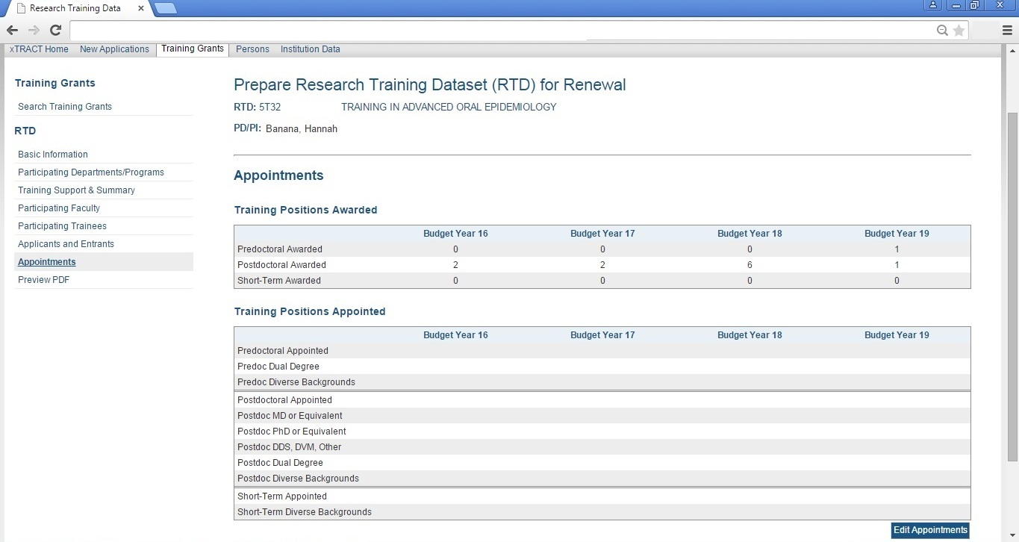
Appointments, Edit Training Positions Appointed (Note: does not apply to new applications)

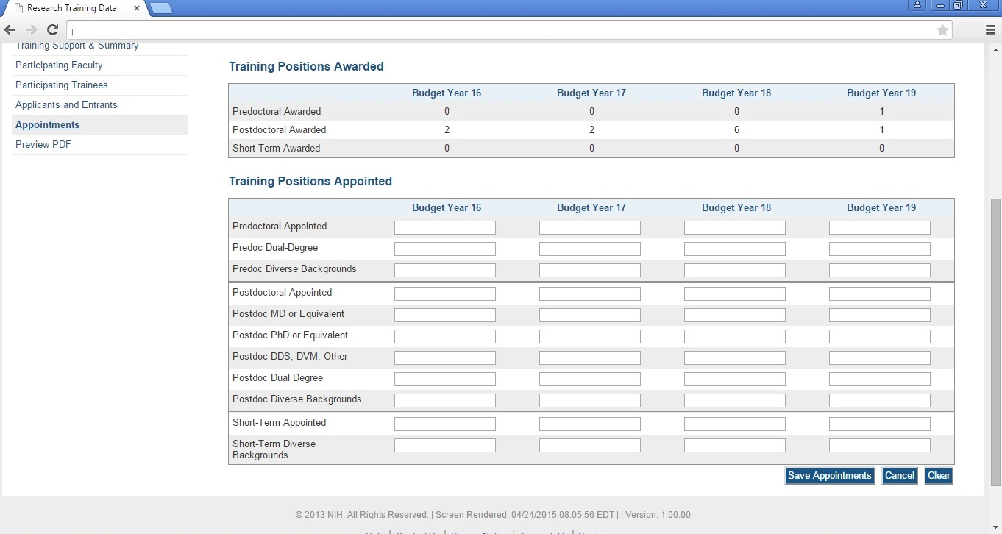
SCREENS FOR PREPARING REVISION APPLICATIONS

Revision Application RTDs can be prepared for existing, awarded training grants and will be searched using the same “Training Grants” search used to find grants eligible for renewal (example repeated below with the “revision” link circled). All screens used to create/maintain Research Training Data Sets (RTDs) for Revision Applications will be identical to those shown in the preceding section, regarding Renewal Applications. The only difference will be that the word “Revision” will be used in any applicable screen labels, instead of the word “Renewal”.
SCREENS FOR PREPARING RPPR SUBMISSIONS
The following pages present the screens used to create/maintain Research Training Data Sets (RTDs) for use in RPPR (Research Performance Progress Report) submissions. RPPR RTDs can be prepared for existing, awarded training grants and will be searched using the same “Training Grants” search used to find grants eligible for renewal and revision.
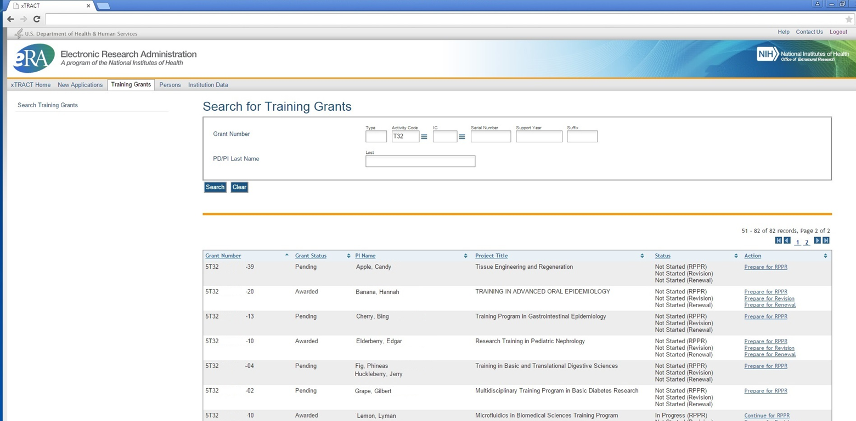
Prepare RPPR RTD, initial screen

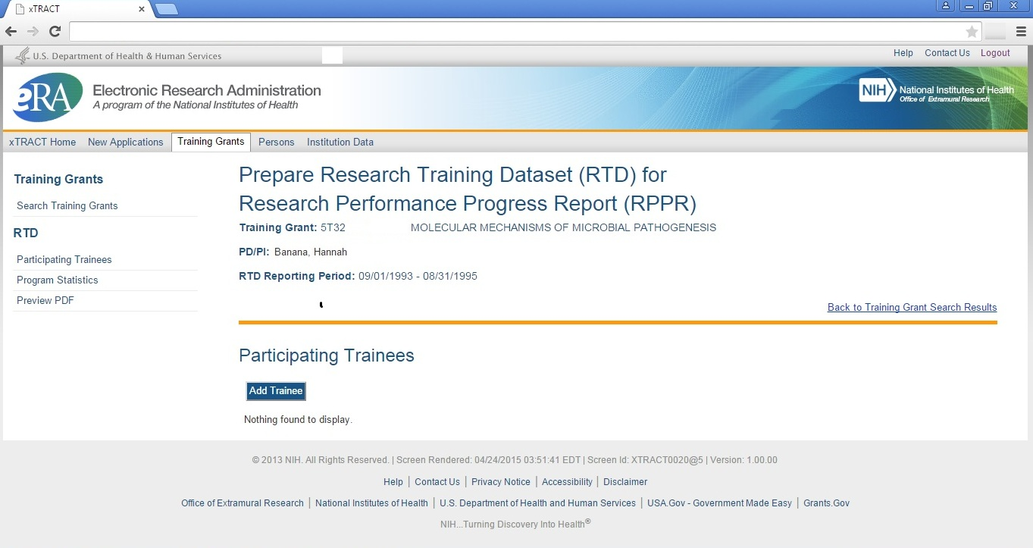
RPPR, Participating Trainees

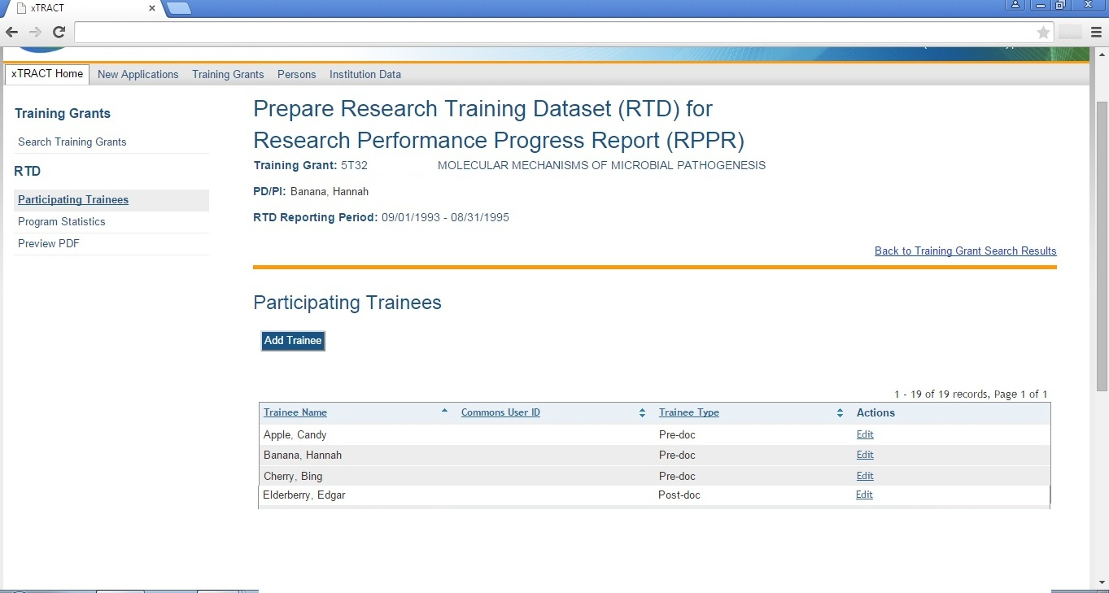
RPPR, Edit Participating Trainee (Predoctoral)

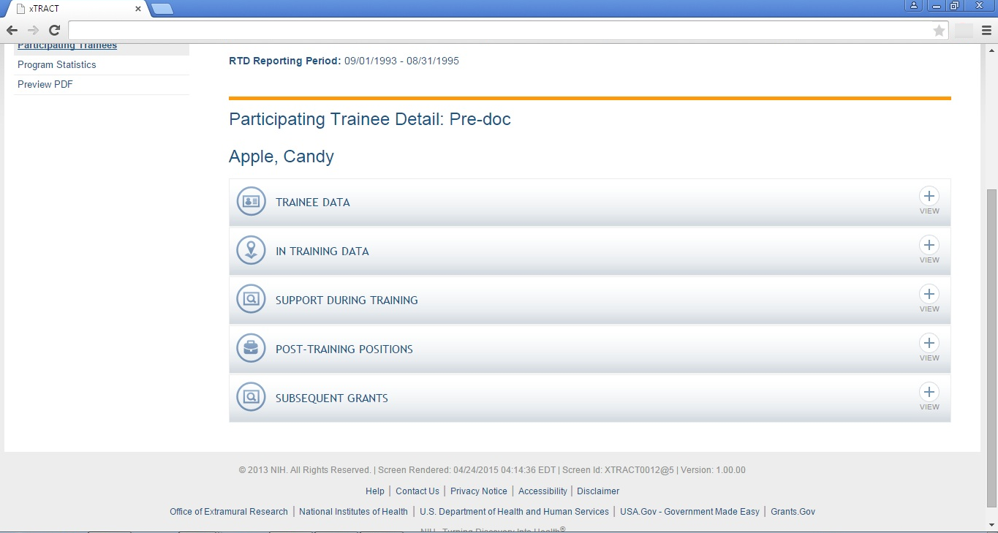

RPPR, Edit Participating Trainee (Predoctoral), Trainee Detail

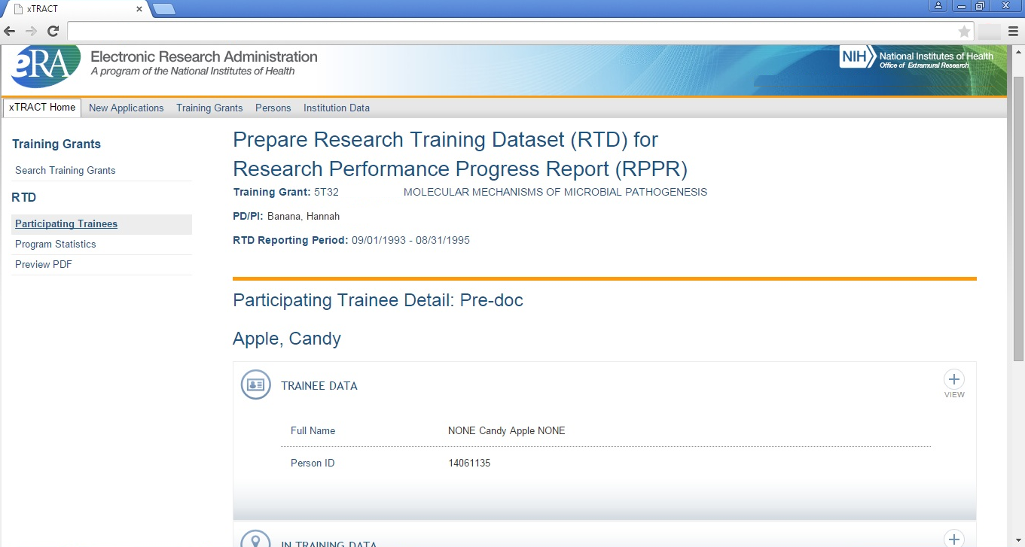

RPPR, Edit Participating Trainee (Predoctoral), In-Training Data, In-Training Indicator

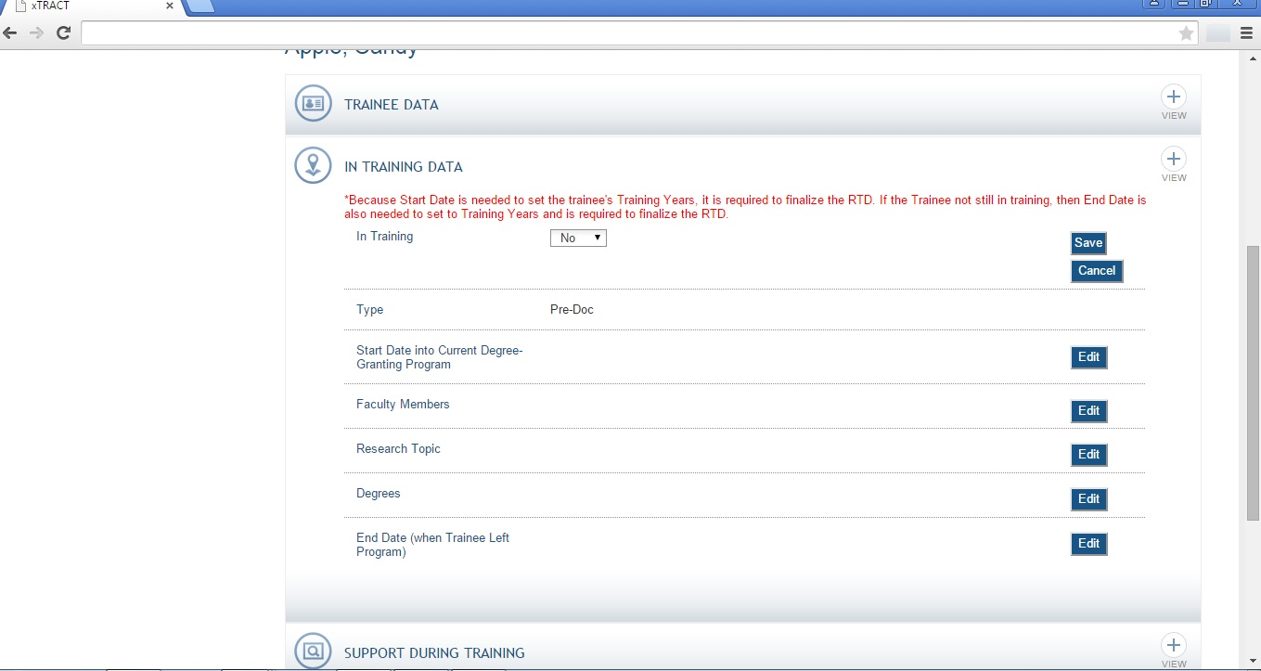
RPPR, Edit Participating Trainee (Predoctoral), In-Training Data, Start Date Into Degree Program

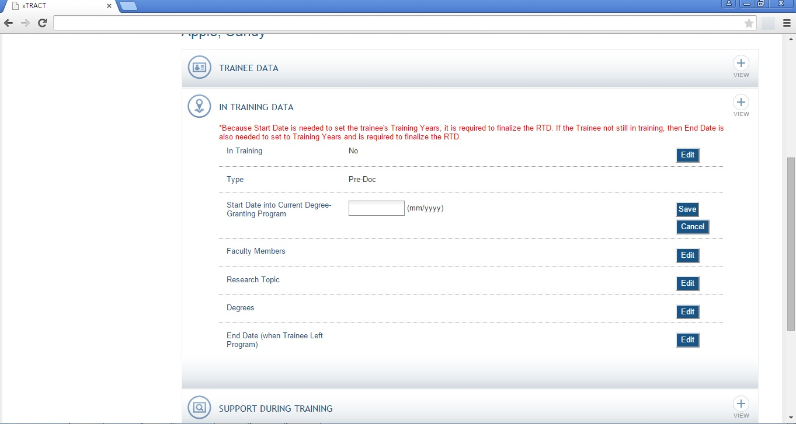

RPPR, Edit Participating Trainee (Predoctoral), In-Training Data, Faculty Members

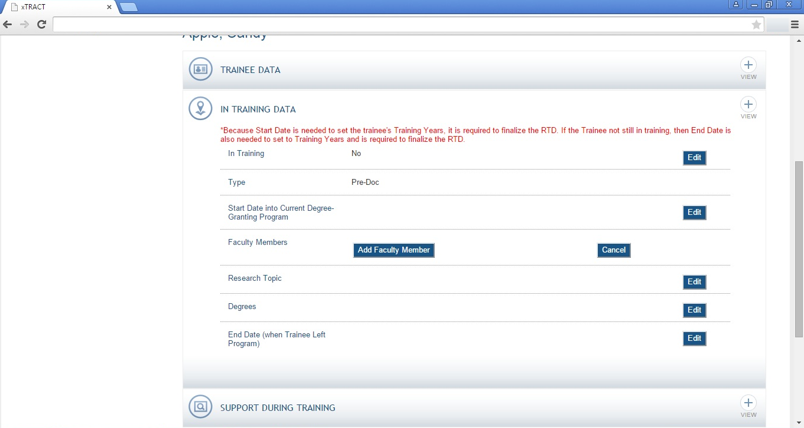

RPPR, Edit Participating Trainee (Predoctoral), In-Training Data, Faculty Members, Add, Search

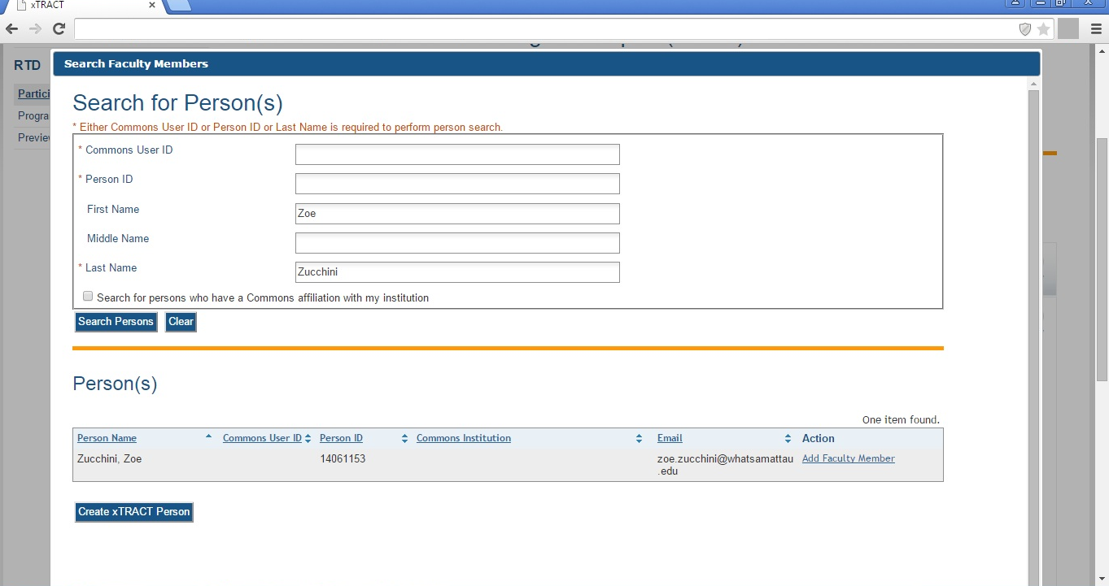

RPPR, Edit Participating Trainee (Predoctoral), In-Training Data, Faculty Members, Add, Selected and Saved

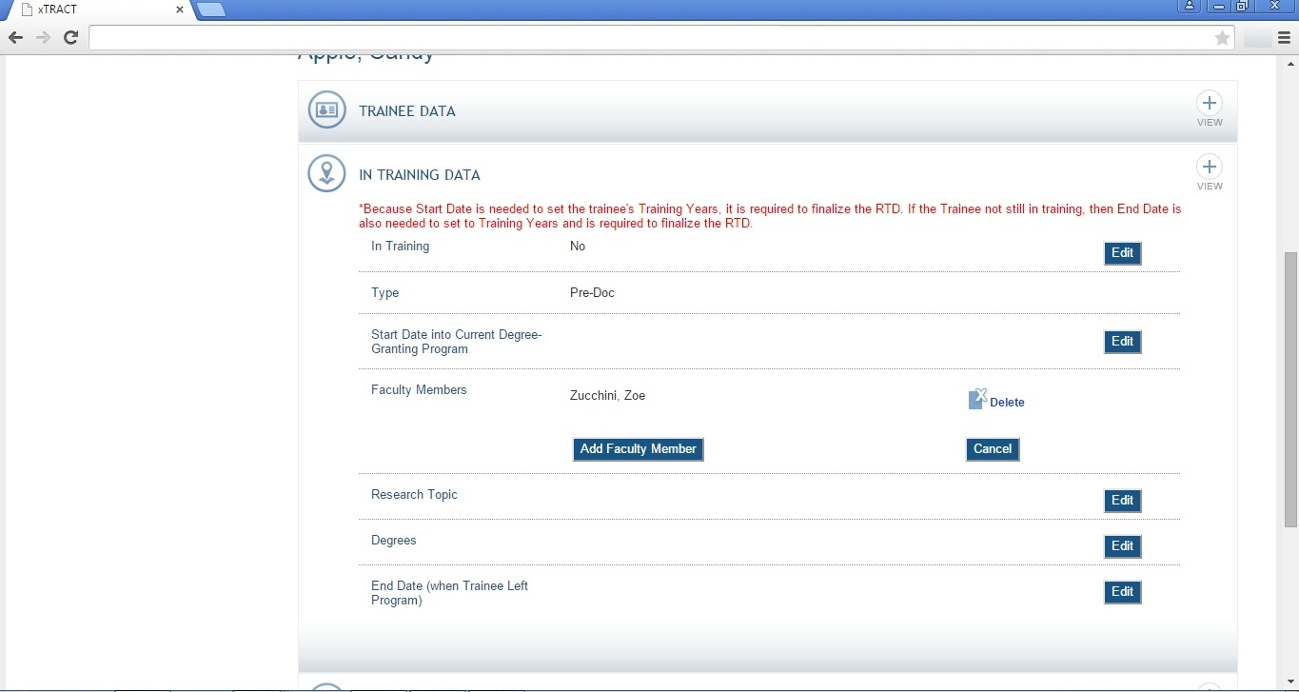

RPPR, Edit Participating Trainee (Predoctoral), In-Training Data, Research Topic

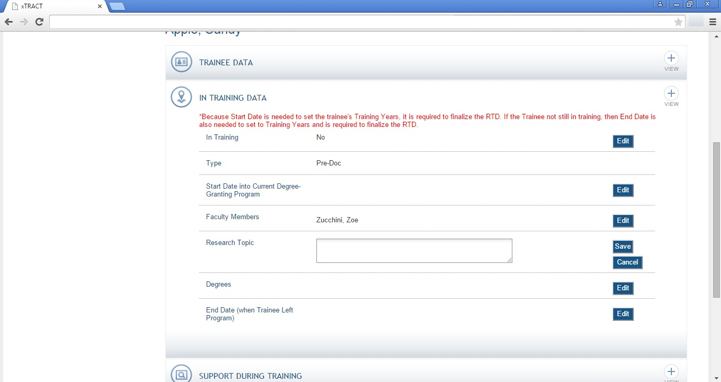

RPPR, Edit Participating Trainee (Predoctoral), In-Training Data, Degrees

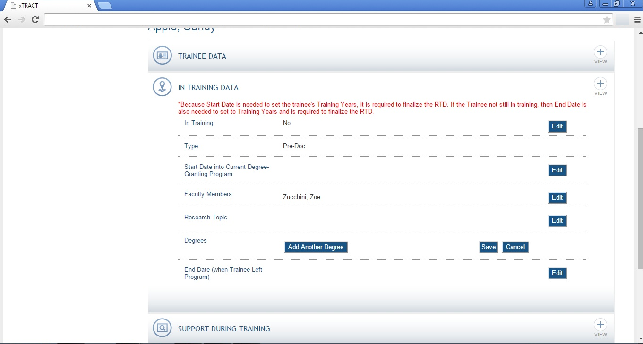
RPPR, Edit Participating Trainee (Predoctoral), In-Training Data, Degrees, Add Non-terminal

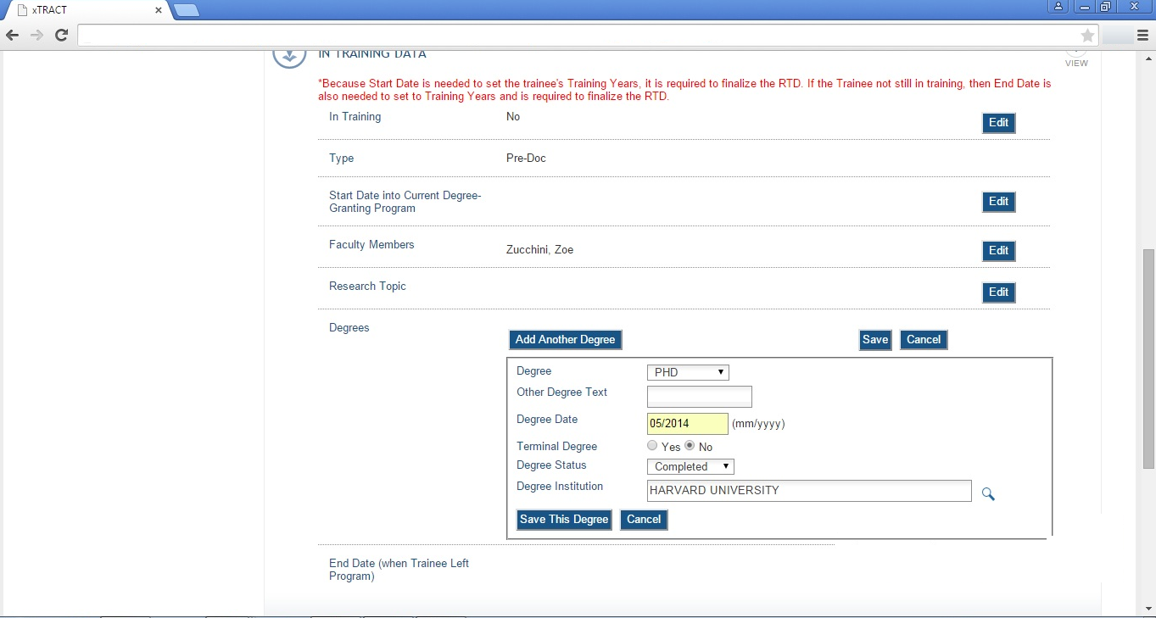

RPPR, Edit Participating Trainee (Predoctoral), In-Training Data, Degrees, Add Terminal

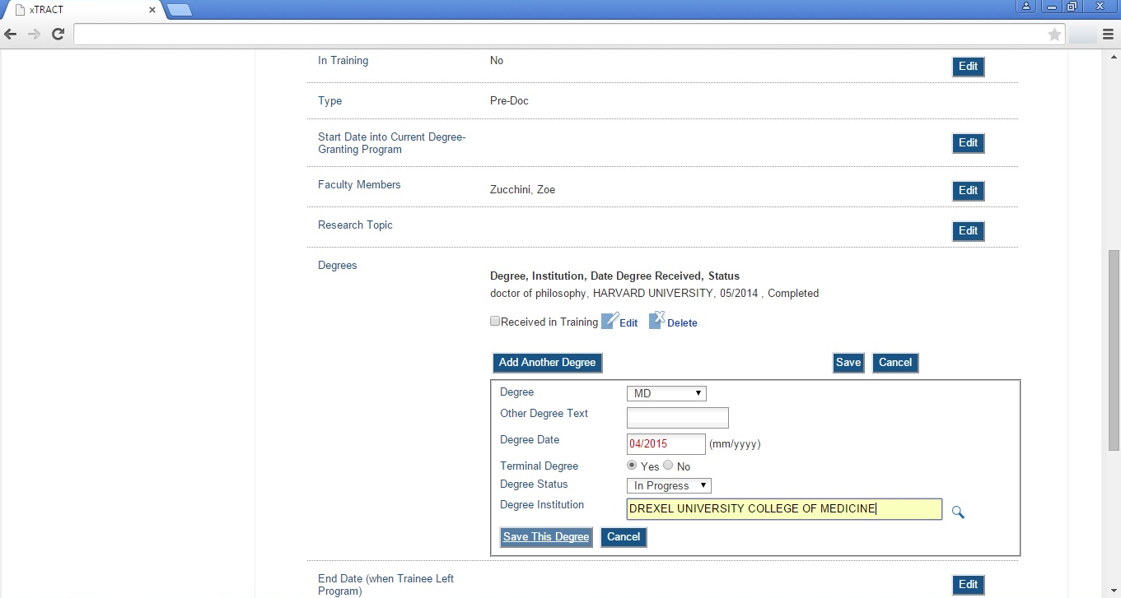
RPPR, Edit Participating Trainee (Predoctoral), In-Training Data, Degrees, Received-In-Training Indicators

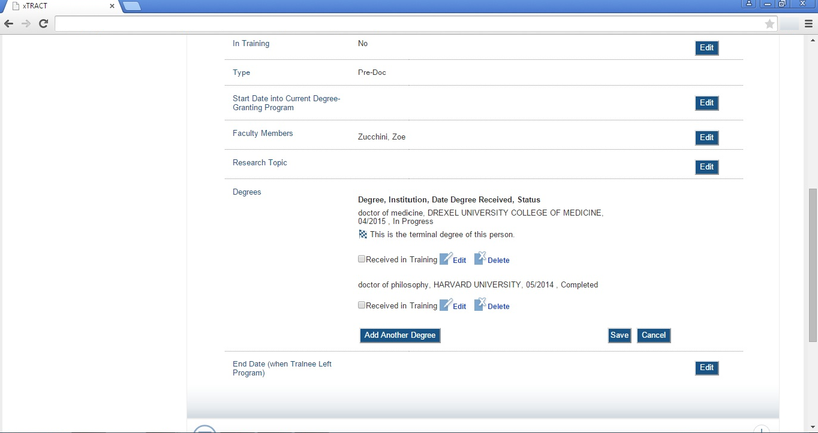

RPPR, Edit Participating Trainee (Predoctoral), In-Training Data, Degrees, End Date (left program)

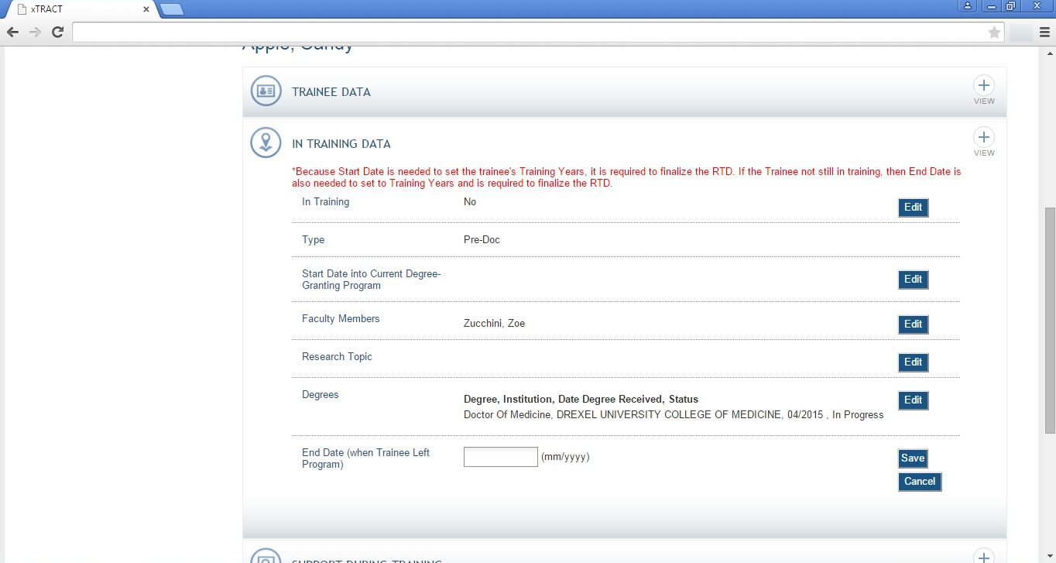

RPPR, Edit Participating Trainee (Predoctoral), Support During Training

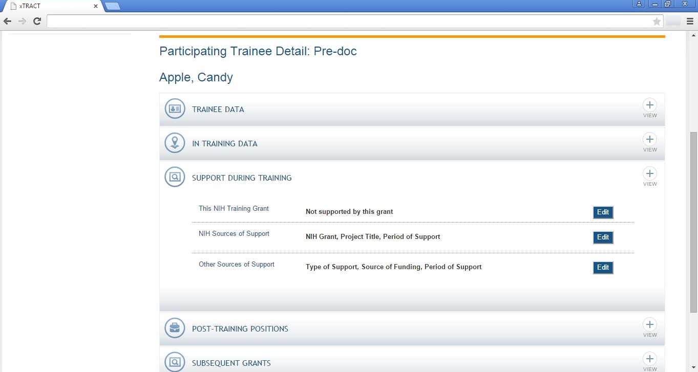
RPPR, Edit Participating Trainee (Predoctoral), Support During Training, This Grant

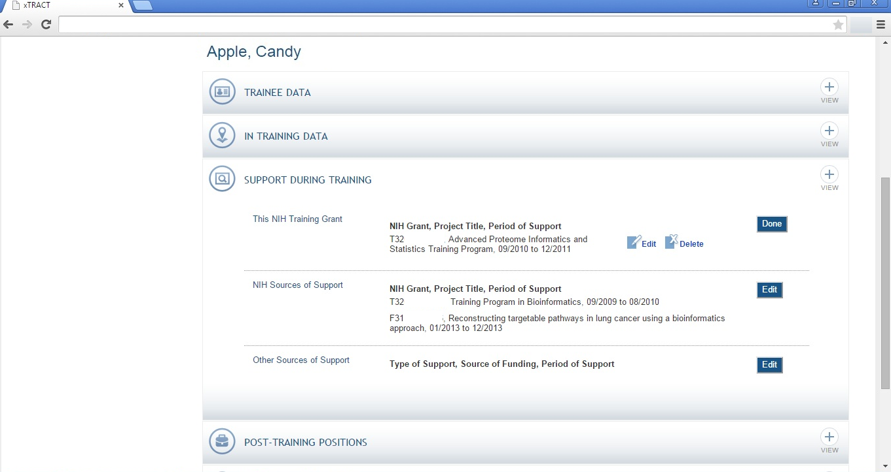
RPPR, Edit Participating Trainee (Predoctoral), Support During Training, This Grant (Edit)

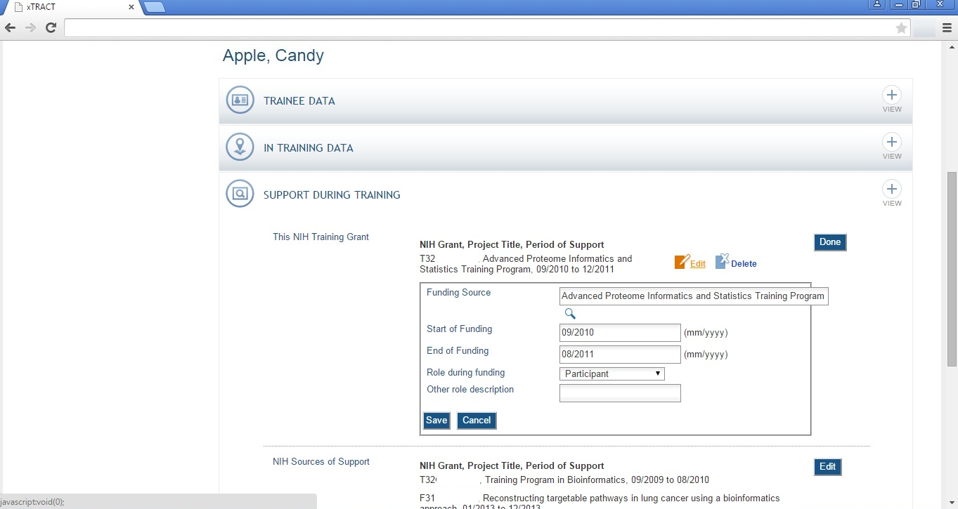
RPPR, Edit Participating Trainee (Predoctoral), Support During Training, NIH Sources

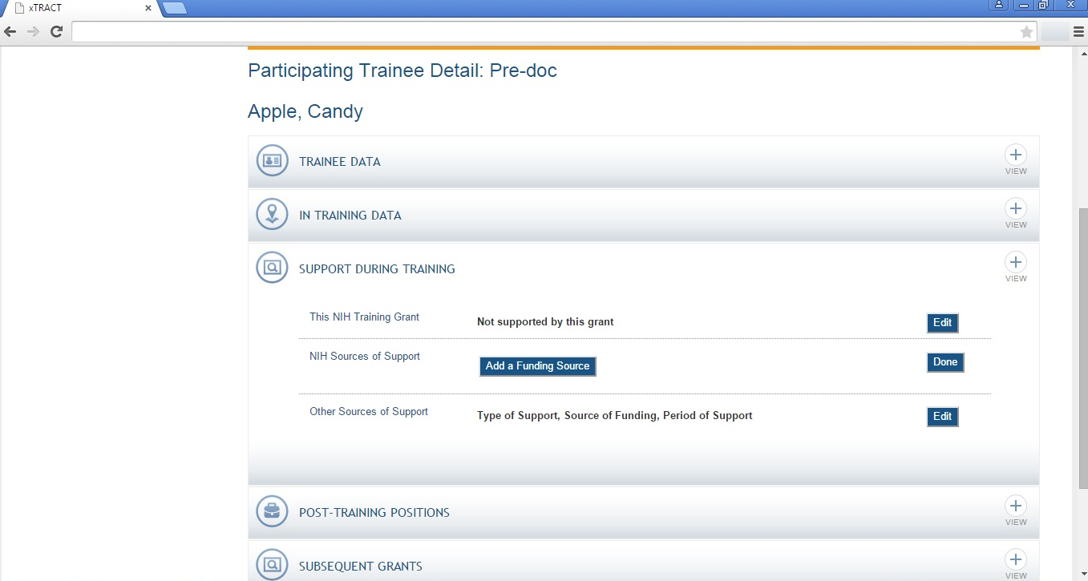

RPPR, Edit Participating Trainee (Predoctoral), Support During Training, NIH Sources

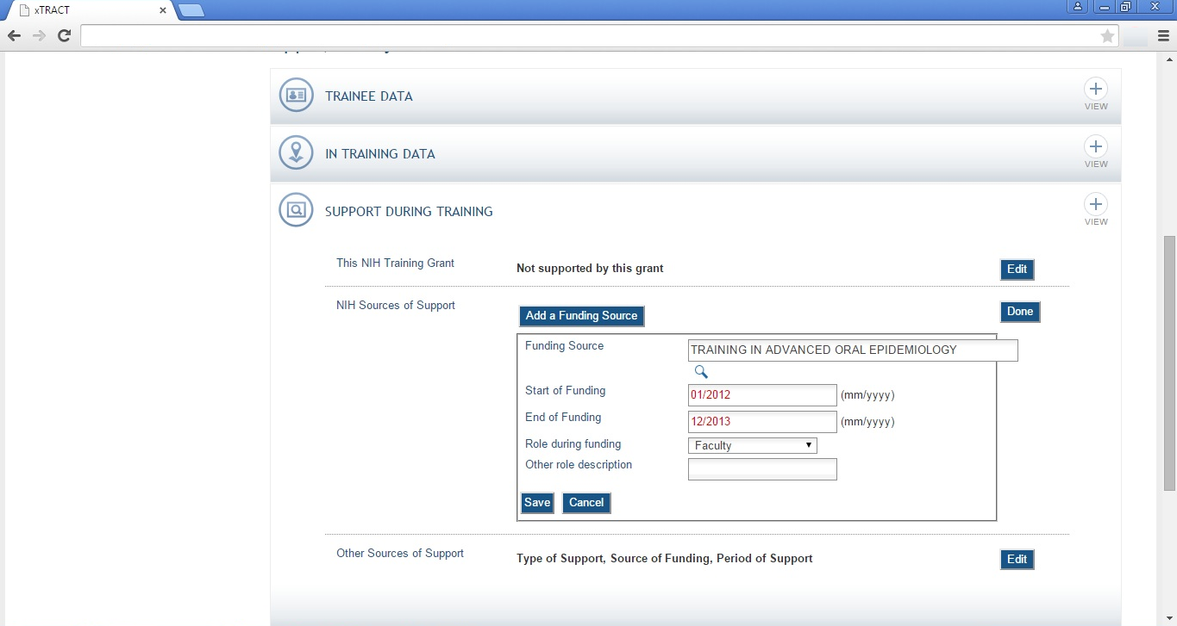

RPPR, Edit Participating Trainee (Predoctoral), Support During Training, Other Sources

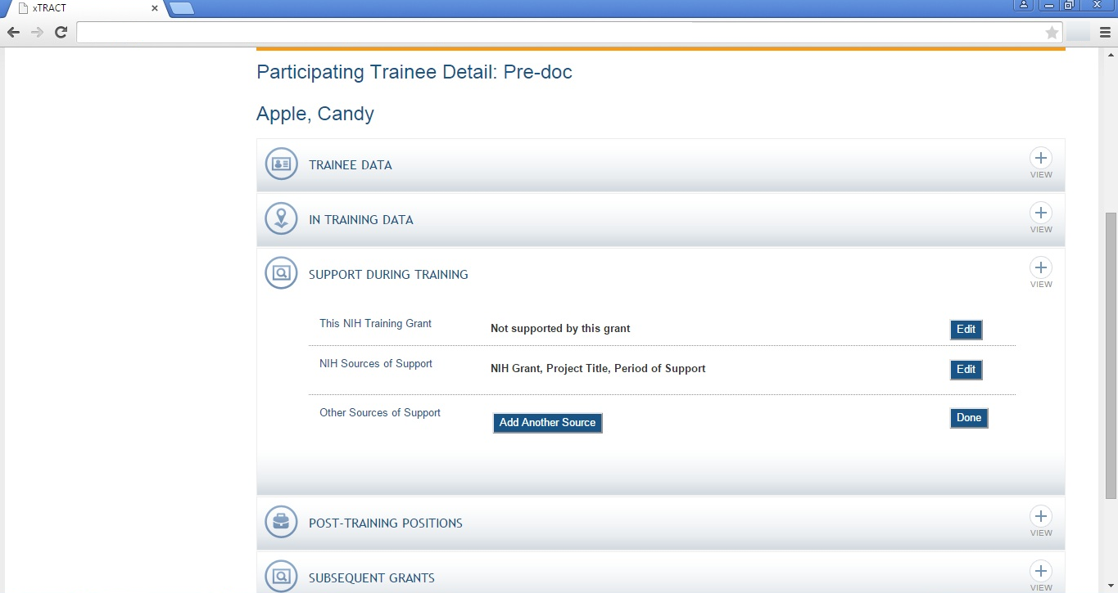
RPPR, Edit Participating Trainee (Predoctoral), Support During Training, Other Sources, Add Source

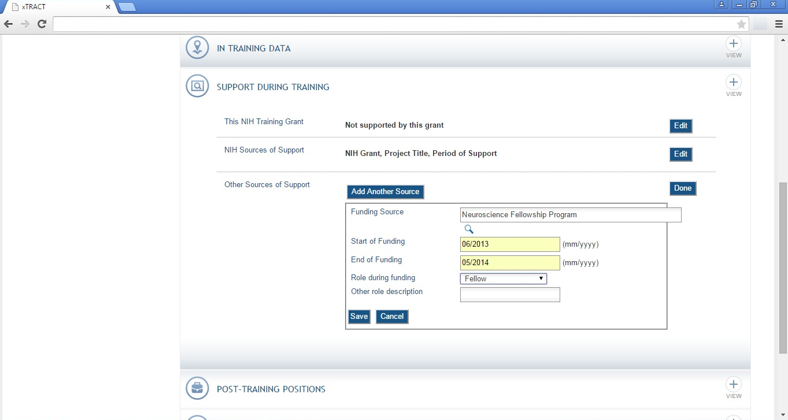
RPPR, Edit Participating Trainee (Predoctoral), Post-Training Positions

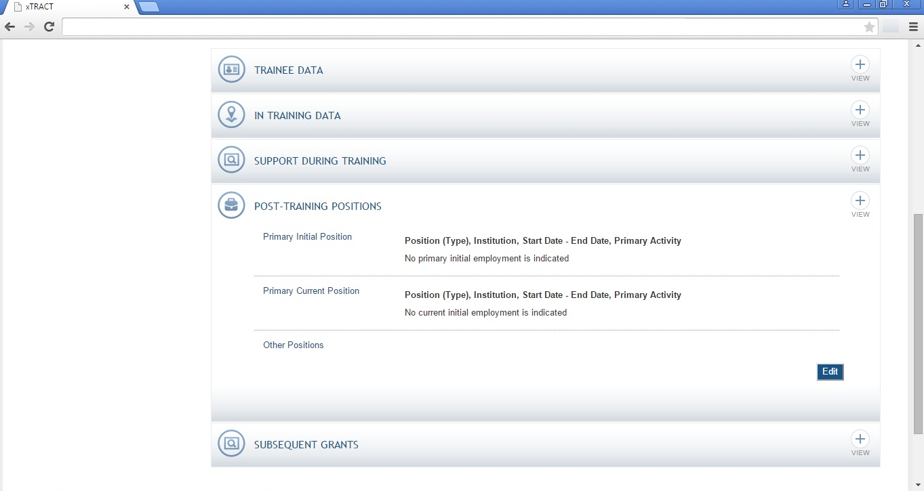
RPPR, Edit Participating Trainee (Predoctoral), Post-Training Positions, Add Position

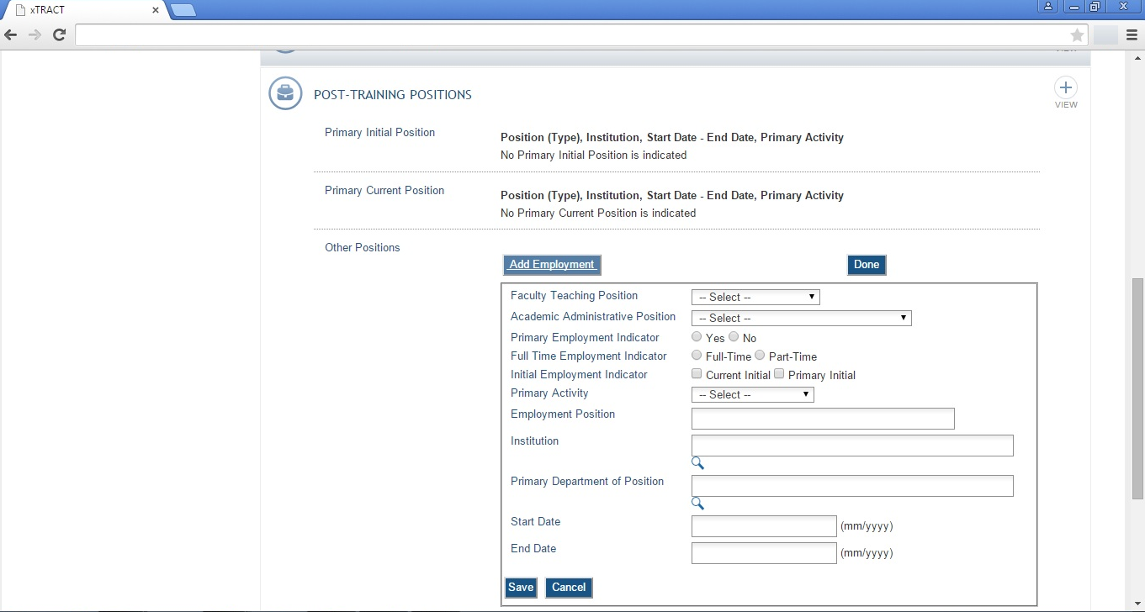

RPPR, Edit Participating Trainee (Predoctoral), Subsequent Grants

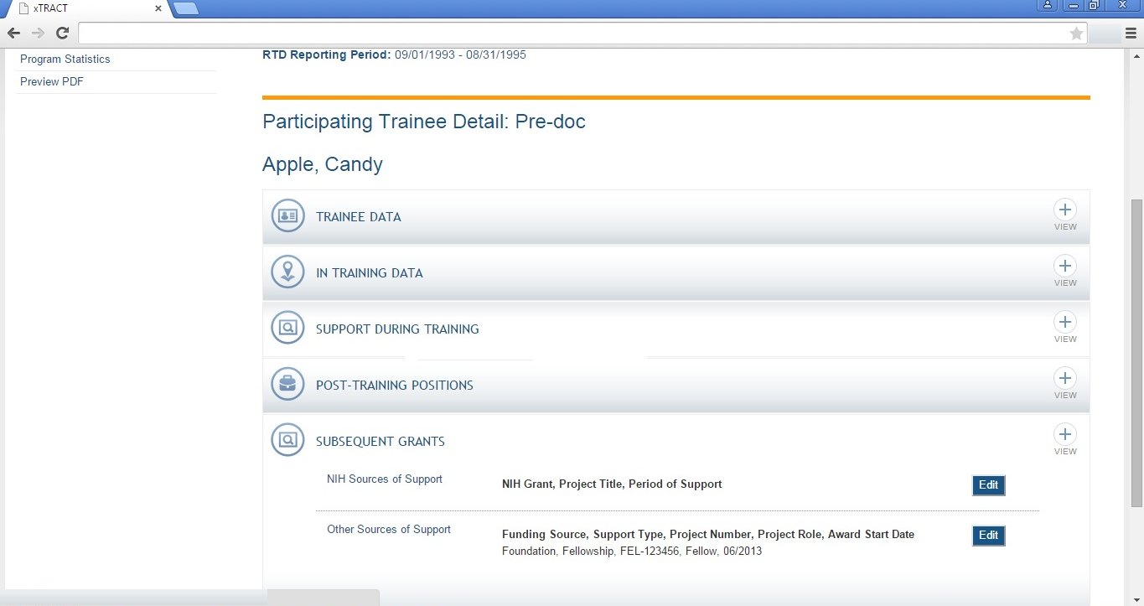

RPPR, Edit Participating Trainee (Predoctoral), Subsequent Grants, NIH Sources of Support

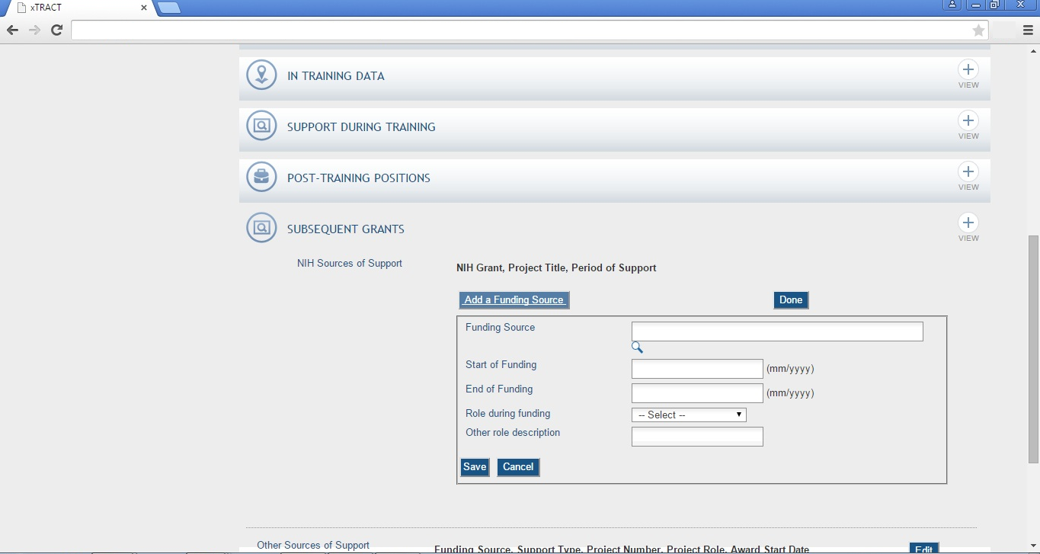
RPPR, Edit Participating Trainee (Predoctoral), Subsequent Grants, Other Sources of Support

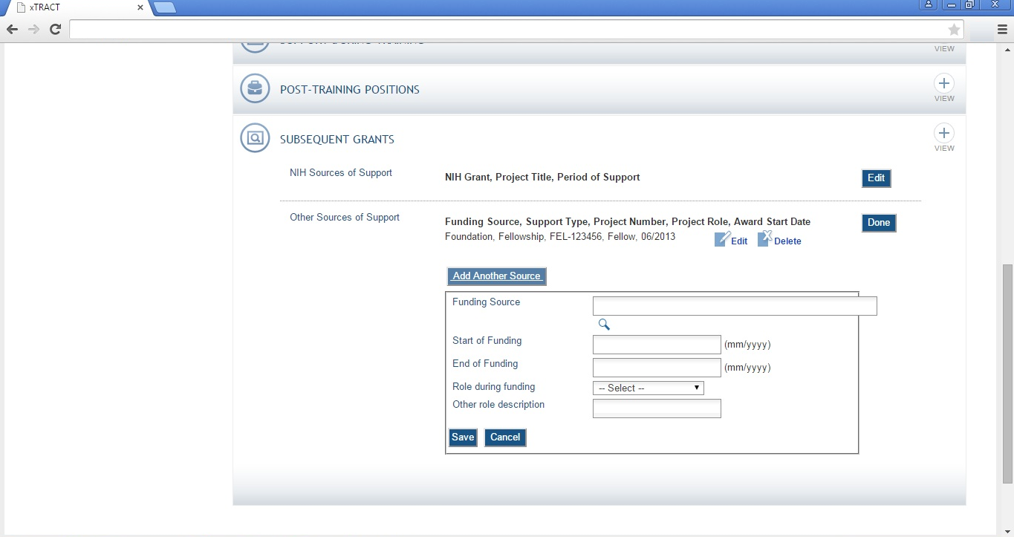
RPPR, Edit Participating Trainee (Predoctoral), Program Statistics

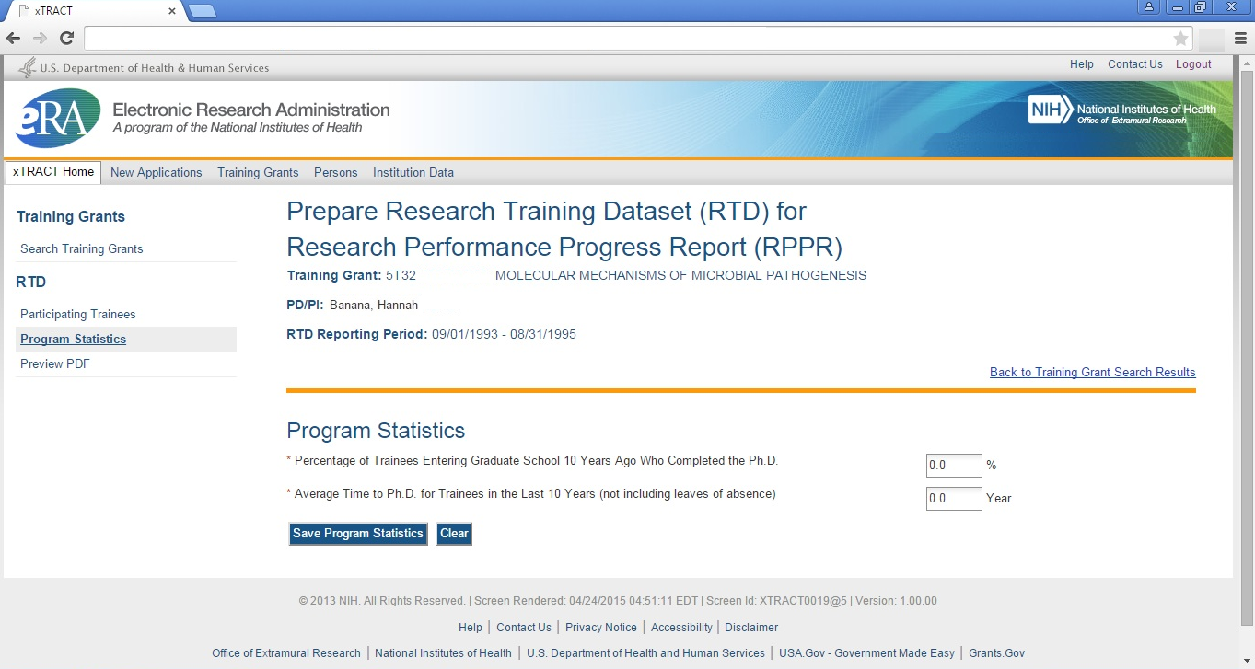

RPPR, Edit Participating Trainee (Postdoctoral), In Training Data
Note: When editing a postdoctoral trainee, In Training is the only section that will be different, in that the circled label will say “postdoctoral”.

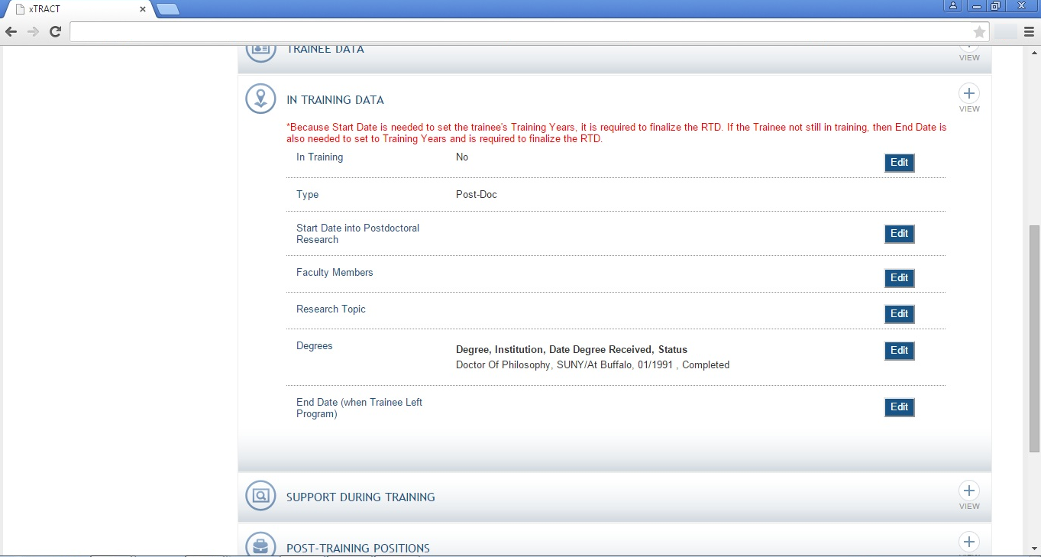
RPPR, Edit Participating Trainee (Short Term)
Note that for a short-term trainee only three of the data sections are used (support during training and post-training positions do not appear)

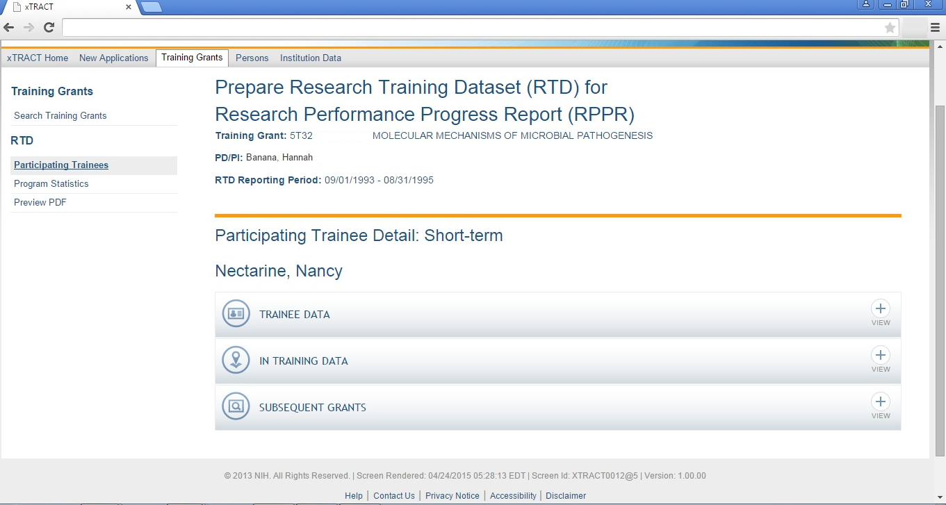
RPPR, Edit Participating Trainee (Short Term), In Training Data
Note: No degrees are collected for short-term, but another data item is unique to this type of trainee (category).

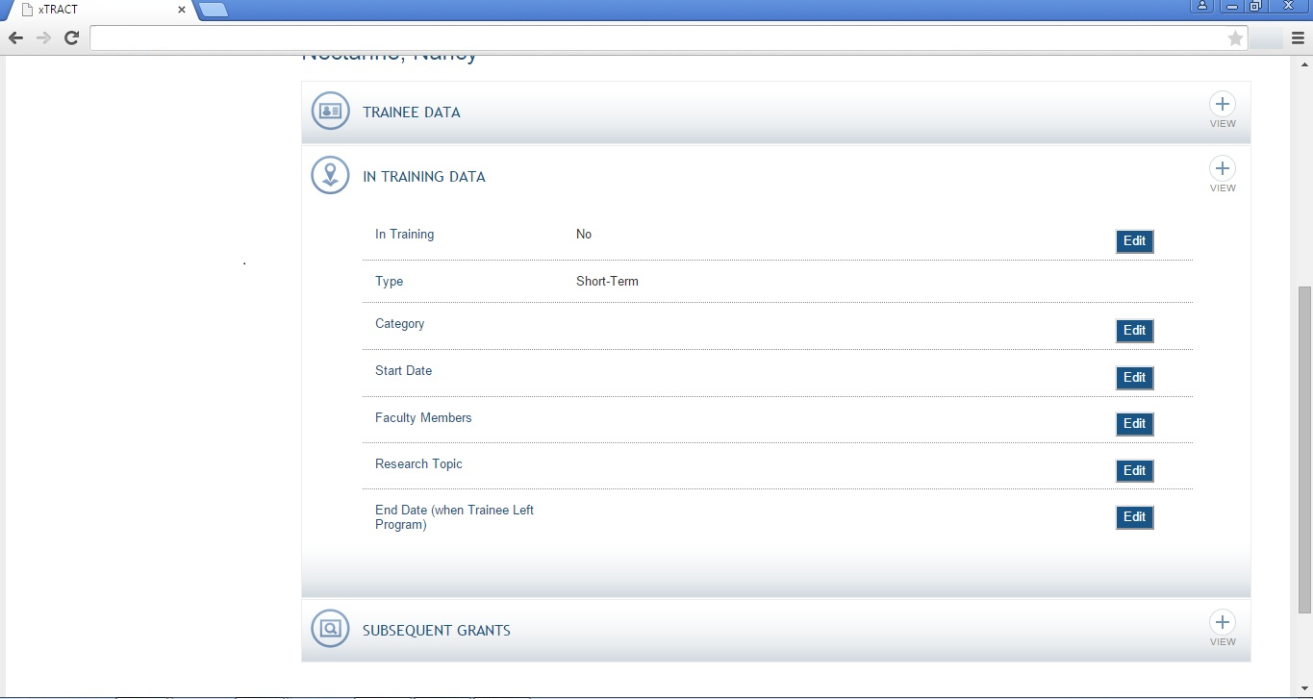

RPPR, Edit Participating Trainee (Short Term), In Training Data, Category

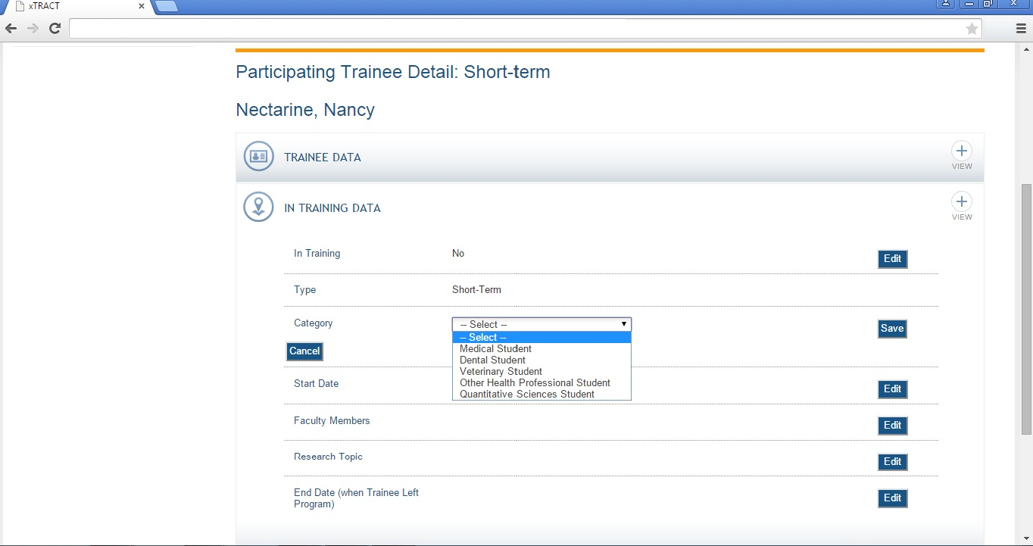

SCREENS FOR PREPARING GENERAL PERSON DATA
In addition to the screens shown previously, which all relate to data entry for an Research Training Dataset, there are also screens for maintaining central data about persons, independent of any one specific RTD. These screens allow for some person-specific data to be edited/maintained centrally, thereby rendering it available for use across all RTD’s. The following pages present the xTRACT screens that provide central person data editing capabilities.
Persons Data, Search

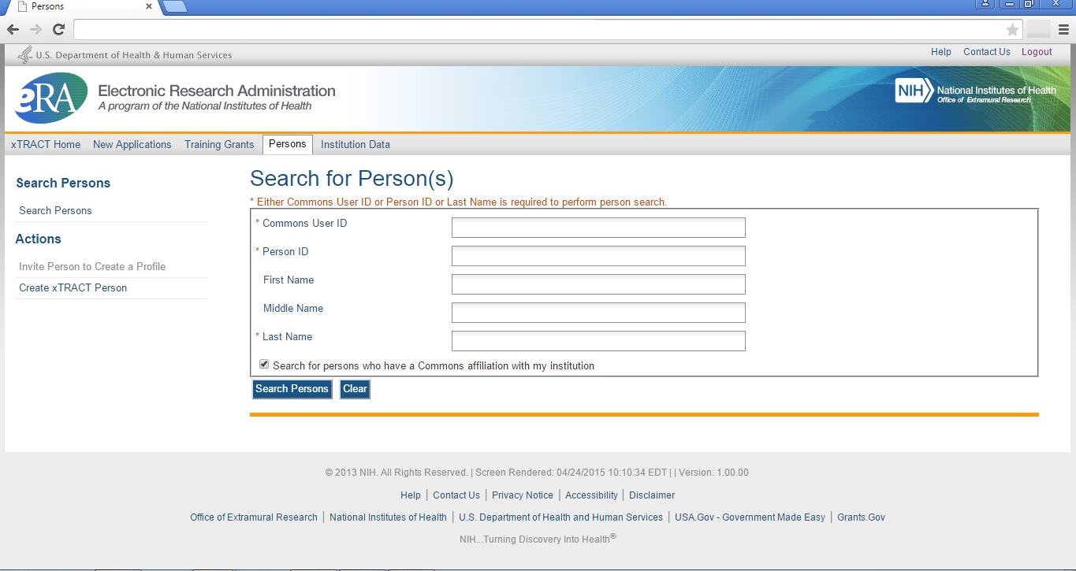
Persons Data, Search Results

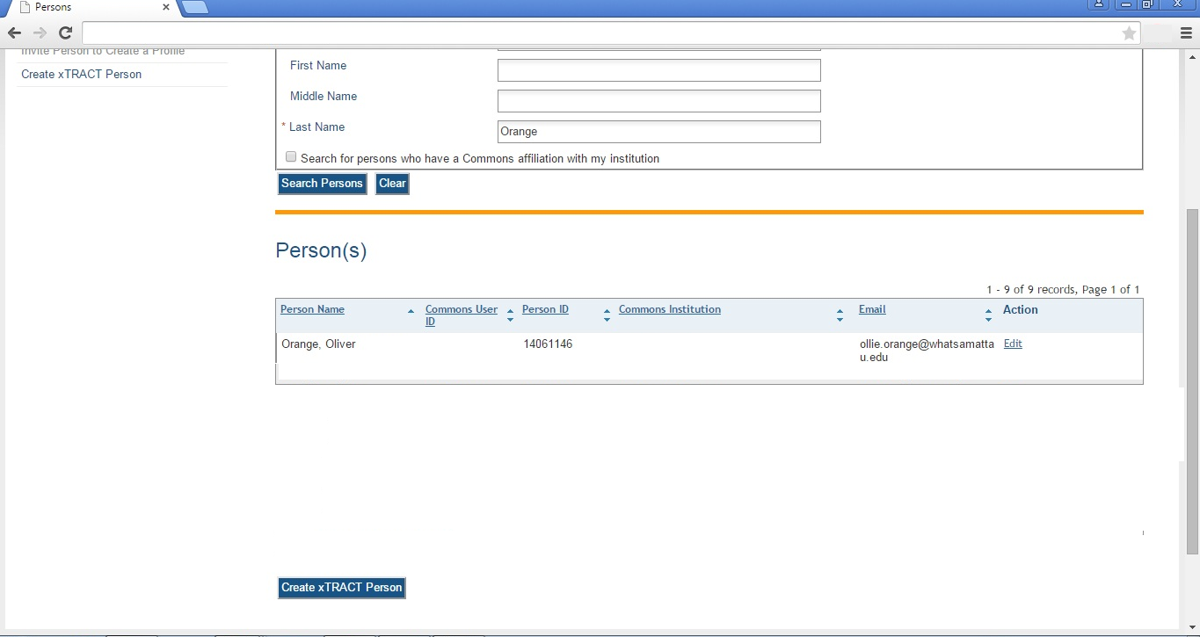

Persons Data, Edit (main)

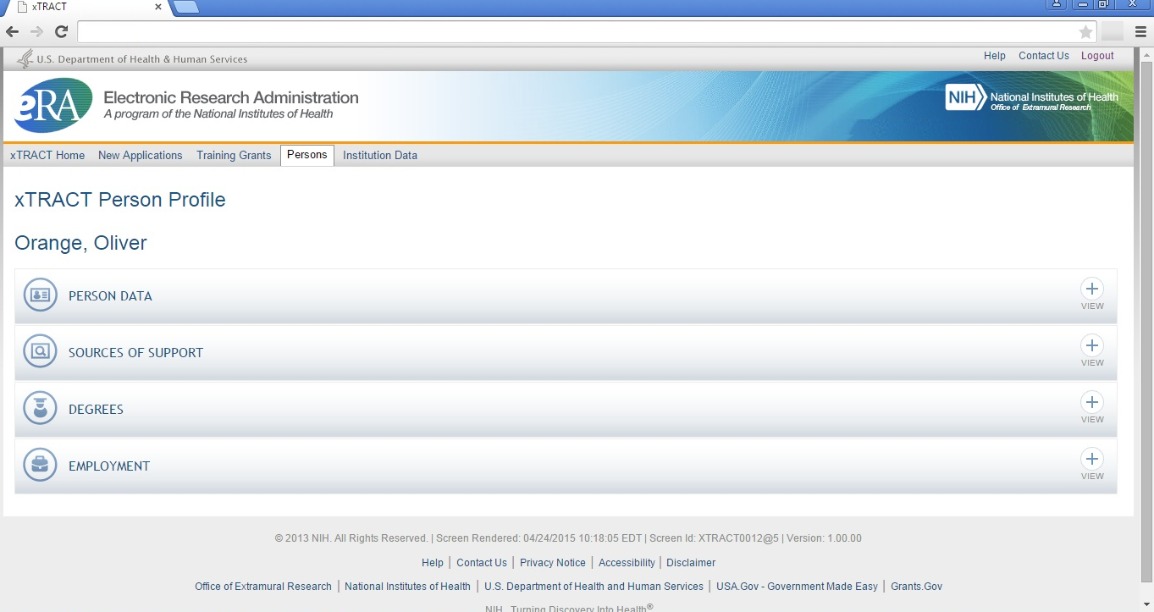

Persons Data, Edit, Person Data Section

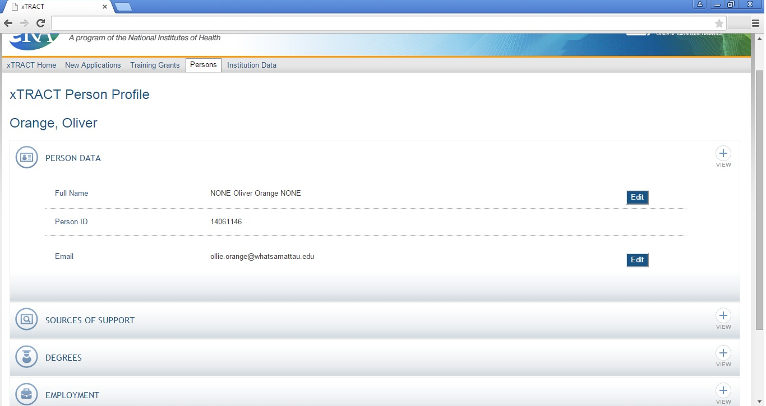

Persons Data, Edit, Person Data Section, Name Edit

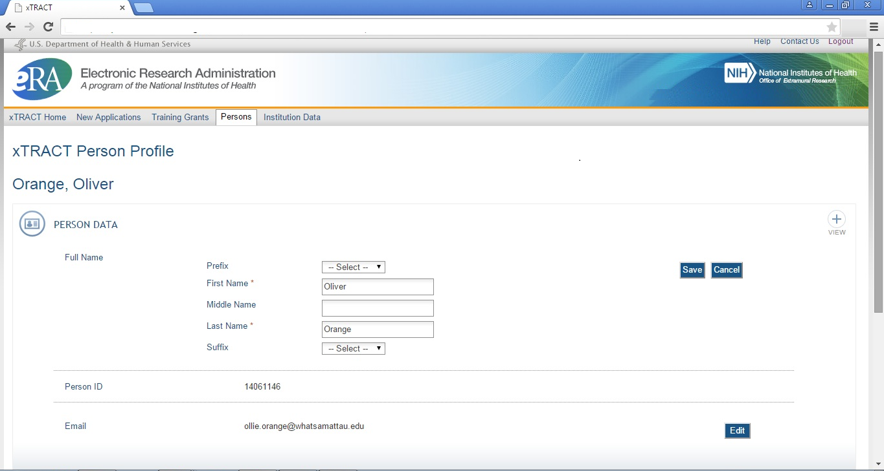

Persons Data, Edit, Person Data Section, Email Edit

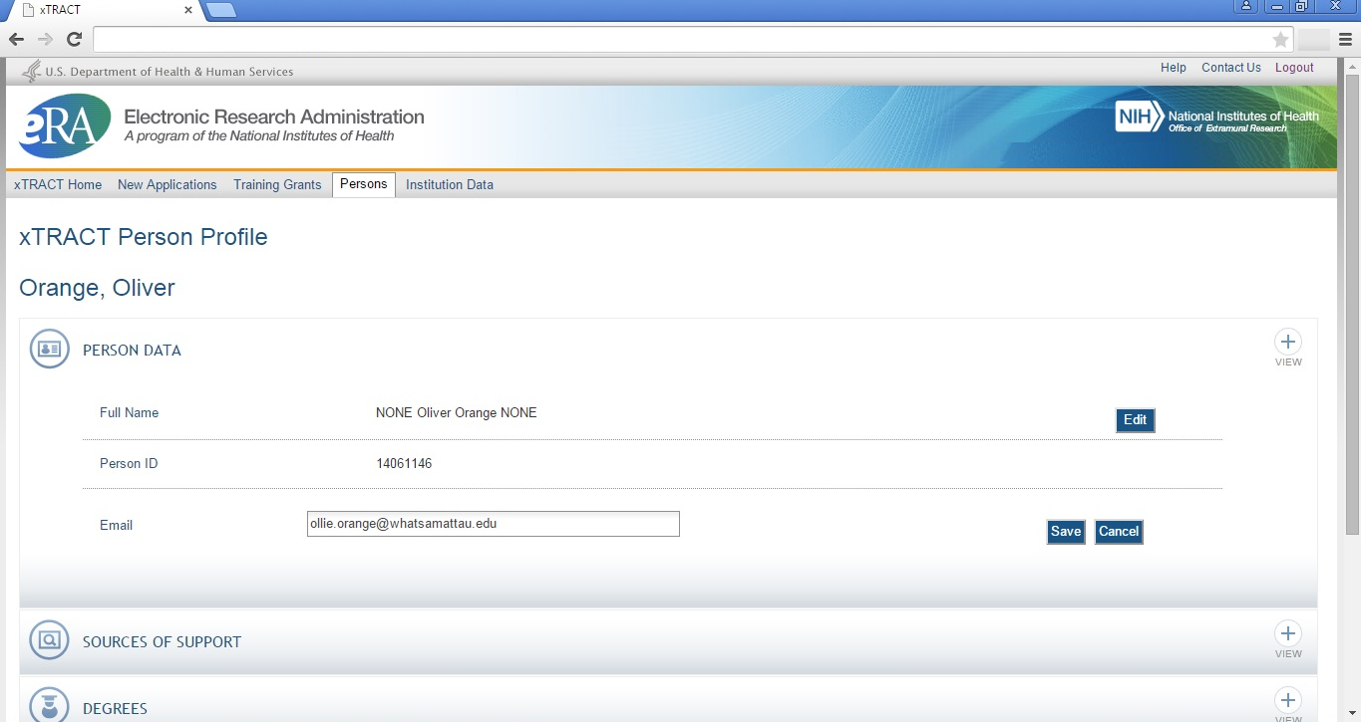
Persons Data, Edit, Person Data Section, Sources Of Support Section

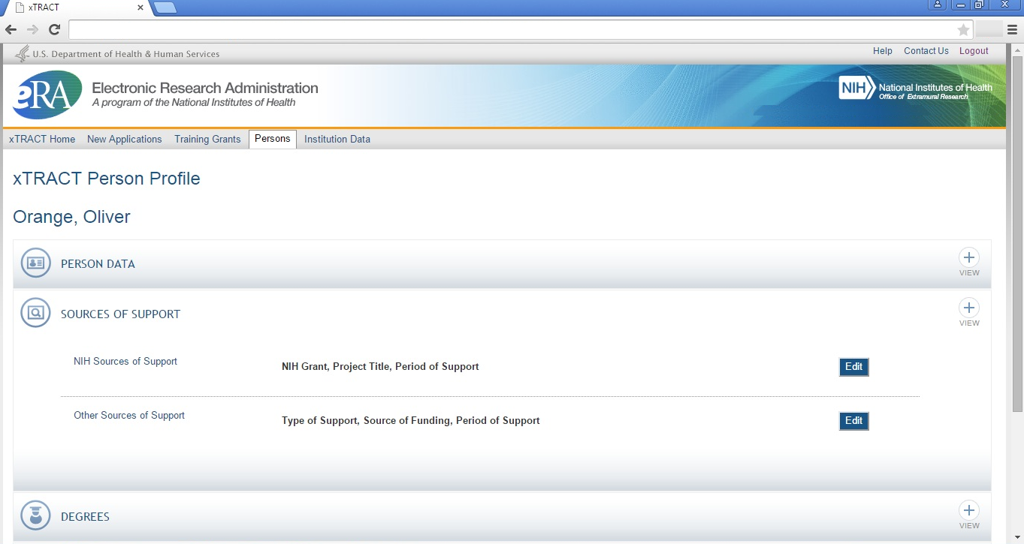

Persons Data, Edit, Person Data Section, Sources Of Support, NIH Sources, Edit

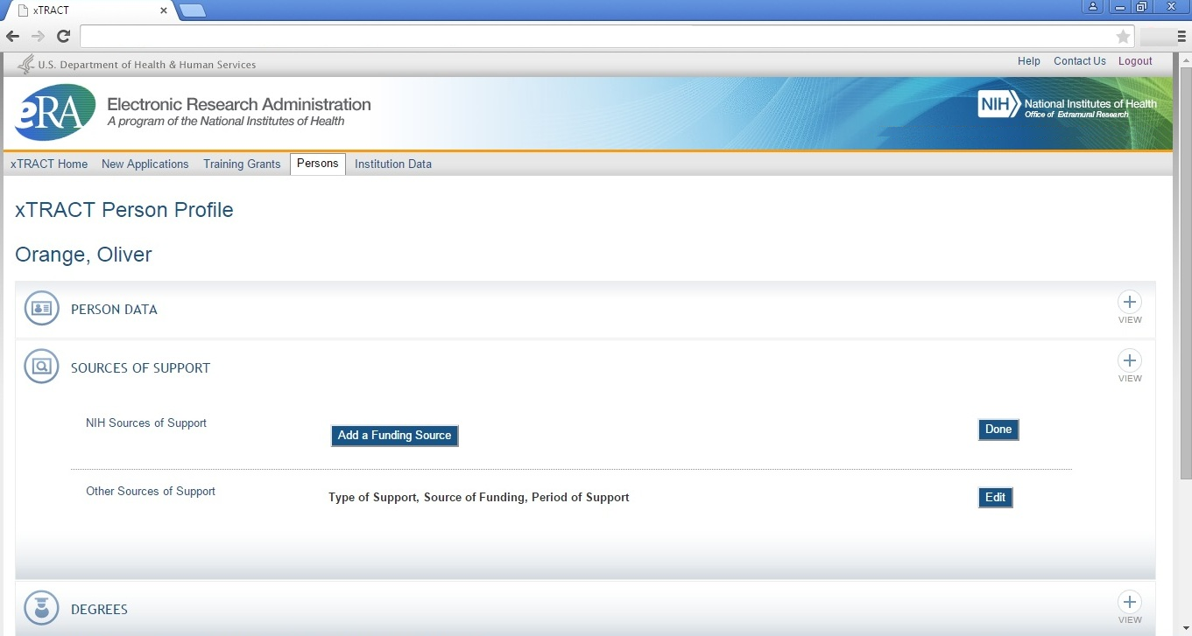

Persons Data, Edit, Person Data Section, Sources Of Support, NIH Sources, Edit, Add Funding Source

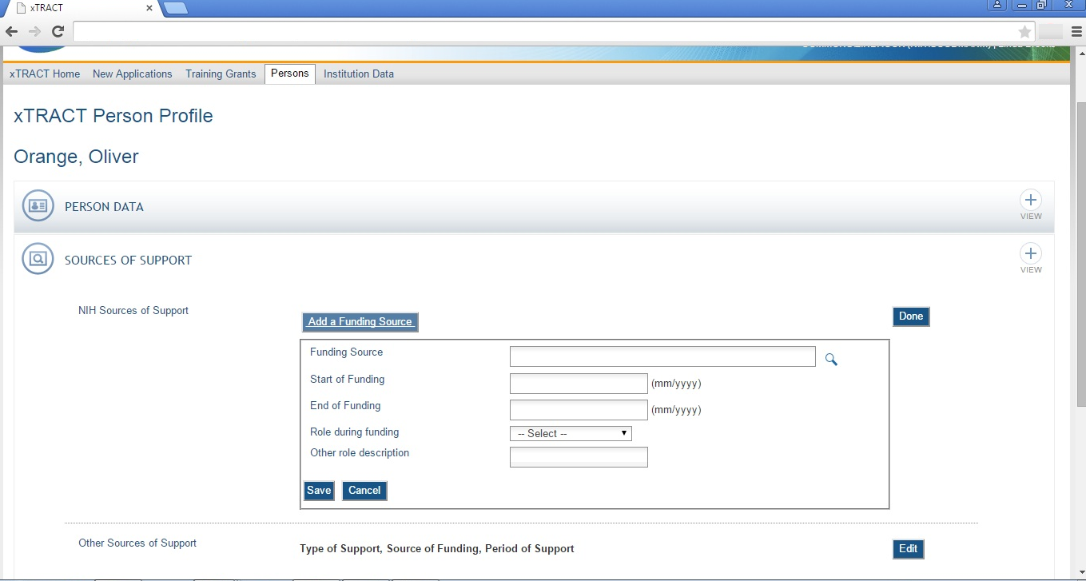

Persons Data, Edit, Person Data Section, Sources Of Support, NIH Sources, Edit, Add Funding Source, Select

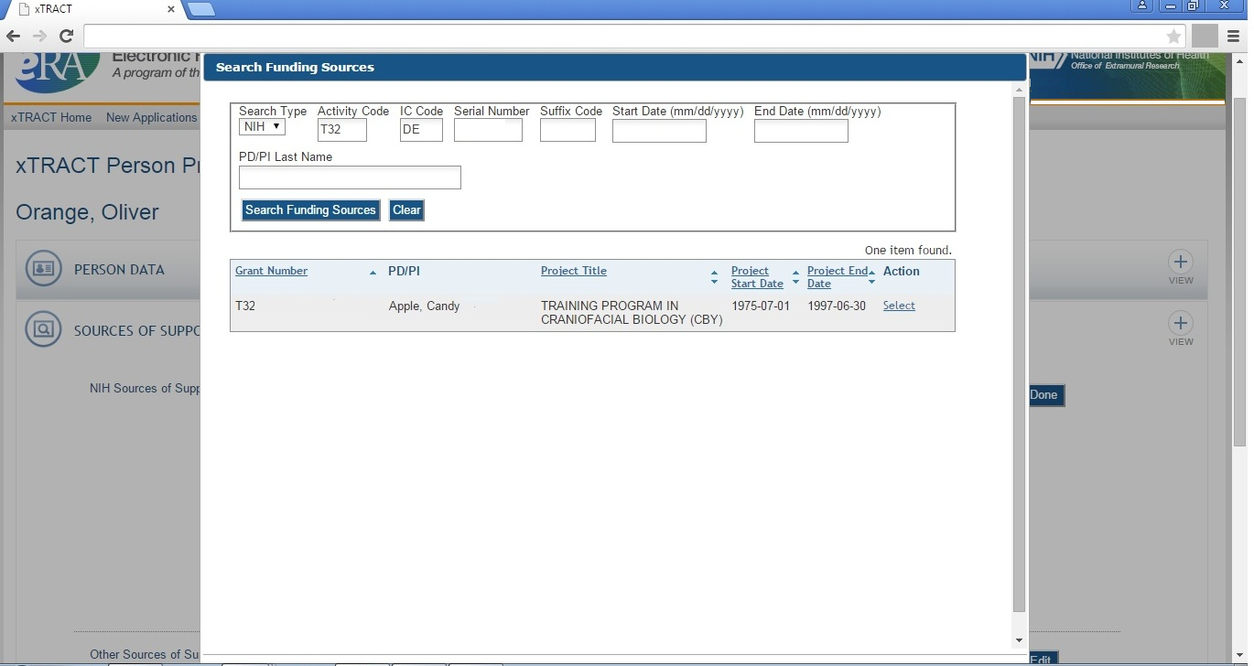

Persons Data, Edit, Person Data Section, Sources Of Support, NIH Sources, Edit, Add Funding Source, Data Entered

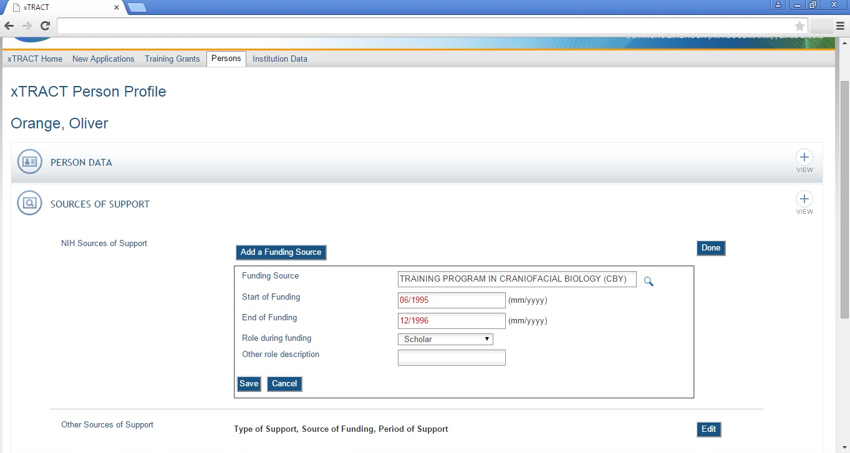

Persons Data, Edit, Person Data Section, Sources Of Support, NIH Sources, Edits Saved and Refreshed

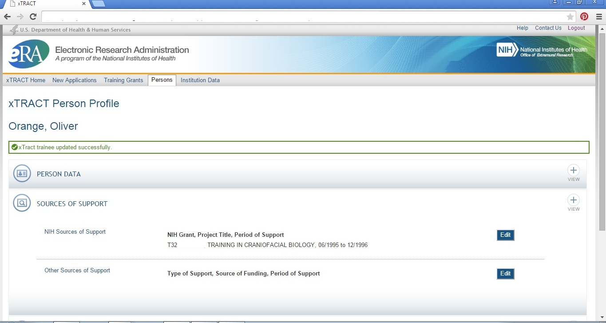
Persons Data, Edit, Person Data Section, Sources Of Support, Other Sources, Edit

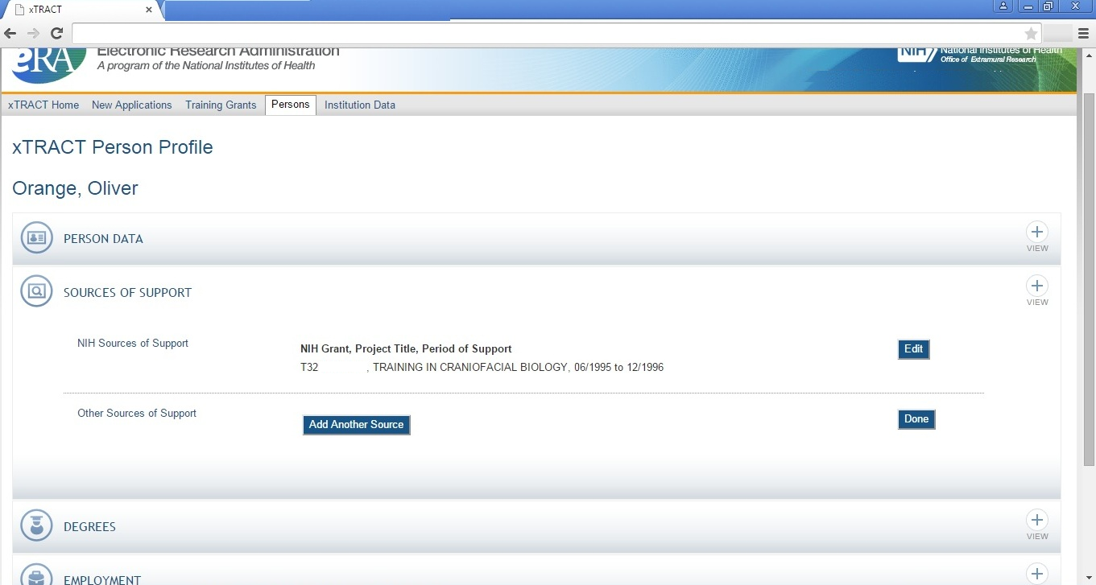
Persons Data, Edit, Person Data Section, Sources Of Support, Other Sources, Edit, Add Source

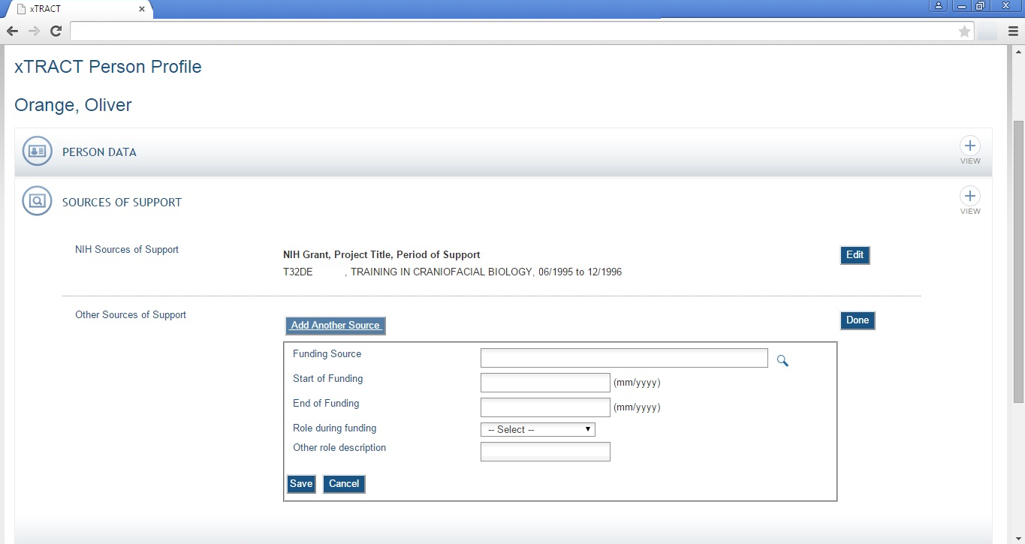

Persons Data, Edit, Person Data Section, Sources Of Support, Other Sources, Edit, Add Source, Select

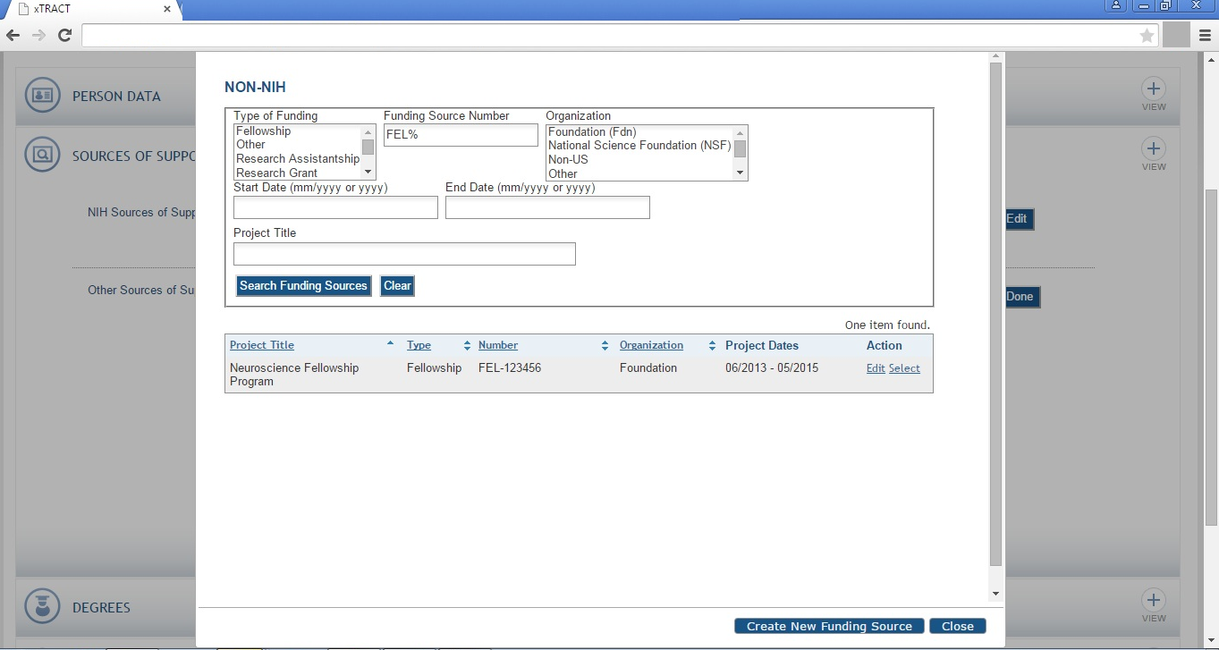

Persons Data, Edit, Person Data Section, Sources Of Support, Other Sources, Edit, Add Source, Data Entered

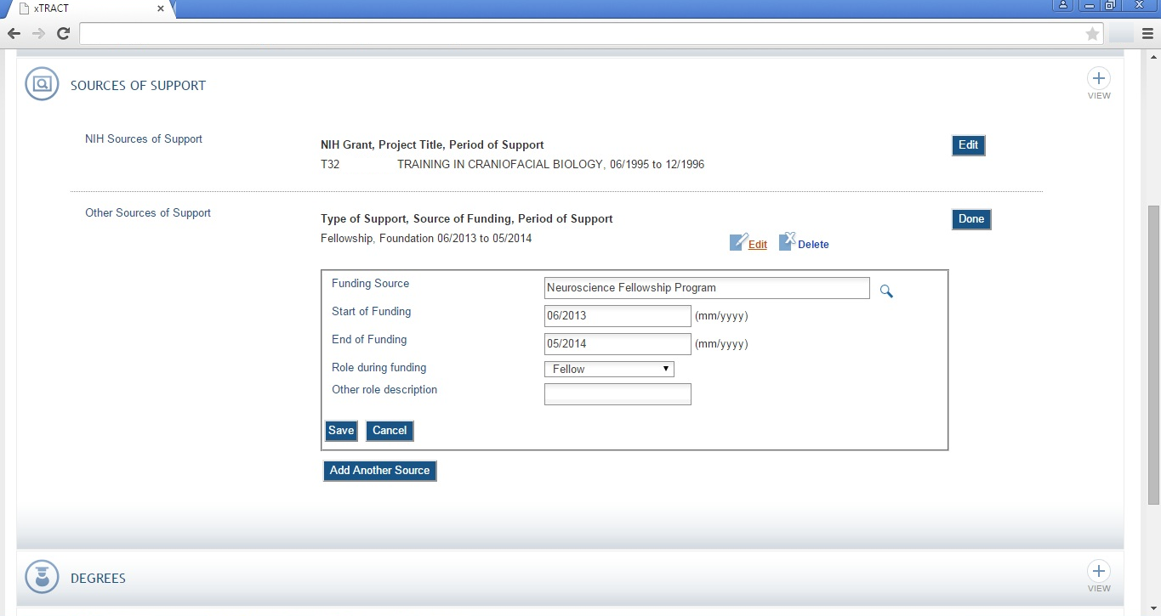

Persons Data, Edit, Person Data Section, Sources Of Support, Other Sources, Edit, Add Source, Saved and Refreshed

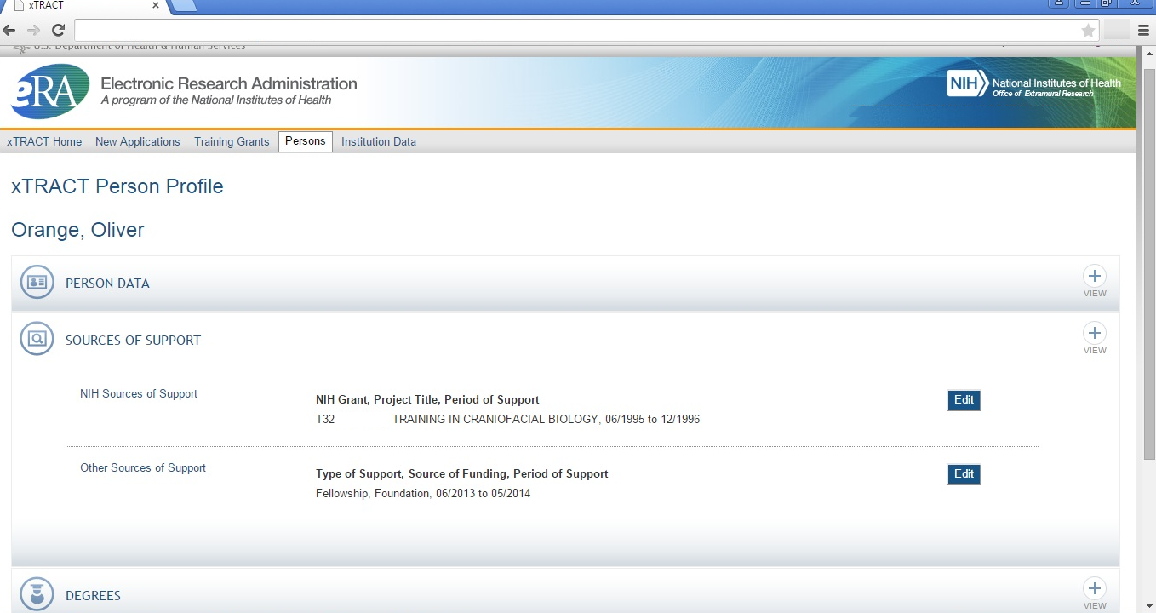
Persons Data, Edit, Degrees Section

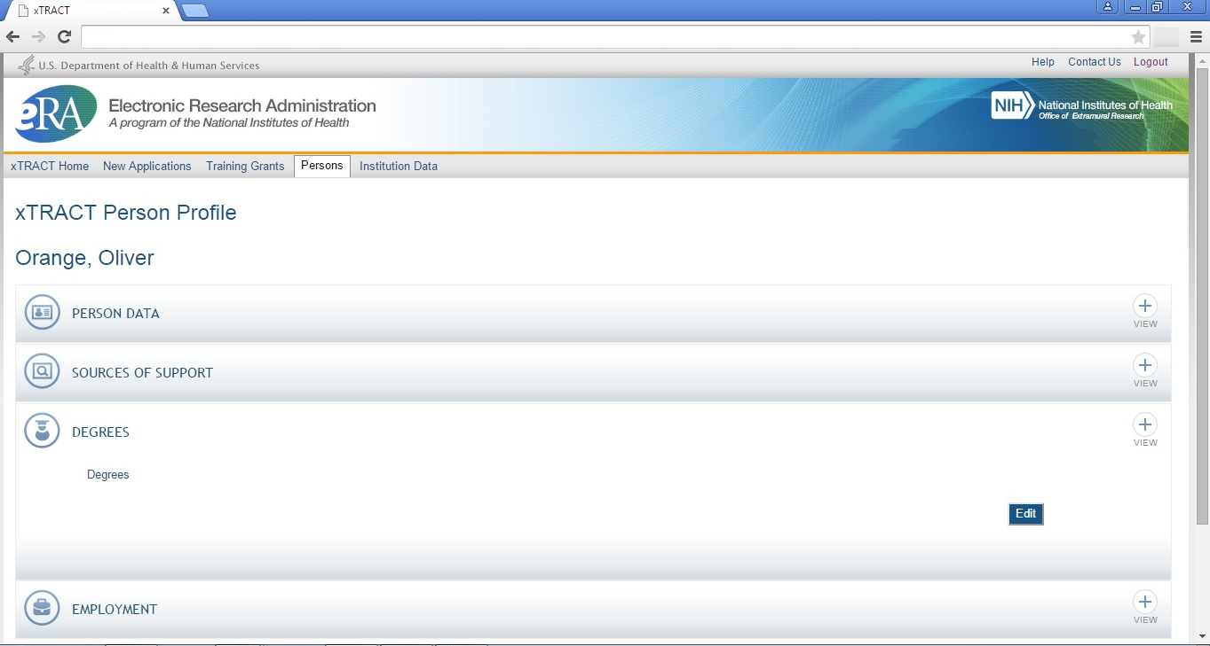

Persons Data, Edit, Degrees Section, Edit

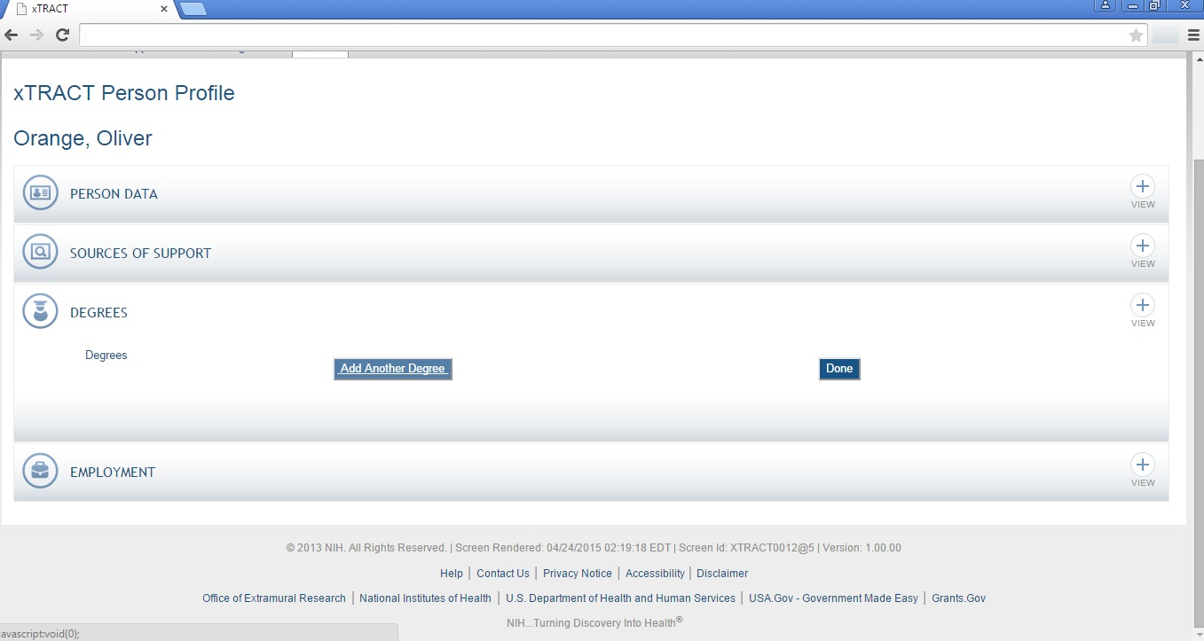

Persons Data, Edit, Degrees Section, Edit, Add Degree

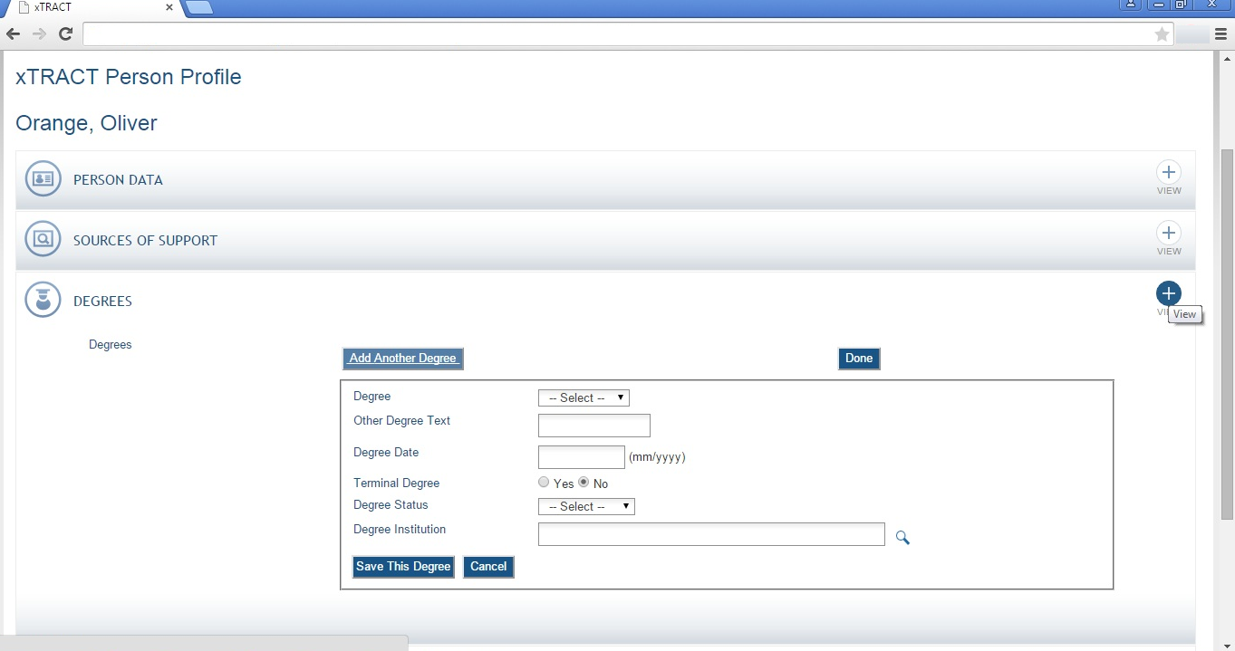

Persons Data, Edit, Degrees Section, Edit, Add Degree, Search for Institution

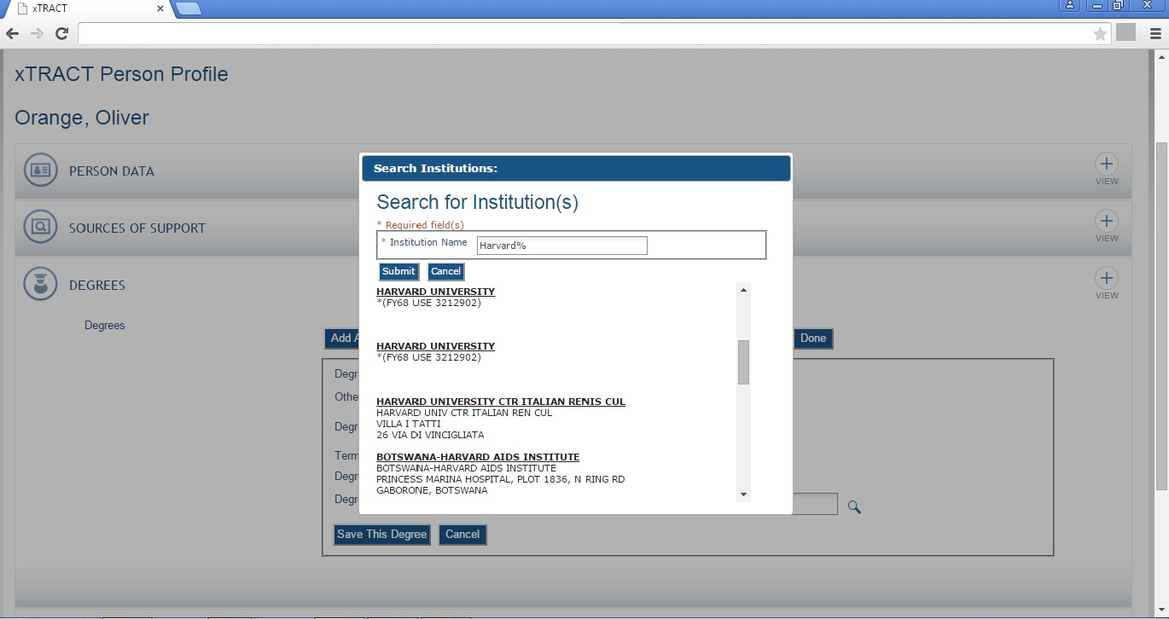

Persons Data, Edit, Degrees Section, Edit, Add Degree, Data Entered

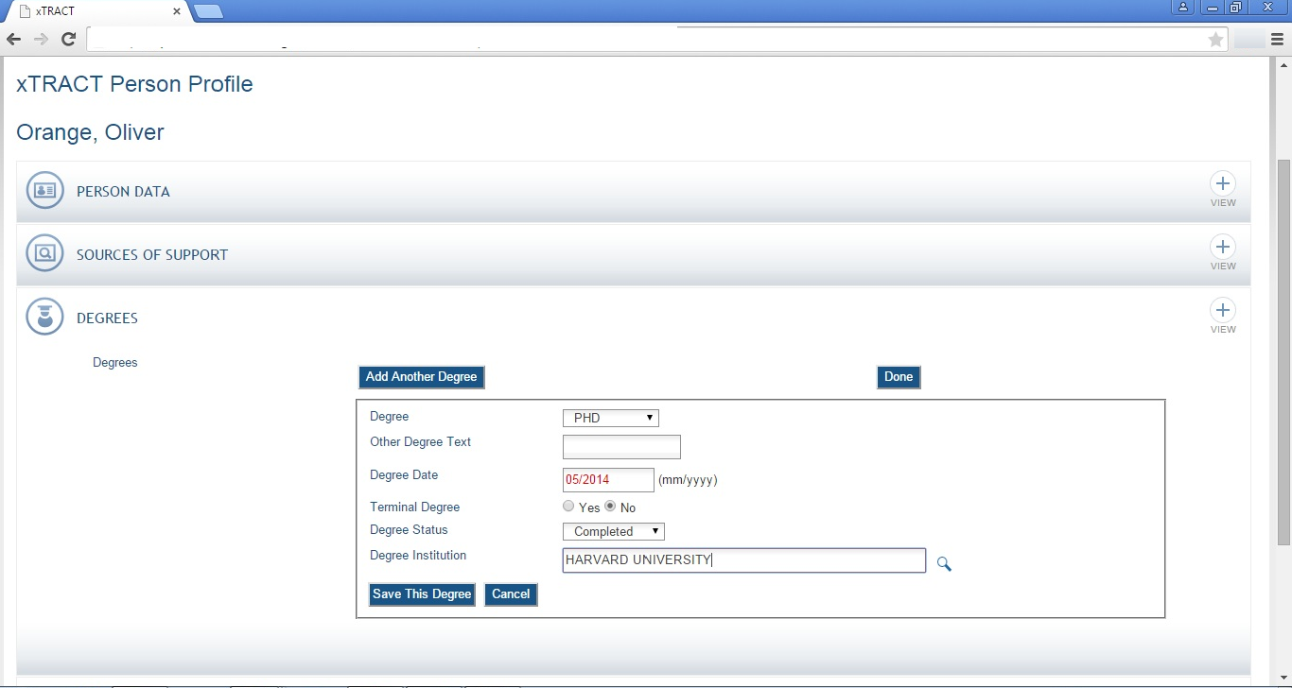
Persons Data, Edit, Degrees Section, Edit, Terminal Degree Indicated

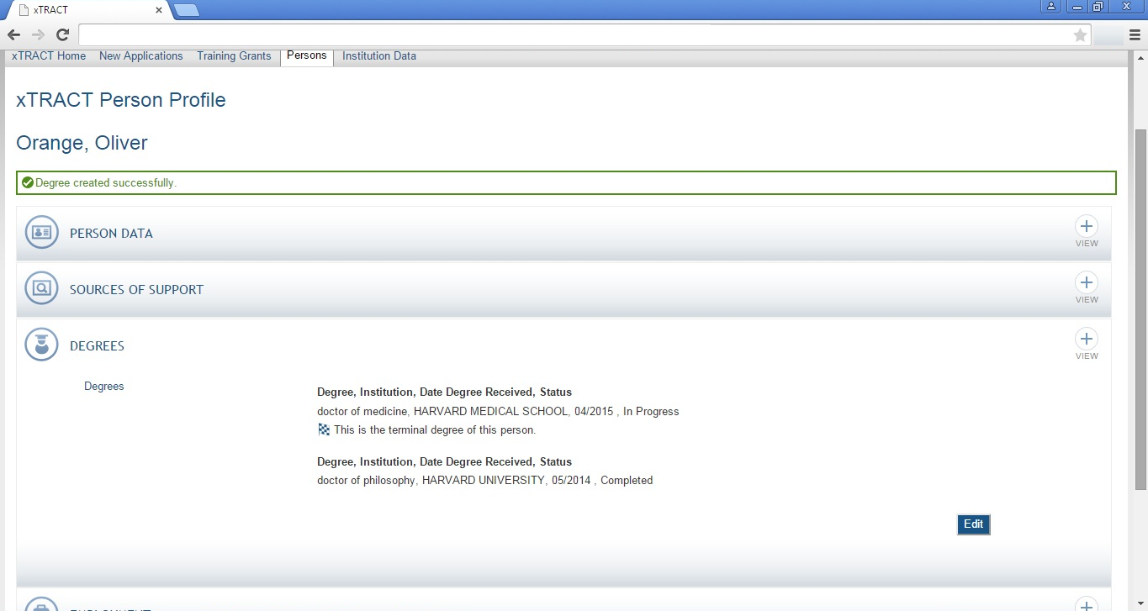

Persons Data, Edit, Employment Section

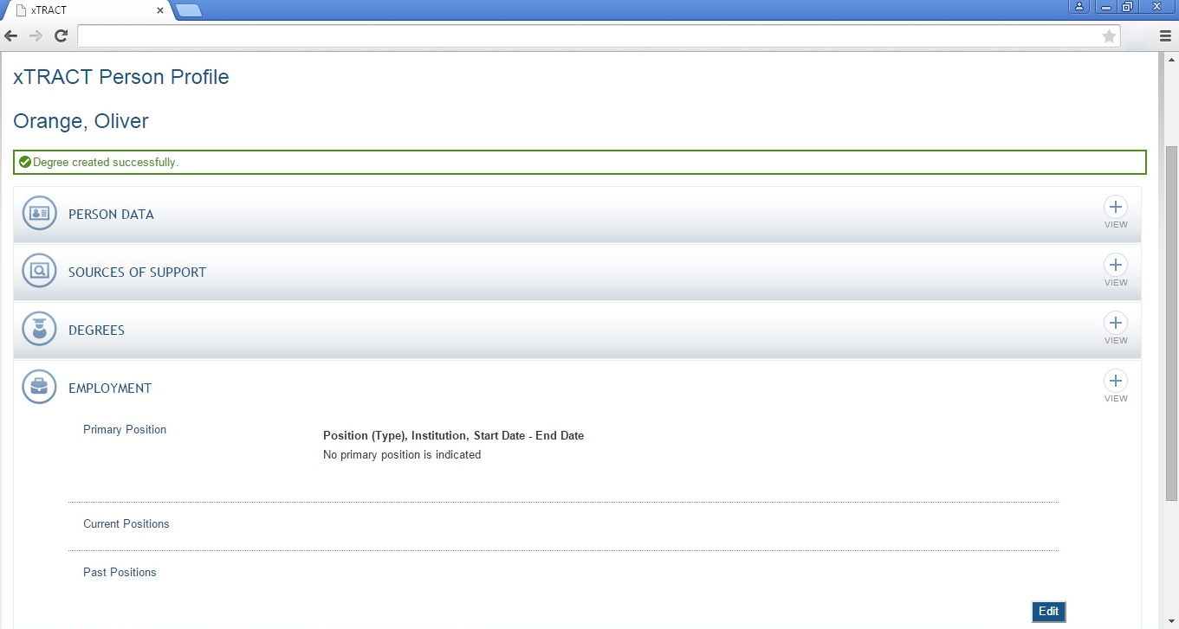
Persons Data, Edit, Employment Section, Edit

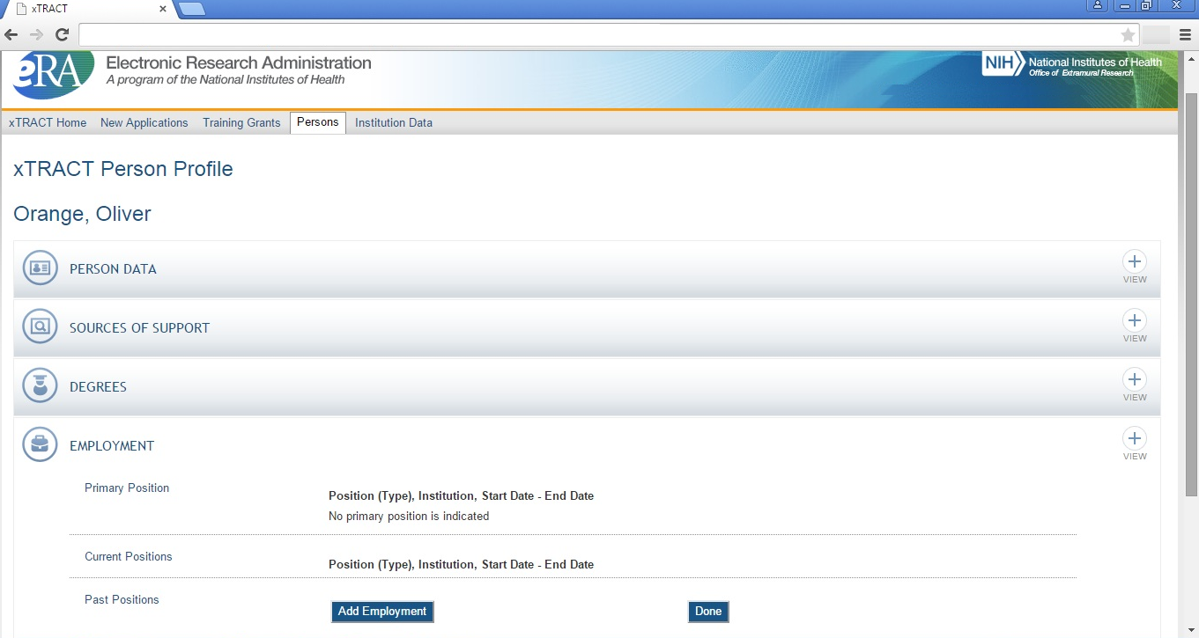
Persons Data, Edit, Employment Section, Edit, Add Employment

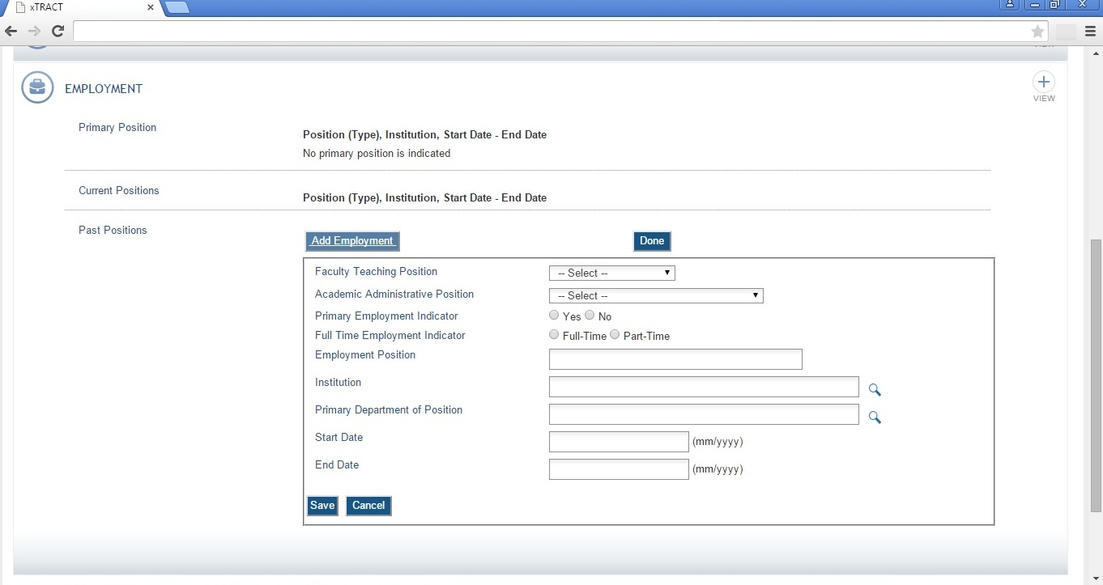
Persons Data, Edit, Employment Section, Edit, Add Employment, Data Entered

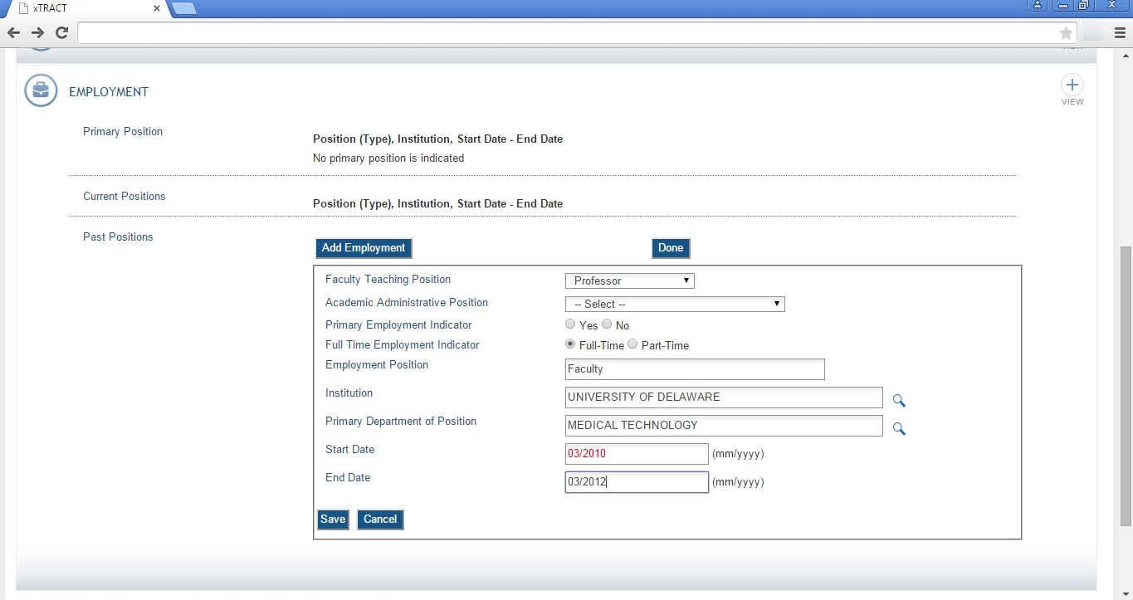

SCREENS FOR PREPARING GENERAL INSTITUTION DATA
There are also screens for maintaining central data about the user’s grantee institution, independent of any one specific RTD. These screens allow for some institution-specific data to be edited/maintained centrally, thereby rendering it available for use across all RTD’s. The two primary categories of institution data maintained in this section are (1) Programs within the institution, and (2) Funding sources. The following pages present the xTRACT screens that provide these central institution data editing capabilities.

Institution Data (main)

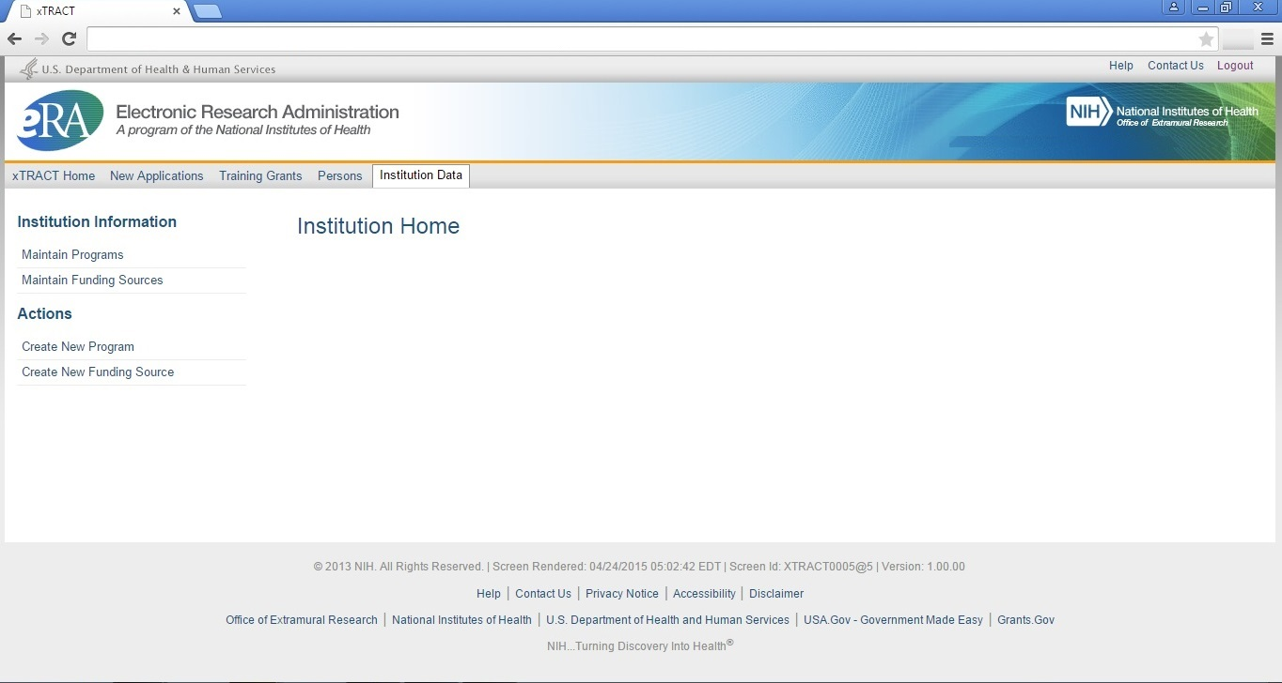

Institution Data, Maintain Programs, Search

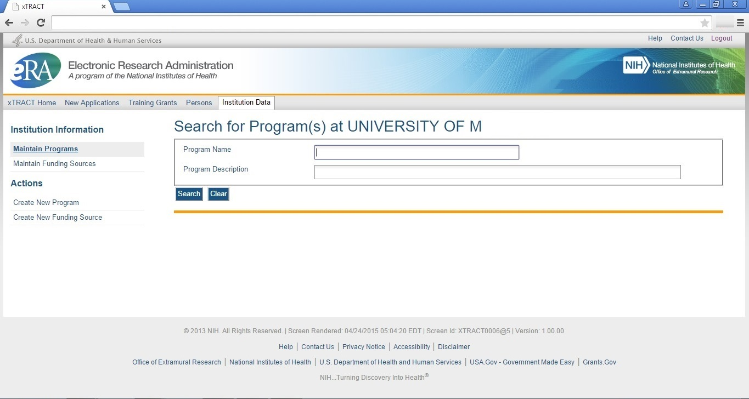

Institution Data, Maintain Programs, Create Program

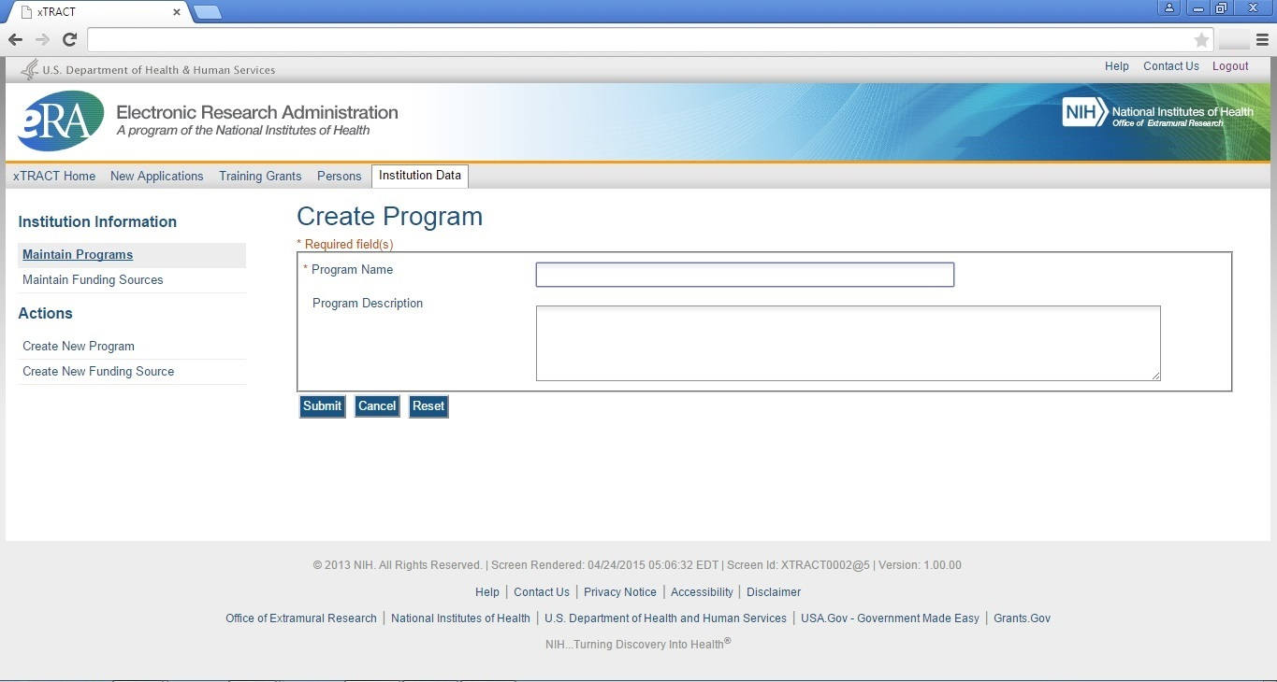

Institution Data, Create New Funding Source

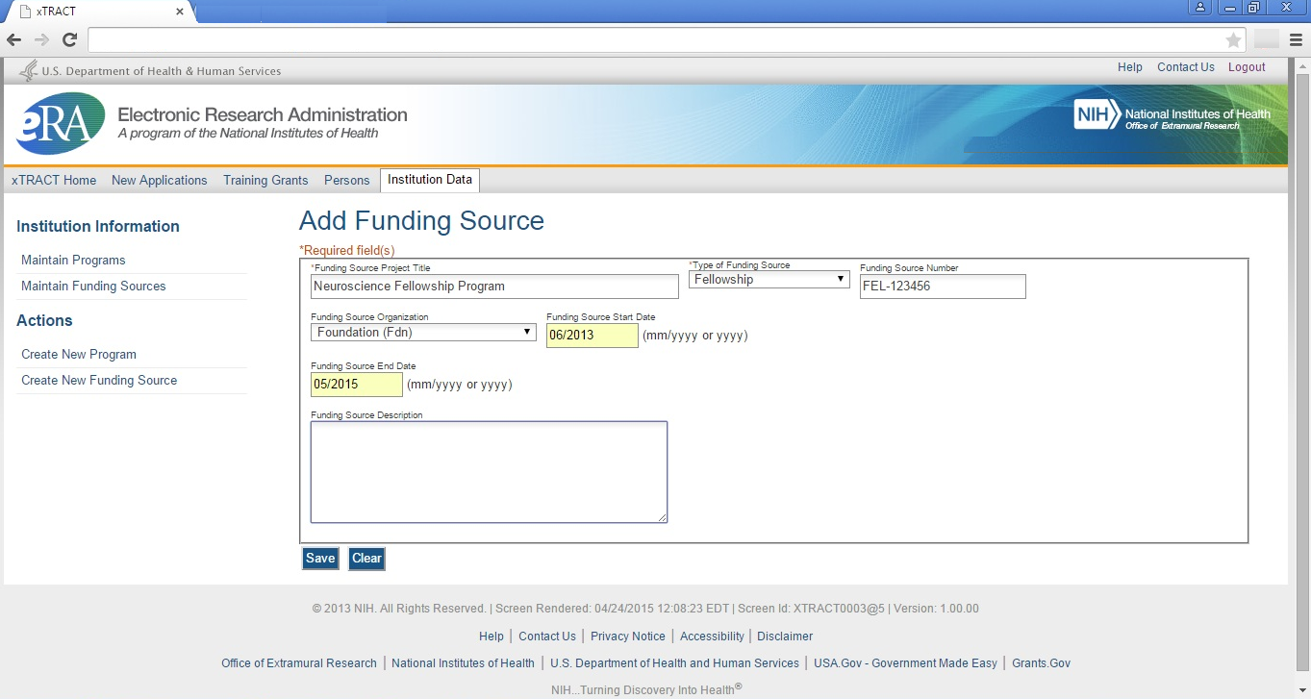
Institution Data, Maintain Funding Sources, Search

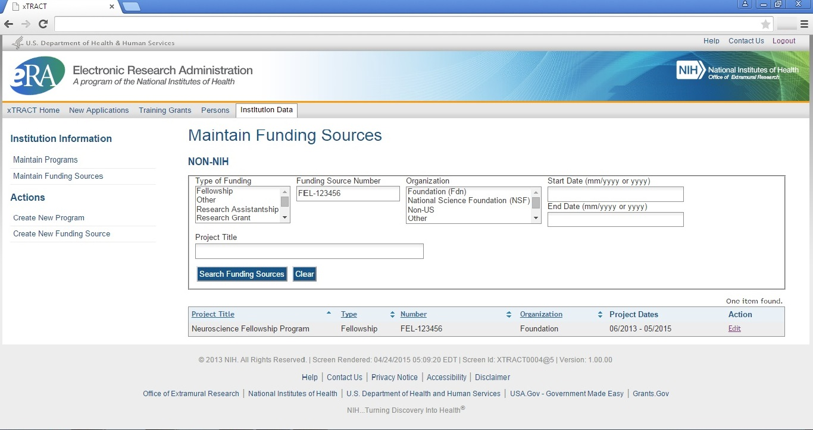

Institution Data, Maintain Funding Sources, Edit Funding Source

