Figure 1: Submit Questionnaire and Link Questionnaire to Nursing Home(s)
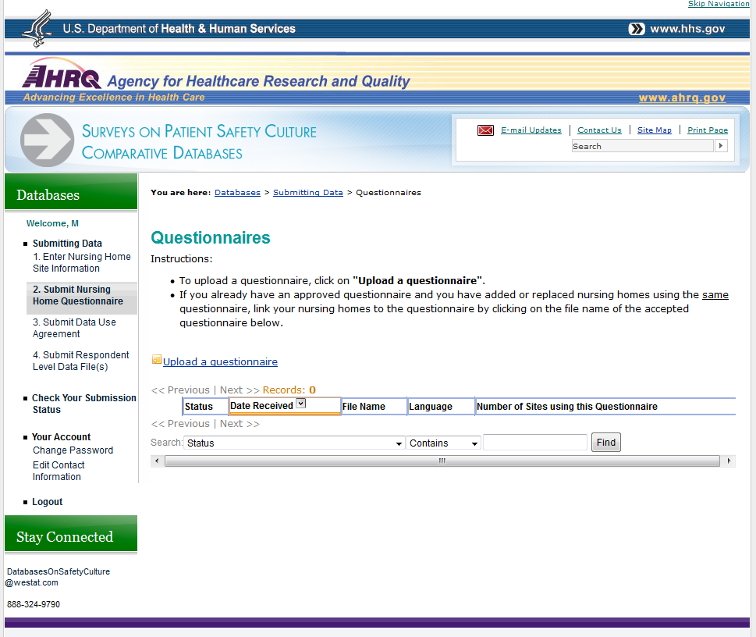

Figure 1: Submit Questionnaire and Link Questionnaire to Nursing Home(s), continued
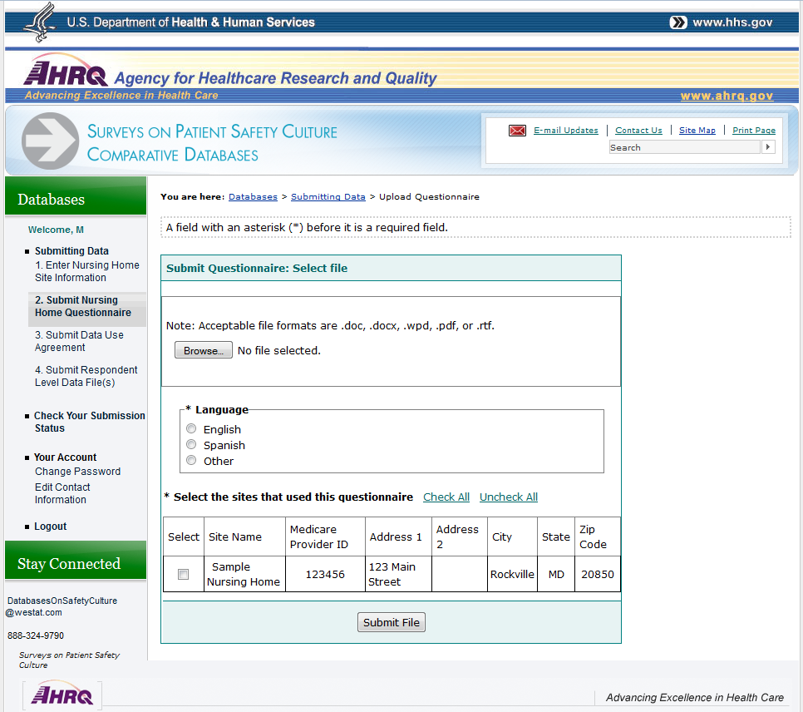

Figure 2: Upload Data File for Each Participating Nursing Home
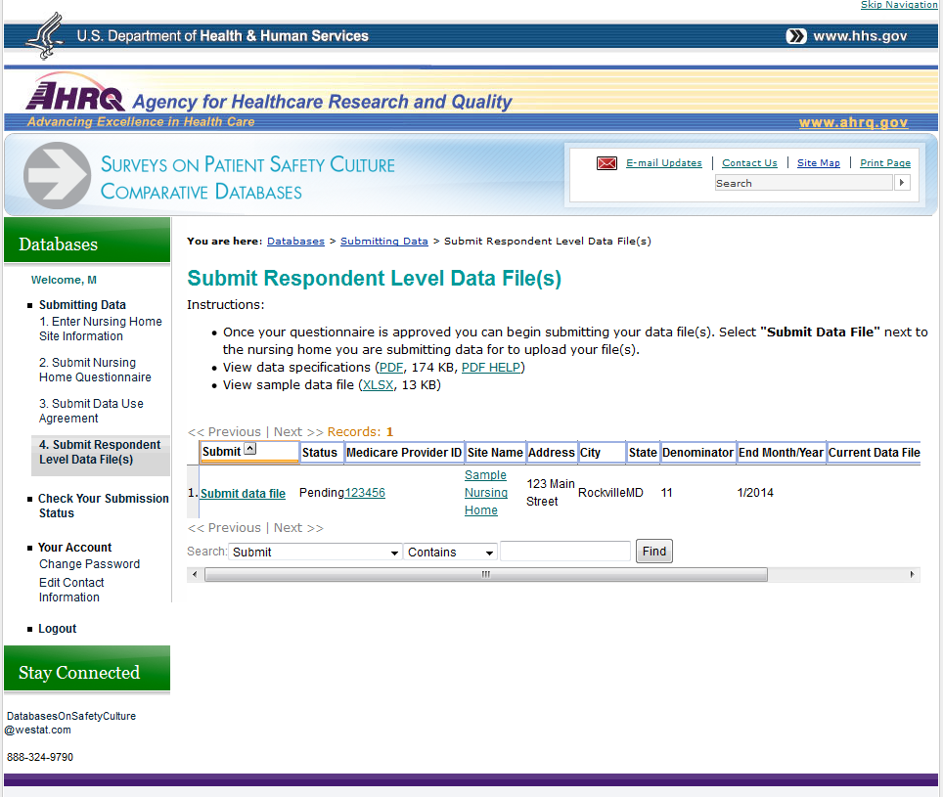

Figure 2: Upload Data File for Each Participating Nursing Home, continued
