Attachment C: Nursing Home Site Information Form

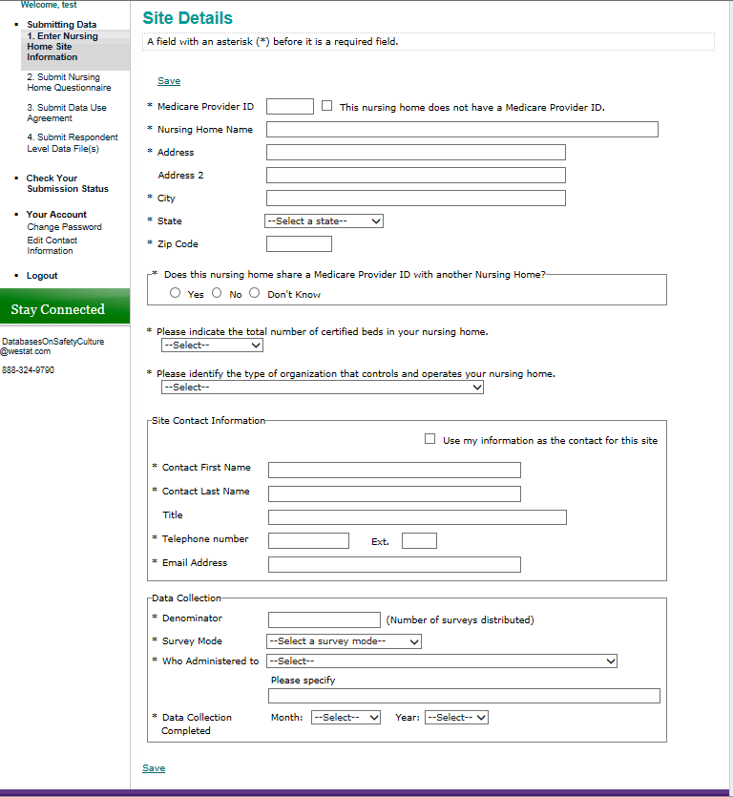
Response options for who administered to:
- All staff/sample of all staff
- Selected departments/units only (please specify)
- Selected staff positions only (please specify)
- Selected departments/units and selected staff positions (please specify)
Response options for certified beds:
- 1-49 beds
- 50-99 beds
- 100-199 beds
- 200 beds or more
Response options for type of organization:
- For Profit – Operated under private commercial ownership
- Non Profit – Operated under voluntary or other nonprofit auspices
- Government – Operated by a governmental entity
Response options for Survey Mode:
- Paper
- Web
- Mixed mode (paper & web)
- Other

Public reporting burden for this collection of information is estimated to average 5 minutes per response, the estimated time required to complete the survey. An agency may not conduct or sponsor, and a person is not required to respond to, a collection of information unless it displays a currently valid OMB control number. Send comments regarding this burden estimate or any other aspect of this collection of information, including suggestions for reducing this burden, to: AHRQ Reports Clearance Officer Attention: PRA, Paperwork Reduction Project (0935-XXXX) AHRQ, 540 Gaither Road, Room # 5036, Rockville, MD 20850.

