Figure 1: Submit Questionnaire and Link Questionnaire to Medical Office(s)
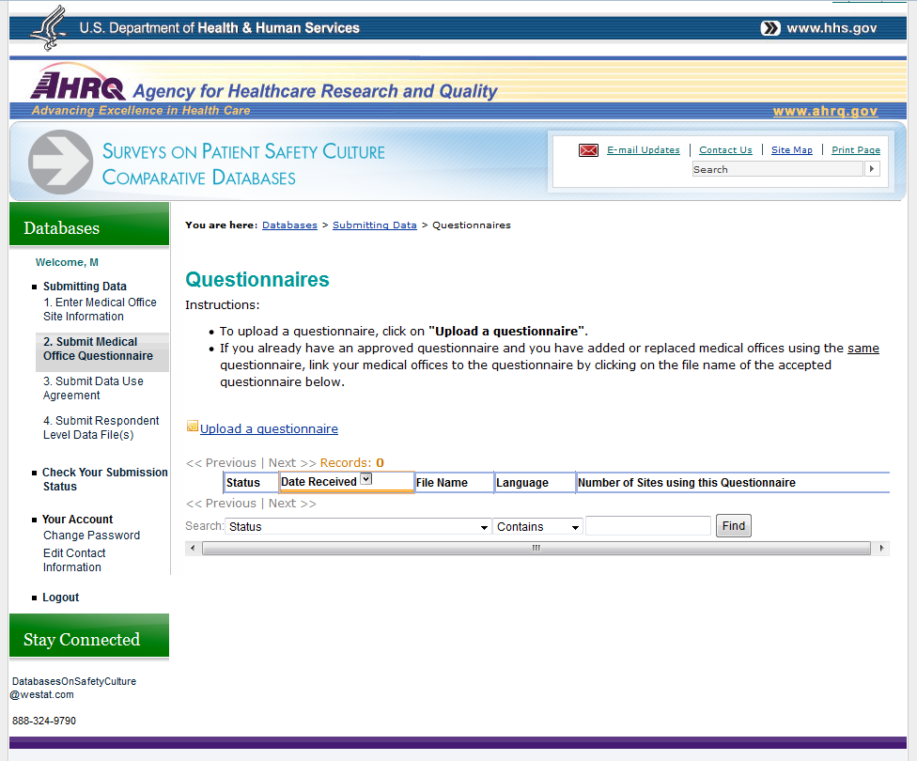

Figure 1: Submit Questionnaire and Link Questionnaire to Medical Office(s), continued
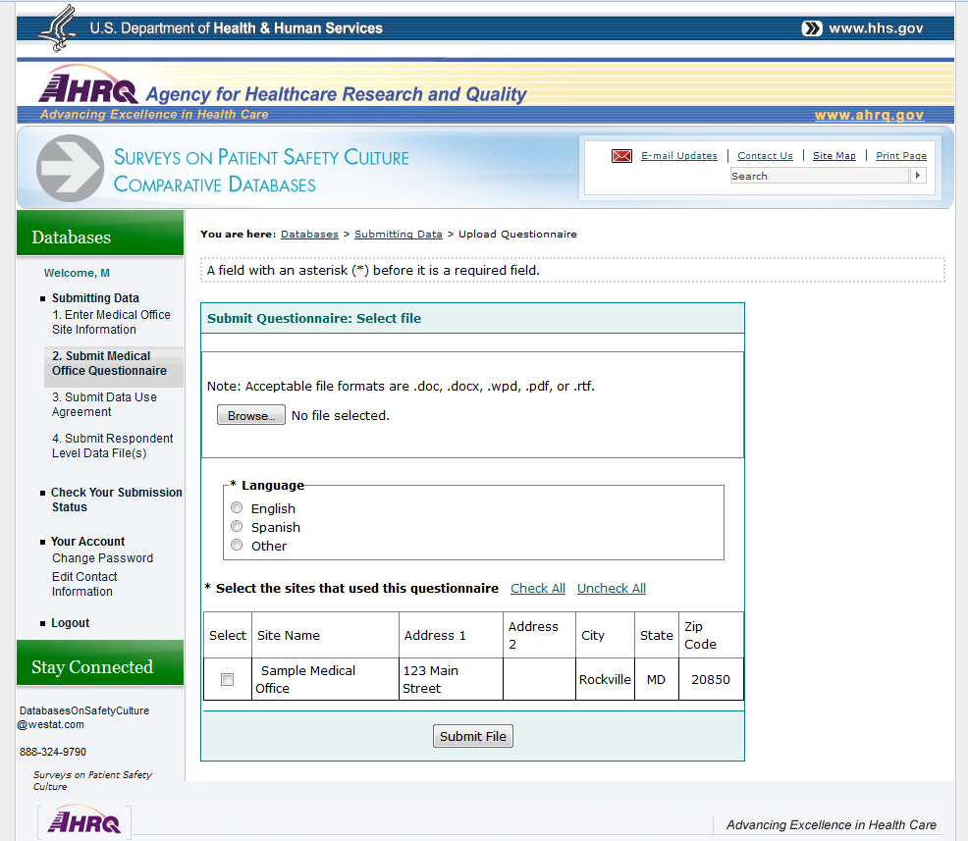

Figure 2: Upload Data for Each Participating Medical Office
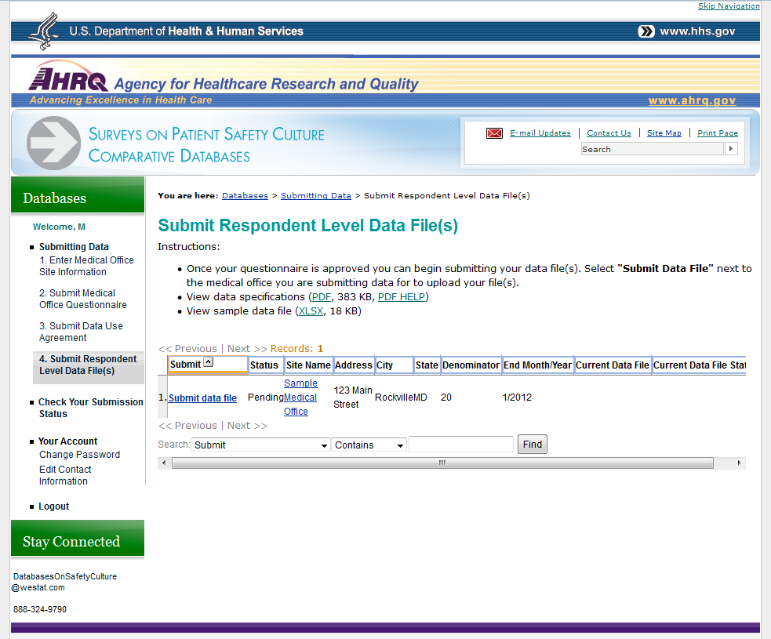

Figure 2: Upload Data for Each Participating Medical Office, continued
