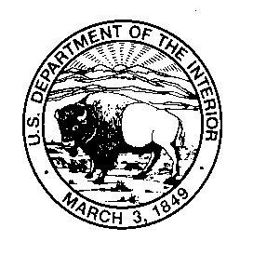
United States Department of the Interior
U.S. Geological Survey
Fort Collins Science Center
2150 Centre Ave., Bldg.C
Fort Collins, Colorado 80526-8118
970.226.XXXX
XXXX@usgs.gov

February 24, 2016

«ID»
Dear NAME,

The U.S. Geological Survey is conducting a survey of Americans like you to discover more about your experiences with and views on nature, specifically wetlands.

Results from the survey will be used to help the U.S. Fish and Wildlife Service, state agencies, and other organizations that manage wetlands and the wildlife that lives there make more informed decisions about the public lands they manage for the use and benefit of all Americans.

Your participation in this survey is voluntary and has been approved through the requirements of the Office of Management and Budget (OMB Control #XXXX-XXXX). It should take you take no more than 20 minutes to complete. When you return your completed survey, your name and address will be deleted from the mailing list and never connected to your answers in any way.

If you would prefer, you can complete the survey online by typing the link below into your computer’s Internet browser (Explorer, Chrome, Firefox, Safari, etc.). When prompted on the webpage, enter the unique password listed below.

www.usgs.gov/XXXX
Your Unique Password: «Password»

If you decide to complete the survey online, or if you have already completed the survey, please recycle the enclosed paper survey.

If you have any questions or comments about this study, we would be happy to talk with you – simply contact us by email at XXXX@usgs.gov or by calling 970.226.XXXX. If for any reason you have changed your mind about participating, please let us know by email or phone, or simply return the blank questionnaire in the enclosed envelope.

Thank you very much for helping with this important study.

Sincerely,

Holly Miller
USGS Social Scientist
Survey Project Leader
OMB Control Number: XXXX-XXXX
Current Expiration Date: XX/XX/XXXX

