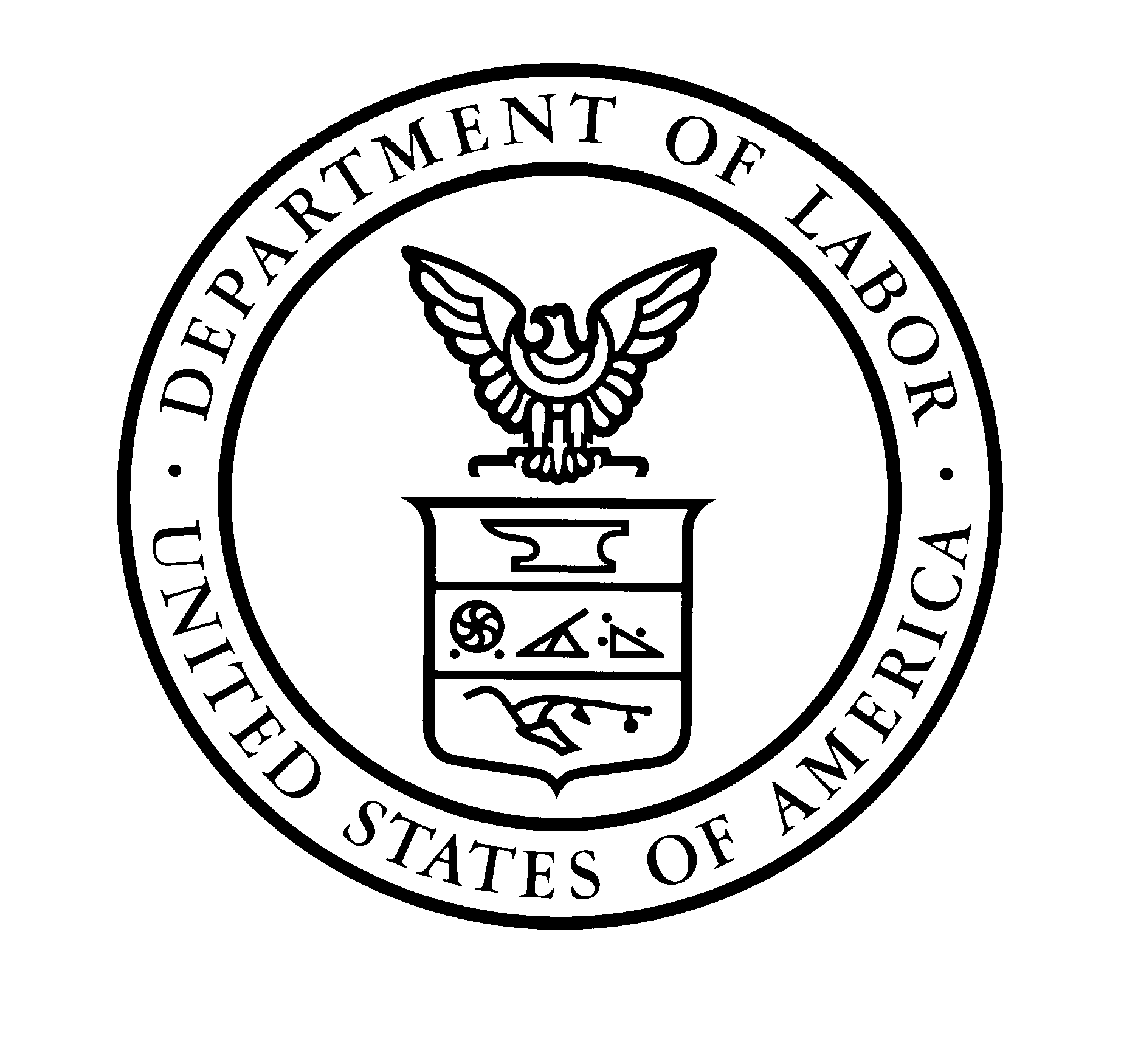
U.S. Department of Labor OMB Control No. 1205-0439
Employment and Training Administration Expiration Date: 9/30/2016

Quarterly Performance Report Form ETA 9104
National Dislocated Worker Grant Electronic Application System

Grantee:
Grant #:
Project Type:
Project:
Grant Quarter:
Performance Period Covered by this Report:
PARTICIPANT DATA
Received Career Services
Received Training Services
Participated in Work-Based Learning
Received Supportive Services
Received Needs-Related Payments (NRPs)
Completed NDWG Services
Employed at Completion of NDWG Services
Employed in Work-Based Learning at Completion of NDWG Services
Total Participants
EXPENDITURE DATA: GRANTEE
Admin (Excluding NRP Processing)
NRP Processing
Other
Total—Program Management and Oversight
Indirect
Total Expenditures: Grantee Level
EXPENDITURE DATA: PROJECT OPERATOR
NDWG-Funded Career Services
NDWG-Funded Training
NDWG-Funded Work-Based Learning
NDWG-Funded Supportive Services
NDWG-Funded NRPs
Other
Admin (Excluding NRP Processing)
NRP Processing
Total—Program Management & Oversight
Total Expenditures: Project Operator Level

Total Expenditures: Grantee and Project Operator

Public Burden Statement:
Persons are not required to respond to this collection of information unless it displays a currently valid OMB Control number. Respondents’ obligation to complete this form is required to obtain or retain benefits ( PL: 107-210). Public reporting burden for this collection of information is estimated to average 30 minutes per response, including the time for reviewing instructions, searching existing data sources, gathering and maintaining the data needed, and completing and reviewing the collection of information. This is public information and there is no expectation of confidentiality. Send comments regarding this burden estimate to the U.S. Department of Labor, Office of National Response, Room C-5311, Washington, D.C. 20210 (Paperwork Reduction Project 1205-0371).
ETA Form 9107 (March 2004)

