I. General Instructions
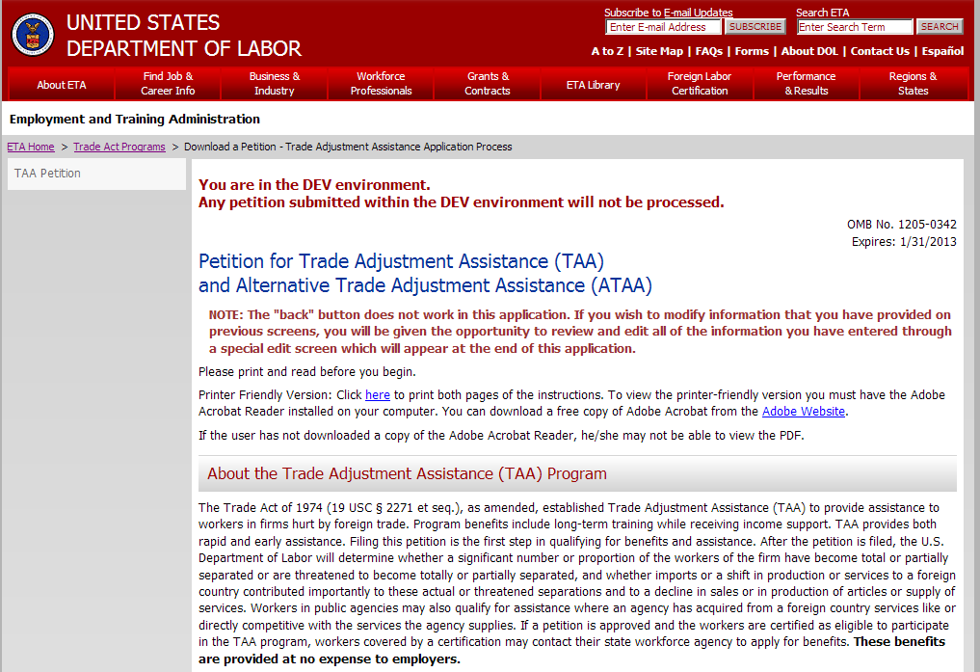
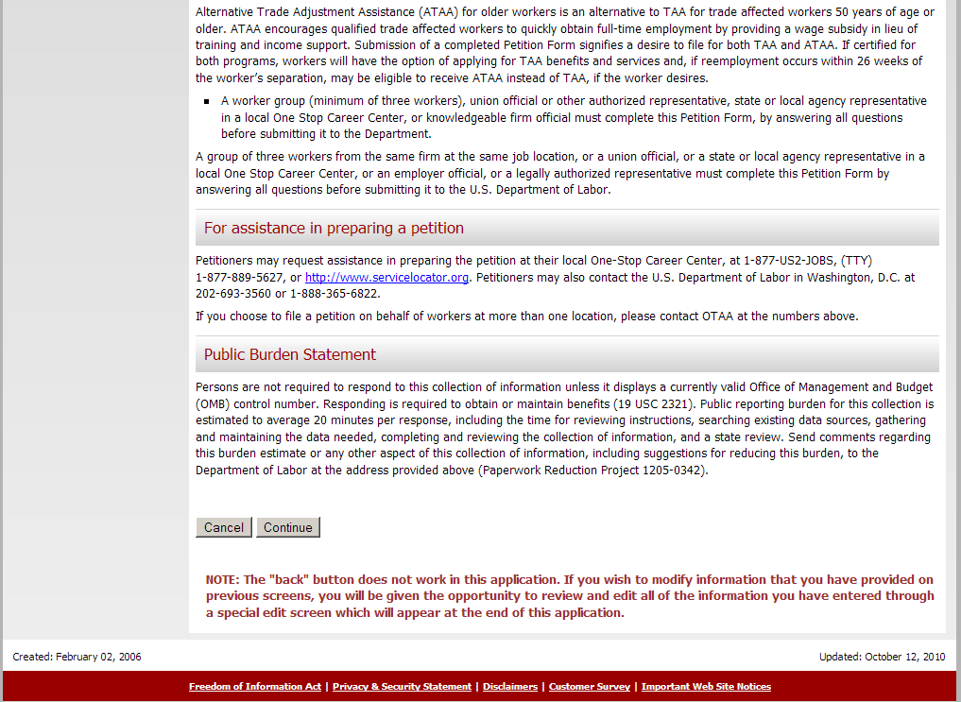
Addition of ATAA in Title throughout Petition form
Addition of a paragraph about the ATAA Program
III. Section 2. Workers’ Firm Information
All reference to public agency and service providers removed.

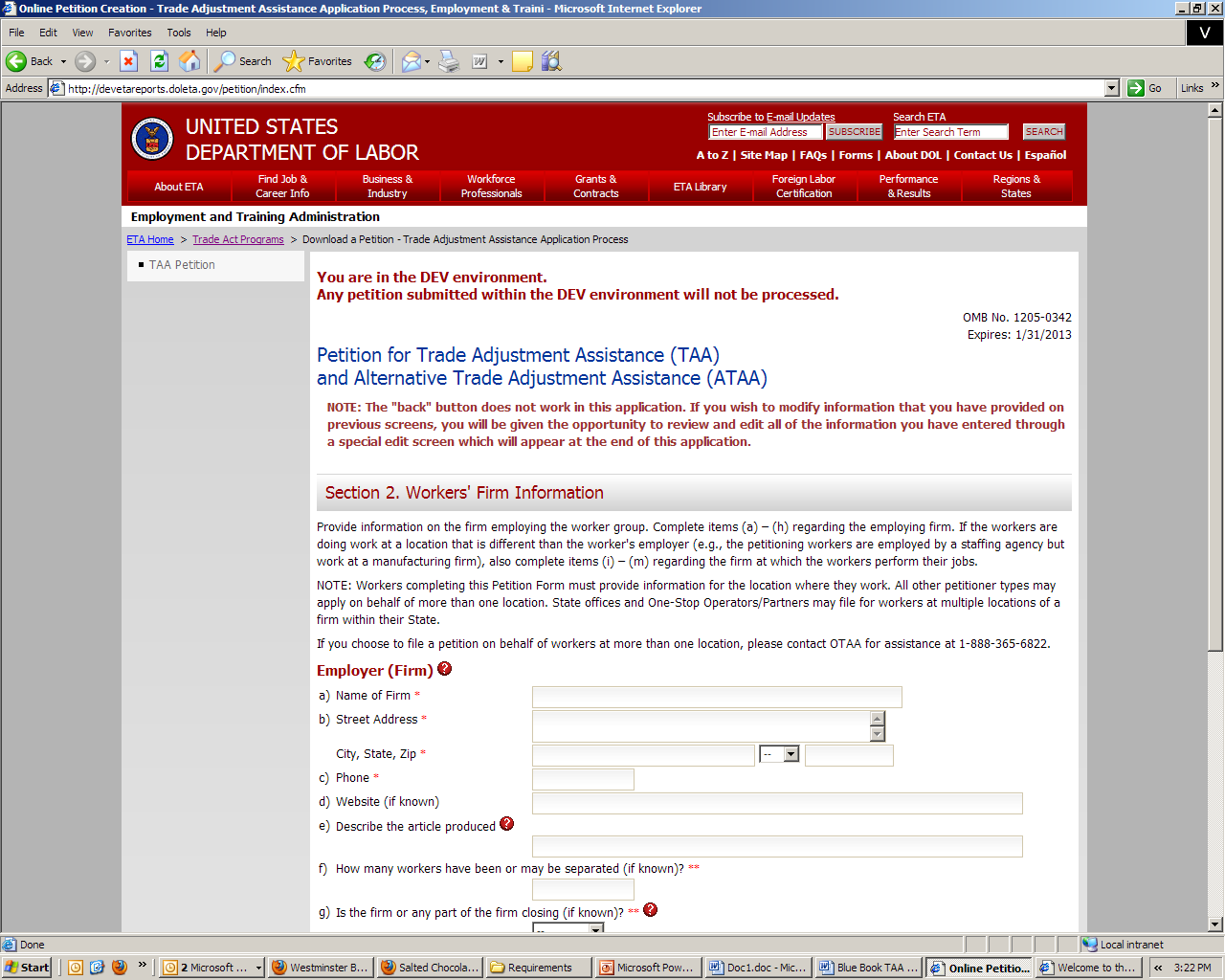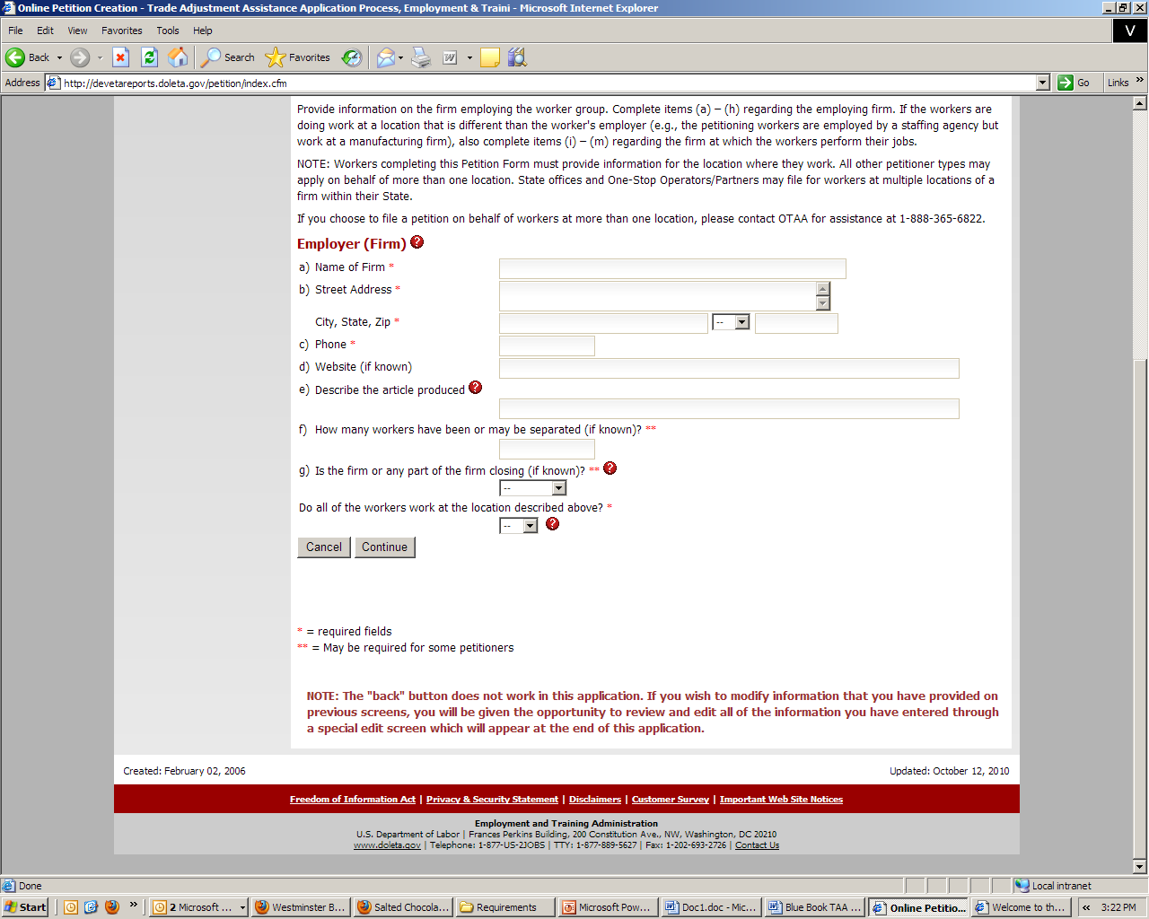
Deletion of “or service supplied”
III. Section 3. Firm/Public Agency Information
Examples of services related trade effects removed.
Deletion of two examples: “services are being outsourced to a foreign country” and “increased imports of services”
