Screen Shots For OMB No. 1513–0013, Change in Bond (Consent of Surety),
TTB F 5000.18

OMB No. 1513–0013, Change in Bond (Consent of Surety), TTB F 5000.18, may be submitted via the various types of TTB permit applications included in TTB’s “Permits Online” system (PONL) at https://www.ttbonline.gov/permitsonline/. (The PONL system includes multiple information collections in each application type.)
Each PONL application type includes a “Consent of Surety” page (shown on page 25 in this example). As instructed on that page, a copy of TTB F 5000.18 must be completed and uploaded as an attachment to the completed application in PONL (see page 26 in this example).

Screen shots showing the PONL log-in page, Paperwork Reduction Act statement page, Privacy Act statement page, and the Consent of Surety page, follow. These pages are the same in each of the application types available in PONL. The example screen shots that follow are from PONL’s Distilled Spirits Plant application. Planned changes to the PONL pages are shown in RED.

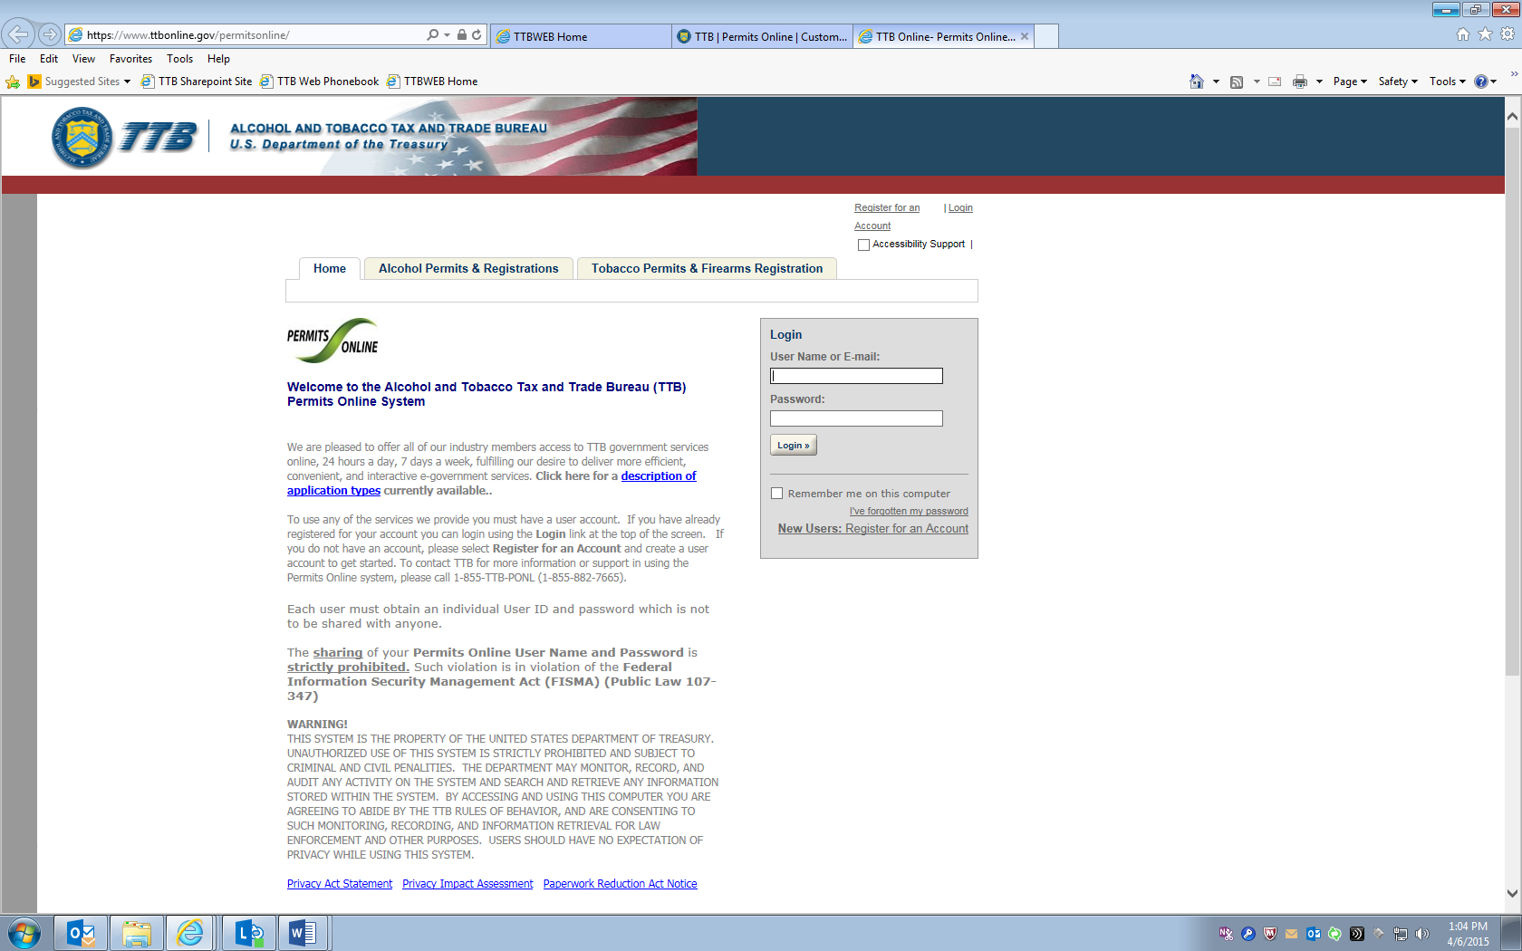
[On the Log-in page (shown above), clicking on the “Paperwork Reduction Act Notice” link leads to this page:]
__________________________________________________________________________________
This request is in accordance with the Paperwork Reduction Act of 1995.

- Power of Attorney Information (OMB No. 1513-0014): This information collection is used by TTB to ensure that only duly authorized individuals are signing documents. The information is voluntary.

- Personnel Questionnaire Information (OMB No. 1513-0002): The information collection is used by TTB to determine if an applicant is eligible to receive an alcohol and tobacco permit. The information is mandatory (26 U.S.C. 5712, 27 U.S.C. 204).

- Change In Bond/Consent of Surety (OMB No. 1513-0013): We use this information to determine whether a business may change its bond. We must identify changes to the business, the surety company, and the bond. The information we request is required for you to obtain a benefit and is mandatory by law (26 U.S.C. 5114(b), 5173, 5272, 5354, 5401(b), and 5711). [will be updated to read: 5114, 5173, 5272, 5354, 5401, and 5711.]

- Environmental Information (OMB No. 1513-0023): This information collection is used by TTB to determine if any environmental impact statement or environmental permit is necessary for the proposed operation. The information is required to obtain a benefit.

- Water Quality Considerations Information (OMB No. 1513-0023): This information collection is used by TTB to determine whether a certification from a State of multi-state authority is needed for discharge of effluent into navigable water of the U.S. This information is required to obtain a benefit.

- Signing Authority Information (OMB No. 1513-0036): This information collection is used by TTB to ensure that only duly authorized individuals are signing documents. This information is voluntary.

- Basic Permit Information (OMB No. 1513-0018): The information is used to determine eligibility of the applicant to engage in certain operations, to determine the location and extent of operations, and to determine whether the operations will be in conformity with Federal laws and regulations. The information requested is required to obtain or retain a benefit and is mandatory by statute (27 U.S.C. 203 and 204 (c)).

- Wine Premises Information (OMB No. 1513-0009): The information is used by TTB to determine if the applicant is eligible to receive a wine premises permit. The information is required to obtain a permit.

- Wine Bond Information (OMB No. 1513-0009): The information is used by the proprietor, or the proprietor and surety company, as a contract to ensure tax payment. The information requested is required to obtain a benefit and is mandatory by statute (26 U.S.C. 5172)

- Registration for Firearms and Ammunition Tax-Free Transactions (OMB No. 1513-0095): This information collected is used to determine the eligibility of the applicant to sell or purchase firearms and ammunition tax-free. The information requested is required to obtain a benefit and is mandatory by statute (26 U.S.C. 4222).

The estimated average burden associated with the Owner/Officer application collection of information is 2 hours, for the Winery application collection of information is 7 hours and 45 minutes or for the Wholesaler/Importer application collection of information is 4 hours and 30 minutes, per respondent or record keeper, depending on individual circumstances. The estimated average burden associated with the Registration for Firearms and Ammunition Tax-Free Transactions collection of information is 3 hours per respondent depending upon individual circumstances. Comments concerning the accuracy of this burden estimate and suggestions for reducing this burden should be addressed to the Reports Management Officer, Regulations and Rulings Division, Alcohol and Tobacco Tax and Trade Bureau, Washington, DC 20220. [the address will be updated to read “1310 G Street, NW., Box 12, Washington, DC 20005”]

An agency may not conduct or sponsor, and a person is not required to respond to a collection of information unless it displays a current, valid OMB control number.

[On the Log-in page (shown above), clicking on the “Privacy Act Statement” link leads to this page:]
_________________________________________________________________________________
TTB Privacy Act Notice:
We provide this information to comply with Sections 3 and 7(b) of the Privacy Act of 1974 (5 U.S.C.§ 552a(e)(3)):
1. What is TTB’s authority to ask for this information?
We require this information under the authority of 26 U.S.C., Section 4222; 26 U.S.C. [5114 will be added], 5171(b), 5173, 5271(b), 5272, 5354, 5356, 5401, 5401(a), 5502(b), 5511(3), 5711 and 5712; 27 U.S.C. 204(c). You must disclose this information to engage in any of the businesses regulated pursuant to the above described statutes.
2. What is the purpose for this information collection?
You give this information to enable TTB to determine your eligibility, suitability, and/or qualifications to engage in a business regulated by TTB.
3. How does TTB routinely use this information?
We use this information to make determinations for the purposes described in paragraph 2. Also, we may disclose the information to other Federal, State, foreign, and local law enforcement, or regulatory agency personnel to verify information in your application where such disclosure is not prohibited by law.
We may disclose the information to the Justice Department if it appears that the furnishing of false information may constitute a violation of Federal law.
Finally, we may disclose the information to members of the public to verify information in your application where such disclosure is not prohibited by law.
4. What happens if I do not supply the information TTB requests?
If you do not supply complete information, we may be prevented from making an informed judgment as described above. If you fail to supply the necessary information it may cause us to delay, deny or disapprove your application.
5. How might TTB disclose my Employer Identification Number (EIN) or Social Security Number (SSN)?
Pursuant to the statutes above, we are authorized to solicit this information. We use these numbers to identify an individual or business. Your disclosure of these numbers is voluntary. If you do not supply these numbers, your application may be delayed.

Permits Online DSP Application Screen shots (includes TTB F 5110.25)

