**COLAs Online Screen Shots**

See: <https://www.ttbonline.gov/>

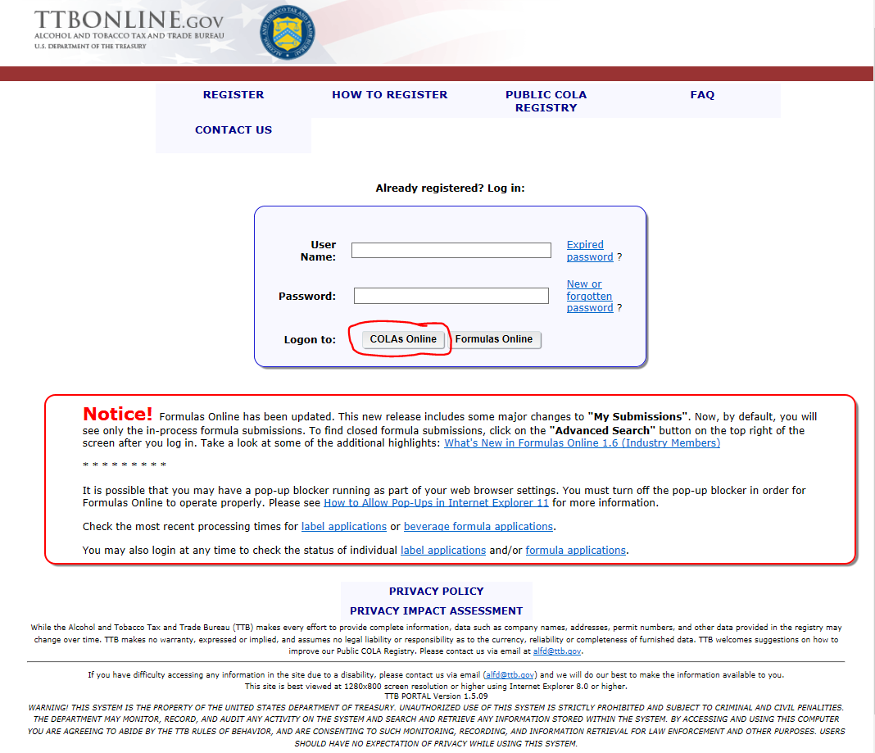

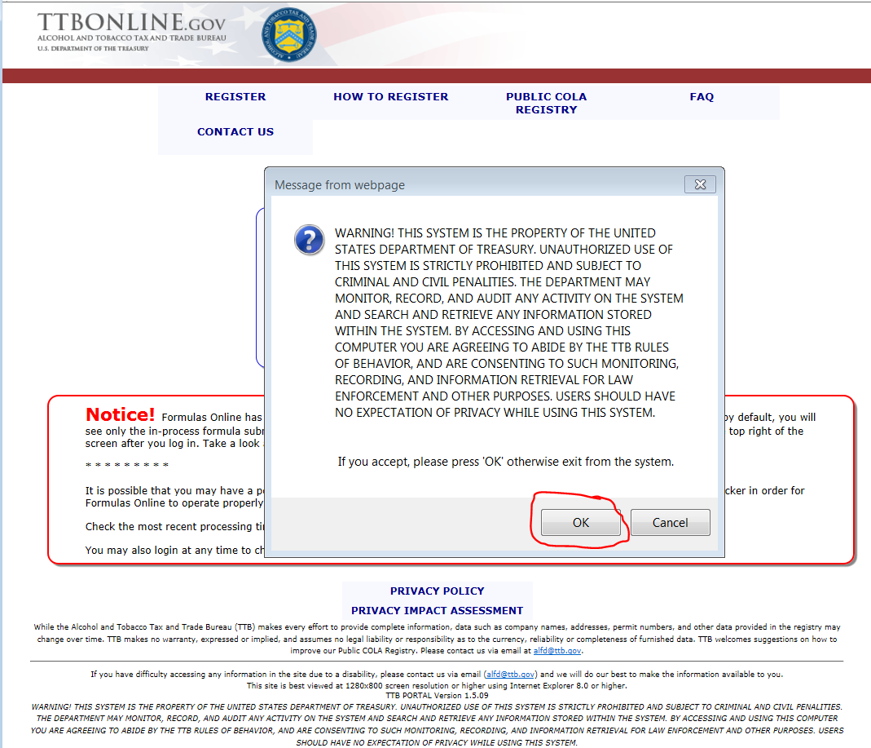

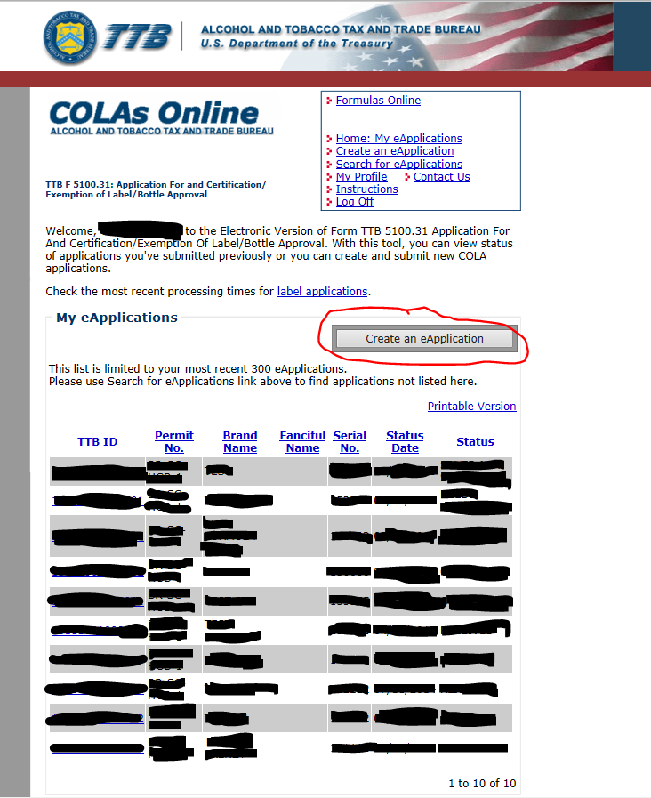

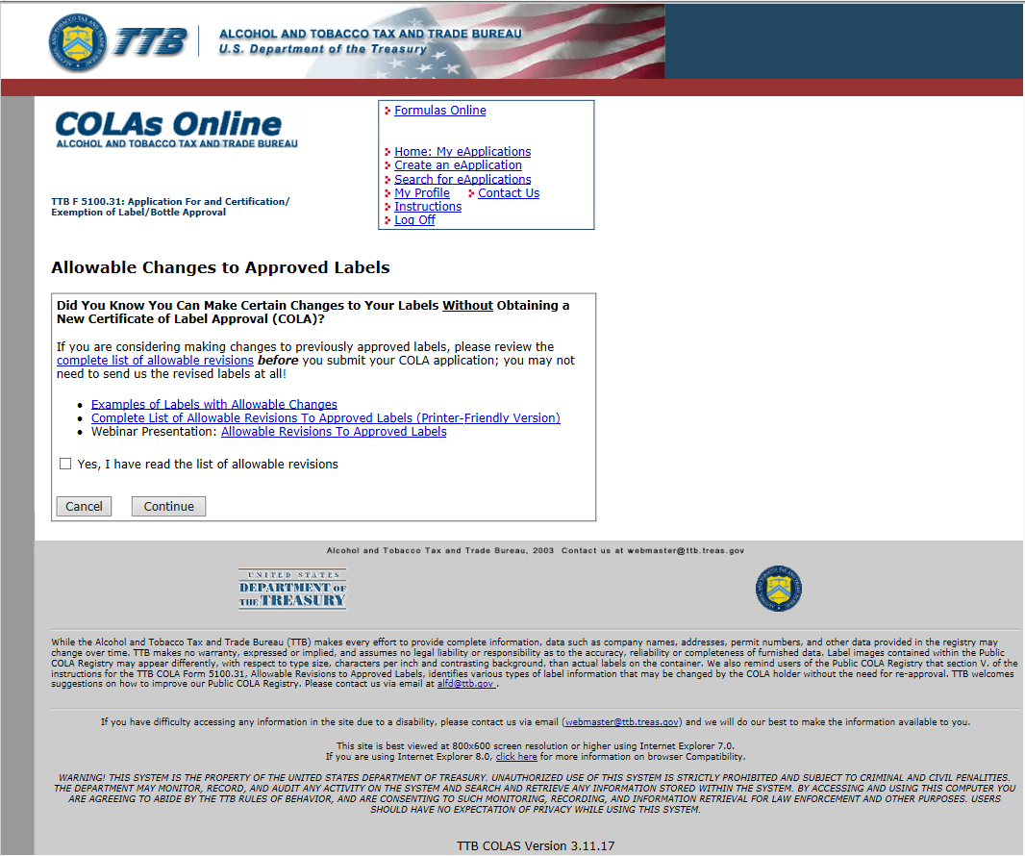

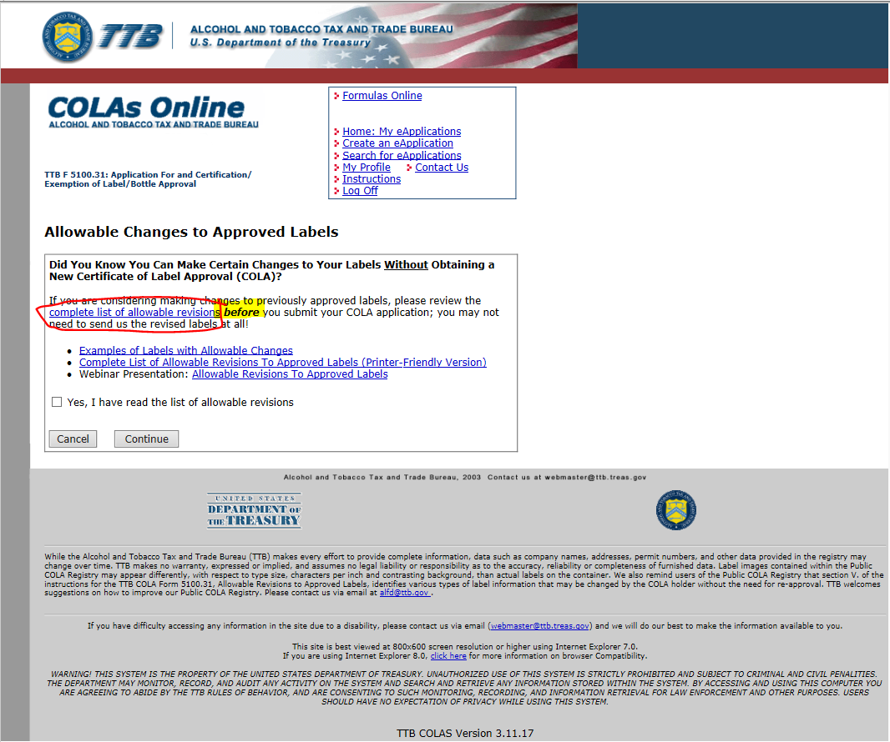

**The List of Allowable Revisions to Approved Labels shown below is the updated list that will be included in Part V of the revised paper form, TTB F 5100.31.**

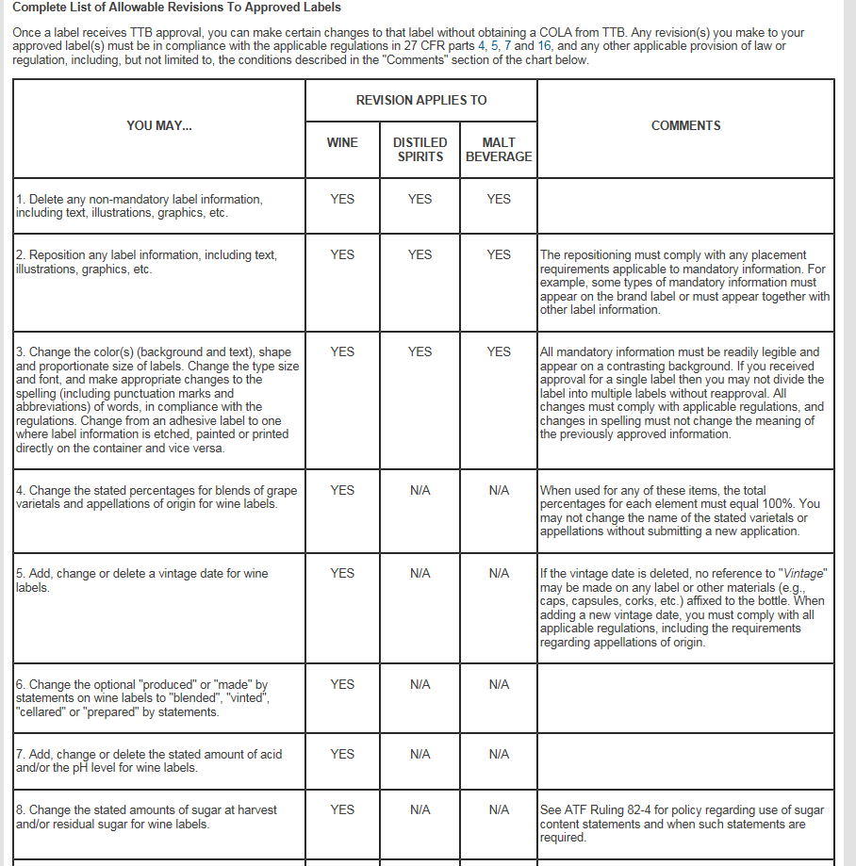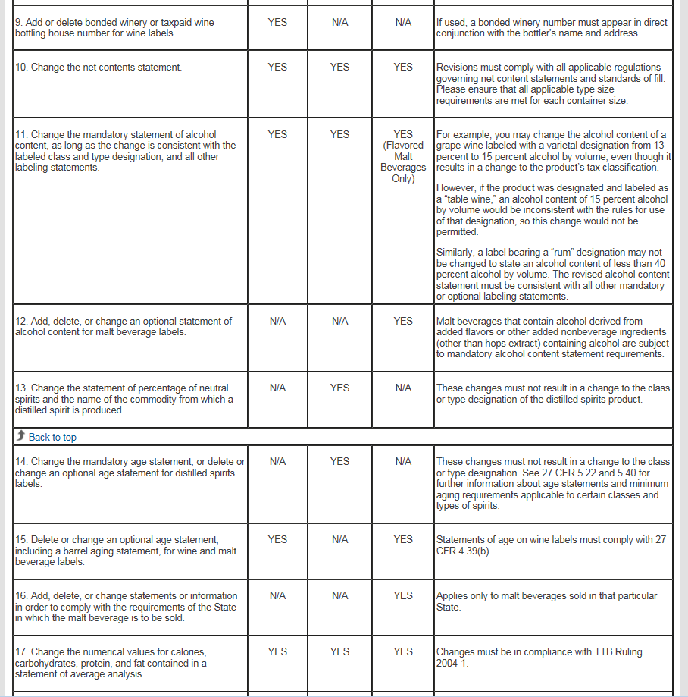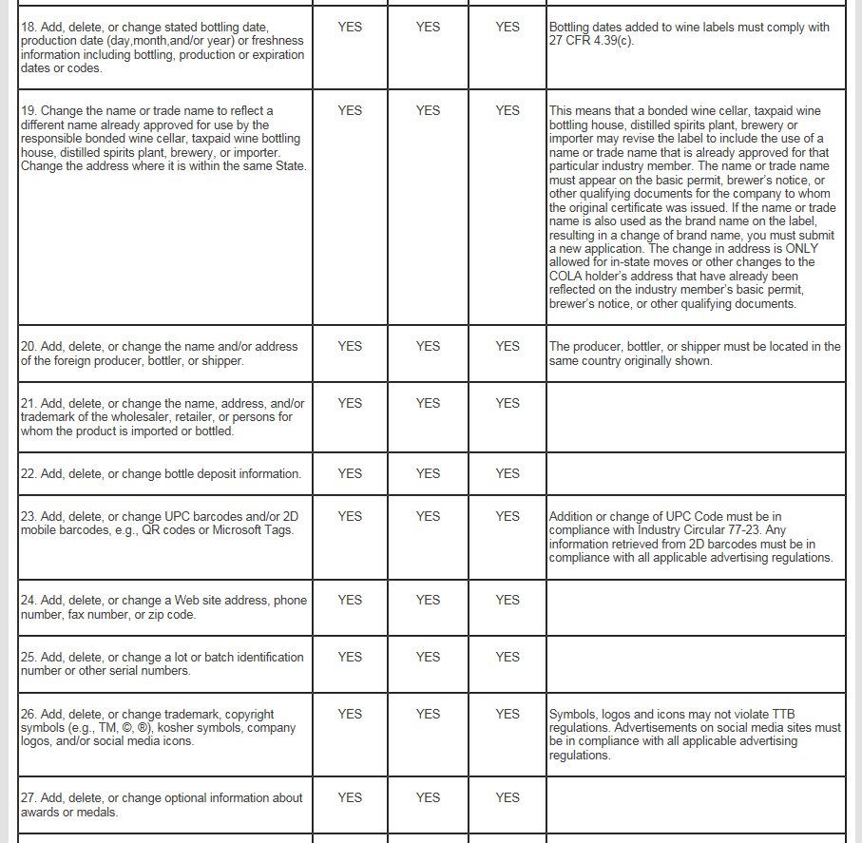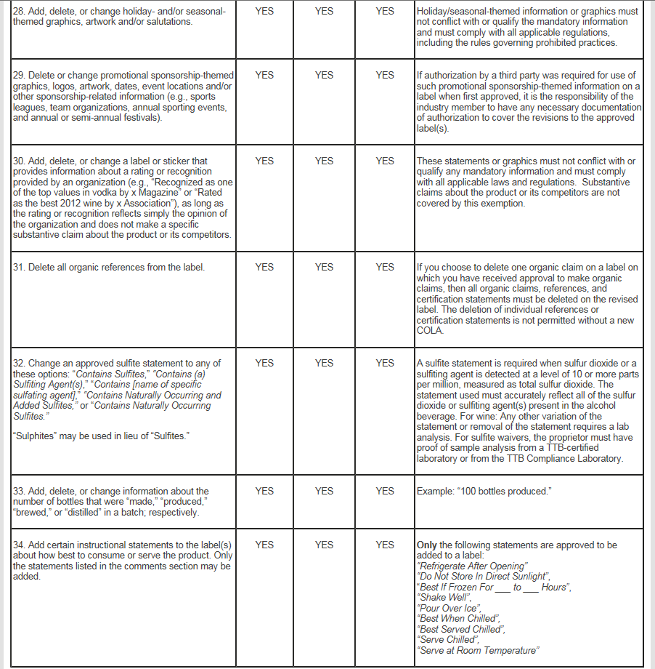

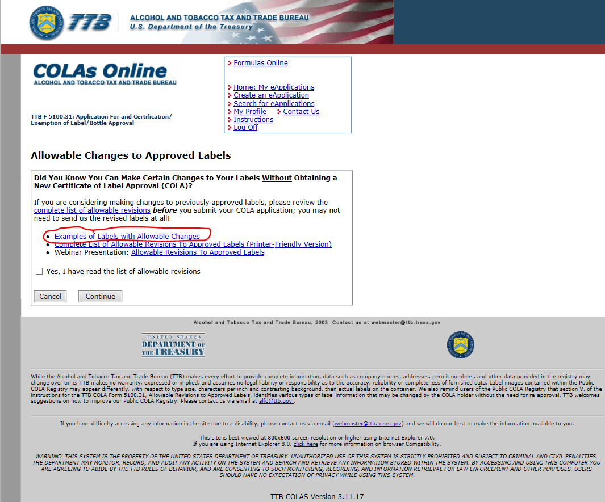

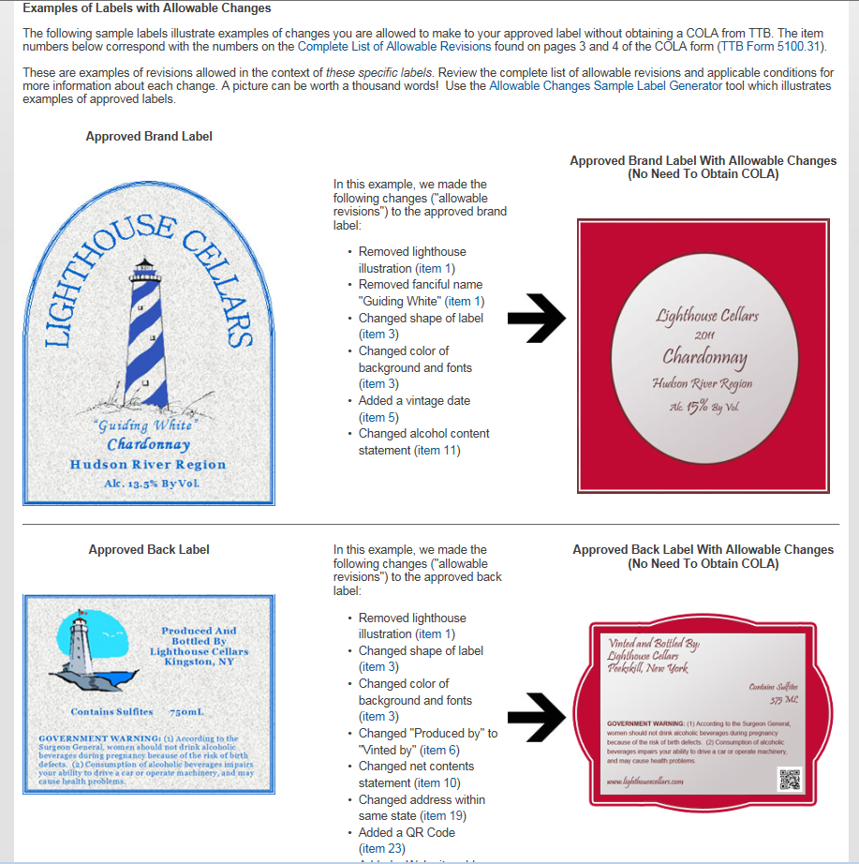

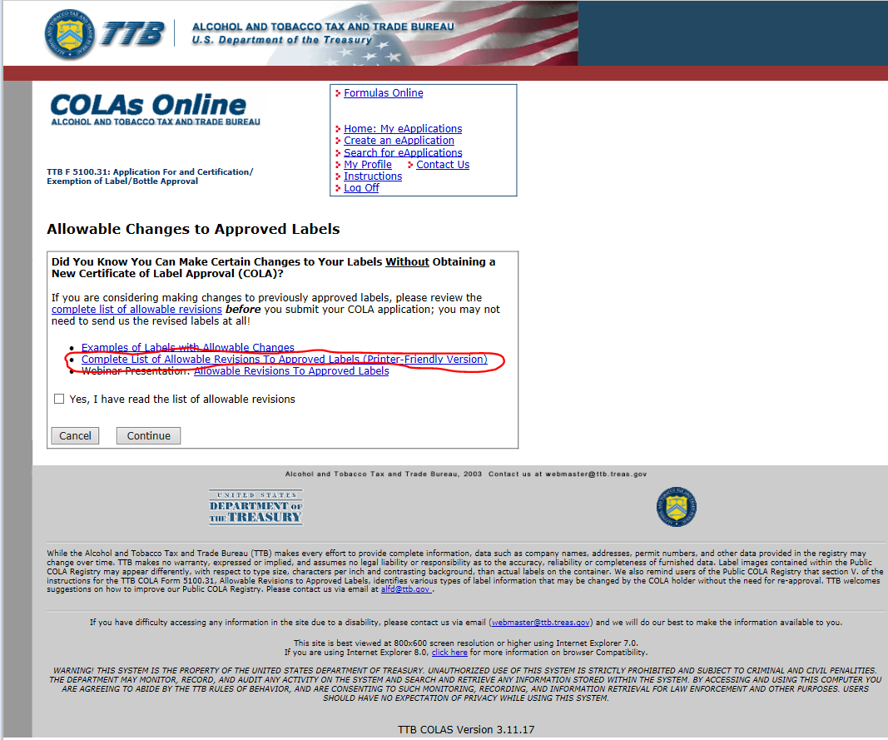

**The link circled above goes to the List of Allowable Revisions to Approved Labels, which is Part V on the paper form, TTB F 5100.31, and it will be updated as shown above to match the updated paper form.**

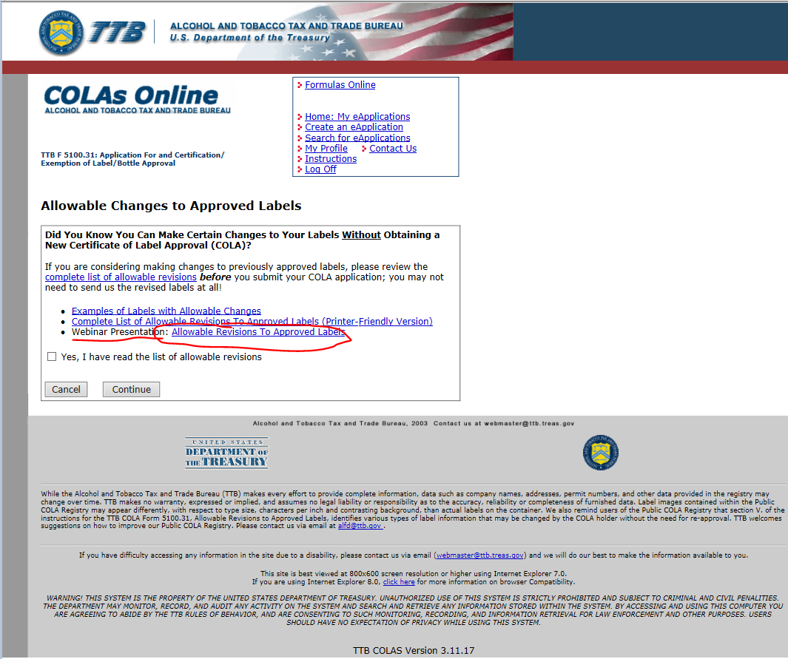

**(Webinar Guidance format is also available to online users)**

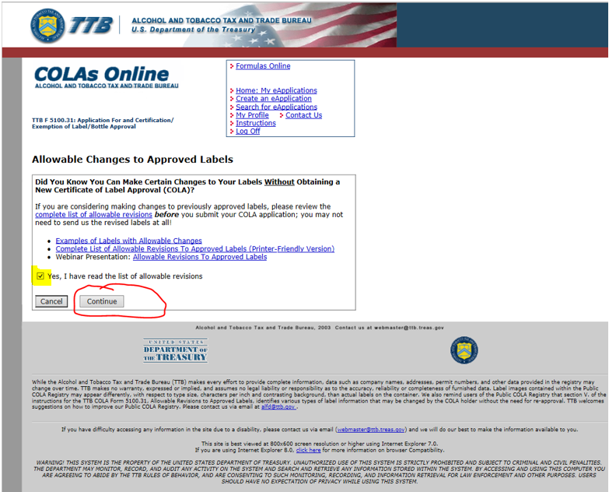

**User must “Acknowledge” before proceeding! This insures that users have read the Allowable List of Revisions to approved Labels, and therefore do not apply for unnecessary COLAs.**

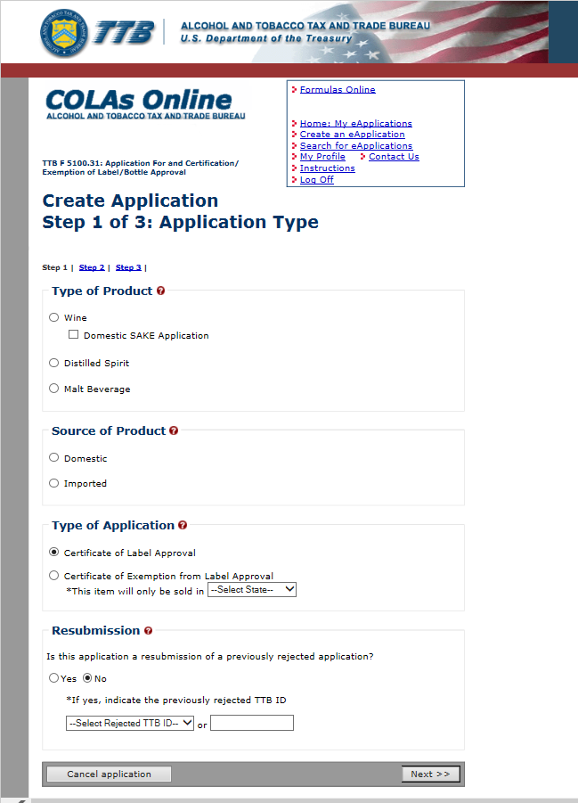

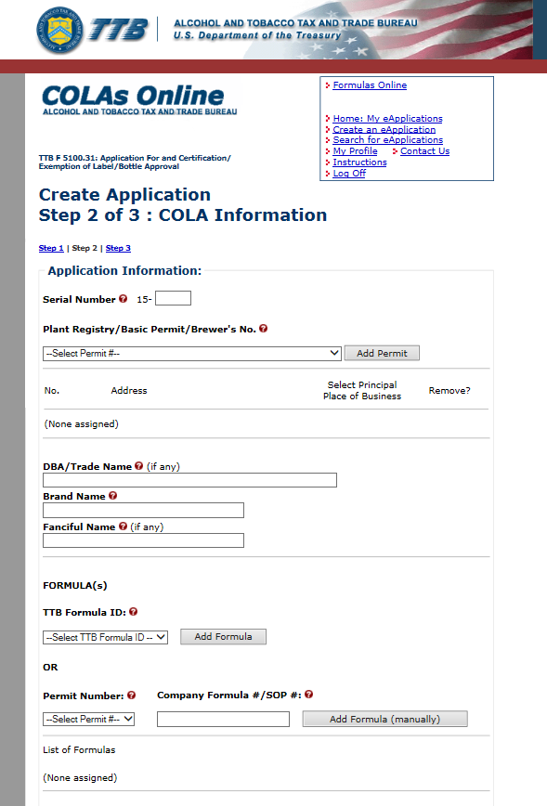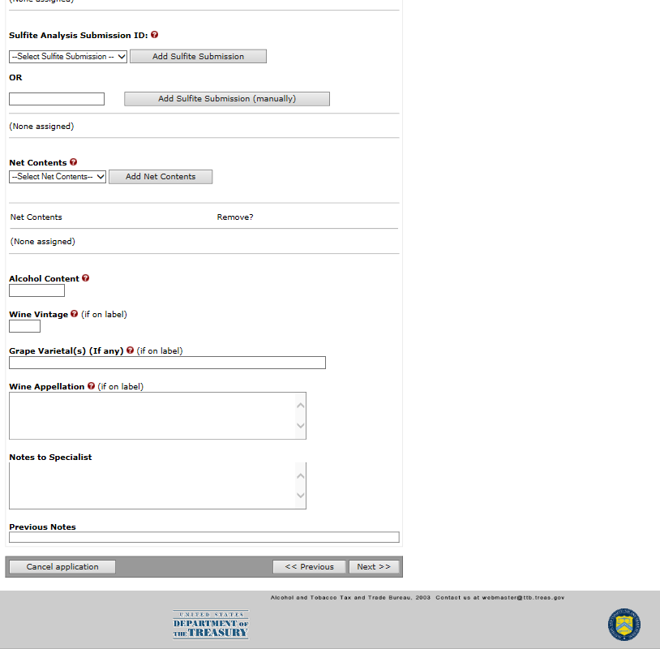

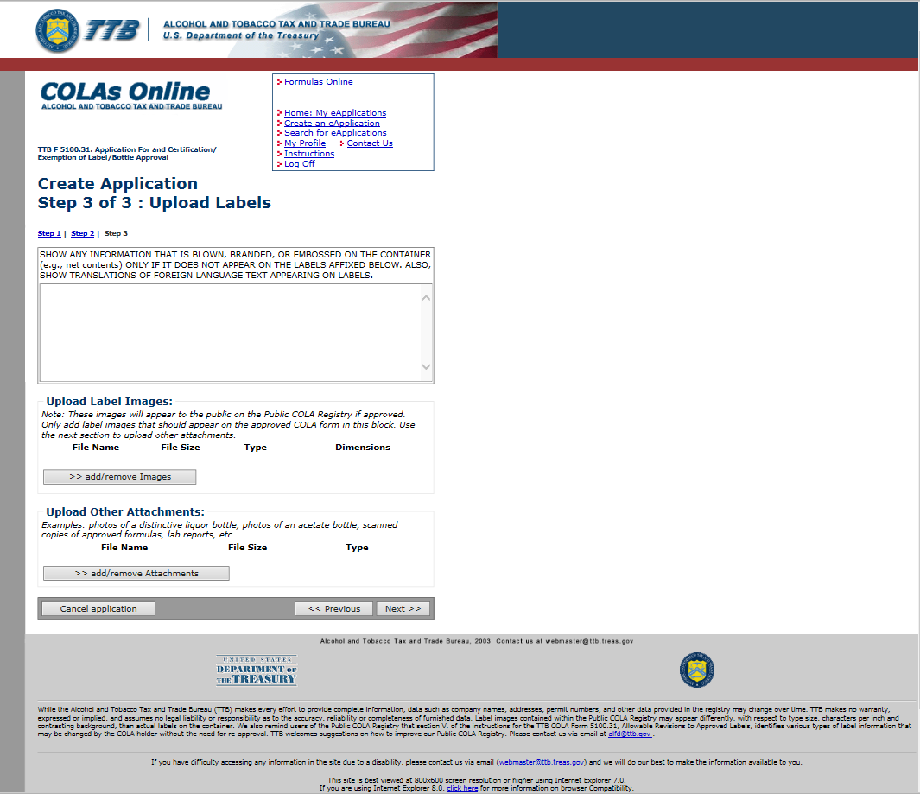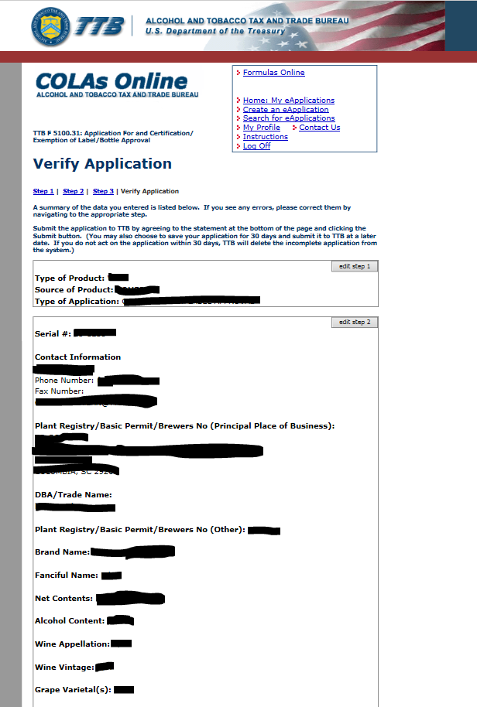

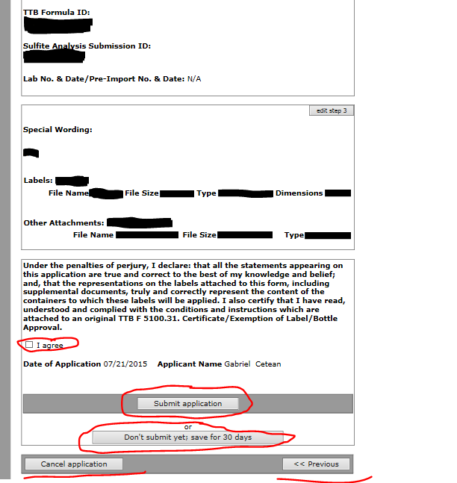

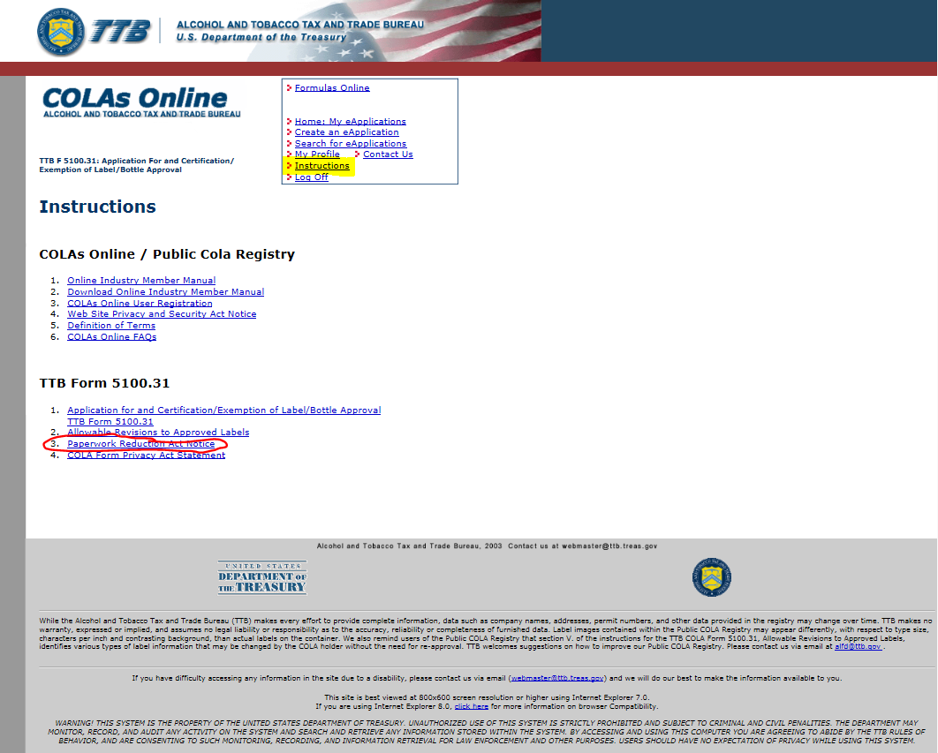

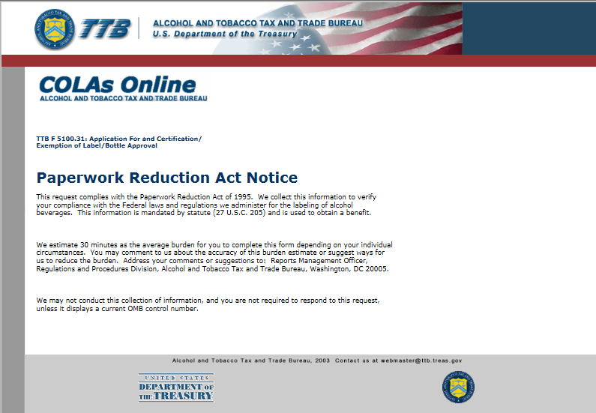

**This Paperwork Reduction Act Notice will be revised to note that the burden estimate for this form is 31 minutes (not the stated 30 minutes). The address for TTB will also be updated to read “1310 G Street, NW., Box 12, Washington, DC 20005.”**

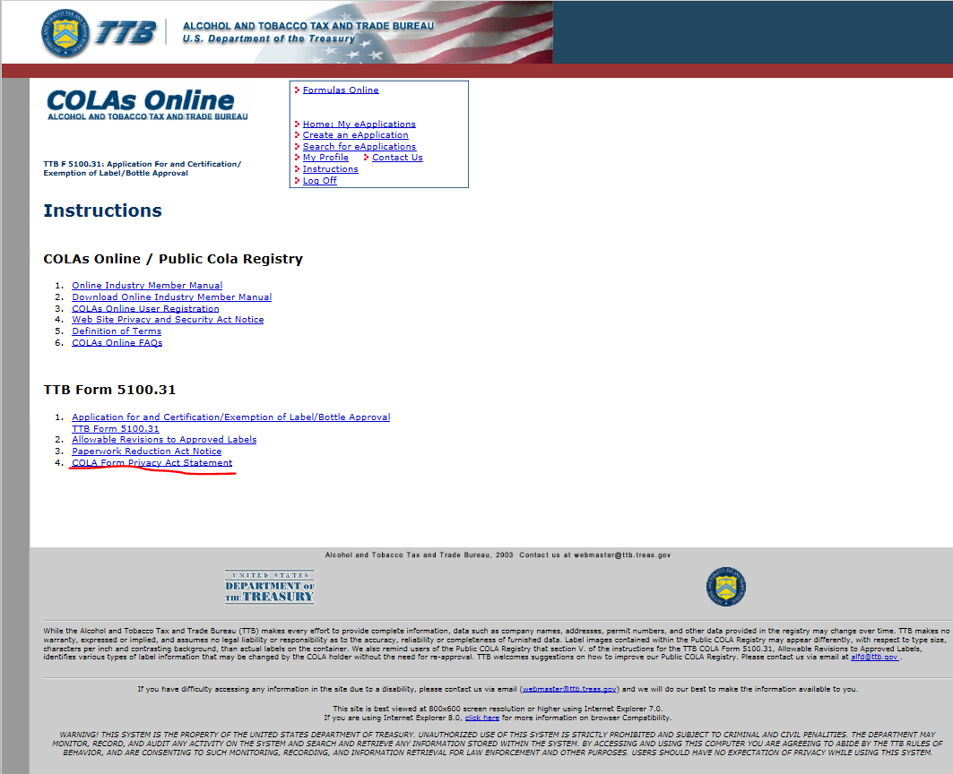

**The COLA Form Privacy Act Statement shown above will be replaced with the “Disclosure Statement from the paper form, TTB F 5100.31, which reads as follows:**

DISCLOSURE STATEMENT

We require this information under the authority of 27 U.S.C. 205(e). You must disclose this information so we may verify your compliance with the Federal laws and regulations we administer for the labeling of alcohol beverages.

We use this information for the purposes described in the preceding paragraph. In addition, the information may be disclosed to other Federal, State, and local law enforcement and regulatory agency personnel to verify information on the application and to aid in the performance of their duties. The information may further be disclosed to the Justice Department if it appears that the furnishing of false information may contribute to a violation of Federal law. If you fail to supply complete information, then there will be a delay in the processing of your application.

After TTB issues a certificate of label approval, a certificate of exemption from label approval, or a distinctive liquor bottle approval, copies of the approved applications are made available for public inspection.