APPENDIX H

RESPONDENT MATERIALS

Early Childhood Longitudinal Study, Kindergarten Class of 2010-11
(ECLS-K:2011)

Spring Fifth-Grade National Data Collection

OMB Clearance Package
#1850-0750 v.18

July 2015

NOTE: The letters for respondents that are included in this appendix have headers indicating to whom the letter will be sent. These headers will be removed before the letters are printed and sent to respondents. Additionally, the OMB expiration date that currently appears as XX/XX/201X will be replaced once a new expiration date is received.

Description of the Materials Included in this Package

This package includes the letters to be sent to different school personnel in the spring of fifth grade. The letters for the fall fifth-grade advance school contact were approved in a previous OMB package. Below is a list of all the letters included in this package, along with an indication of the recipient and the time at which the letters are mailed. There are some formatting issues in the letters (e.g., signature size, pagination) that result from multiple letters being included in one document. These issues will be corrected in the final letters distributed to the respondents.

Spring Fifth-Grade Data Collection Round
- ECLS-K:2011 Parent Consent Form for Child Assessment. This form is included because some schools request a new copy of the form each year.
- Materials mailed at the start of the round, before data collection begins:
  - SPRING 5TH-GRADE PARENT LETTER- Mailed to parents/guardians of study children who are not participating in the hearing evaluation component.
  - SPRING 5TH-GRADE PARENT LETTER FOR HEARING SUBSAMPLE- Mailed to parents/guardians of study children participating in the hearing evaluation component.
  - SPRING 5TH-GRADE TEACHER LETTER- Teachers will be identified during advance school contacts in the fall of 2015. This letter will be mailed to them in spring 2016. If, during data collection in the spring of 2016, children are identified as having switched teachers (for example, because the child changed schools), the new teacher will be given this letter during spring 2016 data collection.
  - SPRING 5TH-GRADE TEACHER LETTER FOR HEARING SUBSAMPLE- This letter will be mailed to teachers in the Hearing Evaluation Component (HEC) schools in spring 2016.
  - SPRING 5TH-GRADE LETTER FOR SCHOOL COORDINATORS AT A CONTINUING (ORIGINAL OR DESTINATION) SCHOOL- Mailed to school coordinators in schools that have participated in the study since the base year or in schools that are identified as “destination schools,” that is, schools into which four or more study children from the same original school have transferred.
  - SPRING 5TH-GRADE LETTER FOR SCHOOL COORDINATORS AT A TRANSFER SCHOOL THAT HAS PARTICIPATED IN A PREVIOUS DATA COLLECTION ROUND- Mailed to school coordinators in schools that were added after the base year because a child transferred into the school and that have participated in at least one prior round of data collection but are not destination schools. A separate letter is needed for these school coordinators because coordinators and schools do not receive an incentive.
  - SPRING 5TH-GRADE LETTER FOR SCHOOL COORDINATORS AT A TRANSFER SCHOOL IDENTIFIED DURING RECRUITMENT- Mailed to school coordinators in schools that were added during the fall 5th grade recruitment and tracking because a child transferred into the school. These schools have not participated in at least one prior round of data collection and are not destination schools. A separate letter is needed for these school coordinators because they have not participated before and coordinators and schools do not receive an incentive.
  - SPRING 5TH-GRADE LETTER FOR SCHOOL COORDINATORS AT A HEARING EVALUATION SCHOOL - Mailed to school coordinators in schools participating in the hearing evaluation component.
  - HEARING EVALUATION FLYER – Mailed to school coordinators and parents for schools and children participating in the hearing evaluation component.
  - SPRING 5TH GRADE CHILD THANK YOU CARD TO ACCOMPANY TOKEN OF APPRECIATION – This card will be mailed to children during spring data collection along with a token of appreciation. The card will have the same design as the birthday card mailed to children each year, with “Happy Birthday” replaced with “Thank you.” This card will be developed if the token of appreciation is approved.
- Letters mailed during data collection to districts, school administrators, and school coordinators in schools that are identified as having study children who transfer into them during the spring fifth-grade data collection:
  - SPRING 5TH-GRADE LETTER FOR NEW TRANSFER DISTRICTS WITH PREVIOUSLY NON-PARTICIPATING SCHOOLS INTO WHICH STUDY CHILDREN HAVE TRANSFERRED - Mailed to school districts that did not have schools participating in the study in a prior round that are now being recruited into the study because a participating study child transferred into one of the district’s schools.
  - SPRING 5TH-GRADE LETTER FOR CONTINUING DISTRICTS WITH PREVIOUSLY NON-PARTICIPATING SCHOOLS INTO WHICH STUDY CHILDREN HAVE TRANSFERRED- Mailed to school districts that have schools that participated in the study in a prior round but in which at least one new school (i.e., one that has not participated in a prior round) is being recruited because a study child transferred into the new school.
  - SPRING 5TH-GRADE SCHOOL ADMINISTRATOR LETTER FOR TRANSFER SCHOOLS IDENTIFIED IN SPRING 2016- Mailed to administrators in schools that did not participate in a prior round of the study but are now being recruited into the study because a participating study child transferred into the administrator’s school.
  - SPRING 5TH-GRADE LETTER FOR SCHOOL COORDINATORS AT A CONTINUING SCHOOL WITH NEW TRANSFER STUDENTS IDENTIFIED IN SPRING 2016- Mailed to school coordinators in schools that have participated in prior rounds of the study but that have new study children who have transferred into them. The school coordinator is mailed this new letter to make it clear that there are additional children who will be assessed during the school visit.
- Letters mailed at the end of the data collection round:
  - SCHOOL ADMINISTRATOR THANK YOU LETTER (INCENTIVES)- Mailed to administrators of participating original and destination schools at the end of the fifth-grade school year along with the $200 thank you token for the school.
  - SCHOOL ADMINISTRATOR THANK YOU LETTER (NO INCENTIVE)- Mailed to administrators of participating transfer schools at the end of the fifth-grade school year.
  - ECLS-K:2011 HEARING EVALUATION REPORT- Mailed to parents of children participating in the hearing evaluations approximately 1 to 2 months after the child’s evaluation containing results of the evaluation.

Tracking Materials
- BIRTHDAY CARD – Mailed each month to children who have a birthday that month.
- POST-IT NOTES FOR PARENTS – Included with spring 2016 parent letter.

Spring Fifth-Grade Materials

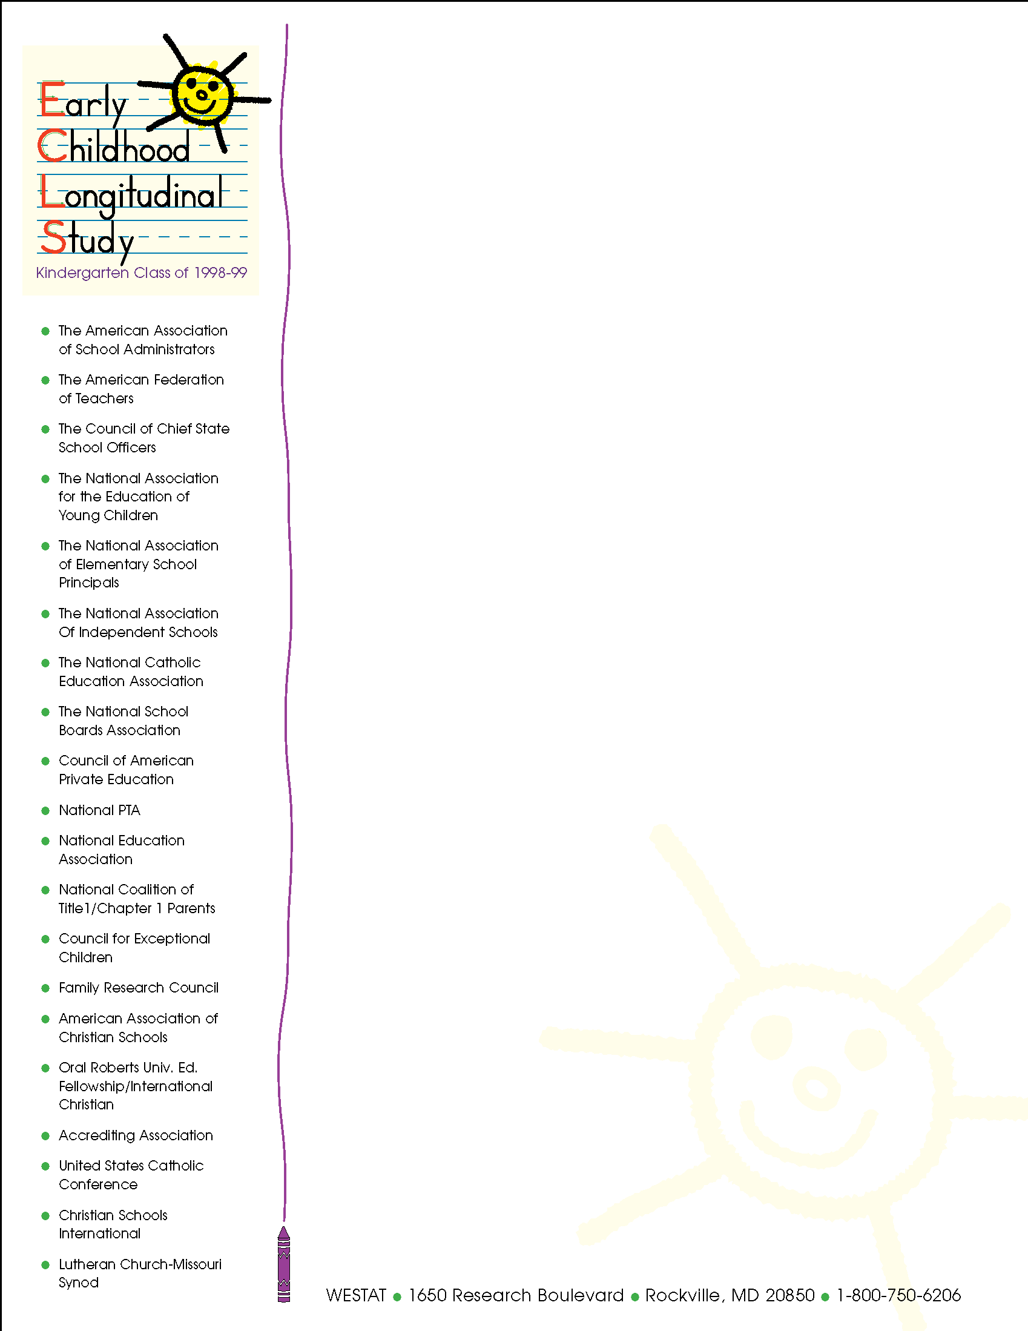
Early Childhood Longitudinal Study, Kindergarten Class 2010-11 (ECLS-K:2011)

Parent Permission for Child to Participate

Your child is being asked to take part in the Early Childhood Longitudinal Study, Kindergarten Class of 2010-11 (ECLS-K:2011), which follows a sample of children from kindergarten through fifth grade. The ECLS-K:2011 is conducted by the National Center for Education Statistics (NCES) of the U.S. Department of Education’s Institute of Education Sciences. Data collection for this study is being carried out on behalf of NCES by Westat. In the 2010-11 school year, children in kindergarten in your child's school and other schools across the nation will be selected to participate in ECLS-K:2011. Your child will be asked to take individually administered assessments designed to measure skills in reading, mathematics, and science. Also as part of the assessment, through a brief number game and a picture game, we will be assessing your child's working memory and regulation of attention. Your child’s teacher and child care provider will complete questionnaires about themselves and your child.

The collection of information in this survey is authorized by 20 U.S. Code, Section 9543. Participation is voluntary. Your responses are protected from disclosure by federal statute (20 U.S. Code, Section 9573). All responses that relate to or describe identifiable characteristics of individuals may be used only for statistical purposes and may not be disclosed, or used, in identifiable form for any other purpose except as required by law. Information from multiple individuals will be combined to produce statistical reports; no information that identifies you or your child (e.g., name or address) will be included in any reports. Your child’s school will not receive any information about you or your child as a part of this study. The valid OMB control number for this information collection is 1850-0750. Approval expires 10/31/2016.

If you have any questions or concerns about the protection of the information you provide or your rights in this research study, contact Gail Mulligan at the National Center for Education Statistics at 1-202-502-7491 or Gail.Mulligan@ed.gov.

PARTICIPATION AGREEMENT

I have read the letter and the information above.

I consent to my child’s participation in the ECLS-K:2011.

I DO NOT consent to my child’s participation in the ECLS-K:2011.

Please complete, sign, and return this form in the enclosed envelope to your child’s school.

CHILD’S NAME:
First and last name

Sign your name:
Signature of parent/guardian Date

Print your name:
First Middle Last

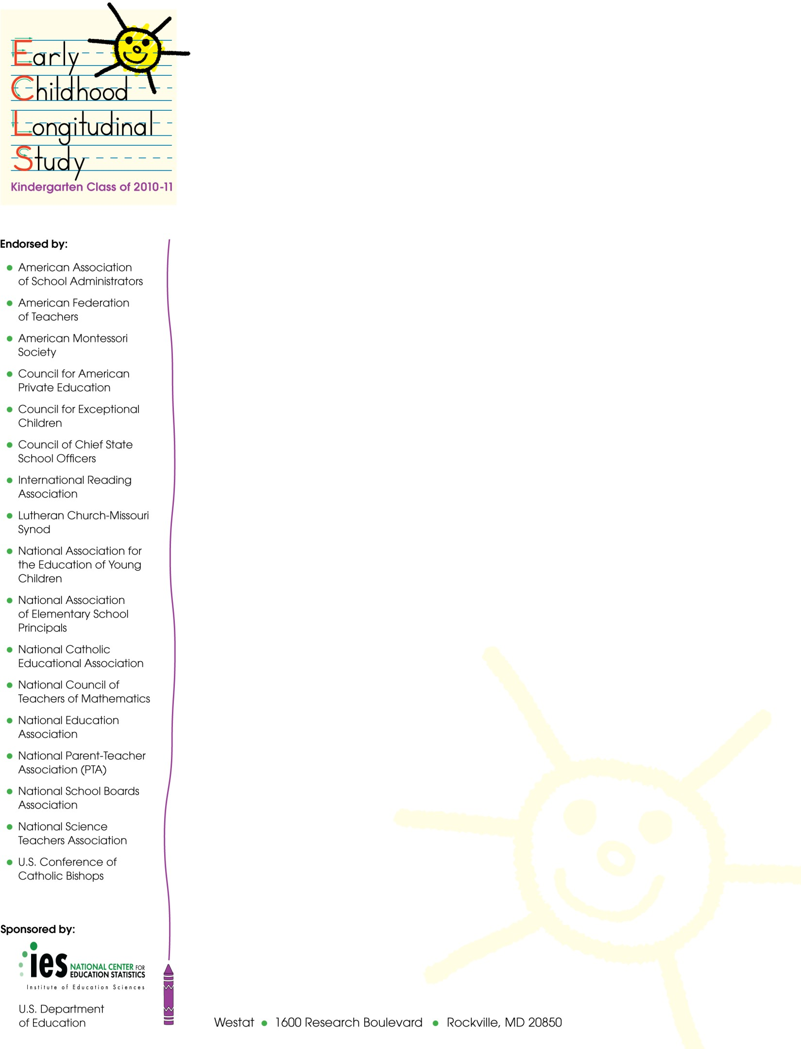
Spring 2016
SPRING 5TH GRADE PARENT LETTER

Dear Parent,

The Early Childhood Longitudinal Study, Kindergarten Class of 2010-11 (ECLS-K:2011) is entering its sixth year of data collection! This is the last round of data collection currently planned for the study. Thanks to the continued participation of families and schools across the country, we have collected a wealth of information that is being used to gain a better understanding of today’s elementary-school students and their experiences. Collecting information this year is important for understanding how your child’s experiences in the early years of elementary school have prepared him or her for the later grades. We are excited to talk with you and your child again this spring and to learn more about your experiences during the 2015-16 school year.

As in the past, our field staff will be visiting your child’s school in the upcoming months to assess your child’s knowledge and skills in reading, mathematics, and science. Our staff also will be assessing your child’s memory and ability to follow directions, as well as measuring his/her height and weight. Once again we are asking children to complete a questionnaire about themselves and their experiences in school. The assessment and the kinds of questions that will be asked are similar to those used in previous years, so the process should feel familiar to your child. As always, children may decline to answer any of the questions asked in the study. Also, participants’ responses will not be associated with their names or provided to school staff. In total, the assessment activities will take approximately 80 minutes to complete.

We are also asking parents to complete a telephone interview with a member of our data collection staff who will be calling your home to conduct the interview. The interview during this round should take about 45 minutes to complete. It includes questions about your child's school, your household, activities you do with your child at home, your child’s behavior and health, and contact with any parents who may not live with your child. As always, our field staff will be happy to conduct the interview at a time that is most convenient for you.

If you have questions about the study, please feel free to call Westat toll free at
1- 888-204-4864 or send an email to ECLSKHELP@westat.com. Also, more information about the ECLS-K:2011, including samples of the questions to be asked of children, is available at the NCES website at http://nces.ed.gov/ecls/myECLSK2011.

Thank you again for your participation!

Sincerely,
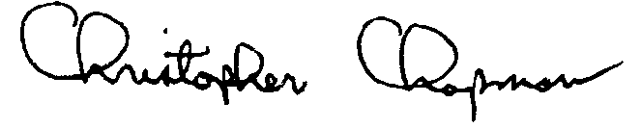
Christopher Chapman
Associate Commissioner, Sample Surveys Division
National Center for Education Statistics, Institute of Education Sciences

The collection of information in this survey is authorized by 20 U.S. Code, Section 9543. Participation is voluntary. Your responses are protected from disclosure by federal statute (20 U.S. Code, Section 9573). All responses that relate to or describe identifiable characteristics of individuals may be used only for statistical purposes and may not be disclosed, or used, in identifiable form for any other purpose except as required by law. Information from multiple individuals will be combined to produce statistical reports; no information that identifies you or your child (e.g., name or address) will be included in any reports. Your child’s school will not receive any information about you or your child as a part of this study. The valid OMB control number for this information collection is 1850-0750. Approval expires XX/XX/201X.

SPRING 5TH GRADE PARENT LETTER – HEARING SUBSAMPLE
Spring 2016

Dear Parent,

The Early Childhood Longitudinal Study, Kindergarten Class of 2010-11 (ECLS-K:2011) is entering its sixth year of data collection! This is the last round of data collection currently planned for the study. Thanks to the continued participation of families and schools across the country, we have collected a wealth of information that is being used to gain a better understanding of today’s elementary-school students and their experiences. Collecting information this year is important for understanding how your child’s experiences in the early years of elementary school have prepared him or her for the later grades. We are excited to talk with you and your child again this spring and to learn more about your experiences during the 2015-16 school year.

As in the past, our field staff will be visiting your child’s school in the upcoming months to assess your child’s knowledge and skills in reading, mathematics, and science. Our staff will be assessing your child’s memory and ability to follow directions, as well as measuring his/her height and weight. Once again, we are asking children to complete a questionnaire about themselves and their experiences in school. The assessment and the kinds of questions that will be asked are similar to those used in previous years, so the process should feel familiar to your child. As always, children may decline to answer any of the questions asked in the study. Also, participants’ responses will not be associated with their names or provided to school staff. In total, the assessment activities will take approximately 80 minutes to complete. In addition to participating in the assessment, some children whose parents have given permission will have their hearing evaluated. These evaluations occur more than once during the study so that researchers can examine how hearing may change during the elementary school years. The hearing evaluation will take about 20 minutes.

We are also asking parents to complete a telephone interview with a member of our data collection staff who will be calling your home to conduct the interview. The interview during this round should take about 45 minutes to complete. It includes questions about your child's school, your household, activities you do with your child at home, your child’s behavior and health, and contact with any parents who may not live with your child. As always, our field staff will be happy to conduct the interview at a time that is most convenient for you.

If you have questions about the study, please feel free to call Westat toll free at
1- 888-204-4864 or send an email to ECLSKHELP@westat.com. Also, more information about the ECLS-K:2011, including samples of the questions to be asked of children, is available at the NCES website at http://nces.ed.gov/ecls/myECLSK2011.

Thank you again for your participation!

Sincerely,
Christopher Chapman
Associate Commissioner, Sample Surveys Division
National Center for Education Statistics, Institute of Education Sciences

The collection of information in this survey is authorized by 20 U.S. Code, Section 9543. Participation is voluntary. Your responses are protected from disclosure by federal statute (20 U.S. Code, Section 9573). All responses that relate to or describe identifiable characteristics of individuals may be used only for statistical purposes and may not be disclosed, or used, in identifiable form for any other purpose except as required by law. Information from multiple individuals will be combined to produce statistical reports; no information that identifies you or your child (e.g., name or address) will be included in any reports. Your child’s school will not receive any information about you or your child as a part of this study. The valid OMB control number for this information collection is 1850-0750. Approval expires XX/XX/201X.

Spring 2016
SPRING 5TH GRADE TEACHER LETTER

Dear Teacher,

We are very happy that your school is participating in the Early Childhood Longitudinal Study, Kindergarten Class of 2010-11 (ECLS-K:2011), the third in a series of longitudinal studies of young children conducted by the National Center for Education Statistics (NCES). Like the earlier studies, the ECLS-K:2011 will be an important source of data for researchers and policy makers to address key issues related to children’s development and learning. The ECLS-K:2011 is described in more detail in the brochure included in your study package. For more information on this and the prior longitudinal studies, you can also visit the NCES website at http://nces.ed.gov/ecls/.

The study began in the 2010-11 school year with students who were in kindergarten. We have identified one or more students in the study who are in your classroom this school year. For the study data to accurately represent the early schooling experiences of all children in America, it is vital that the sampled students take part in each phase of the study. Therefore, this spring we would like to conduct a child assessment with the sampled children who are attending your school. A component of the data collection involves collecting data about the sampled students from their teachers using self-administered questionnaires. We also will collect information from the school administrator, as well as the students’ parents.

Teachers are essential contributors to the ECLS-K:2011. You provide valuable insights into the classroom experiences of the children participating in the study. We will ask you to help us in several ways. As the teacher of at least one of our sampled children, we will ask you to answer some questions about your classroom and background, and we will ask you to complete a subject-specific questionnaire for each child participating in the study who is a student of yours. You will receive $20 as a thank you for participating plus $7 for each of the child-level questionnaires you are asked to complete. We also will need your cooperation as we complete one-on-one child assessments in your school. We will make arrangements with your school’s ECLS-K:2011 school coordinator regarding the times that we can have access to the children and where the assessments will take place. It is possible that we will be taking study children out of your classroom so that they can participate in the assessment. The assessments are designed to measure children’s reading, mathematics, and science skills and knowledge, as well as obtain indicators of children’s memory and ability to follow rules in structured tasks. Children also will have their height and weight measured and will complete a questionnaire about themselves and their experiences in school. These assessment activities will take approximately 80 minutes per child to complete.

Your participation in this study is voluntary; however, I encourage you to participate in the ECLS-K:2011. Please read the enclosed materials for more information about the study and your important role in it. These materials provide instructions for you on how to complete the questionnaires and return them to your school’s ECLS-K:2011 school coordinator. They also provide information about the one-on-one child assessments.

The National Center for Education Statistics of the U.S. Department of Education’s Institute of Education Sciences is conducting the ECLS-K:2011. Data collection for the study is being carried out on behalf of NCES by Westat. The ECLS-K:2011 has been endorsed by the national education organizations listed on this letter. NCES is authorized to conduct this study under 20 U.S. Code, Section 9543. Under that law, the data you provide may be used only for statistical purposes and may not be disclosed, or used, in identifiable form for any other purpose except as required by law (20 U.S. Code, Section 9573). The U.S. Office of Management and Budget has approved the data collection under OMB # 1850-0750 (expires XX/XX/201X). Information collected from multiple individuals will be combined to produce reports of findings from the ECLS-K:2011. The reports will not identify participating districts, schools, children and their parents, or individual staff.

Thank you for your support of the ECLS-K:2011. If you have questions about the study, please feel free to call Westat toll free at 1-888-204-4864 or send an email to ECLSKHELP@westat.com. Also, more information about the ECLS-K:2011 is available at http://nces.ed.gov/ecls/myECLSK2011.

Thank you for your time and consideration of the study.
Christopher Chapman
Associate Commissioner, Sample Surveys Division
National Center for Education Statistics, Institute of Education Sciences

Spring 2016
SPRING 5TH GRADE TEACHER LETTER – HEC schools

Dear Teacher,

We are very happy that your school is participating in the Early Childhood Longitudinal Study, Kindergarten Class of 2010-11 (ECLS-K:2011), the third in a series of longitudinal studies of young children conducted by the National Center for Education Statistics (NCES). Like the earlier studies, the ECLS-K:2011 will be an important source of data for researchers and policy makers to address key issues related to children’s development and learning. The ECLS-K:2011 is described in more detail in the brochure included in your study package. For more information on this and the prior longitudinal studies, you can also visit the NCES website at http://nces.ed.gov/ecls/.

The study began in the 2010-11 school year with students who were in kindergarten. We have identified one or more students in the study who are in your classroom this school year. For the study data to accurately represent the early schooling experiences of all children in America, it is vital that the sampled students take part in each phase of the study. Therefore, this spring we would like to conduct a child assessment with the sampled children who are attending your school. A component of the data collection involves collecting data about the sampled students from their teachers using self-administered questionnaires. We also will collect information from the school administrator, as well as the students’ parents.

Teachers are essential contributors to the ECLS-K:2011. You provide valuable insights into the classroom experiences of the children participating in the study. We will ask you to help us in several ways. As the teacher of at least one of our sampled children, we will ask you to answer some questions about your classroom and background, and we will ask you to complete a subject-specific questionnaire for each child participating in the study who is a student of yours. You will receive $20 as a thank you for participating plus $7 for each of the child-level questionnaires you are asked to complete. We also will need your cooperation as we complete one-on-one child assessments in your school. We will make arrangements with your school’s ECLS-K:2011 school coordinator regarding the times that we can have access to the children and where the assessments will take place. It is possible that we will be taking study children out of your classroom so that they can participate in the assessment. The assessments are designed to measure children’s reading, mathematics, and science skills and knowledge, as well as obtain indicators of children’s memory and ability to follow rules in structured tasks. Children also will have their height and weight measured and will complete a questionnaire about themselves and their experiences in school. These assessment activities will take approximately 80 minutes per child to complete. In addition to participating in the assessment, some children will have their hearing evaluated. These evaluations are conducted with the same group of children at multiple points throughout the study so that researchers can examine how hearing may change during the elementary school years. The hearing evaluation will take about 20 minutes and will be conducted only with children whose parents have previously given their consent for the screening.

Your participation in this study is voluntary; however, I encourage you to participate in the ECLS-K:2011. Please read the enclosed materials for more information about the study and your important role in it. These materials provide instructions for you on how to complete the questionnaires and return them to your school’s ECLS-K:2011 school coordinator. They also provide information about the one-on-one child assessments.

The National Center for Education Statistics of the U.S. Department of Education’s Institute of Education Sciences is conducting the ECLS-K:2011. Data collection for the study is being carried out on behalf of NCES by Westat. The ECLS-K:2011 has been endorsed by the national education organizations listed on this letter. NCES is authorized to conduct this study under 20 U.S. Code, Section 9543. Under that law, the data you provide may be used only for statistical purposes and may not be disclosed, or used, in identifiable form for any other purpose except as required by law (20 U.S. Code, Section 9573). The U.S. Office of Management and Budget has approved the data collection under OMB # 1850-0750 (expires XX/XX/201X). Information collected from multiple individuals will be combined to produce reports of findings from the ECLS-K:2011. The reports will not identify participating districts, schools, children and their parents, or individual staff.

Thank you for your support of the ECLS-K:2011. If you have questions about the study, please feel free to call Westat toll free at 1-888-204-4864 or send an email to ECLSKHELP@westat.com. Also, more information about the ECLS-K:2011 is available at http://nces.ed.gov/ecls/myECLSK2011.

Thank you for your time and consideration of the study.
Christopher Chapman
Associate Commissioner, Sample Surveys Division
National Center for Education Statistics, Institute of Education Sciences

Spring 2016
SPRING 5TH GRADE LETTER FOR SCHOOL COORDINATORS AT A CONTINUING (ORIGINAL OR DESTINATION) SCHOOL

[NAME]
[SCHOOL NAME]
[ADDRESS 1]
[ADDRESS 2]
[CITY, STATE ZIP]

Dear School Coordinator:

We are very happy that your school is participating in the Early Childhood Longitudinal Study, Kindergarten Class of 2010-11 (ECLS-K:2011). As you know, this spring we are planning to collect information from the study children at your school, their parents, their teachers, and their school’s administrator. Enclosed is a check for $25 in appreciation for your helping us with this important study.

As in our previous visits to your school, the participating children will complete one-on-one assessments with trained ECLS-K:2011 assessors. These assessments are designed to measure children’s reading, mathematics, and science skills and knowledge, as well as obtain indicators of children’s memory and ability to follow rules in structured tasks. Children also will have their height and weight measured and will complete a questionnaire about themselves and their experiences in school. These assessment activities will take approximately 80 minutes for each child to complete.

A component of the study involves collecting information about the sampled students from their teachers using self-administered questionnaires. We also will collect information from the school administrator. As a token of our appreciation for its participation, your school will receive a check for $200.

We appreciate your help with four tasks, which are detailed in the enclosed materials. These are: (1) confirm that the children participating in the ECLS-K:2011 are attending your school (the list of participating children will be sent separately); (2) confirm the date and time for the spring activities; (3) identify an appropriate space for the assessments; and (4) identify the primary teachers of the participating children. Please read the enclosed materials for more information about the study and your important role in it.

The National Center for Education Statistics of the U.S. Department of Education’s Institute of Education Sciences is conducting the ECLS-K:2011. Data collection for the study is being carried out on behalf of NCES by Westat. The ECLS-K:2011 has been endorsed by the national education organizations listed on this letter. NCES is authorized to conduct this study under 20 U.S. Code, Section 9543. Under that law, the data you provide may be used only for statistical purposes and may not be disclosed, or used, in identifiable form for any other purpose except as required by law (20 U.S. Code, Section 9573). The U.S. Office of Management and Budget has approved the data collection under OMB # 1850-0750 (expires XX/XX/201X).

Thank you for your support of the ECLS-K:2011. We look forward to working with you and your school again. An ECLS-K:2011 representative will call you in the coming weeks to further explain the study and your responsibilities. If you have any questions or concerns in advance of the phone call, please call Westat toll free at 1-888-204-4864 or send an email to ECLSKHELP@westat.com.

Sincerely,
Christopher Chapman
Associate Commissioner, Sample Surveys Division
National Center for Education Statistics, Institute of Education Sciences

Spring 2016
SPRING 5TH GRADE LETTER FOR SCHOOL COORDINATORS AT A TRANSFER SCHOOL THAT HAS PARTICIPATED IN A PREVIOUS DATA COLLECTION ROUND

[NAME]
[SCHOOL NAME]
[ADDRESS 1]
[ADDRESS 2]
[CITY, STATE ZIP]

Dear School Coordinator:

We are very happy that your school is participating in the Early Childhood Longitudinal Study, Kindergarten Class of 2010-11 (ECLS-K:2011). As you know, this spring we are planning to collect information from the study children at your school, their parents, their teachers, and their school’s administrator.

As in our previous visits to your school, the participating children will complete one-on-one assessments with trained ECLS-K:2011 assessors. These assessments are designed to measure children’s reading, mathematics, and science skills and knowledge, as well as obtain indicators of children’s memory and ability to follow rules in structured tasks. Children also will have their height and weight measured and will complete a questionnaire about themselves and their experiences in school. These assessment activities will take approximately 80 minutes for each child to complete.

A component of the study involves collecting information about the sampled students from their teachers using self-administered questionnaires. We also will collect information from the school administrator.

We appreciate your help with four tasks, which are detailed in the enclosed materials. These are (1) confirm that the children participating in the ECLS-K:2011 are attending your school (the list of participating children will be sent separately); (2) confirm the date and time for the spring activities; (3) identify an appropriate space for the assessments; and (4) identify the primary teachers of the participating children. Please read the enclosed materials for more information about the study and your important role in it.

The National Center for Education Statistics of the U.S. Department of Education’s Institute of Education Sciences is conducting the ECLS-K:2011. Data collection for the study is being carried out on behalf of NCES by Westat. The ECLS-K:2011 has been endorsed by the national education organizations listed on this letter. NCES is authorized to conduct this study under 20 U.S. Code, Section 9543. Under that law, the data you provide may be used only for statistical purposes and may not be disclosed, or used, in identifiable form for any other purpose except as required by law (20 U.S. Code, Section 9573). The U.S. Office of Management and Budget has approved the data collection under OMB # 1850-0750 (expires XX/XX/201X).

Thank you for your support of the ECLS-K:2011. We look forward to working with you and your school again. An ECLS-K:2011 representative will call you in the coming weeks to further explain the study and your responsibilities. If you have any questions or concerns in advance of the phone call, please call Westat toll free at 1-888-204-4864 or send an email to ECLSKHELP@westat.com.

Sincerely,
Christopher Chapman
Associate Commissioner, Sample Surveys Division
National Center for Education Statistics, Institute of Education Sciences

Spring 2016
SPRING 5TH GRADE LETTER FOR SCHOOL COORDINATORS AT A TRANSFER SCHOOL IDENTIFIED DURING RECRUITMENT

[NAME]
[SCHOOL NAME]
[ADDRESS 1]
[ADDRESS 2]
[CITY, STATE ZIP]

Dear School Coordinator:

We are very happy that your school is participating in the Early Childhood Longitudinal Study, Kindergarten Class of 2010-11 (ECLS-K:2011). One or more students who have participated in the study at a different school have transferred to your school. This spring we are planning to collect information from these students, their parents, their teachers, and their school’s administrator.

Participating children will complete one-on-one assessments with trained ECLS-K:2011 assessors. These assessments are designed to measure children’s reading, mathematics, and science skills and knowledge, as well as obtain indicators of children’s memory and ability to follow rules in structured tasks. Children also will have their height and weight measured and will complete a questionnaire about themselves and their experiences in school. These assessment activities will take approximately 80 minutes for each child to complete.

A component of the study involves collecting information about the sampled students from their teachers using self-administered questionnaires. We also will collect information from the school administrator.

We appreciate your help with four tasks, which are detailed in the enclosed materials. These are (1) confirm that the children participating in the ECLS-K:2011 are attending your school (the list of participating children will be sent separately); (2) confirm the date and time for the spring activities; (3) identify an appropriate space for the assessments; and (4) identify the primary teachers of the participating children. Please read the enclosed materials for more information about the study and your important role in it.

The National Center for Education Statistics of the U.S. Department of Education’s Institute of Education Sciences is conducting the ECLS-K:2011. Data collection for the study is being carried out on behalf of NCES by Westat. The ECLS-K:2011 has been endorsed by the national education organizations listed on this letter. NCES is authorized to conduct this study under 20 U.S. Code, Section 9543. Under that law, the data you provide may be used only for statistical purposes and may not be disclosed, or used, in identifiable form for any other purpose except as required by law (20 U.S. Code, Section 9573). The U.S. Office of Management and Budget has approved the data collection under OMB # 1850-0750 (expires XX/XX/201X).

Thank you for your support of the ECLS-K:2011. We look forward to working with you and your school. An ECLS-K:2011 representative will call you in the coming weeks to further explain the study and your responsibilities. If you have any questions or concerns in advance of the phone call, please call Westat toll free at 1-888-204-4864 or send an email to ECLSKHELP@westat.com.

Sincerely,
Christopher Chapman
Associate Commissioner, Sample Surveys Division
National Center for Education Statistics, Institute of Education Sciences

Spring 2016
SPRING 5TH GRADE LETTER FOR SCHOOL COORDINATORS AT A HEARING EVALUATION SCHOOL

[NAME]
[SCHOOL NAME]
[ADDRESS 1]
[CITY, STATE ZIP]

Dear School Coordinator:

We are very happy that your school is participating in the Early Childhood Longitudinal Study, Kindergarten Class of 2010-11 (ECLS-K:2011). As you know, this spring we are planning to collect information from the study children at your school, their parents, their teachers, and their school’s administrator. Enclosed is a check for $25 in appreciation for your helping us with this important study.

As in our previous visits to your school, the participating children will complete one-on-one assessments with trained ECLS-K:2011 assessors. These assessments are designed to measure children’s reading, mathematics, and science skills and knowledge, as well as obtain indicators of children’s memory and ability to follow rules in structured tasks. Children also will have their height and weight measured and will complete a questionnaire about themselves and their experiences in school. These assessment activities will take approximately 80 minutes for each child to complete. In addition to participating in the assessment, some children will have their hearing evaluated. These evaluations are conducted with the same group of children at multiple points throughout the study so that researchers can examine how hearing may change during the elementary school years. The hearing evaluation will take about 20 minutes and will be conducted only with children whose parents have previously given their consent for the screening.

A component of the study involves collecting information about the sampled students from their teachers using self-administered questionnaires. We also will collect information from the school administrator. As a token of our appreciation for its participation, your school will receive a check for $200.

We appreciate your help with four tasks, which are detailed in the enclosed materials. These are: (1) confirm that the children participating in the ECLS-K:2011 are attending your school (the list of participating children will be sent separately); (2) confirm the date and time for the spring activities; (3) identify an appropriate space for the assessments and hearing evaluations; and (4) identify the primary teachers of the participating children. Please read the enclosed materials for more information about the study and your important role in it.

The National Center for Education Statistics of the U.S. Department of Education’s Institute of Education Sciences is conducting the ECLS-K:2011. Data collection for the study is being carried out on behalf of NCES by Westat. The ECLS-K:2011 has been endorsed by the national education organizations listed on this letter. NCES is authorized to conduct this study under 20 U.S. Code, Section 9543. Under that law, the data you provide may be used only for statistical purposes and may not be disclosed, or used, in identifiable form for any other purpose except as required by law (20 U.S. Code, Section 9573). The U.S. Office of Management and Budget has approved the data collection under OMB # 1850-0750 (expires XX/XX/201X).

Thank you for your support of the ECLS-K:2011. We look forward to working with you and your school again. An ECLS-K:2011 representative will call you in the coming weeks to further explain the study and your responsibilities. If you have any questions or concerns in advance of the phone call, please call Westat toll free at 1-888-204-4864 or send an email to ECLSKHELP@westat.com.

Sincerely,
Christopher Chapman
Associate Commissioner, Sample Surveys Division
National Center for Education Statistics, Institute of Education Sciences

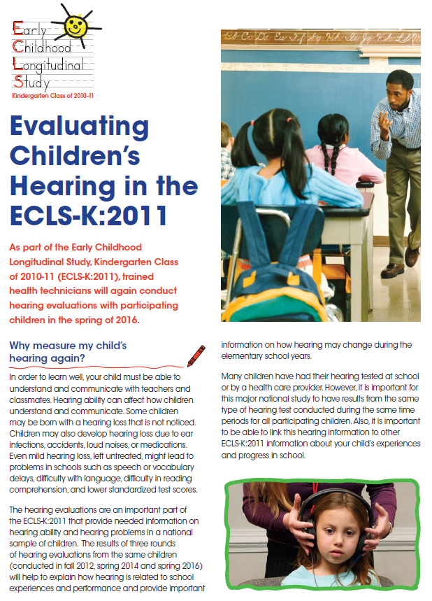
HEARING EVALUATION FLYER

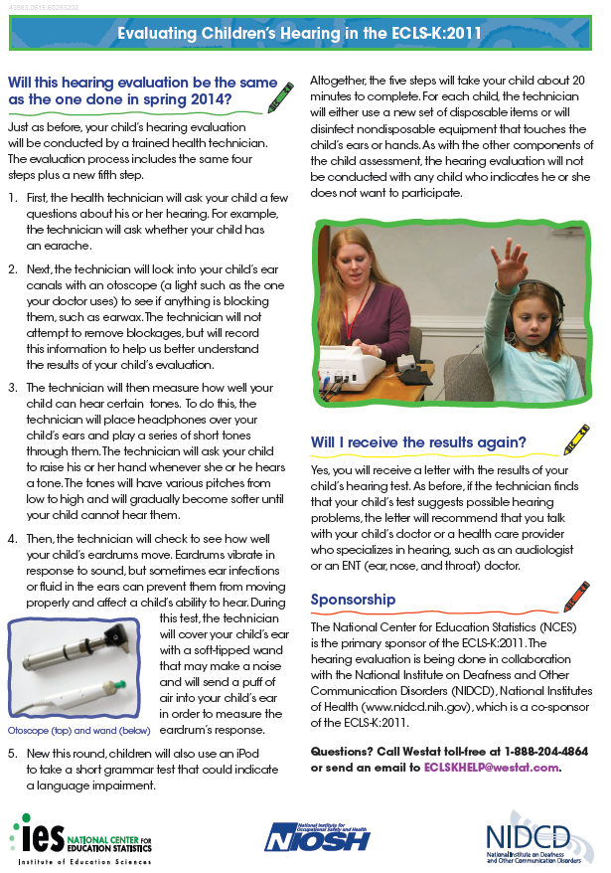

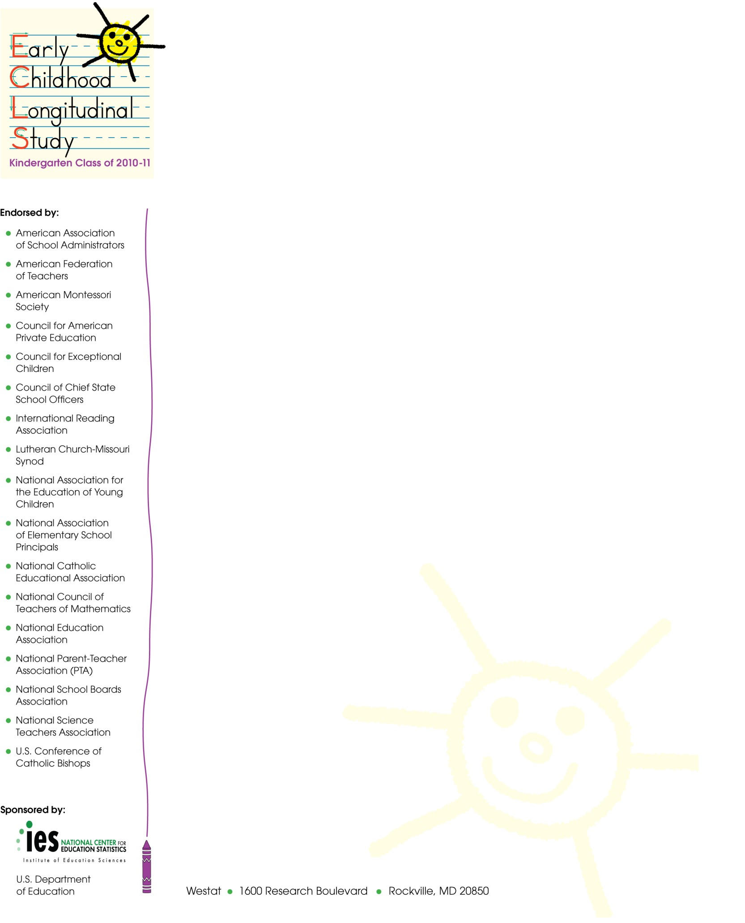
Spring 2016
SPRING 5TH GRADE LETTER FOR NEW TRANSFER DISTRICTS WITH PREVIOUSLY NON-PARTICIPATING SCHOOLS INTO WHICH STUDY CHILDREN HAVE TRANSFERRED

[SUPERINTENDENT NAME]
[DISTRICT NAME/DIOCESE]
[ADDRESS]
[ADDRESS2]
[CITY, STATE ZIP]

Dear Superintendent:

I am writing to inform you that one or more students who are participating in the Early Childhood Longitudinal Study, Kindergarten Class of 2010-11 (ECLS-K:2011) have transferred to a school in your district.

The ECLS-K:2011 is the third in a series of longitudinal studies of young children conducted by the National Center for Education Statistics (NCES). These studies are important sources of data for researchers and policy makers to address key issues related to children’s development and learning, including literacy in the home, the teaching of reading and mathematics, and the associations between physical exercise, childhood obesity, and well-being. Researchers using the data have published their findings widely in scientific journals and the popular press. NCES also presents results from these studies for practitioners and the general public on our website, http://nces.ed.gov/ecls.

Like its predecessor studies, the ECLS-K:2011 provides important information on children’s early learning and development, transition into kindergarten, and progress through elementary school. The new cohort of students’ school experiences can be compared to those of over a decade earlier to study the extent to which the demographic profile of children and their environment for learning have changed, and how these changes relate to developmental and academic differences across the cohorts.

The ECLS-K:2011 began in the fall of 2010, and the study children have been participating since that time. As in prior rounds, this spring the study children will complete individual assessments with trained ECLS-K:2011 assessors. These assessments are designed to measure children’s reading, mathematics, and science skills and knowledge, as well as obtain indicators of children’s memory and ability to follow rules in structured tasks, both of which are associated with learning. Children also will have their height and weight measured and will complete a questionnaire about themselves and their experiences in school. These assessment activities will take approximately 80 minutes per child to complete. Parents of the study children will be asked to participate by providing background information about their children and their families during a telephone interview. The children’s teachers will be asked to provide information about themselves and the sampled children. We also will ask the school’s administrator to complete a self-administered questionnaire about the school and his or her background.

Participation in this study is voluntary; however, we ask your agency to support the participation of schools in your district in the ECLS-K:2011. Because the ECLS-K:2011 is designed to be a representative sample of U.S. students, its accuracy depends on the full participation of the sampled schools and students.

The National Center for Education Statistics of the U.S. Department of Education’s Institute of Education Sciences is conducting the ECLS-K:2011. Data collection for the study is being carried out on behalf of NCES by Westat. The ECLS-K:2011 has been endorsed by the national education organizations listed on this letter. NCES is authorized to conduct this study under 20 U.S. Code, Section 9543. Under that law, the data provided by your schools, staff, students, and their parents may be used only for statistical purposes and may not be disclosed, or used, in identifiable form for any other purpose except as required by law (20 U.S. Code, Section 9573). The U.S. Office of Management and Budget has approved the data collection under OMB # 1850-0750 (expires XX/XX/201X).

In preparation for spring activities in the schools, in the next few days an ECLS-K:2011 representative will contact the schools in your district that the study’s students attend. We are required by law to protect the names of schools in the study from disclosure; we ask that each district respect this requirement and protect the identity of participating schools as well. Information collected from multiple individuals will be combined to produce reports of findings from the ECLS-K:2011. The reports will not identify participating districts, schools, children and their parents, or individual staff.

Detailed information about the ECLS-K:2011 can be found in the brochure enclosed with this letter. If you have questions about the study, please feel free to call Westat toll-free at 1-888-204-4864 or send an email to ECLSKHELP@westat.com. Also, more information about the ECLS-K:2011 is available at: http://nces.ed.gov/ecls/MyECLSK2011.

Thank you for your support of the ECLS-K:2011.

Sincerely,
Christopher Chapman
Associate Commissioner, Sample Surveys Division
National Center for Education Statistics, Institute of Education Sciences

Enclosures: ECLS-K:2011 Brochure

Spring 2016
SPRING 5TH GRADE LETTER FOR CONTINUING DISTRICTS WITH PREVIOUSLY NON-PARTICIPATING SCHOOLS INTO WHICH STUDY CHILDREN HAVE TRANSFERRED

[SUPERINTENDENT NAME]
[DISTRICT NAME/DIOCESE]
[ADDRESS]
[CITY, STATE ZIP]

Dear Superintendent:

We are very happy that schools in your district are participating in the Early Childhood Longitudinal Study, Kindergarten Class of 2010-11 (ECLS-K:2011). Thank you for helping make their participation possible. I am writing to inform you that one or more students who are participating in the ECLS-K:2011 have transferred to a school in your district that was not previously part of the study.

The participating children will complete individual assessments with trained ECLS-K:2011 assessors. These assessments are designed to measure children’s reading, mathematics, and science skills and knowledge, as well as obtain indicators of children’s memory and ability to follow rules in structured tasks, both of which are associated with learning. Children also will have their height and weight measured and will complete a questionnaire about themselves and their experiences in school. These assessment activities will take approximately 80 minutes per child to complete. Parents of the study children will be asked to participate by providing background information about their children and their families during a telephone interview. The children’s teachers will be asked to provide information about themselves and the sampled children. We also will ask the school’s administrator to complete a self-administered questionnaire about the school and his or her background.

Participation in this study is voluntary; however, we ask your agency to support the participation of schools in your district in the ECLS-K:2011. Because the ECLS-K:2011 is designed to be a representative sample of U.S. students, its accuracy depends on the full participation of the sampled schools and students.

The National Center for Education Statistics of the U.S. Department of Education’s Institute of Education Sciences is conducting the ECLS-K:2011. Data collection for the study is being carried out on behalf of NCES by Westat. The ECLS-K:2011 has been endorsed by the national education organizations listed on this letter. NCES is authorized to conduct this study under 20 U.S. Code, Section 9543. Under that law, the data provided by your schools, staff, students, and their parents may be used only for statistical purposes and may not be disclosed, or used, in identifiable form for any other purpose except as required by law (20 U.S. Code, Section 9573). The U.S. Office of Management and Budget has approved the data collection under OMB # 1850-0750 (expires XX/XX/201X).

In preparation for spring activities in the schools, in the next few days an ECLS-K:2011 representative will contact the schools in your district that the study’s students attend. We are required by law to protect the names of schools in the study from disclosure; we ask that each district respect this requirement and protect the identity of participating schools as well. Information collected from multiple individuals will be combined to produce reports of findings from the ECLS-K:2011. The reports will not identify participating districts, schools, children and their parents, or individual staff.

If you have questions about the study, please feel free to call Westat toll-free at 1-888-204-4864
or send an email to ECLSKHELP@westat.com. Also, more information about the ECLS-K:2011 is available at: http://nces.ed.gov/ecls/MyECLSK2011.

Thank you for your support of the ECLS-K:2011.

Sincerely,
Christopher Chapman
Associate Commissioner, Sample Surveys Division
National Center for Education Statistics, Institute of Education Sciences

Spring 2016
SPRING 5TH GRADE SCHOOL ADMINISTRATOR LETTER FOR TRANSFER SCHOOLS IDENTIFIED IN SPRING 2016

[PRINCIPAL NAME]
[SCHOOL NAME]
[ADDRESS 1]
[ADDRESS 2]
[CITY, STATE ZIP]

Dear School Administrator:

I am writing to invite you to participate in an insightful study, the Early Childhood Longitudinal Study, Kindergarten Class of 2010-11 (ECLS-K:2011). The ECLS-K:2011 began in the 2010-11 school year with approximately 18,200 children in about 950 schools across the country. We are inviting you to participate because one or more students who are participating in the study have transferred to your school.

The ECLS-K:2011 is the third in a series of longitudinal studies of young children conducted by the National Center for Education Statistics (NCES). These studies are important sources of data for researchers and policy makers to address key issues related to children’s development and learning including literacy in the home, the teaching of reading and mathematics, and the associations between physical exercise, childhood obesity, and well-being. Researchers using the data have published their findings widely in scientific journals and the popular press. NCES also presents results from these studies for practitioners and the general public on our website, http://nces.ed.gov/ecls.

Like its predecessor studies, the ECLS-K:2011 provides important information on children’s early learning and development, transition into kindergarten, and progress through elementary school. The new cohort of students’ school experiences can be compared to those of over a decade earlier to study the extent to which the demographic profile of children and their environments for learning have changed, and how these changes relate to developmental and academic differences across the cohorts. The study is described in more detail in the enclosed brochure.

The participation of each of the selected schools is crucial to the success of this important study. For the study data to accurately represent the early schooling experiences of all children in America, it is vital that the sampled students take part in each phase of the study. Therefore, this spring we would like to conduct a child assessment with the study children who are now attending your school.

The participating children will complete individual assessments with trained ECLS-K:2011 assessors. These assessments are designed to measure children’s reading, mathematics, and science skills and knowledge, as well as obtain indicators of children’s memory and ability to follow rules in structured tasks, both of which are associated with learning. Children also will have their height and weight measured and will complete a questionnaire about themselves and their experiences in school. These assessment activities will take approximately 80 minutes per child to complete. Parents of the study children will be asked to participate by providing background information about their children and their families during a telephone interview. The children’s teachers will be asked to provide information about themselves and the sampled children. We also will ask you to complete a self-administered questionnaire about your school and background.

Participation in this study is voluntary; however, I encourage your school’s participation in the ECLS-K:2011. Because the ECLS-K:2011 is designed to be a representative sample of U.S. students, its accuracy depends on the full participation of your school, teachers, and students. We are asking you to identify a staff member at your school to act as a liaison with the ECLS-K:2011 and facilitate the activities in the school that are part of the study. In appreciation for their time and efforts, participating teachers will receive a monetary token as a thank you for their time and effort.

The National Center for Education Statistics of the U.S. Department of Education’s Institute of Education Sciences is conducting the ECLS-K:2011. Data collection for the study is being carried out on behalf of NCES by Westat. The ECLS-K:2011 has been endorsed by the national education organizations listed on this letter. NCES is authorized to conduct this study under 20 U.S. Code, Section 9543. Under that law, the data provided by your school, staff, students, and their parents may be used only for statistical purposes and may not be disclosed, or used, in identifiable form for any other purpose except as required by law (20 U.S. Code, Section 9573). The U.S. Office of Management and Budget has approved the data collection under OMB # 1850-0750 (expires XX/XX/201X). Information collected from multiple individuals will be combined to produce reports of findings from the ECLS-K:2011. The reports will not identify participating districts, schools, children and their parents, or individual staff.

Within the next few days, an ECLS-K:2011 representative will contact you about participating in this important study. If you have questions about the study, please feel free to call Westat toll-free at 1-888-204-4864 or send an email to ECLSKHELP@westat.com. Also, more information about the ECLS-K:2011 is available at http://nces.ed.gov/ecls/MyECLSK2011.

Thank you for your support of the ECLS-K:2011.

Christopher Chapman
Associate Commissioner, Sample Surveys Division
National Center for Education Statistics, Institute of Education Sciences

Enclosure: ECLS-K:2011 Brochure

Spring 2016
SPRING 5TH GRADE LETTER FOR SCHOOL COORDINATORS AT A CONTINUING SCHOOL WITH NEW TRANSFER STUDENTS IDENTIFIED IN SPRING 2016

[NAME]
[SCHOOL NAME]
[ADDRESS 1]
[ADDRESS 2]
[CITY, STATE ZIP]

Dear School Coordinator:

We are very happy that your school is participating in the Early Childhood Longitudinal Study, Kindergarten Class of 2010-11 (ECLS-K:2011). As you know, this spring we are planning to collect information from the study children at your school, their parents, their teachers, and their school’s administrator. One or more students who have participated in the study at a different school have transferred to your school, and we would like to complete assessments with them, along with the children who have participated in your school in the past.

As with the other participating children at your school, these additional children will complete one-on-one assessments with trained ECLS-K:2011 assessors. These assessments are designed to measure children’s reading, mathematics, and science skills and knowledge, as well as obtain indicators of children’s memory and ability to follow rules in structured tasks. Children also will have their height and weight measured and will complete a questionnaire about themselves and their experiences in school. These assessment activities will take approximately 80 minutes for each child to complete.

A component of the study involves collecting information about the sampled students from their teachers using self-administered questionnaires. We also will collect information from the school administrator.

We appreciate your help with four tasks, which are detailed in the enclosed materials. These are (1) confirm that the children participating in the ECLS-K:2011 are attending your school (the list of participating children will be sent separately); (2) confirm the date and time for the spring activities; (3) identify an appropriate space for the assessments; and (4) identify the primary teachers of the participating children. Please read the enclosed materials for more information about the study and your important role in it.

The National Center for Education Statistics of the U.S. Department of Education’s Institute of Education Sciences is conducting the ECLS-K:2011. Data collection for the study is being carried out on behalf of NCES by Westat. The ECLS-K:2011 has been endorsed by the national education organizations listed on this letter. NCES is authorized to conduct this study under 20 U.S. Code, Section 9543. Under that law, the data you provide may be used only for statistical purposes and may not be disclosed, or used, in identifiable form for any other purpose except as required by law (20 U.S. Code, Section 9573). The U.S. Office of Management and Budget has approved the data collection under OMB # 1850-0750 (expires XX/XX/201X).

Thank you for your support of the ECLS-K:2011. We look forward to working with you and your school again. An ECLS-K:2011 representative will call you in the coming weeks to further explain the study and your responsibilities. If you have any questions or concerns in advance of the phone call, please call Westat toll free at 1-888-204-4864 or send an email to ECLSKHELP@westat.com.

Sincerely,
Christopher Chapman
Associate Commissioner, Sample Surveys Division
National Center for Education Statistics, Institute of Education Sciences

SCHOOL ADMINISTRATOR THANK YOU LETTER - INCENTIVES

Spring 2016

[PRINCIPAL NAME]
[SCHOOL NAME]
[ADDRESS]
[CITY, ST ZIP]

Dear School Administrator,

Thank you for participating in the Early Childhood Longitudinal Study, Kindergarten Class of 2010-11 (ECLS-K:2011). Enclosed is $200 for your school as a token of our appreciation for your school’s participation in this important study of American education.

The study has been very successful over the past 6 years because of the cooperation and participation of the children, parents, schools, school administrators, and teachers. You can find further information and results from the study at our website at http://www.myeclsk2011.com/default.html.

Thank you for your support of the ECLS-K:2011. If you have any questions or concerns please call our toll-free number 1-888-204-4864 or email us at ECLSKHELP@westat.com.

Sincerely,
Christopher Chapman
Associate Commissioner, Sample Surveys Division
National Center for Education Statistics, Institute of Education Sciences

SCHOOL ADMINISTRATOR THANK YOU LETTER - NO INCENTIVE

Spring 2016

[PRINCIPAL NAME]
[SCHOOL NAME]
[ADDRESS]
[CITY, ST ZIP]

Dear School Administrator,

Thank you for participating in the Early Childhood Longitudinal Study, Kindergarten Class of 2010-11 (ECLS-K:2011).

The study has been very successful over the past 6 years because of the cooperation and participation of the children, parents, schools, school administrators, and teachers. You can find further information and results from the study at our website at http://www.myeclsk2011.com/default.html.

Thank you for your support of the ECLS-K:2011. If you have any questions or concerns please call our toll-free number 1-888-204-4864 or email us at ECLSKHELP@westat.com.

Sincerely,
Christopher Chapman
Associate Commissioner, Sample Surveys Division
National Center for Education Statistics, Institute of Education Sciences

ECLS-K:2011 HEARING EVALUATION REPORT

STUDENT NAME: <Child’s first name> <Child’s last name>
DATE OF HEARING EVALUATION: <date of hearing evaluation >

The Early Childhood Longitudinal Study – Kindergarten Class of 2010-11 (ECLS-K:2011) conducted hearing evaluations on some children this spring. <Child’s first name> received this hearing check at school on <date>.
[RESULTS A – for children with sufficient thresholds to produce a summary report]
Results of the hearing check <text from audiometry table or “show that <child’s first name>’s hearing is within the expected range, meaning that <child’s first name> was able to hear sounds that children with normal hearing can hear.”>. Details about <child’s first name>’s hearing check are provided on the attached page. Please note that we may not have been able to check all of the sounds during <child’s first name>’s evaluation. If some sounds were not checked, it was likely because there was not enough time or the room was too noisy to complete the entire evaluation.
[RESULTS B – for children with insufficient thresholds to produce a summary report]
Unfortunately, we cannot summarize the results of <child’s first name>’s hearing check because we were not able to obtain results for enough sounds to draw conclusions about <child’s first name>’s hearing. This likely happened because there was not enough time or the room was too noisy to complete the evaluation. Details about any results we could obtain are provided on the attached page.

[PHYSICIAN’S REFERRAL TEXT A – for children with any threshold > 15 dB HL]
The ECLS-K:2011 hearing evaluation can identify possible hearing problems but cannot determine the cause of those problems. While our study staff attempted to do the hearing check in a quiet location, the testing conditions in the school may have affected the results. This evaluation does not replace a full hearing examination by a medical professional. If you have not already done so, we recommend that you talk to your child’s doctor or other health professional about scheduling a complete hearing evaluation. You may wish to take this report with you to the doctor or other health professional.
[PHYSICIAN’S REFERRAL TEXT B –for all other children]
While our study staff attempted to do the hearing check in a quiet location, the testing conditions in the school may have affected the results. This evaluation does not replace a full hearing examination by a medical professional. Please talk to your child’s doctor or other health professional about a complete hearing evaluation if you have any concerns about <child’s first name>’s hearing.

The ECLS-K:2011 hearing evaluations were overseen by certified audiologists at the Centers for Disease Control and Prevention (CDC). If you have any questions about this hearing evaluation, please contact the ECLS-K:2011 audiology team at 513-533-8485 or CLT6@cdc.gov.

The National Institute on Deafness and Other Communication Disorders (NIDCD) sponsored the hearing evaluations included in the ECLS-K:2011. The NIDCD is part of the National Institutes of Health (NIH), the nation’s medical research agency. For further information on hearing loss and its effects, prevention, treatment, or rehabilitation, please contact the NIDCD at 800-241-1044 or visit them on the web at www.nidcd.nih.gov.

ECLS-K:2011 HEARING EVALUATION REPORT (continued)

STUDENT NAME: <Child’s first name> <Child’s last name>
DATE OF HEARING EVALUATION: <date of hearing evaluation >

Detailed Report
The softest sounds a person can hear are called hearing thresholds. The ECLS-K:2011 hearing evaluation checked thresholds at several different pitches, or frequencies, which are measured in Hertz. Some of the sounds had a lower frequency (such as 2000 Hertz, which is about the pitch of a watch ticking), and some of the sounds had a higher frequency (such as 8000 Hertz, which is about the pitch of birds chirping).
Thresholds are measured in decibels. The threshold tells how loud each sound had to be for <child’s first name> to be able to hear it. When thresholds are smaller, that means your child can hear quieter sounds, which indicates better hearing. Threshold values that are more than 15 decibels (about as loud as a breeze blowing through the leaves of a tree) indicate possible hearing difficulty in children.
<Child’s first name>’s results are shown in the table below. Thresholds towards the left of the table (for example, 2000 Hertz) indicate how well your child can hear lower-pitched sounds and thresholds toward the right (for example, 8000 Hertz) indicate how well your child can hear higher-pitched sounds. Thresholds in bold indicate hearing levels that are higher than what is expected for children and may need further evaluation.

<Child’s first name>’s Hearing Thresholds by Ear and Pitch
Pitch of Tested Sound (Frequency in Hertz)
 | (lower) |  | 1000 | 2000 | 3000 | 4000 | 6000 | 8000 | (higher)
Right Ear Thresholds |  |  |  |  |  |  |  |  | (decibels)
Left Ear Thresholds |  |  |  |  |  |  |  |  | (decibels)

[Include shaded columns in table only if any thresholds exist for at least one of the shaded cells.]
[Print the following legends only if the code explained by them appears in the table.]
* * * = It was too noisy or there was not enough time to test this sound.
NRS = No Response. Your child did not indicate he or she could not hear this sound even when it was very loud
Tracking Materials

BIRTHDAY CARD
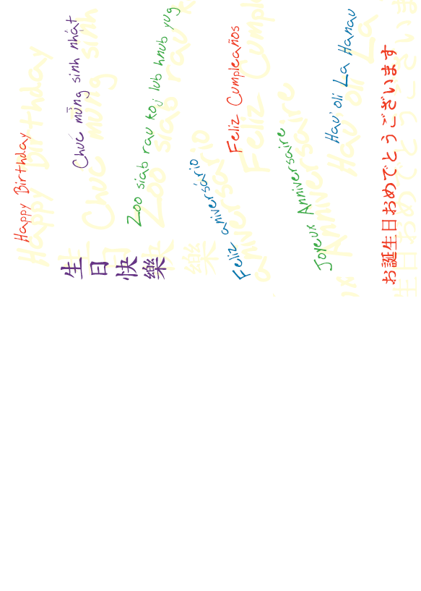
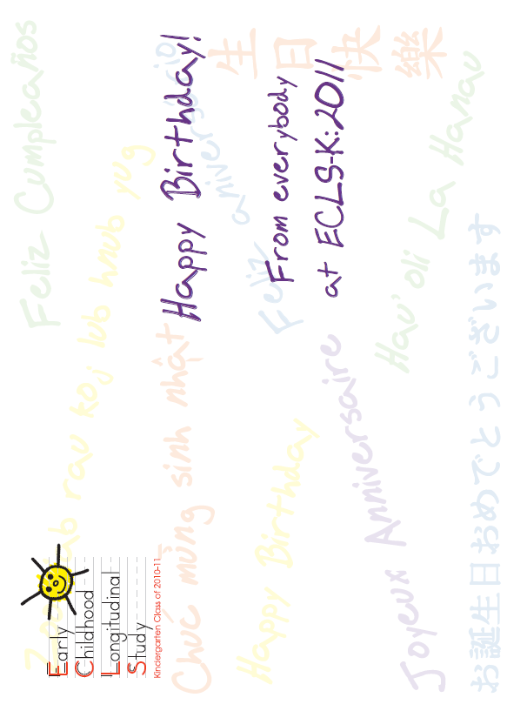

Post-it notes for parents

