Natural Gas STAR Program: Memorandum of
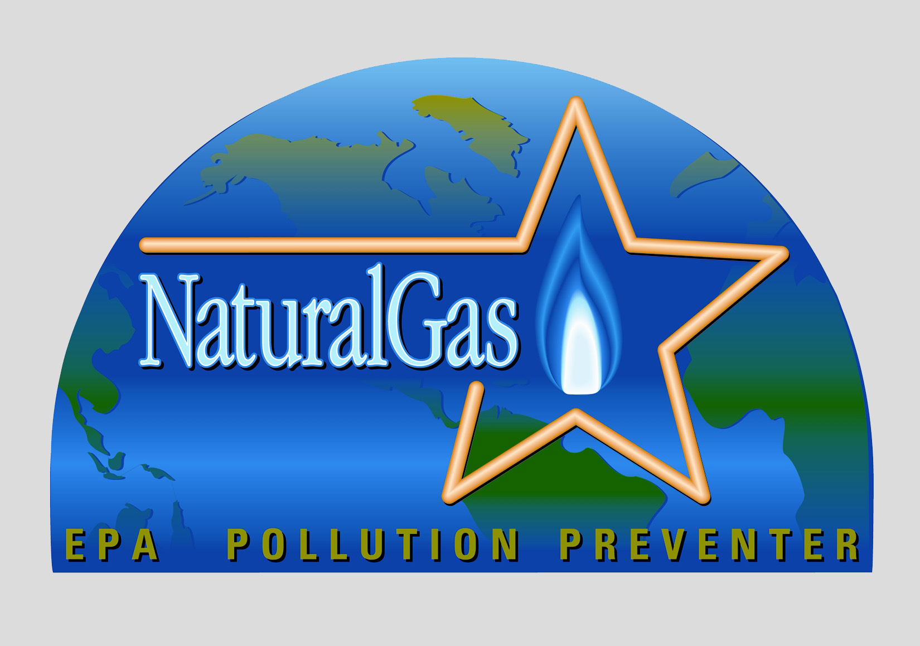
Under the Global Methane Initiative, The Natural Gas STAR Program is a flexible, non-regulatory, and voluntary partnership between the EPA and the international oil and natural gas industry aimed at facilitating and accounting for cost-effective methane emission reductions worldwide.

The Natural Gas STAR Program has identified technologies and operating & maintenance practices in use by industry as cost-effective options for reducing methane emissions. A complete listing of these measures can be found at epa.gov/gasstar.

Please send completed forms to:

Roger Fernandez
The Natural Gas STAR Program
Team Leader
Phone: +1 (202) 343-9386
Fax: +1 (202) 343-2202
E-mail: fernandez.roger@epa.gov

Standard Mail:
Roger Fernandez
The Natural Gas STAR Program
U.S. EPA (6207J)
1200 Pennsylvania Avenue, NW
Washington, DC 20460
U.S.A.

Express/Overnight Mail:
Roger Fernandez
The Natural Gas STAR Program
U.S. EPA (6207J)
1310 L Street, NW
Washington, DC 20005
U.S.A.

EPA Form No. 5900-108

EPA Form No. 5900-108
Understanding for International Operations

This is a voluntary agreement between ___________________________________________ (company name) and the U.S. Environmental Protection Agency (EPA) for the purpose of reducing methane releases to the atmosphere by implementing cost-effective emission reduction technologies and practices.

Authorized Company Representative: (name)

Signature: Date:

Paul M. Gunning: Director, Climate Change Division, U.S. Environmental Protection Agency

Signature: Date:

Partner’s Designated Natural Gas STAR Implementation Manager:
Name:
Title:
Address:
City/State:
Zip Code/Postal Code:
Country:
Telephone:
Fax:
E-mail:

EPA’s Responsibilities

- Assign a Natural Gas STAR Representative responsible for assisting the partner in implementing the Program.
- Assist partners with Program implementation by: (1) analyzing emerging technologies and practices; (2) developing workshops and training courses; and (3) cataloguing and communicating technologies and operation & maintenance practices.
- Provide partners with public recognition for their commitment to the Program.

Natural Gas STAR Partner’s Responsibilities

- Appoint a company representative as the Natural Gas STAR Program Implementation Manager responsible for implementing this voluntary agreement.
- Submit an implementation plan within one year of signing this agreement outlining expected activities and scope of implementation.
- Implement, within three years, applicable technologies and operation & maintenance practices at facilities as outlined in the implementation plan when cost-effective (as defined by the partner).
- Submit annual reports describing the measures implemented, the cost of implementation, and the associated methane emission reductions.
- Communicate participation to employees and cooperate with EPA efforts to publicize the Program.

General Terms

- This agreement can be terminated by either party at any time, with no notice or penalties and no further obligation. EPA agrees not to publicize a partner’s withdrawal from the Program.
- The partner agrees that the activities it undertakes connected with this MOU are not intended to provide services to the U.S. Government and that the partner will not seek compensation from the U.S. Government.
- The partner agrees that it will not claim or imply that its participation in the Program constitutes EPA approval or endorsement of anything other than the commitment to the Program.
The public reporting and recordkeeping burden for this collection of information is estimated to average 59 hours per response. Send comments on the Agency’s need for this information, the accuracy of the provided burden estimates, and any suggested methods for minimizing respondent burden, including through the use of automated collection techniques to the Director, Collection Strategies Division, U.S. Environmental Protection Agency (2822T), 1200 Pennsylvania Ave., NW, Washington, D.C. 20460. Include the OMB control number in any correspondence. Do not send the completed form to this address.

