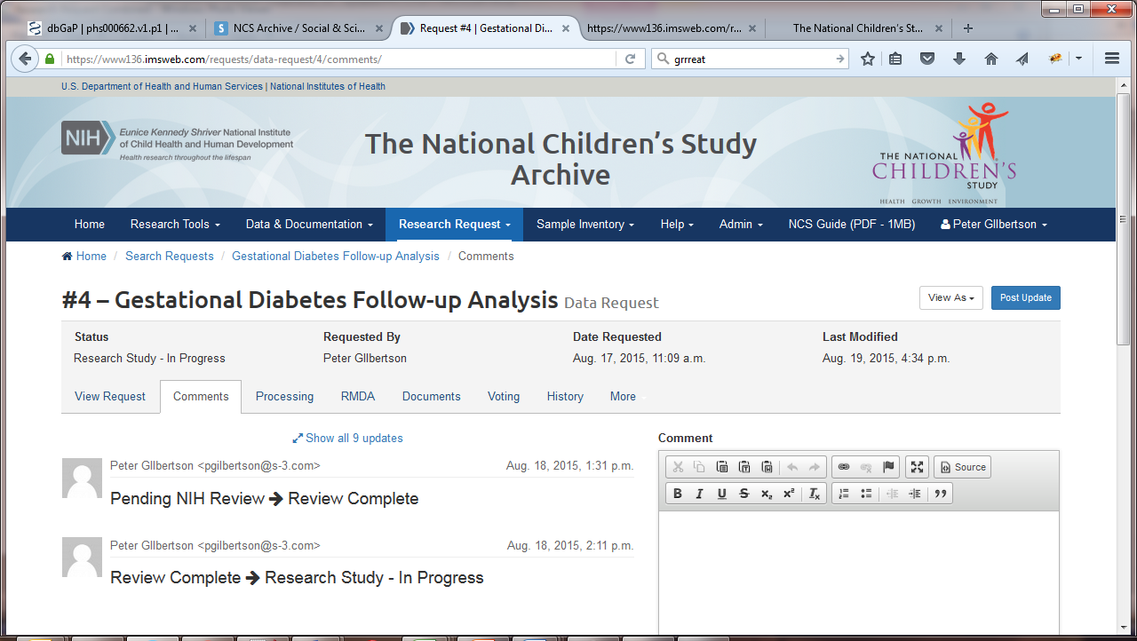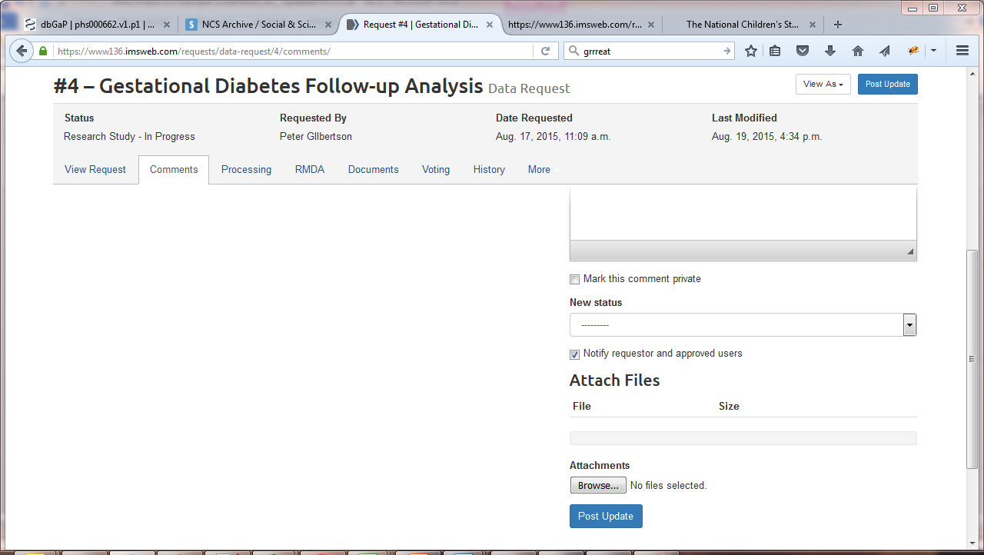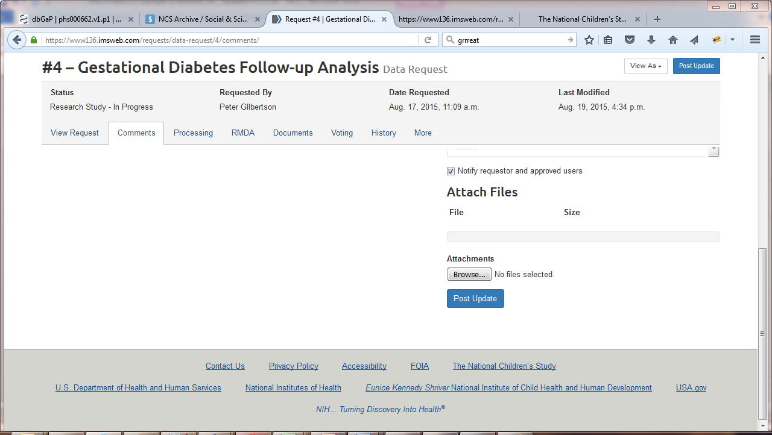

Public reporting burden for this collection of information is estimated to average 10 minutes per response, including the time for reviewing instructions, searching existing data sources, gathering and maintaining the data needed, and completing and reviewing the collection of information. **An agency may not conduct or sponsor, and a person is not required to respond to, a collection of information unless it displays a currently valid OMB control number.** Send comments regarding this burden estimate or any other aspect of this collection of information, including suggestions for reducing this burden, to: NIH, Project Clearance Branch, 6705 Rockledge Drive, MSC 7974, Bethesda, MD 20892-7974, ATTN: PRA (0925-0647). Do not return the completed form to this address.

**Privacy Act Notification:** Information collected as part of the data use agreement, data request forms, and distribution agreement may be made public in part or in whole for tracking and reporting purposes. This Privacy Act Notification is provided pursuant to Public Law 93-579, Privacy Act of 1974, 5 U.S.C. Section 552a. Authority for the collection of the information requested below from the recipient comes from the authorities regarding the establishment of the National Institutes of Health, its general authority to conduct and fund research and to provide training assistance, and its general authority to maintain records in connection with these and its other functions (42 U.S.C. 203, 241, 289l-1 and 44 U.S.C. 3101), and Section 301 and 493 of the Public Health Service Act. These records will be maintained in accordance with the Privacy Act System of Record Notice 09-25-0200 (https://oma.od.nih.gov/forms/Privacy%20Documents/PAfiles/0200.htm) covering “Clinical, Basic and Population-based Research Studies of the National Institutes of Health (NIH), HHS/NIH/OD.” The primary uses of this information are to document, track, and monitor and evaluate the use of the NCS Archive, as well as to notify interested recipients of updates, corrections or other changes to the NCS data. The Federal Privacy Act protects the confidentiality of some NIH records. The NIH and any users that are provided access to the NCS Archive will have access to the information collected by the NIH from the Recipient, as part of the data use agreement, data request forms, and distribution agreement for the purposes described above. In addition, the Act allows the release of some information without the Recipient’s permission; for example, if it is requested by members of Congress or other authorized individuals. The information requested is voluntary, but necessary for obtaining access to data and samples in the NCS Archive.