Attachment 2: PRES Website

https://prevention.nih.gov/prevention-researach/expertise-survey

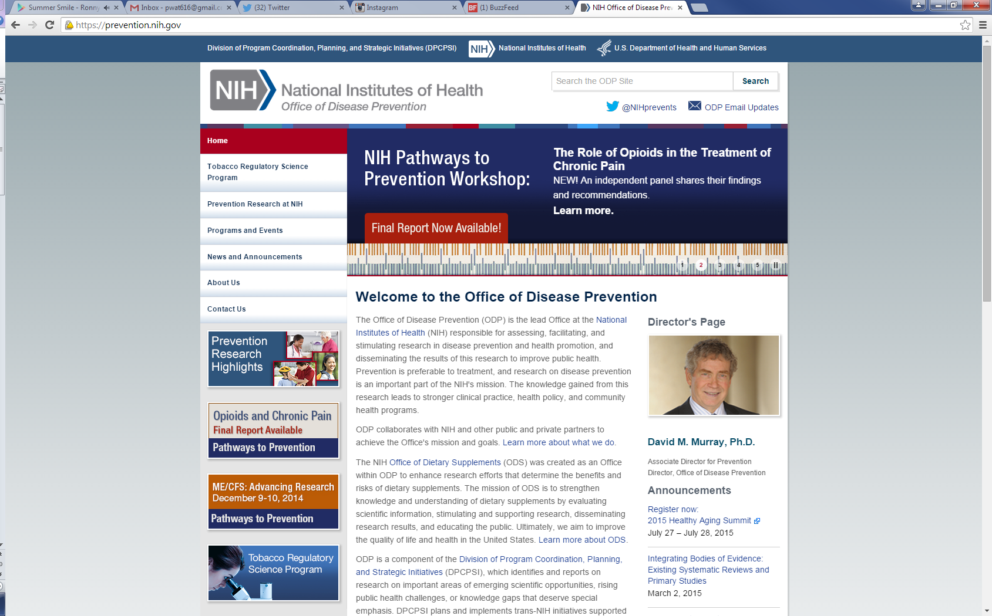

Text for PRES Landing Page:
Prevention Research Expertise Survey (PRES)
The Prevention Research Expertise Survey collects data on scientists’ methodological and content expertise to support an electronic directory. This electronic directory will help NIH Scientific Review Officers (SROs) identify experts in prevention science methods to include on their review panels.

What information will you need to include?
You will need to provide your name, contact information, and skill levels in a variety of prevention science methods and content areas. You will also have the opportunity to upload your curriculum vitae.

How will your information be used?
The information that you provide will be used to populate the electronic directory. The directory is a web interface that NIH SROs can use to access the data gathered by the survey. Search features will allow SROs to easily identify scientists with the best match of skills in relevant methodological and content areas.

How long will it take to complete the survey?
Public reporting burden for this collection of information is estimated to average 20 minutes per response, including the time for reviewing instructions, searching existing data sources, gathering and maintaining the data needed, and completing and reviewing the collection of information. An agency may not conduct or sponsor, and a person is not required to respond to, a collection of information unless it displays a currently valid OMB control number. Send comments regarding this burden estimate or any aspect of this collection of information, including suggestions for reducing this burden, to: NIH, Project Clearance Branch, 6705 Rockledge Drive, MSC 7974, Bethesda, MD 20892 -7972, ATTN: PRA (0925-xxxx). Do not return the completed form to this address.

Why should you participate?
Participation in the PRES is strictly voluntary and there are no consequences for choosing not to participate. If you chose to share your information, you may be asked to review applications, either on an ad hoc basis or as part of a study section.

