Date:

Dear [Mr./Ms./Dr. Name of Grievant]

I work for the End Stage Renal Disease (ESRD) National Coordinating Center (NCC). We work with Medicare to make sure patients are happy with the way their ESRD Network handles their grievance. Please know that we are not connected in any way to the ESRD Network or your dialysis center.

We are calling patients who have filed a grievance to take part in a survey. We will use what we learn from this survey to help Medicare support Networks and improve the way they handle the grievance process.

Our records show you filed a grievance with [Network Name] on or around [Complete Date]. If this is true, we would like to ask you some questions about your contact with the Network.

A surveyor from The Jackson Group will be calling you soon. Anything you tell the surveyor is private; we will not share your answers with the [Network Name] or your dialysis center. Your answers will not change your Medicare benefits or the care you receive. You can also decide whether you want to talk when the surveyor calls you.

If you did not file a grievance, please tell the surveyor during the call. We will try to call you up to five times to set up your interview. We will choose a time that is good for you.

One of our surveyors will call you between the following dates:

* mm/dd/yyyy and mm/dd/yyyy [between 9:00 am and 7:00 pm]

If you do not have time to talk when the surveyor calls, you can choose a better time for your interview.

The surveyor will ask different types of questions during the call. Each call should last 15 minutes. The questions will be about your contact with [Network Name] during the time you filed your grievance. They will not be about what happened with your grievance. We will keep your answers private. Your dialysis facility or the Network. will not see your answers. Your answers will not change your Medicare benefits.

Your feedback is very important to us. But if you choose not to take this survey, there will be no change in the care and services you receive.

If you have any questions or would like a paper copy of the survey to follow during your phone call, please contact:

Kathleen Egan, Medicare, xxx-xxx-xxxx, Email [Kathleen.Egan@cms.hhs.gov](mailto:Kathleen.Egan@cms.hhs.gov).

Thank you for your time.

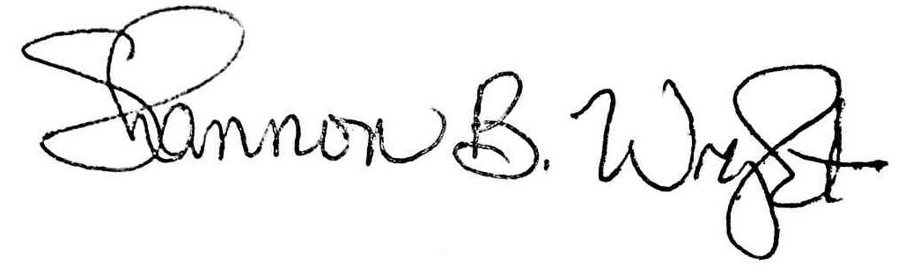

Shannon B. Wright, Director OMB Control Number: 0938-1185

End Stage Renal Disease NCC Expiration Date: 12/10/2015