Supporting Statement for OMB Clearance Request

Appendix J: Survey Flyer

Pathways for Advancing Careers and Education (PACE) – Follow-up Data Collection

OMB No. 0970-0397

November 2014

Submitted by:

Brendan Kelly

Office of Planning, Research  
and Evaluation

Administration for Children  
and Families

**U.S. Department of Health and Human Services**

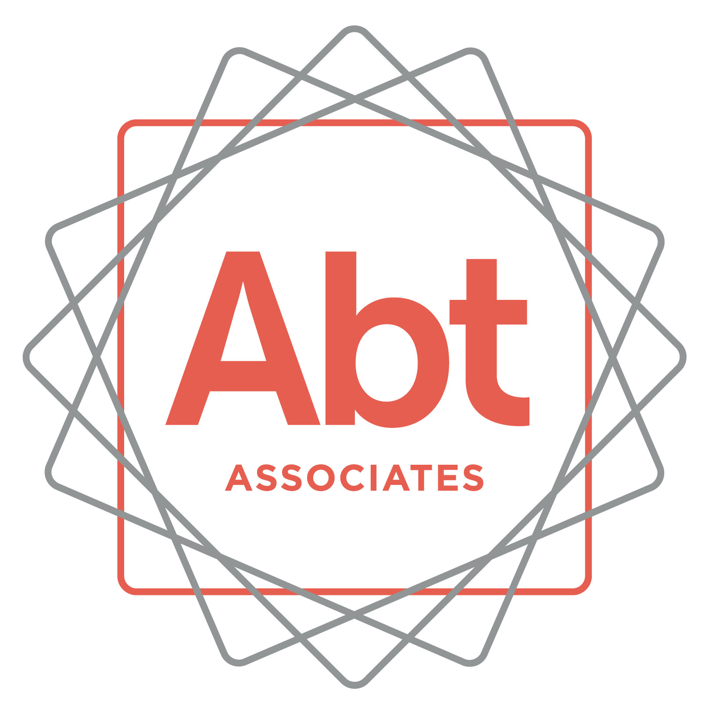

**We have been trying to reach you!** We’re following up about the Pathways for Advancing Careers and Education (PACE) study (previously known as the Innovative Strategies for Increasing Self-Sufficiency study). You agreed to participate in this study about 36 months ago. This is a very important research study funded by the U.S. Department of Health and Human Services that will help improve education and employment programs for others.

After you complete the interview, **you will receive $40 in appreciation for your participation.**

To schedule your interview or to get more information about the study, please call ___________________________

at ___________________________

You may also call my supervisor XX at **1-866-491-0770** (toll free).

Thank you and we look forward to speaking with you soon!

**ABTSRBIID­­­_____________________________________**

Please mention this number when you call