**Bandit Software: Batch submission of Bird Banding Data Collection**

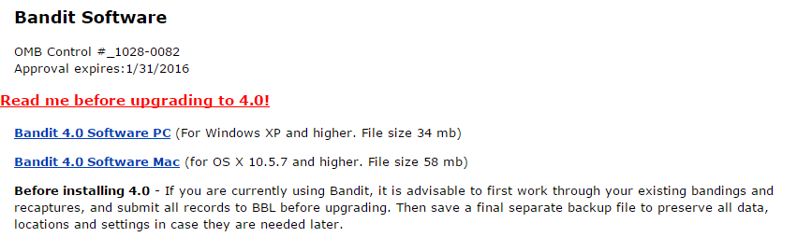

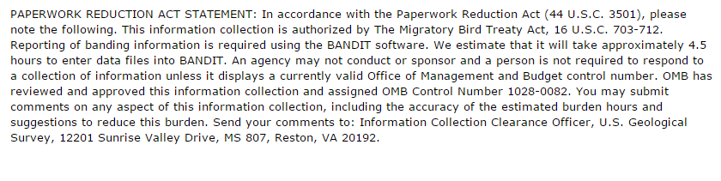

This PRA statement will be updated to read: **Reporting of banding information is voluntary but batch submissions must use the BANDIT software.**

This PRA statement is being updated on the software through Change Control Management. The top level menu appears on the next page. There are many data entry forms to customize the settings for the application. All of those pages are visible in the manual that is part of the collection. The main data collection form looks like a spreadsheet and is shown on page 3.

**Top Level Menu**



**Bandit main data entry form**



All of the data entry forms follow this same layout for the purpose of uploading a batch of data to Bandit.