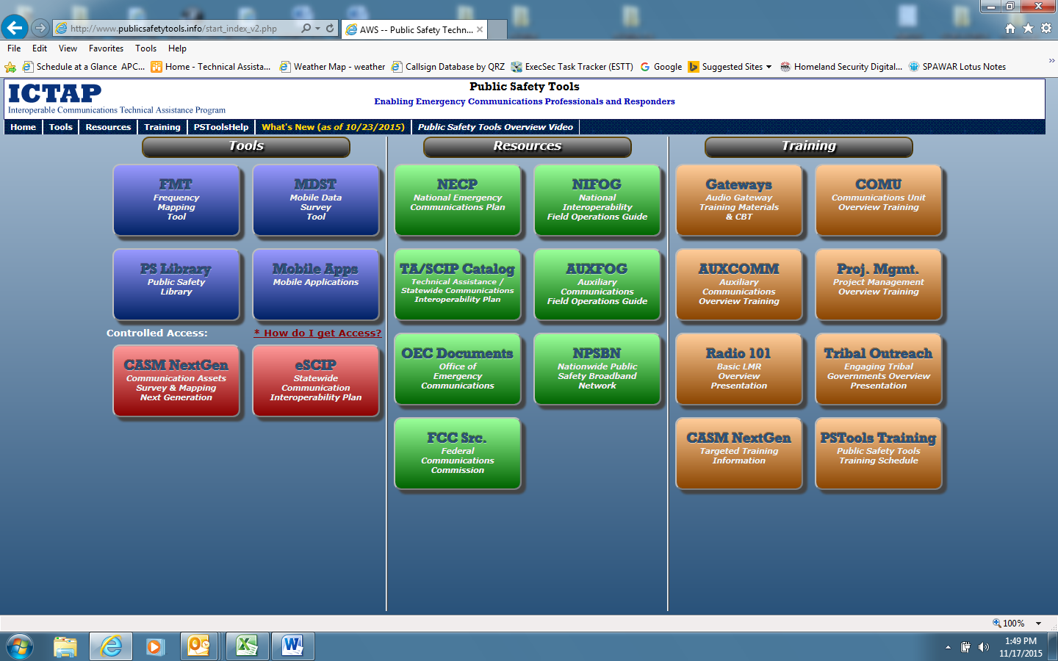

Electronic (fillable) and PDF versions of the Technical Assistance (TA) Request (DHS Form 9043) and TA Evaluation (DHS Form 9042) may be accessed on the OEC Public Safety Tools site at: (shown above) <http://www.publicsafetytools.info>

Followed by clicking on the green ‘TA/SCIP catalog’ Icon under resources.