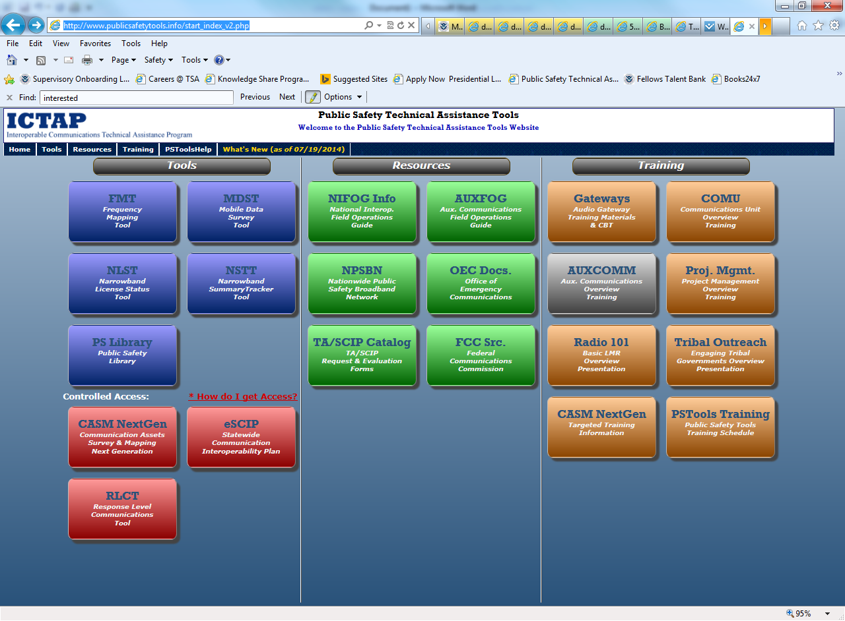
User click on TA/SCIP Catalog (green section , lower left)

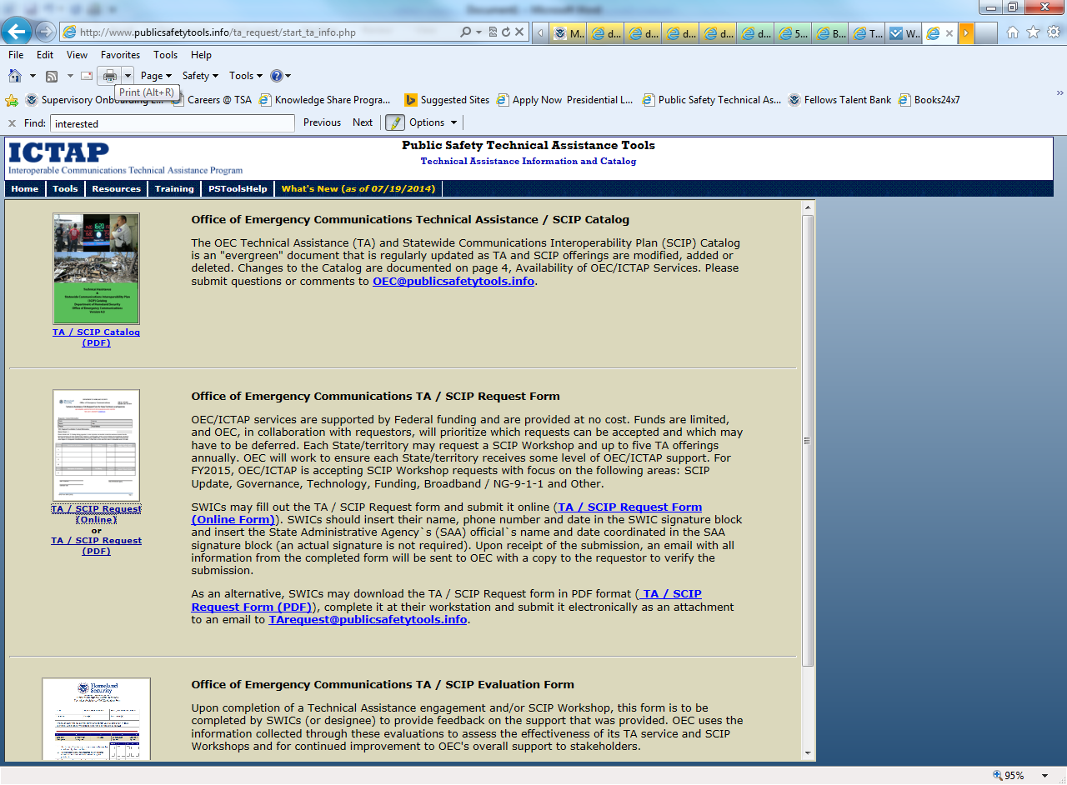
User may choose to complete the TA/SCIP Request form online or select the pdf version.

If the user selects the PDF version, the first page of the request form pdf displays the instructions, OMB Control Number and expiration date, privacy information, burden statement, etc.

Office of Emergency Communications TA / SCIP Request Form (online)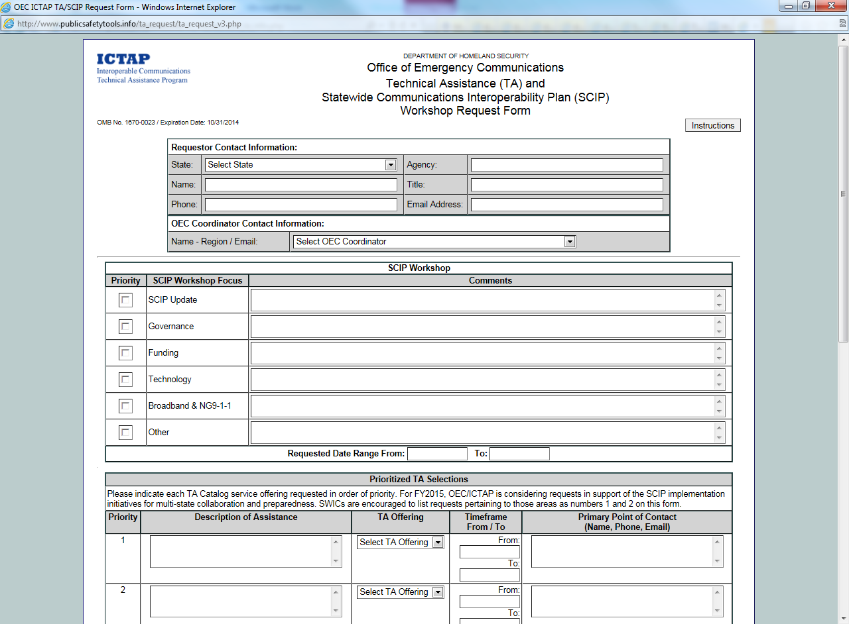
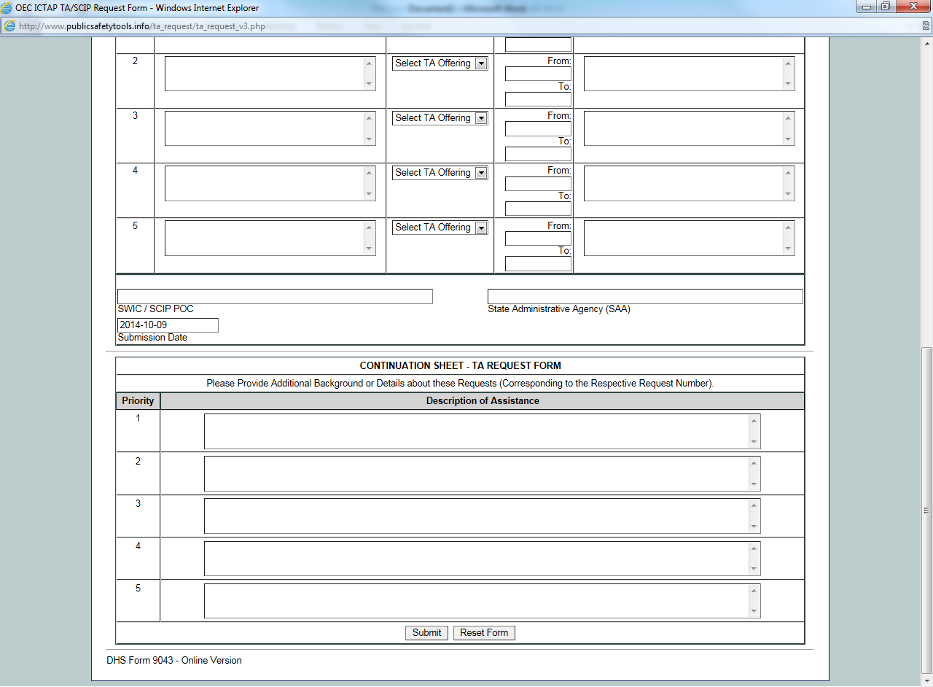

Link for the online version: http://www.publicsafetytools.info/ta_request/ta_request_v3.php. Instructions for using the online version and the pdf version are included on this screen. However, once the user clicks on the link to the online version, there is a button to click for instructions that displays the instructions, OMB Control Number and expiration date, privacy information, burden statement, etc.

Office of Emergency Communications TA / SCIP Request Form
Instruction page
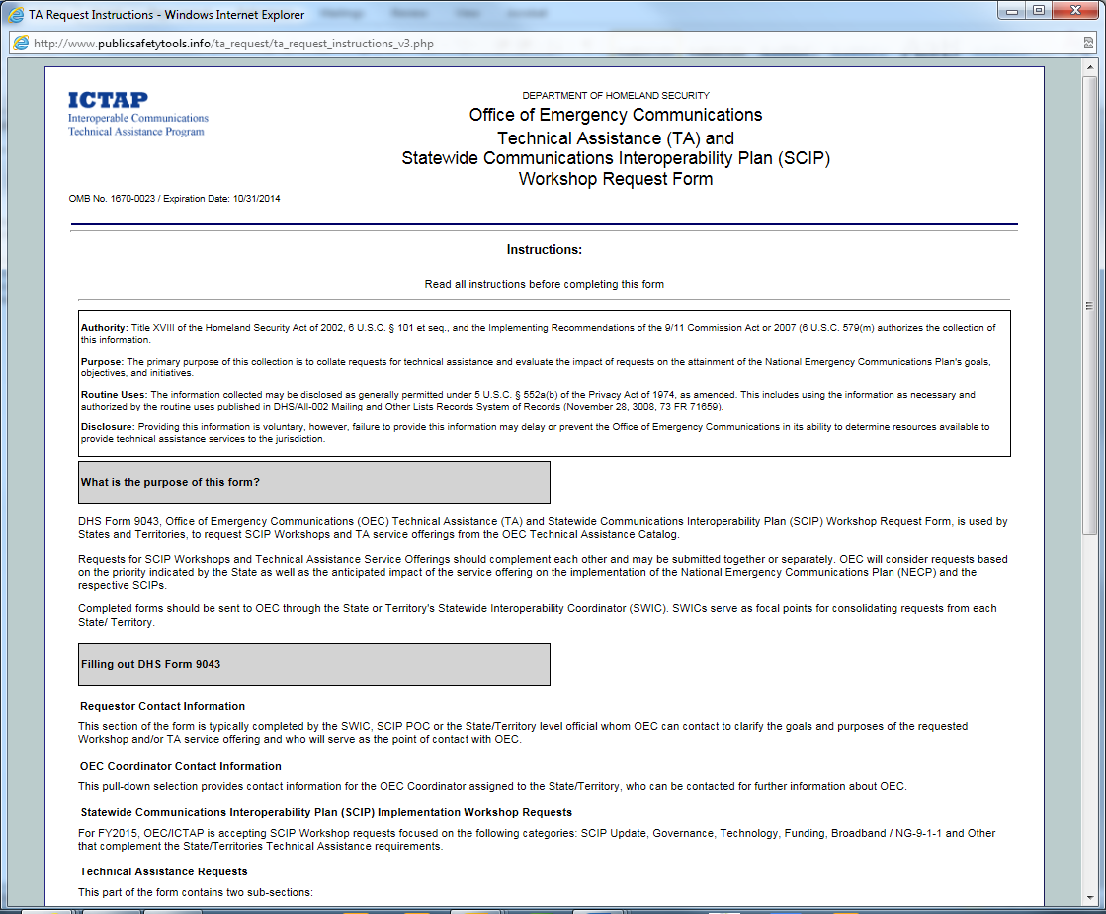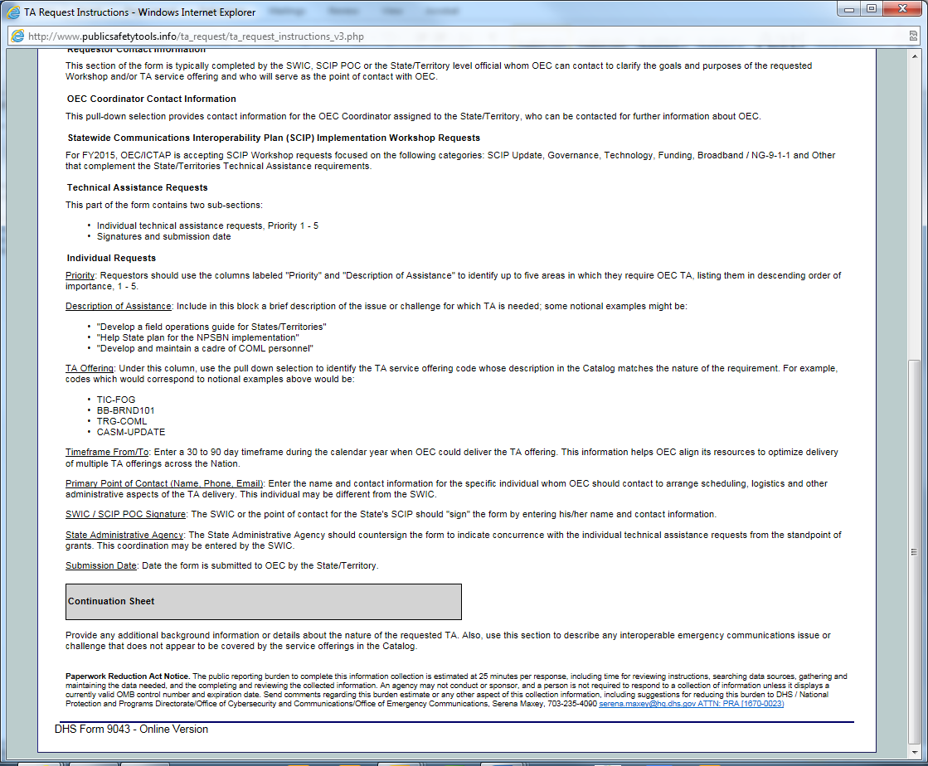
Office of Emergency Communications TA / SCIP Evaluation Form (online)
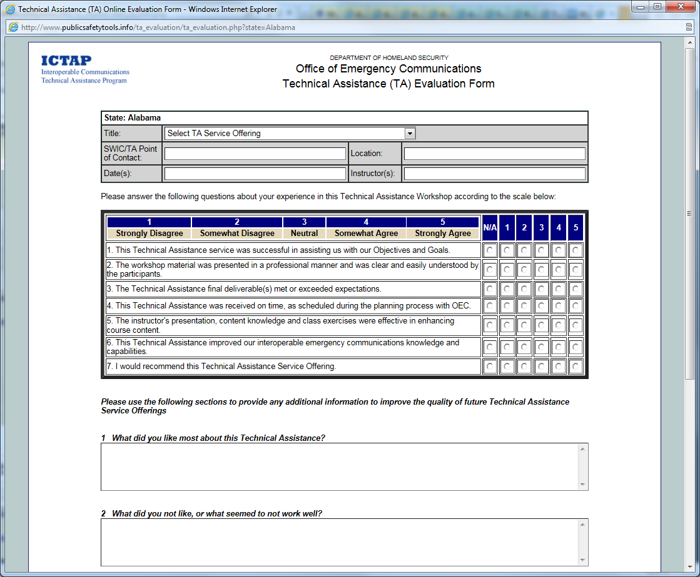
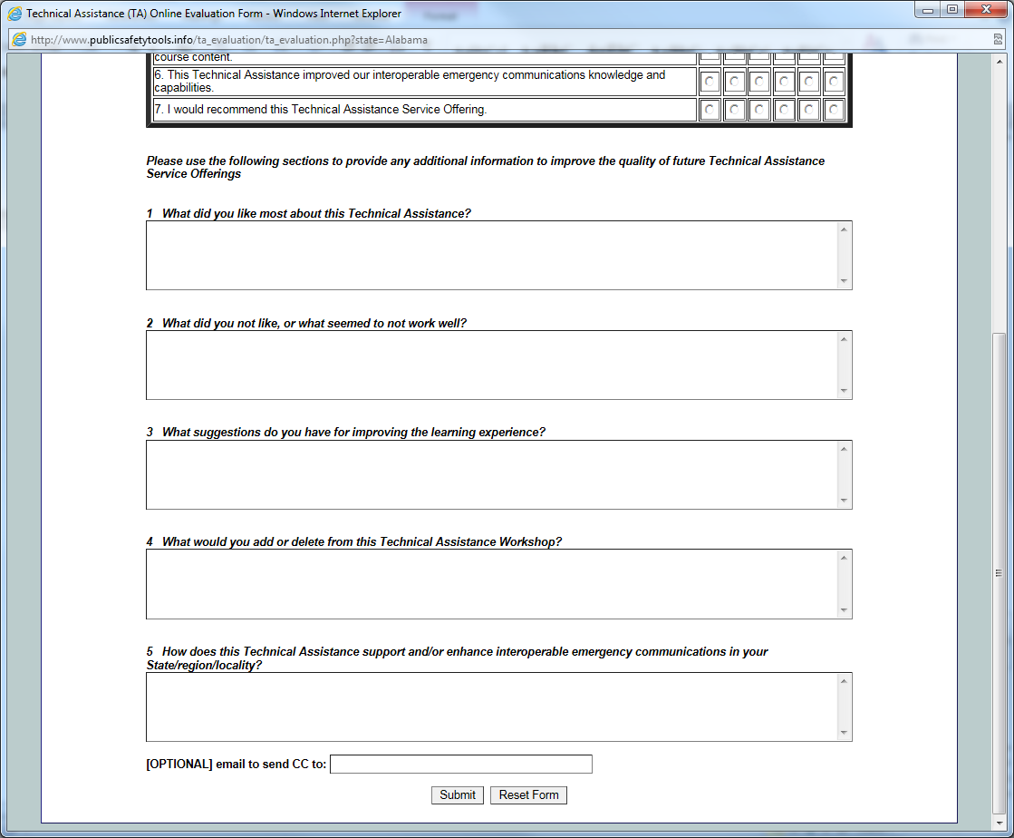

Office of Emergency Communications TA / SCIP Evaluation Form

