NEWS RELEASE 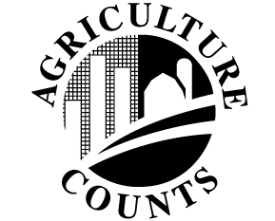
United States Department of Agriculture
NATIONAL AGRICULTURAL STATISTICS SERVICE
[STATE NAME] FIELD OFFICE
[ADDRESS]

FOR IMMEDIATE RELEASE | Contact: [Firstname] [Lastname]
[Month ##], [Year] | (XXX) XXX-XXXX

USDA TO CONDUCT ANNUAL FLORICULTURE SURVEY TO GATHER DATA
ON RAPIDLY CHANGING INDUSTRY

[CITY, STATE] – The U.S. Department of Agriculture’s National Agricultural Statistics Service (NASS) will conduct the Commercial Floriculture Survey in [STATE] and 14 other major floriculture states. Between [start date] and [end date], growers will be asked to provide information on production area, sales of floriculture commodities and the number of agricultural workers on their operation.
“The information obtained through this survey will help identify state and national trends in areas such as new product development and changing production practices so that growers can make vital business decisions and evaluate the results of the growing season said [Firstname Lastname], Director of the NASS [State] Field Office.
“By participating in the survey, floriculture growers ensure that NASS can provide accurate data on floriculture production, thereby enabling USDA and the industry to be more responsive to domestic and international markets and consumer needs,” [Lastname] explained.
NASS will compile and analyze the survey information and publish the results in May 2016 in the report, Floriculture Crops.
As with all NASS surveys, the information respondents provide is confidential by law. “NASS safeguards the privacy of all responses and publishes only state- and national-level data, ensuring that no individual operation or producer can be identified,” stated [LASTNAME].
All reports are available on the NASS web site: www.nass.usda.gov. For more information on NASS surveys and reports, call the NASS [STATE] Field Office at [Toll-free Number].
###
NASS provides accurate, timely, useful and objective statistics in service to U.S. agriculture. We invite you to provide occasional feedback on our products and services. Sign up at http://usda.mannlib.cornell.edu/subscriptions and look for “NASS Data User Community.”

USDA is an equal opportunity provider, employer and lender. To file a complaint of discrimination, write: USDA, Director, Office of Civil Rights, 1400 Independence Ave., S.W., Washington, D.C. 20250-9410 or call (800) 795-3272 (voice), or (202) 720-6382 (TDD).

