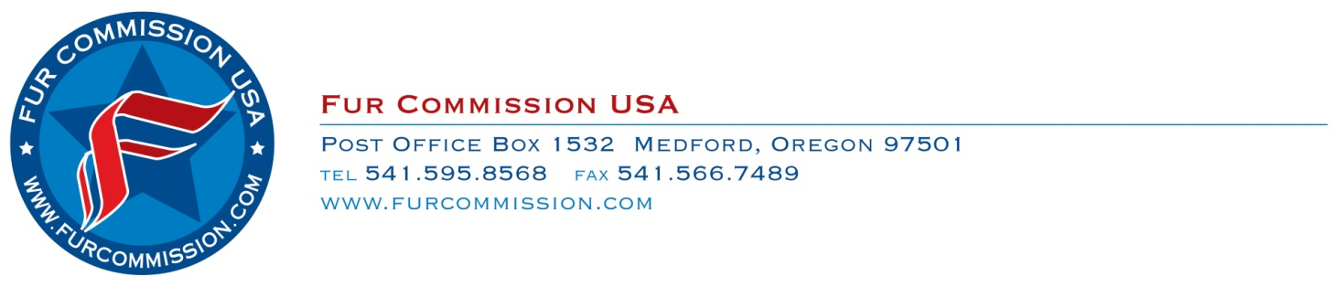
April 30, 2015

Dear Rancher:

Enclosed please find the United States Department of Agriculture (USDA) annual survey on mink farming. Fur Commission USA encourages all mink farmers to take the time to complete and return this important document.

The USDA survey is the sole source of statistical information on the US mink farming industry. Fur Commission USA uses the results of this survey to educate legislators throughout the country on the impact of mink production to their states and districts. The survey is also used extensively to promote the industry through various media outlets. A complete statistical profile provides accurate counts on farms, establishes pelt price averages, and enables us to identify important industry trends. The fact that it is authored by the USDA gives it weight that we cannot provide within the industry.

The survey data is STRICTLY CONFIDENTIAL. Farm names, addresses, and other personal information are considered private and are exempt from release under the Freedom of Information Act. Data on individual farms cannot be released to the public under any circumstances!

Your response to the survey is voluntary and not required by law, but the cooperation of mink farmers is important in developing accurate estimates on the economic impact of our business, both regionally and nationally. Please take a few minutes to respond to the survey and if you have any questions or concerns, feel free to contact me at the Fur Commission USA office.

Sincerely,

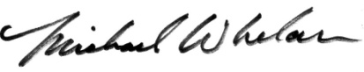

Michael Whelan
Executive Director
Fur Commission USA
541-595-8568

