**Enter your survey responses online using the Census Bureau’s website.**

**STEP 1: Go to the survey’s website https://**[**respond.census.gov/**](https://respond.census.gov/aspep)**gus**

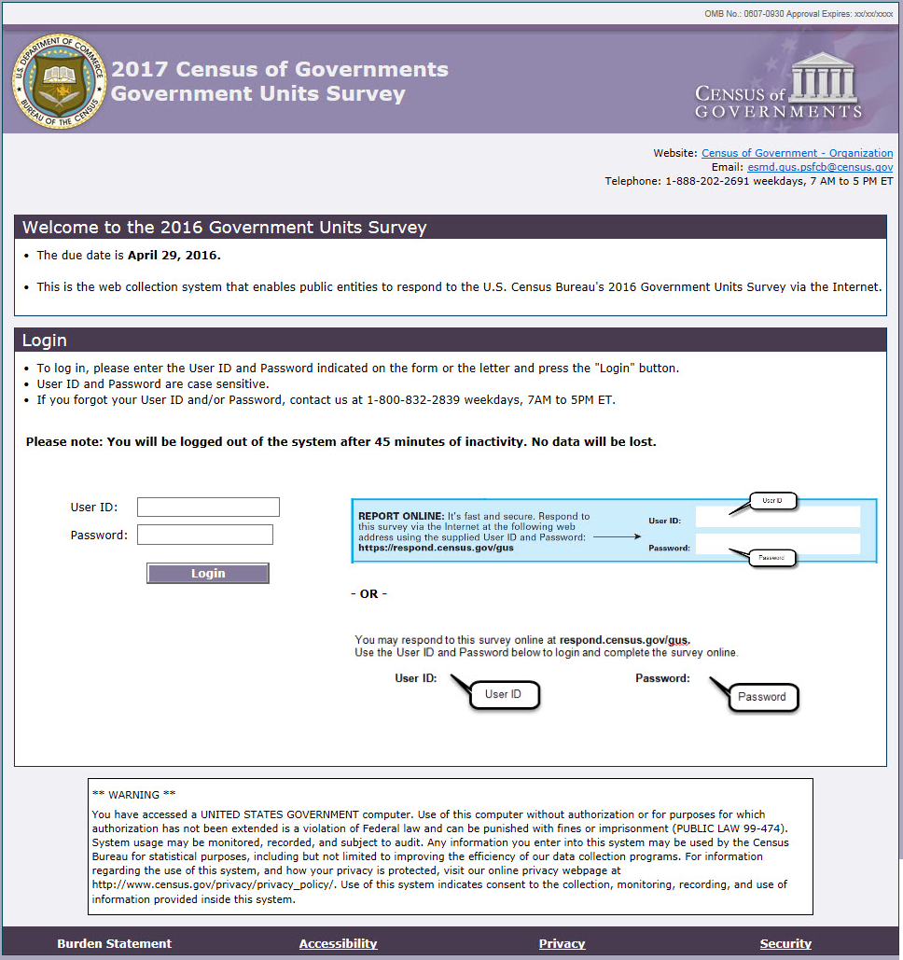

**STEP 2:**  **Enter your User ID and Password found in the letter you received in the mail.**

Our web collection system is both

***fast*** and ***secure***.

It allows you to:

* Upload files
* View auto-summed totals
* Assess possible data issues instantly
* Navigate with a user-friendly interface
* Access detailed information about the survey
* Print a blank form
* Review and print a completed copy of the form

**2017 Census Of Governments**

**Government Units Survey**

**- Electronic Reporting -**

**Respond Online!**