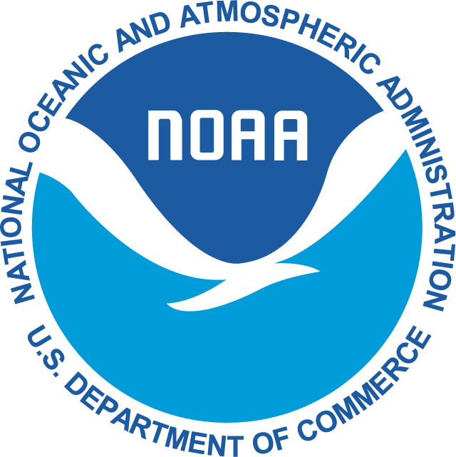
Expiration Date
PERMIT APPLICATION FEE: $30
UNITED STATES DEPARTMENT OF COMMERCE

National Oceanic and Atmospheric Administration
NATIONAL MARINE FISHERIES SERVICE
West Coast Region
501 West Ocean Blvd, Suite 4200
Long Beach, CA 90802

OMB#: 0648-0204
APPROVAL EXPIRES: 08/31/2016
Pacific Highly Migratory Species
Vessel Permit Renewal Application
Please write-in any changes or corrections
VESSEL INFORMATION
USCG Documentation or State Registration Number
Vessel Name
Home Port and State |  |  |  |  |  | Hail Port and State
Radio Call Sign |  |  |  |  |  | VMS
Registered Length (Ft.) |  |  | Registered Breadth (Ft.) |  |  |  | Registered Depth (Ft.)
Gross Tons |  |  | Net Tons |  |  |  | CFPV Passenger Cap.
Hold Capacity (Short tons, 1 ST= 2,000 lbs.)
Refrigeration Type |  |  |  | Propulsion Type |  |  |  | Horsepower
Hull Material
Year Built |  | Location Built |  |  |  |  |  | Crew Size
Previous Vessel Name/Flag/Effective Dates
Gear Type Authorized by the HMS Permit (Addition of gear types may be subject to further authorization)

VESSEL OWNERSHIP INFORMATION
Permit Holder and/or Company Name
Business Mailing Address
Business Telephone |  | Fax |  | Mobile
Email Address
Additional Owners/Birthdate (if new)

SIGNATURE
I certify that the above information is complete, true, and correct to the best of my knowledge and belief.

Name (Print legibly) Signature Date

___________________________________ _________________________________ ____________

Permit application fee: $30.00 payable to “US Department of Commerce – NOAA”
Mail to: Permits Office, 501 W Ocean Blvd. Suite 4200, Long Beach, CA 90802

