Attachment 2
OMB Control Number 0920-0765
Fellowship Management System
Non-substantive Change Request
Proposed changes to the CDC Public Health Associate program (PHAP)
FMS Host Site Module
Date Submitted: September 4, 2015
PHAP Host Site Module
Screen shots of modified questions

Table of Contents

1 Public Health Agency Details: Contact Information 3
2 Public Health Agency Details: Population Description 4
3 Public Health Agency Details: Organizational Structure 5
4 Public Health Agency Statement 6
5 Assignment Details 7
6 Program Details 8
7 Appendix A 9
Add Activity 9
8 Appendix B 11
Add Training 11
Training Types 11
9 Appendix C 12
Primary Supervisor Information 12
10 Appendix D 13
Secondary Supervisor Information 13
11 Appendix E 14
CIO Categorical Program Areas List 14

Public Health Agency Details: Contact Information
- Click the Primary link to display the primary supervisor entry screen shown in Appendix C.
- Click the Secondary link to display the secondary supervisor entry screen shown in Appendix D.
- Allow ability to upload letter or support form in the Director Contact section.
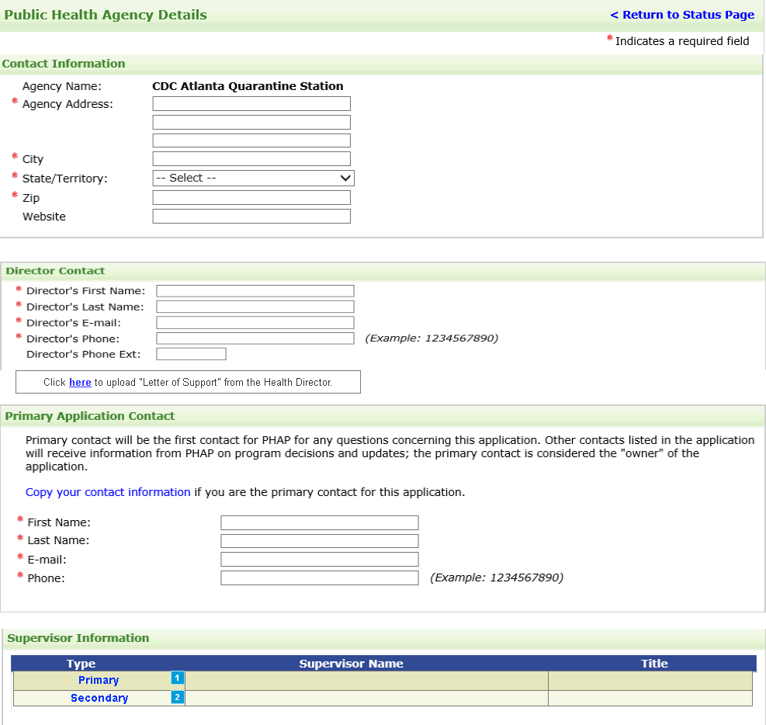

Public Health Agency Details: Population Description
- The Primary Topic field is a dropdown that will include “Other” – see Appendix F for dropdown list
- Allow ability to select multiple categories for Race, Life Stages and Primary Topic

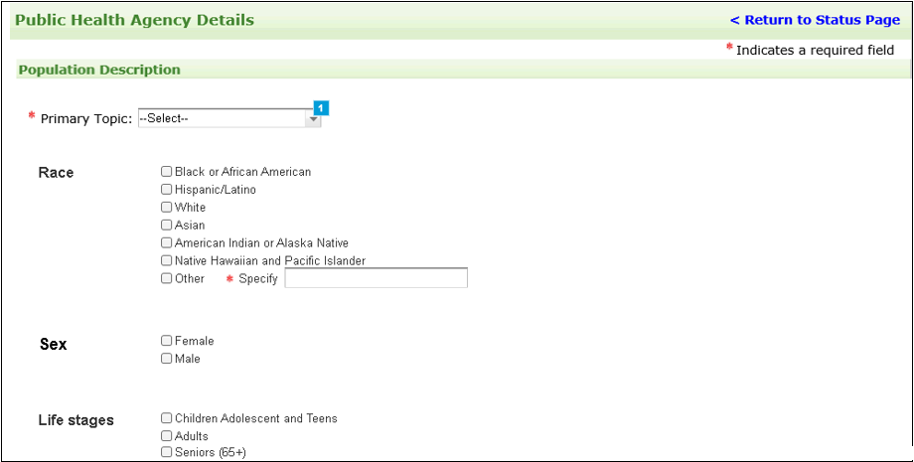

Public Health Agency Details: Organizational Structure

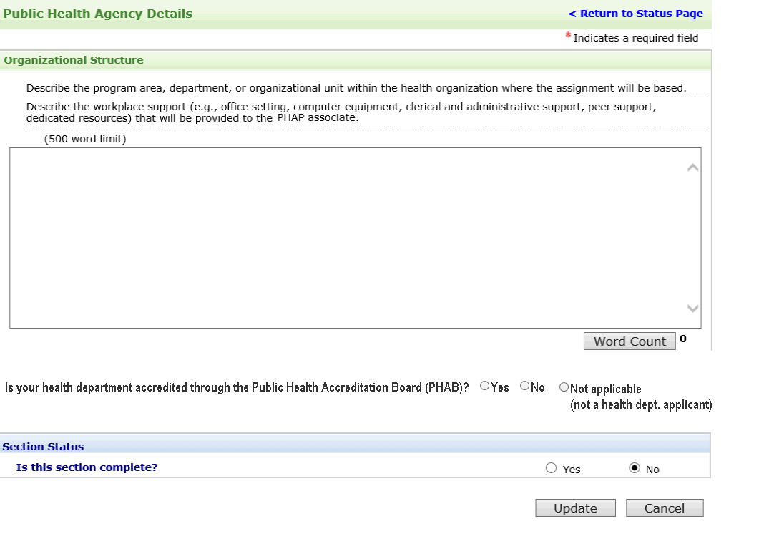

Public Health Agency Statement

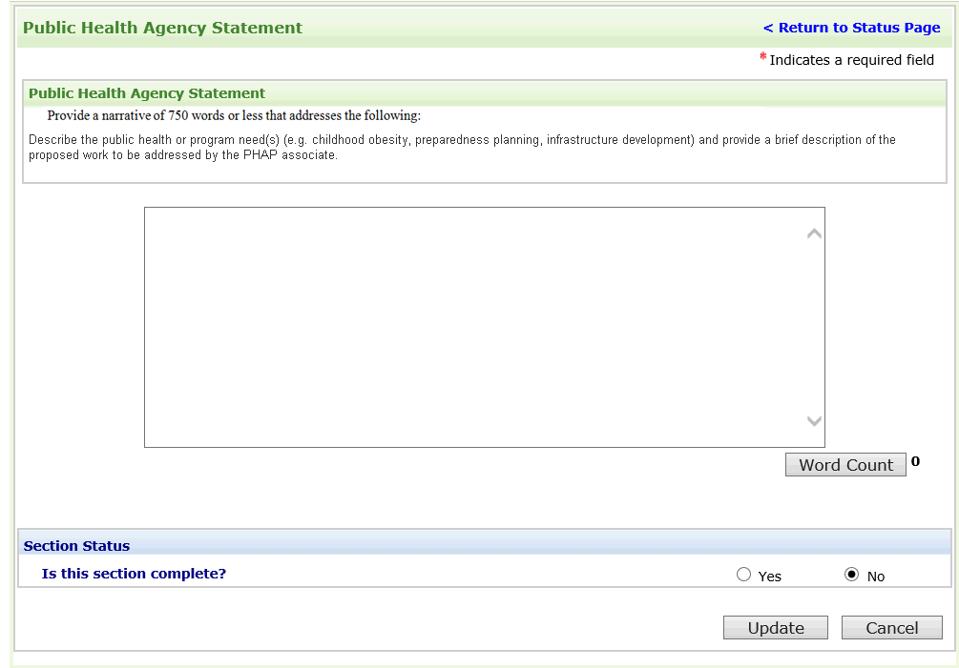

Assignment Details
- Added column in table to capture the Program Area

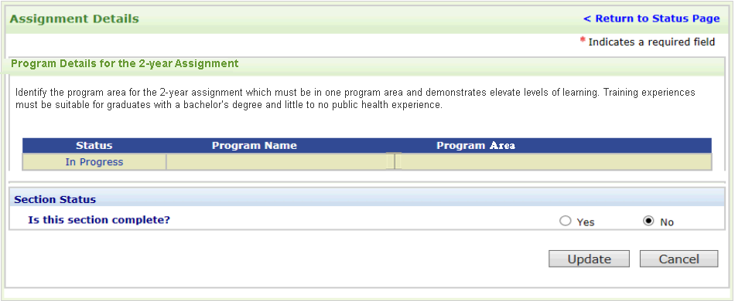

Program Details
- Click the Add Activity button to display the Add Activity screen shown in Appendix A.
- Click the Add Training button to display the Add Training screen shown in Appendix B.
- Click the Primary link to display the primary supervisor entry screen shown in Appendix C.
- Click the Secondary link to display the secondary supervisor entry screen shown in Appendix D.
- Program dropdown will be the list of CIO Categorical Program Areas shown in Appendix E.

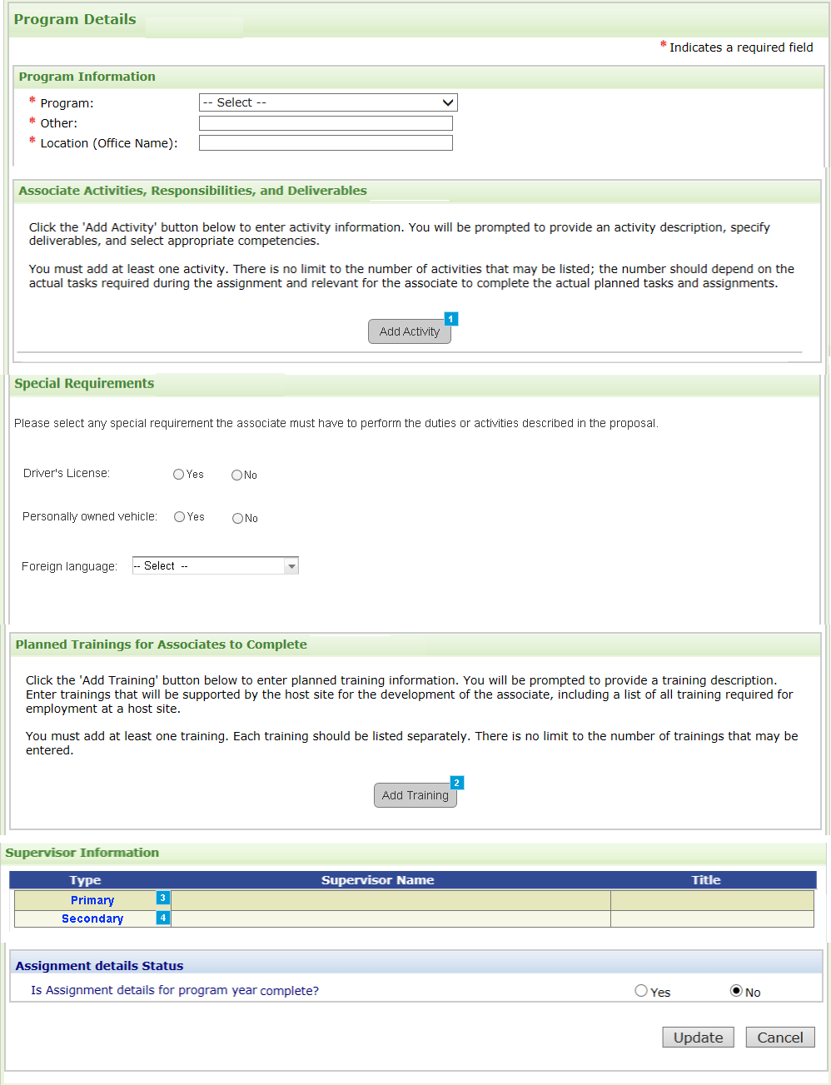

Appendix A

Add Activity
- Level of Responsibility dropdown list will include: Team Member, Coordinator, Lead or Other (specify)
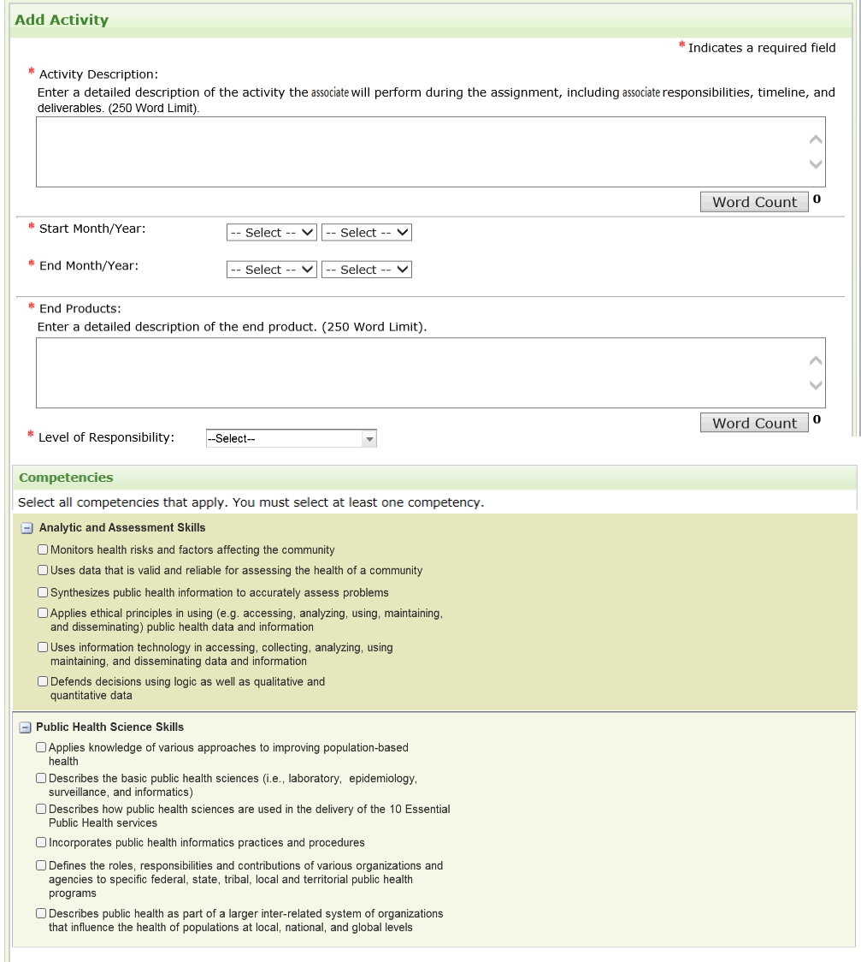

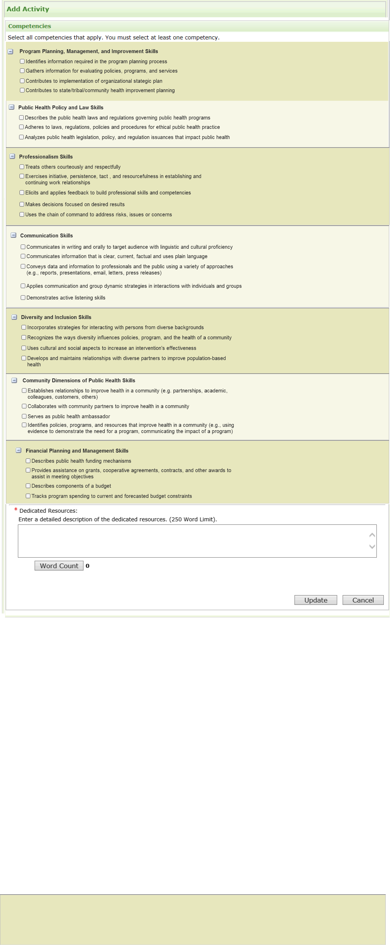

Appendix B

Add Training
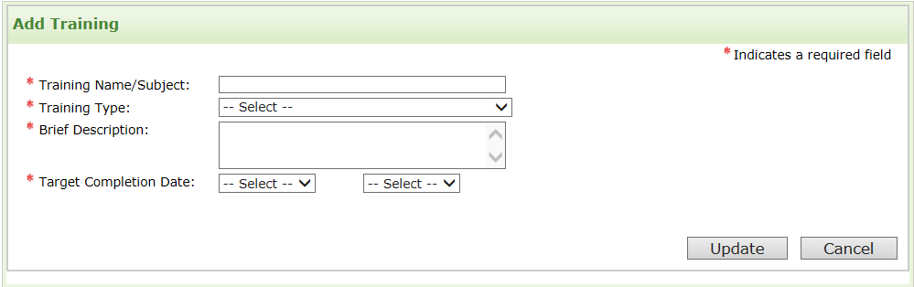

Training Types
- One-on-One
- E-Learning Non-CDC
- Classroom: HD
- Classroom: Outside Sponsor
- E-learning CDC

Appendix C

Primary Supervisor Information

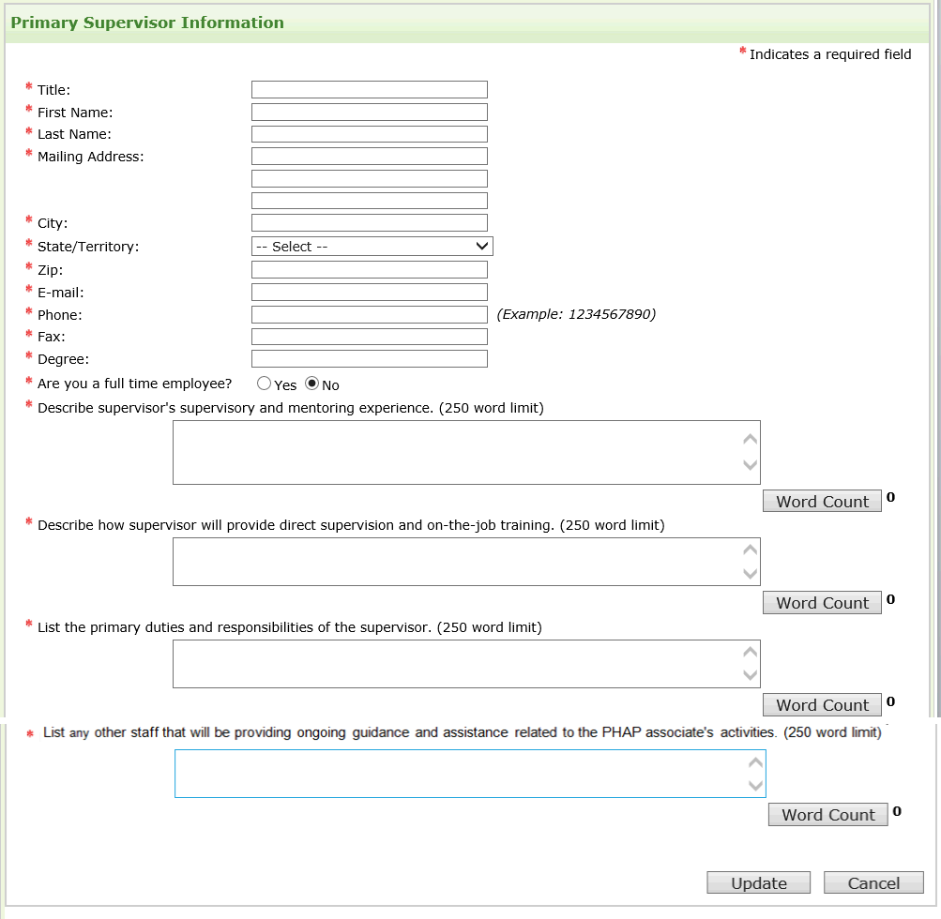

Appendix D

Secondary Supervisor Information
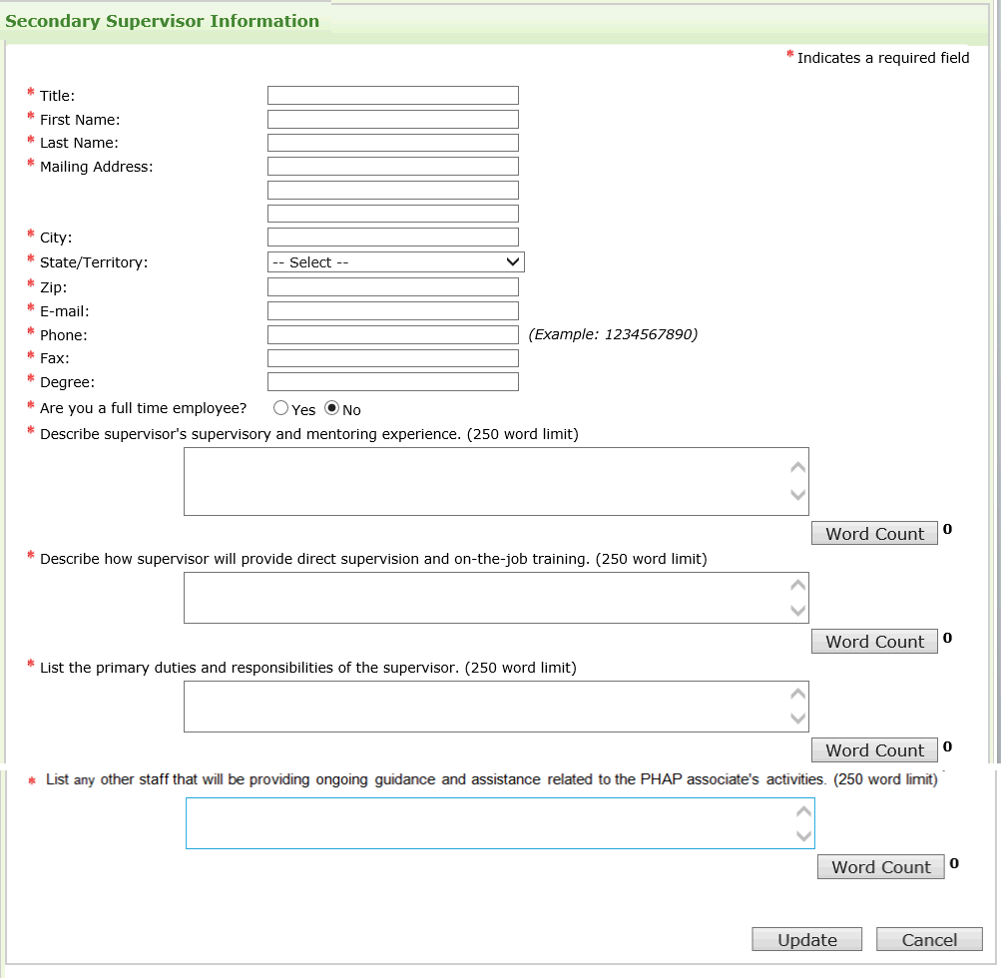

Appendix E

CIO Categorical Program Areas List (the CIO and division will not be visible to the host site but will link to CIO on admin page)

CIO |  | Categorical Program Area(s)
1. | Center for Surveillance, Epidemiology, and Laboratory Services (CSELS) | Division of Public Health Information Dissemination (DPHID  - Genomics  - Community Health Status Indicators (CHSI)  - Informatics Innovation Unit (IIU)  - Informatics R&D Laboratory (within IIU)  - Community Health Assessment for Population Health Improvement  Division of Laboratory Systems  - Clinical Laboratory Improvement Program  - Laboratory Sustainability  - Laboratory Policies and Guidance  Division of Health Informatics and Surveillance  - BioSense  - Epi Info™  - Message Validation, Processing, and Provisioning System (MVPS)  - NEDSS Base System (NBS)  - Countermeasure Tracking Systems (CTS)  - Laboratory Response Network (LRN) Data Exchange Activities  - Public Health Information Network  - National Notifiable Diseases Surveillance System (NNDSS)  - NNDSS Modernization Initiative (NMI)  - National Syndromic Surveillance Program (NSSP
2. | National Center for Birth Defects and Developmental Disabilities (NCBDDD) | Division of Birth Defects and Developmental Disabilities  - Autism surveillance and research  - Newborn Screening - birth defects surveillance and research  - Congenital Heart Defects  - Safe medication use during pregnancy  - Prevention of Fetal Alcohol Spectrum Disorders  - Learn the Signs Act Early (LTSAE) – developmental milestones  - Folic acid-preventable neural tube defects in the United States and globally  Division of Human Development and Disabilities  - Disability and Health State Programs (18). Healthy behaviors, emergency preparedness, healthcare access and equity issues for people living with disabilities  - Disability and Health Data System  - Complex Chronic Conditions - Muscular Dystrophy, Spina Bifida and Fragile X  - Early childhood development, Tourette Syndrome and Attention Deficit and Hyperactivity Disorder  - Early Hearing Detection and Intervention (newborn hearing screening)  Division of Blood Disorders  - Hemophilia, Sickle cell and Von Willebrand Disease  - Clotting disorders such as venous thromboembolism (VTE)
3. | National Center for Chronic Disease Prevention and Health Promotion (NCCDPHP) | - Diabetes prevention/education  - Physical activity  - Nutrition  - Obesity  - Cardiovascular health (HTN prevention and control, Million Hearts, sodium reduction)  - Cancer prevention and screening (breast, cervical, skin, prostate, and colorectal)  - Maternal and infant health (SIDS, teen pregnancy)  - Smoking prevention and cessation  - School health  - Oral health (fluoridation, sealants)  - Arthritis (Living Well With)  - Reproductive health
4. | National Center for Emerging and Zoonotic Infectious Diseases (NCEZID) | - Advanced molecular detection  - Antimicrobial resistance and healthcare associated infections  - Epi and lab capacity program  - Emerging infectious diseases  - Food safety  - Lyme disease  - National Healthcare Safety Network  - Prion disease  - Quarantine  - Vector-borne diseases  - All other emerging and zoonotic infectious diseases
5. | National Center for HIV/AIDS, STD, and TB Prevention (NCHHSTP) | - STD/HIV  - TB prevention  - Viral hepatitis  - Adolescent and school health
6. | National Center for Immunizations and Respiratory Diseases (NCIRD) | - Immunizations  - Vaccine Preventable Diseases
7. | National Center for Injury Prevention and Control (NCIPC) | - Motor vehicle injuries  - Prescription drug overdoses  - Growth areas:  - Child abuse and neglect  - Older adult falls  - Sexual violence  - Youth sports concussions
8. | National Center on Environmental Health (NCEH) | - Air pollution and respiratory health  - Asthma and allergies  - Bio-monitoring (nutritional status, exposure to environmental chemicals and toxic substances  - Built Environment/Healthy Community Design (i.e. Transportation, Planning, and Physical Activity)  - Cancer  - Chemical Weapons Demilitarization  - Children’s Environmental Health  - Climate Change and Health  - Cruise ship sanitation  - Emergency Response and/or disaster preparedness  - Environmental Public Health Tracking (i.e., surveillance of environmental health-related health effects or conditions)  - Food Safety  - Hazardous Materials Response  - Healthy Homes and Lead Poisoning Prevention  - Indoor/Outdoor Air Quality  - Newborn Screening and Birth Defects  - Pest, Vector, and Animal Control  - Poison Control  - Public/Private Water Safety and Protection  - Radiation and Radon Control  - Regulation, Inspection, and Licensing (e.g. restaurants, pools, campgrounds, hospitals)  - Reproductive and Birth Outcomes  - Solid and Hazardous Waste  - Toxicology
9. | National Institute for Occupational Safety and Health (NIOSH) | - Impacts of nanotechnology on workers  - Cancer, reproductive, and cardiovascular diseases associated with work  - Economic analysis of safety and health interventions  - Health and safety of emergency responders  - Engineering controls  - Tools for assessing exposure to workplace hazards  - Conducting workplace investigations of health hazards (Health Hazard Evaluation)  - Hearing Loss prevention  - Immune, Dermal, and Infectious diseases associated with work conditions  - Musculoskeletal disorders and ergonomics  - Identifying occupational health disparities amongst workers of different backgrounds  - Personal protective equipment and technology  - Radiation exposure  - Respiratory diseases  - Small-business safety and health  - The intersection of occupational safety and health with health promotion  - Traumatic injury at work  - Work schedules and policies (including shiftwork and long work hours)  - Work-stress  - Worker’s compensation  - Studies and interventions in specific sectors:  - Agriculture, Forestry and Fishing  - Construction  - Healthcare and Social Assistance  - Manufacturing  - Mining  - Oil and Gas Extraction  - Public Safety  - Service Industry  - Transportation, Warehousing and Utilities  - Wholesale and Retail Trade
10. | Office for State, Tribal, Local and Territorial Support (OSTLTS) | - Health department accreditation  - Tribal health  - Public health law  - Public health performance improvement / quality improvement  - Community health improvement  - Community health assessments  - Community health improvement planning  - Health system transformation  - Territorial health
11. | Office of Public Health Preparedness and Response (OPHPR) | - Community Preparedness  - Community Recovery  - Emergency Operations Center (EOC) Coordination  - Emergency Public Information and Warning  - Fatality Management  - Information Sharing  - Mass Care  - Medical Countermeasure (MCM) Dispensing  - MCM Management and Distribution  - Medical Surge  - Non-Pharmaceutical Interventions  - Public Health Laboratory Testing  - Public Health Surveillance and Epi Investigations  - Responder Safety and Health  - Volunteer Management

