Form Approved
OMB No. 0935-0118
Exp. Date 12/31/2015

Attachment 94

MEDICAL EXPENDITURE PANEL SURVEY

MEDICAL PROVIDER COMPONENT

DATA FORM

FOR

PHARMACIES

for

REFERENCE YEAR 2014

OMB HYPERLINK ON FIRST SCREEN

DCS: READ THIS ALOUD ONLY IF REQUESTED BY RESPONDENT.

PRESS NEXT TO CONTINUE IN THIS EVENT FORM

PRESS BREAKOFF TO DISCONTINUE

(Public reporting burden for this collection of information is estimated to average 3 minutes per response, the estimated time required to complete the survey. An agency may not conduct or sponsor, and a person is not required to respond to, a collection of information unless it displays a currently valid OMB control number. Send comments regarding this burden estimate or any other aspect of this collection of information, including suggestions for reducing this burden, to: AHRQ Reports Clearance Officer Attention: PRA, Paperwork Reduction Project (0935-0118) AHRQ, 540 Gaither Road, Room # 5036, Rockville, MD 20850.)

OMB No. 0935-0118; Exp. Date XX/XX/XXXX

Q1. Date Filled
MONTH DAY YEAR

Q2. Prescription information will be identified using: 1 = NDC
2 = Drug Name, Strength/Unit, and Dosage Form
NOTE: TRY TO OBTAIN NDC. USE DRUG NAME
ONLY IF NDC NOT AVAILABLE.

Q2a. NDC

ENTER 11-DIGIT NDC WITHOUT DASHES OR SPACES.
NDC IS UNKNOWN OR REFUSED, RETURN TO PREVIOUS SCREEN AND SELECT DRUG NAME OPTION

Q3a. Quantity:

Q4. How many days were supplied?

IF PRESCRIPTION WAS TO BE USED “AS NEEDED” ENTER 999

Q5. Patient Payment: $

Q5a. Were there any 3rd party payers?

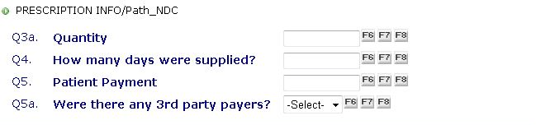

Q2b. Drug Name:

Q2b_1 Check this box to indicate Durable Medical Equipment

Q2c. Strength

Q2d. Unit:

Q2c1. Strength:

Q2d2. Unit:

Q2e. Dosage Form:

Other Specify:

Q3a. Quantity:

Q3b Unit:

OTHER, PLEASE SPECIFY

Q4. How many days were supplied?

IF PRESCRIPTION WAS TO BE USED “AS NEEDED” ENTER 999

Q5. Patient Payment: $

Q5a. Were there any 3rd party payers?

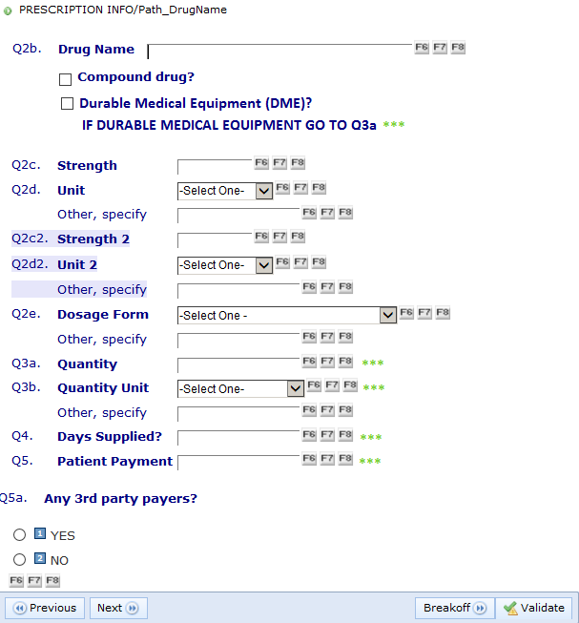

FAQ LINK AND/OR JOBAID FOR INSTRUCTIONS PREVIOUSLY ON SCREEN

FINAL SCREEN

Q6. Type of 3rd Party Payer
Other Specify Source

Q7. 3rd Party Payment $

NOTE: IF PATIENT PAYMENT WAS $1 OR LESS,
EXPECT THE 3rd PARTY PAYER TO BE A
PUBLIC PROGRAM, E.G., MEDICAID OR
OTHER STATE/LOCAL GOVT, ETC.

Any more 3rd Party Payers?
- YES
- NO

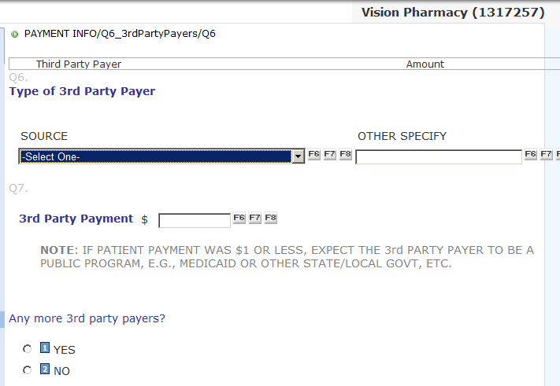

FINISH SCREEN
PRESS VALIDATE TO COMPLETE THIS EVENT FORM.

