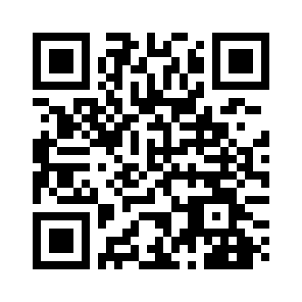
Overall Evaluations
  - Please take this online: https://www.surveymonkey.com/r/LANSummitOverall
- How did you hear about the Summit? Mark only one.
e-mail LAN website Twitter past participant
colleague other (please describe)______________

Please use the following scale to rate the items in questions 2-6:
(1 - poor 2 - fair 3 - average 4 - good 5 - excellent)
- the Summit overall ___
- the service of the meeting organizers ___
- registration process ___
- overall program content ___
- the Summit interactive web portal used in each session ___

Please use the following scale to answer questions 7 & 8:
(1 - not likely 2 - somewhat likely 3 - likely 4 - very likely 5 - extremely likely)
- How likely is it that you will attend this summit in the future?
- How likely is it that you will take action or further action on implementing an APM as a result of attending the Summit?
- Please list any suggestions for future topics.

- Additional comments (you may use the back of this page)

Overall Evaluations
  - Please take this online: https://www.surveymonkey.com/r/LANSummitOverall
- How did you hear about the Summit? Mark only one.
e-mail LAN website Twitter past participant
colleague other (please describe)______________

Please use the following scale to rate the items in questions 2-6:
(1 - poor 2 - fair 3 - average 4 - good 5 - excellent)
- the Summit overall ___
- the service of the meeting organizers ___
- registration process ___
- overall program content ___
- the Summit interactive web portal used in each session ___

Please use the following scale to answer questions 7 & 8:
(1 - not likely 2 - somewhat likely 3 - likely 4 - very likely 5 - extremely likely)
- How likely is it that you will attend this summit in the future?
- How likely is it that you will take action or further action on implementing an APM as a result of attending the Summit?
- Please list any suggestions for future topics.

- Additional comments (you may use the back of this page)

OMB No: 0938-1297
Expiration Date 1/31/2019
According to the Paperwork Reduction Act of 1995, no persons are required to respond to a collection of information unless it displays a valid OMB control number. The valid OMB control number for this information collection is 0938-1297. The time required to complete this information collection is estimated to average 3 minutes per response, including the time to review instructions, search existing data resources, gather the data needed, and complete and review the information collection. If you have comments concerning the accuracy of the time estimate(s) or suggestions for improving this form, please write to: CMS, 7500 Security Boulevard, Attn: PRA Reports Clearance Officer, Mail Stop C4-26-05, Baltimore, Maryland 21244-1850. Please do not send applications, claims, payments, medical records or any documents containing sensitive information to the PRA Reports Clearance Office. Please note that any correspondence not pertaining to the information collection burden approved under the associated OMB control number listed on this form will not be reviewed, forwarded, or retained. If you have questions or concerns regarding where to submit your documents, please contact PaymentNetwork@mitre.org.

OMB No: 0938-1297
Expiration Date 1/31/2019
According to the Paperwork Reduction Act of 1995, no persons are required to respond to a collection of information unless it displays a valid OMB control number. The valid OMB control number for this information collection is 0938-1297. The time required to complete this information collection is estimated to average 3 minutes per response, including the time to review instructions, search existing data resources, gather the data needed, and complete and review the information collection. If you have comments concerning the accuracy of the time estimate(s) or suggestions for improving this form, please write to: CMS, 7500 Security Boulevard, Attn: PRA Reports Clearance Officer, Mail Stop C4-26-05, Baltimore, Maryland 21244-1850. Please do not send applications, claims, payments, medical records or any documents containing sensitive information to the PRA Reports Clearance Office. Please note that any correspondence not pertaining to the information collection burden approved under the associated OMB control number listed on this form will not be reviewed, forwarded, or retained. If you have questions or concerns regarding where to submit your documents, please contact PaymentNetwork@mitre.org.

