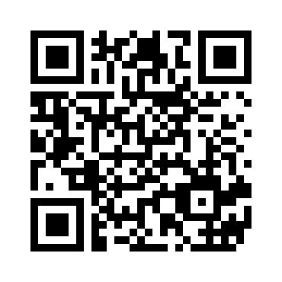
Session #: _____
  - Please take this online: https://www.surveymonkey.com/r/lansummitsession
Please using the following scale to answer questions 1 & 2:
(1 - poor 2 - fair 3 - average 4 - good 5 - excellent)
- Please rate this session
- Please rate the format
Please use the following scale to answer questions 3 & 4:
(1 - not likely 2 - somewhat likely 3 - likely 4 - very likely 5 - extremely likely)
- How likely are you to attend a session on this topic again?
- With this information, how likely are you to take further action on implementing an APM?
- What was the single most valuable takeaway for you from this session?
- Additional comments

OMB No: 0938-1297
Expiration Date 1/31/2019
According to the Paperwork Reduction Act of 1995, no persons are required to respond to a collection of information unless it displays a valid OMB control number. The valid OMB control number for this information collection is 0938-1297. The time required to complete this information collection is estimated to average 3 minutes per response, including the time to review instructions, search existing data resources, gather the data needed, and complete and review the information collection. If you have comments concerning the accuracy of the time estimate(s) or suggestions for improving this form, please write to: CMS, 7500 Security Boulevard, Attn: PRA Reports Clearance Officer, Mail Stop C4-26-05, Baltimore, Maryland 21244-1850. Please do not send applications, claims, payments, medical records or any documents containing sensitive information to the PRA Reports Clearance Office. Please note that any correspondence not pertaining to the information collection burden approved under the associated OMB control number listed on this form will not be reviewed, forwarded, or retained. If you have questions or concerns regarding where to submit your documents, please contact PaymentNetwork@mitre.org.

