**Attachment P:**

**ODPHP Physical Activity Guidelines, 2nd Edition**

**Stimulus Materials for Child Focus Groups**

OMB Control Number: 0990-0281

December 21, 2017

**Submitted to:**

Sherrette Funn

Office of the Chief Information Officer

U.S. Department of Health and Human Services

**Submitted by:**

Frances Bevington

Strategic Communication and Public Affairs Advisor

Office of Disease Prevention and Health Promotion

U.S. Department of Health and Human Services

Participants will be asked to look at two physical activity related materials during the focus groups. The moderator will ask participants to discuss what they like and don’t like about the materials.

**Handout**

[Be a Fit Kid: 10 Tips for Being Active Every Day](https://choosemyplate-prod.azureedge.net/sites/default/files/audiences/Tipsheet2_BeAFitKid.pdf)

**Length:** 1 page

**Description:** Activity suggestions from the USDA for 8-12 year olds

**More information from source:** “Fit kids are physically active and play for at least 1 hour every day. Look for ways to make physical activity a part of your day. Do activities that build your muscles, get your heart pumping, and make you feel good about yourself.”

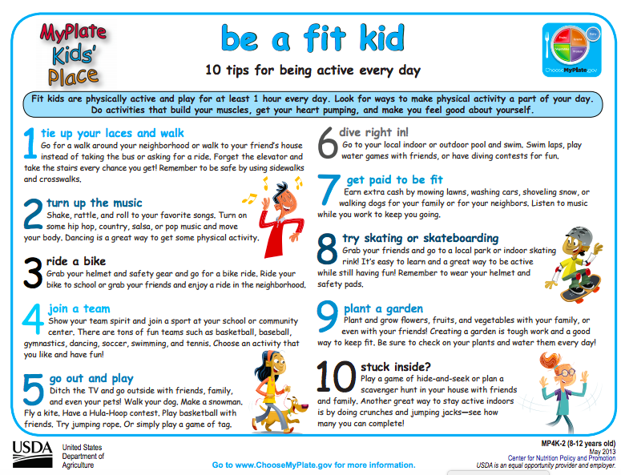

**Tracker**

**Length**: 1 page

**Description:** Physical activity tracker from HealthyKids ([www.healthykids.nsw.gov.au](http://www.healthykids.nsw.gov.au))

**More information from source:** “Print this page each week and record your physical activity type and duration in the table below. Aim for at least 60 minutes each day.”

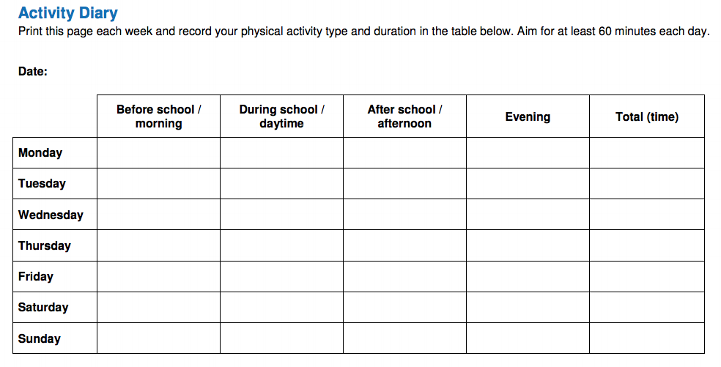

**Video** (will only be shown to participants if time allows)

[Fuel Up to Play 60 Kickoff Dance](https://www.youtube.com/watch?v=xya6tFCgwPU)

**Length:** 1:26

**Description:** Dance video by Fuel Up to Play 60

**More information from source:** “It's fun. It's catchy. It's the dance you've been waiting for. Learn more about how to kick off Fuel Up to Play 60 at your school today: [http://bit.ly/2x9YIL7](https://www.youtube.com/redirect?q=http%3A%2F%2Fbit.ly%2F2x9YIL7&redir_token=G6xrMFSwcvfAm_7cXSYoST82Ych8MTUxMjY3Mzk5NEAxNTEyNTg3NTk0&v=xya6tFCgwPU&event=video_description)”

