**Attachment Q:**

**ODPHP Physical Activity Guidelines, 2nd Edition**

**Stimulus Materials for Adolescent Focus Groups**

OMB Control Number: 0990-0281

December 21, 2017

**Submitted to:**

Sherrette Funn

Office of the Chief Information Officer

U.S. Department of Health and Human Services

**Submitted by:**

Frances Bevington

Strategic Communication and Public Affairs Advisor

Office of Disease Prevention and Health Promotion

U.S. Department of Health and Human Services

Participants will be asked to look at a physical activity-related infographic, video, and tracker. The moderator will ask participants to discuss what they like and don’t like about the materials.

**Infographic**

[Exercise Makes You Smart?](https://www.essa.org.au/exercise-makes-you-smart-infographic/)

**Audience:** Teens

**Length:** about 1 page (showing top part only)

**Description:** Infographic posted on Exercise & Sports Science Australia web site that illustrates how exercise affects classroom performance

**More information from source:** “Physical activity that can pump up your brain”

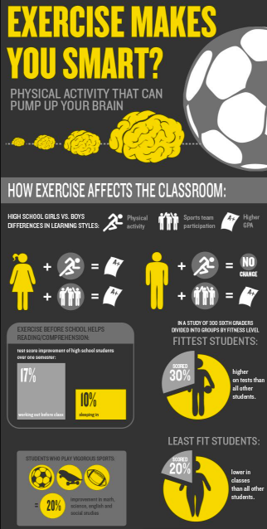

**Video**

[7 Workout Motivation Hacks for When You’re Feeling Lazy](https://www.youtube.com/watch?v=As8CfrEbP_A&feature=youtu.be)

**Length**: 6:23

**Description:** Motivation tips and tricks for getting physical activity into your day

**More information from source:** “Sometimes you just wanna do a whole lotta nothing. But then that just turns into laziness… so my sister Jackelyn and I are gonna talk about 7 REAL things you can do to get out of your rut and GET MOVING!”

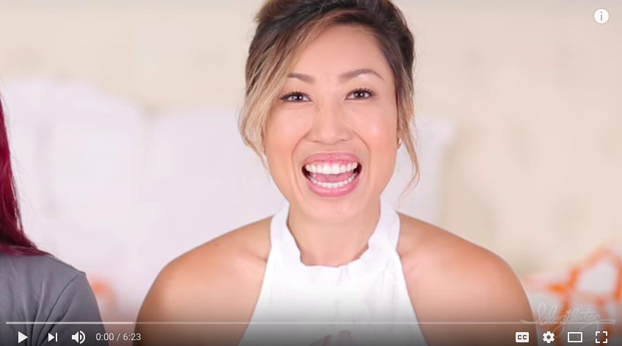

**Tracker**

[Presidential Active Lifestyle Award (PALA) Paper Log](https://www.hhs.gov/sites/default/files/pala-plus.pdf)

**Length:** 1 page (showing 2nd page only)

**Description:** Printable activity tracker from the President’s Council on Fitness, Sports & Nutrition

**More information from source:** “Circle each healthy eating goal you achieve. Enter your daily physical activity in minutes and add up the total at the end of the week.”

