**Appendix B-1:**

**Map of Parks Requiring Air Tour Management Plans**

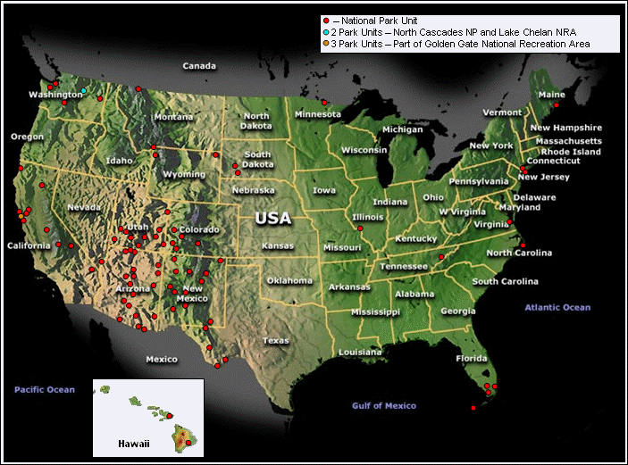

**Appendix B-2:**

**Parks Averaging At Least 365 Air Tour Operations per Year**

